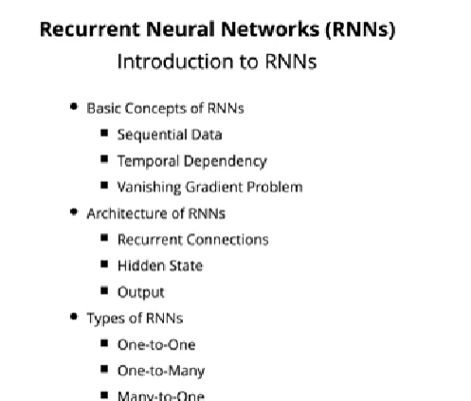

Recurrent Neural Network is also a type of neural network which are used in natural language processing, sequential data processing, time series data processing, audio related data.

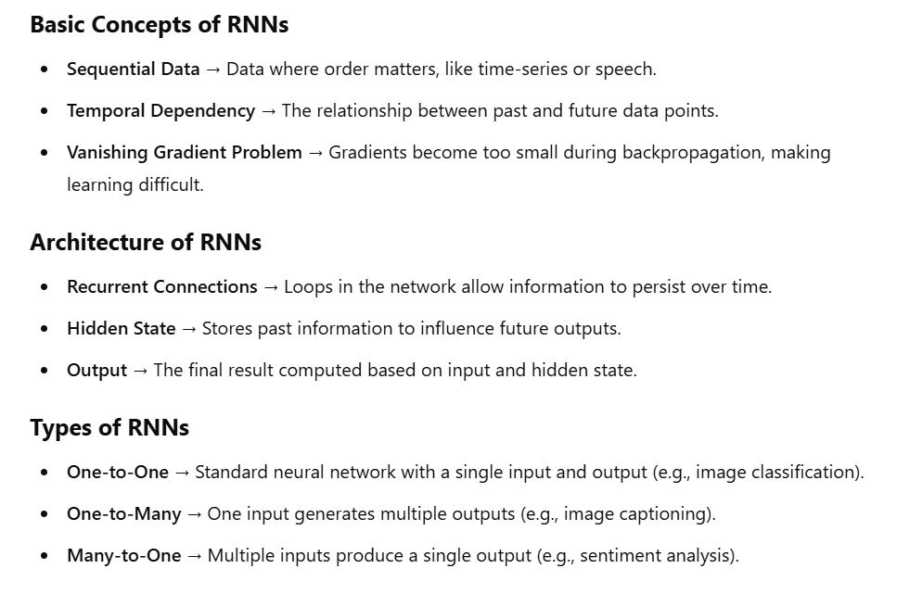

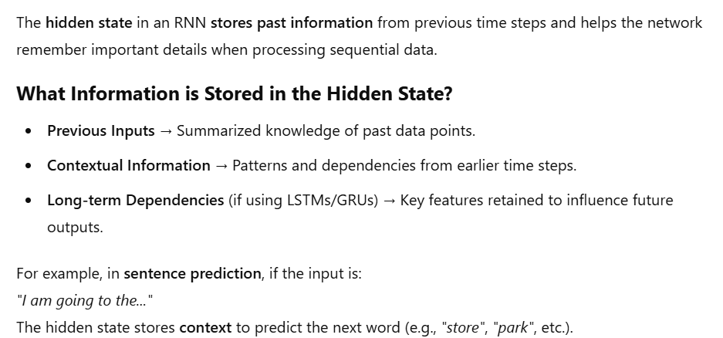

**SOLUTION FOR VANISHING GRADIENT PROBLEM**

