**What is data augmentation?**

* There will be an situation when we can't give large amount ot

   input to build model.

 * It will complicated to memorize all the inputs in model.

 * Here the data augmentation play's it's role.

 * It creates new data based on existing data

**EX:**  consider a model are trained with the below only one image to detect a flower

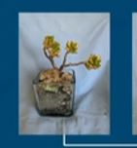

On model test phase What if it will have image like below to make prediction

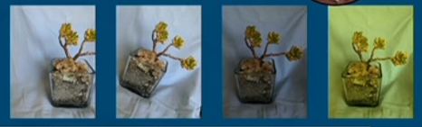

In this type of scenario the model do data augmentation, it will trying to mimic all these possible cropped images by cropping or adjusting it’s brightness, hue in it’s trained image to make correct prediction.

So in this process we will take one single training example and tries to generate four training examples just by applying image transformation.

In machine learning data augmentation are used to expand the traning samples for more generalization.

See the below Screen shot for more

