TABLE OF CONTENTS HTML

## TASKS PAGE NO.

| Sr. No |  |  |
| --- | --- | --- |
| 01 | Text Formatting |  |
| 02 | HTML LIST: Ordered & Unordered |  |
| 03 | HTML LIST: Nested & Definition |  |
| 04 | HTML LINKS |  |
| 05 | HTML TABLES |  |
| 06 | HTML TABLES: Spanning – Rows Column |  |
| 07 | HTML IMAGES: Alignment - Horizontally |  |
| 08 | HTML IMAGES: Alignment - Vertically |  |
| 09 | HTML IFRAME |  |
| 10 | HTML FORMS |  |
| 11 | CSS: ALIGN IMAGES AND TEXT FORMATTING |  |
| 12 | CSS: LISTS TABLES AND FORMS |  |

## HTML TASK CHECKLIST

This checklist are filled out and maintained by the instructor. It is used for purpose of assessment and potential certification. In order to complete the module all of the requirements must be fully satisfied.

### HTML TASK CHECKLIST

| Sr.# | Description | Marks Obtained | Total Marks | Signature |
| --- | --- | --- | --- | --- |
| 01 | Text Formatting |  |  |  |
| 02 | HTML LIST: Ordered & Unordered |  |  |  |
| 03 | HTML LIST: Nested & Definition |  |  |  |
| 04 | HTML LINKS |  |  |  |
| 05 | HTML TABLES |  |  |  |
| 06 | HTML TABLES: Spanning – Rows Column |  |  |  |
| 07 | HTML IMAGES: Alignment - Horizontally |  |  |  |
| 08 | HTML IMAGES: Alignment - Vertically |  |  |  |
| 09 | HTML IFRAME |  |  |  |
| 10 | HTML FORMS |  |  |  |
| 11 | CSS: ALIGN IMAGES AND TEXT FORMATTING |  |  |  |
| 12 | CSS: LISTS TABLES AND FORMS |  |  |  |

# **TASK # 01 – TEXT FORMATTING**

#### Write the code to display the below page.

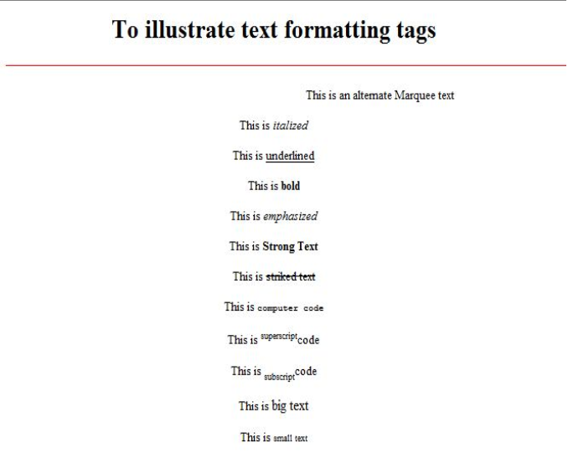

## CODE

## OUTPUT

# **TASK # 02 – ORDERED LIST AND UNORDERED LIST**

#### Create a page that looks like the one depicted below.

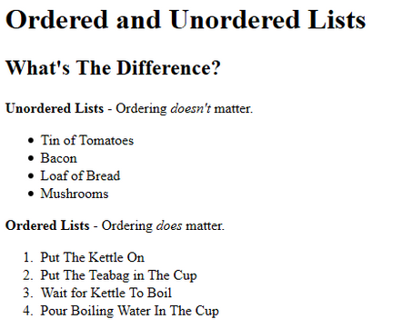

## CODE

## OUTPUT

# **TASK # 03 – DEFINITION LIST AND NESTED LIST**

A Program to illustrate Nested and Definition tag.

|  |
| --- |
| NESTED LIST |
|  |
| DEFINITION LIST |
|  |

## CODE

## OUTPUT

# **TASK # 04 - LINKS**

Create a page that supports the following hyperlinks depicted

* Link to all of the assignments example assignment_01.html assignment_02.html
* Create link to Amazon.com

## CODE

## OUTPUT

# **ASSIGNMENT # 05 – TABLES**

Create a page having tables like the below

|  |
| --- |
| TABLE 1 |
|  |
| TABLE 2 |
|  |

## CODE

## OUTPUT

# **ASSIGNMENT # 06 – TABLES ROW & COLUMN SPANNING**

Create a table like the one below

|  |
| --- |
| **ROW SPANNING** |
|  |
| **COLUMN SPANNING** |
|  |

## CODE

## OUTPUT

# **ASSIGNMENT # 07 – IMAGE HORIZONTAL**

Create a page like this

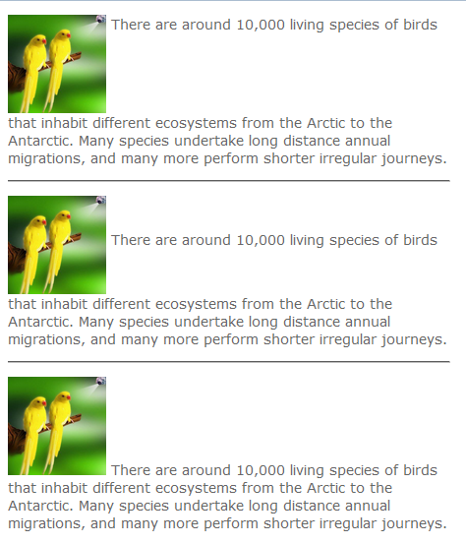

## CODE

## OUTPUT

# **ASSIGNMENT # 08 – IMAGE VERTICAL ALIGN**

Create a page like this

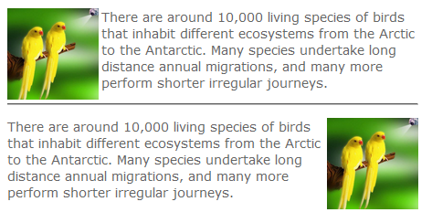

## CODE

## OUTPUT

# **ASSIGNMENT # 09 – IFRAME**

Create a page like this

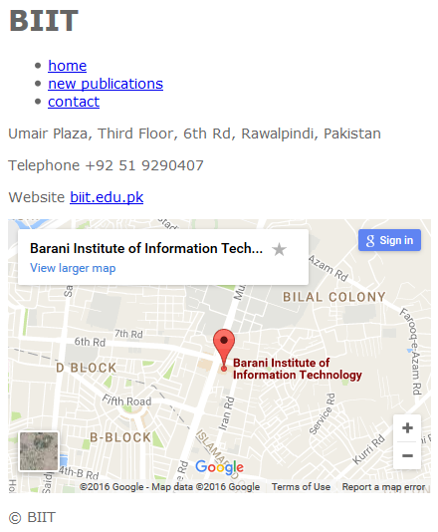

## CODE

## OUTPUT

# **ASSIGNMENT # 10 – FORMS**

Create a page having a form like the below one

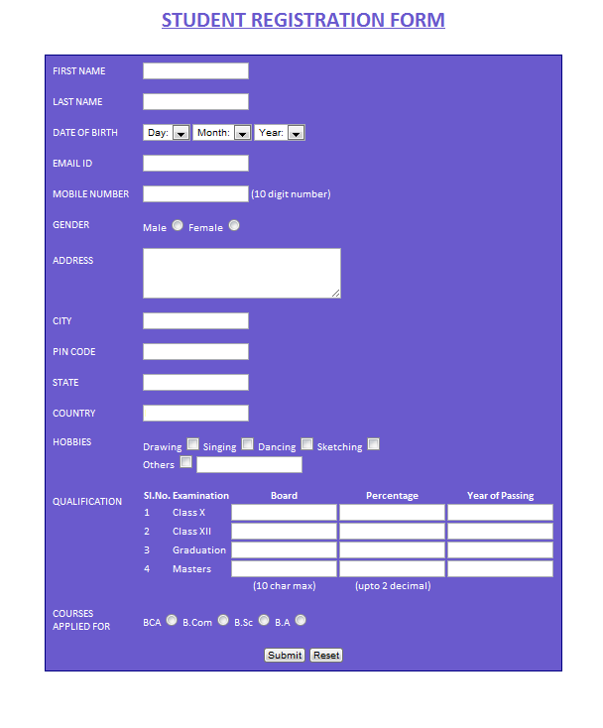

## CODE

## OUTPUT

# **ASSIGNMENT # 11 – CSS TEXT AND IMAGES**

Create a page like the one below



## CODE

## OUTPUT

# **ASSIGNMENT # 11 – CSS LISTS TABLES AND FORMS**

Create a page like the one below

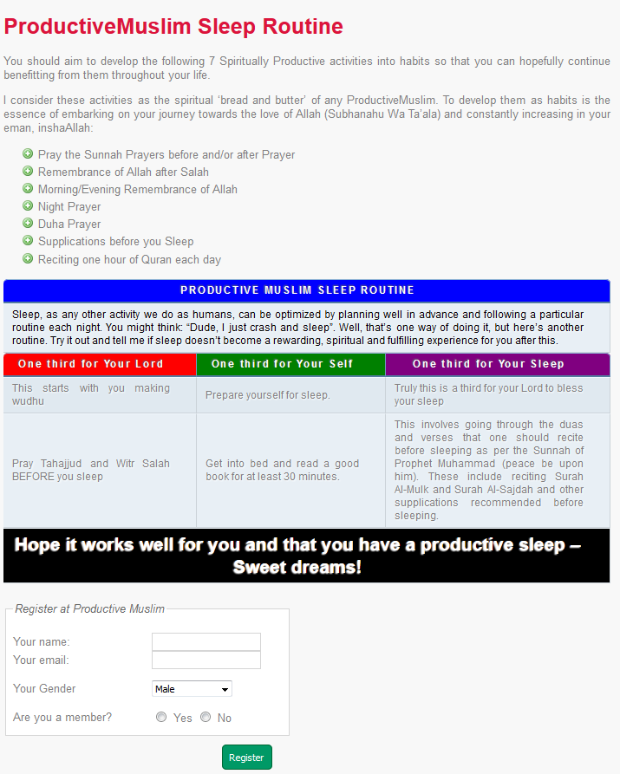

## CODE

## OUTPUT