PROJECT REPORT ON

# INTRODUCTION

### 1.1 OVERVIEW

My project name is Fresh Bites Catering (Food and Beverage - Industry), Fresh Bites Catering, a catering service, utilizes Zoho Books to manage their sales, track inventory, and handle invoicing. They can generate professional invoices for clients and track expenses related to ingredients and supplies. Zoho Books helps them maintain accurate financial records and streamline their catering operations.

### 1.2 PURPOSE

At Fresh Bites, we are on a mission to revolutionize the way people access nutritious food in today's fast-paced world . We understand the importance of a balanced diet and the impact it has on productivity, well-being, and overall health Our innovative smart vending machines offer a diverse range of nutrient-rich meals, snacks, and beverages , catering to various dietary needs and preferences. We proudly serve schools, hospitals, office buildings, museums, and other high-traffic locations , ensuring that students, staff, visitors, and busy professionals can make healthier choices with ease and convenience .

# PROBLEM DEFINITION & DESIGN THINKING

* 1. Empathy Map

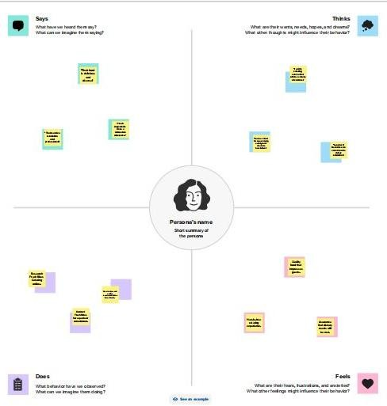

* 1. **Ideation & Brainstroming map**

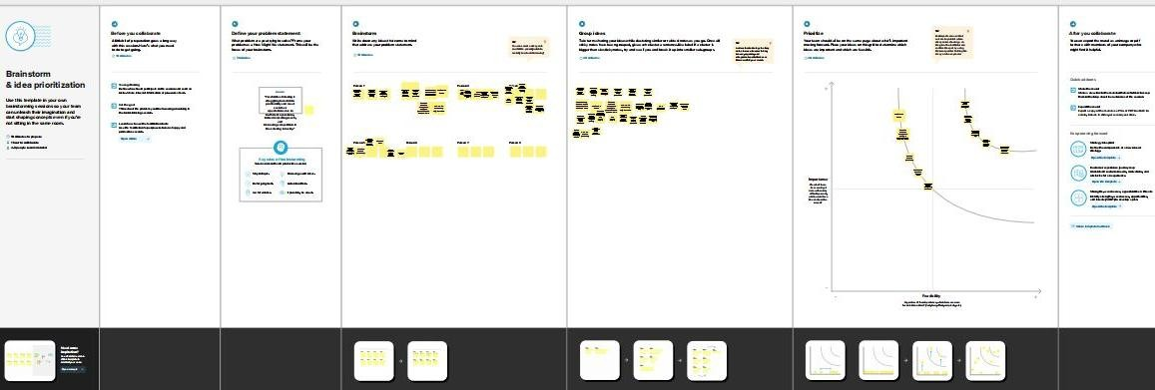

# RESULT

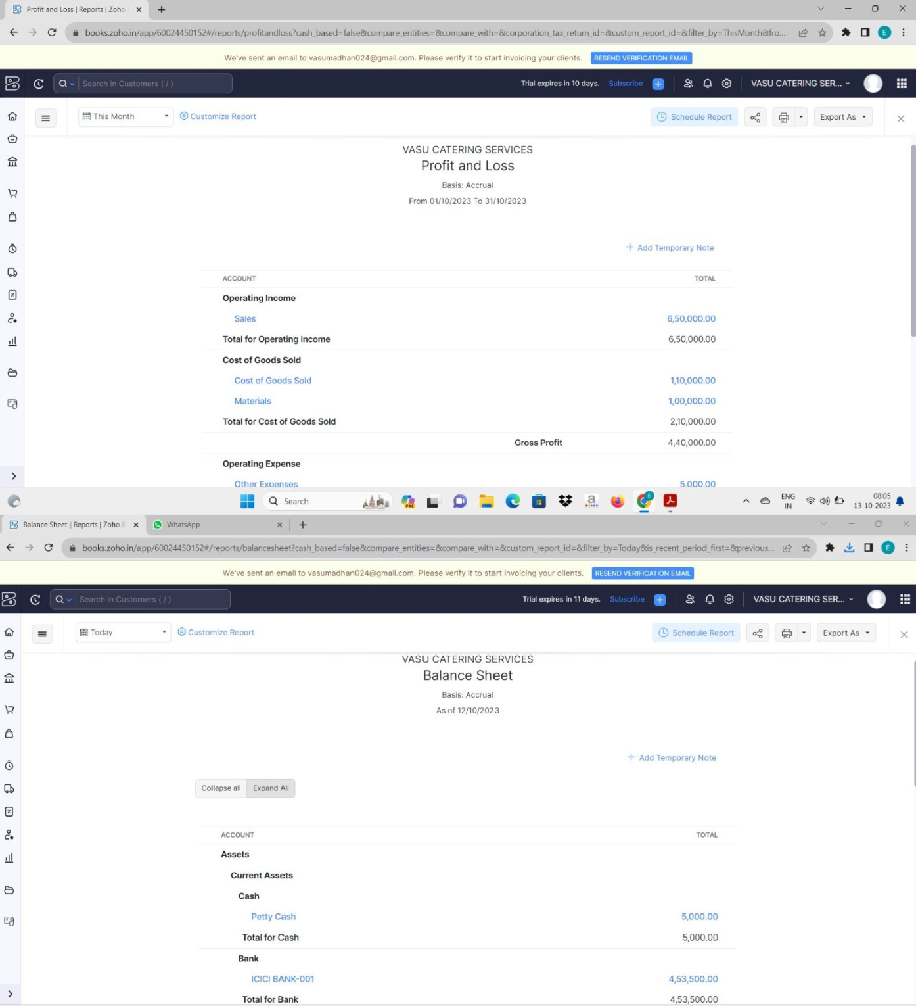

1. **ADVANTAGES & DISADVANTAGES**

## Advantages:

1. Nutrition plays a crucial role in providing the edge needed to go above and beyond.
2. Great in-house food and drink services create an environment for workplace friendships to thrive.
3. With access to healthy food on their lunch breaks and friendly faces around the office.
4. Plus, with nutritious and delicious food giving your workers that extra boost of motivation and productivity.
5. At Eurest, we can give your workforce something to look forward to each day.

## Disadvantages:

1.Potential for greater risk if costs not managed effectively.

2.Non core business/lack of expertise.

3.Increased senior management time required from organization

# APPLICATIONS

**GIT HUB AND ZOHO BOOKS** are used to applied the solution.

# CONCLUSION

we desire to improve one’s health and wellness can manifest in many ways: the desire for better health, greater knowledge of healthy choices and protection from harmful ingredients. Consumers increasingly look to brands to help – or encourage – them with the products, services, and tools to achieve their Healthy Wellbeing goals. There are many reasons for the continued growth of health and wellness trends and food allergies have been a key trigger for the growth.

**7.Future Scope**

According to an IMARC report, in the fiscal years 2022-2027, the Indian F&B industry would expand at a CAGR of 12.5%, contributing 3% of India's GDP in the retail market. Especially with technological innovations making their way into the industry, new trends are emerging.