**Setting up launch.json with in VS code to launch Chrome with relevant capabilities**

**Prerequisites**

1. VS code
2. Working codebase of Angular or ionic

**Steps**

1. Launch the code base through command line to open VS code.



1. Click on the **Debug** icon.

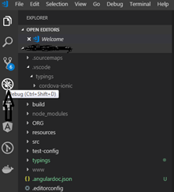

1. Click on the **Configure** icon for launch.json.

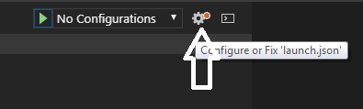

1. Select Chrome in the Select Environment.

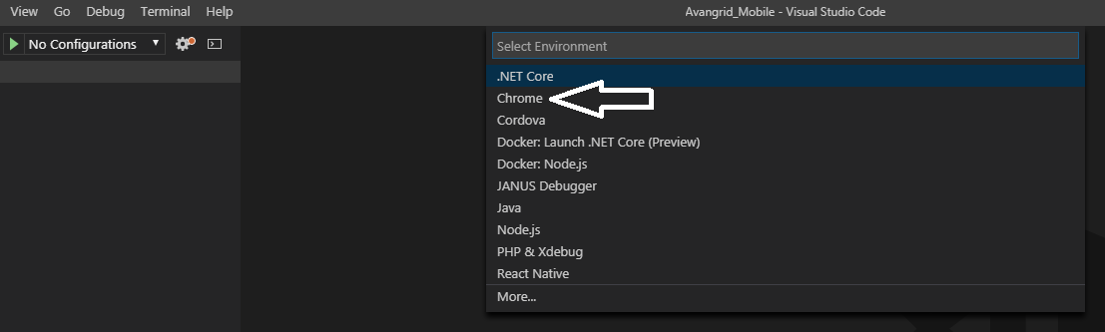

1. launch.json comes up.

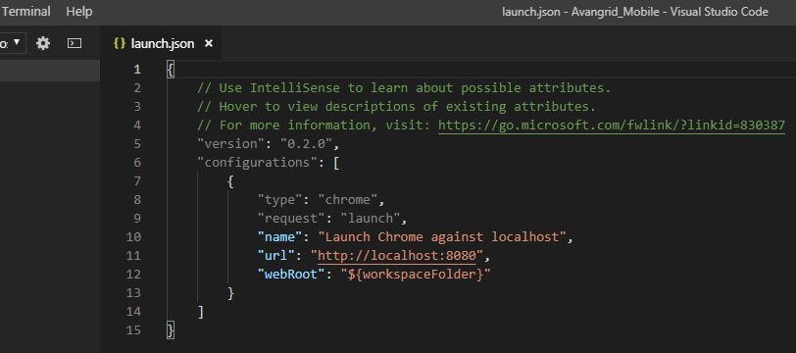

1. Rename the **name** option as you prefer (optional). It automatically updates the name in the Launch option with the Green arrow.

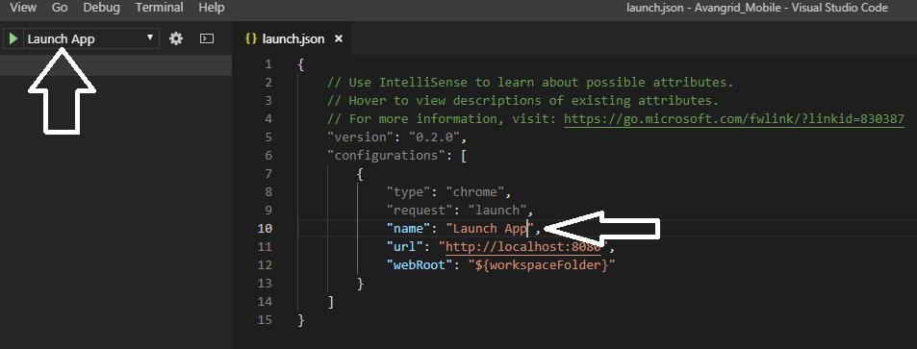

1. Add a command after **webRoot** and enter.
2. Add **runtimeArgs**.

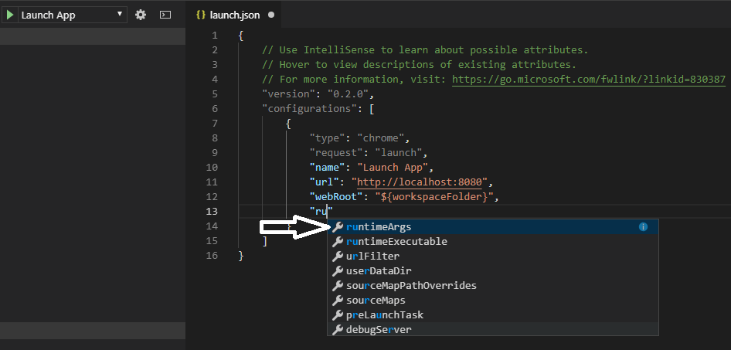

1. In the Square brackets add arguments of your choice like

"--incognito",

"--auto-open-devtools-for-tabs",

"--window-size=1080,1080" etc

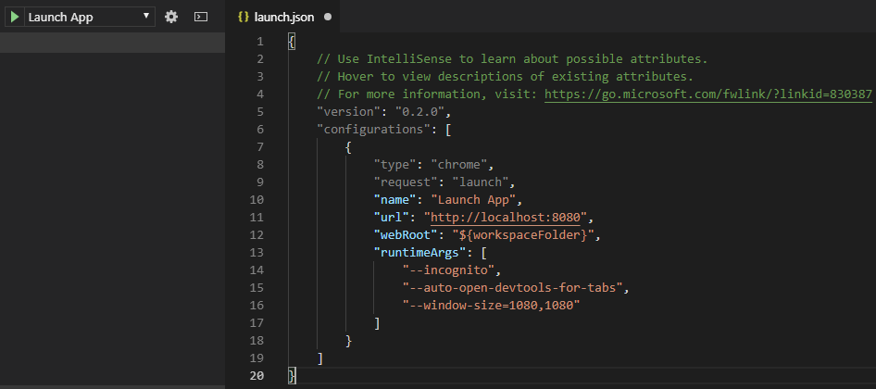

1. Before you launch the Chrome make sure you have the ng serve or ionic serve started in the command line. Make sure the port number in URL is the one targeted for and change it accordingly.
2. After saving, click on the Green Arrow to Start Debugging which actually launches the browser.

