**Django Admin Pannel**

I created a database. It is default Admin Pannel of Django. I am trying to create Custom Admin Pannel according to Us.

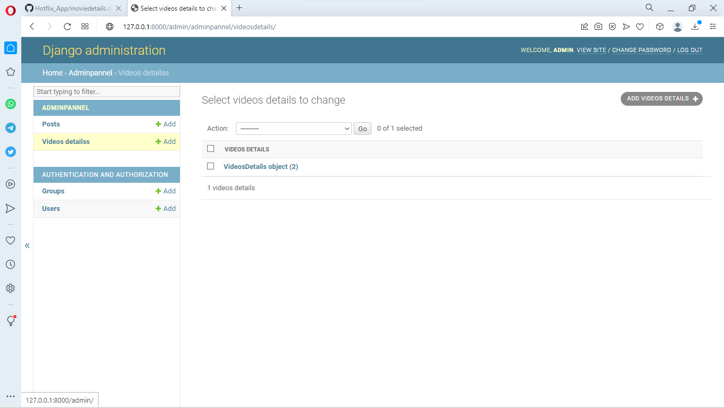

**It is Details of Table**

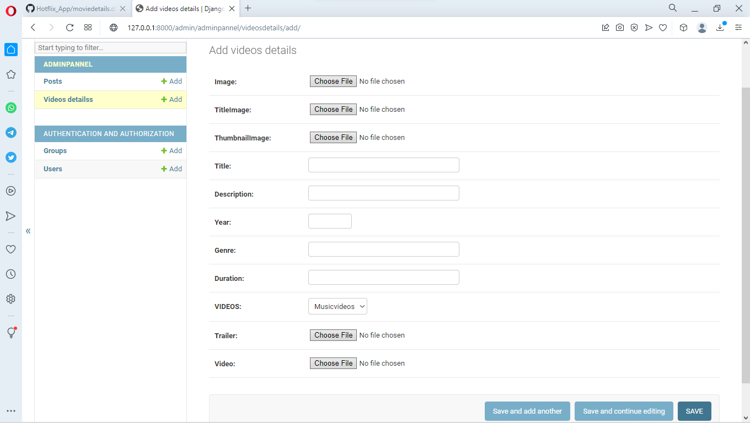

**Default Sing-Up Format of Django**

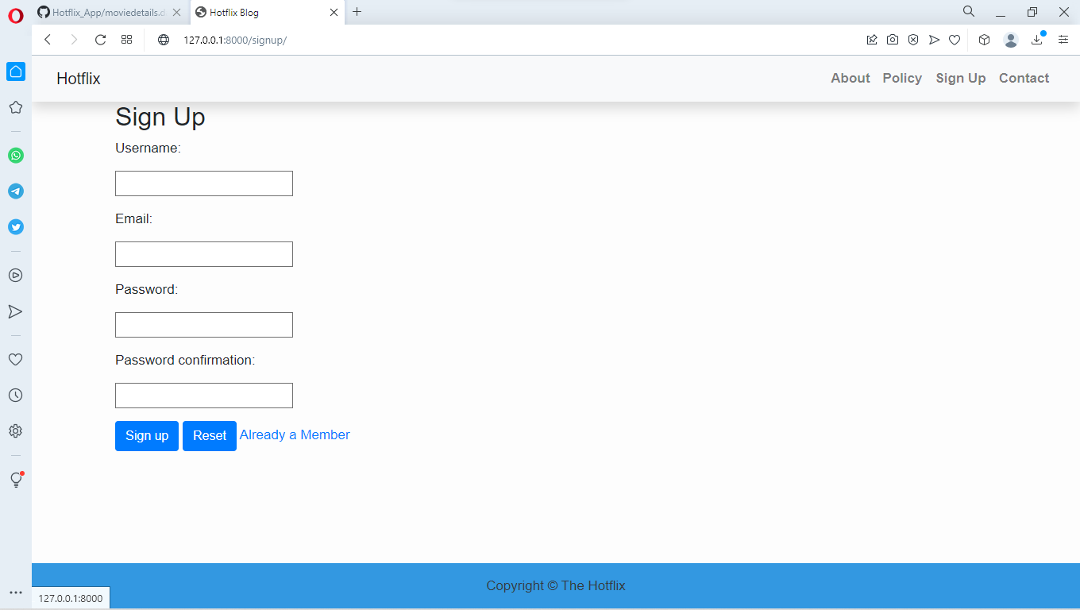

**Login**

