App Guide – How to Use the Application

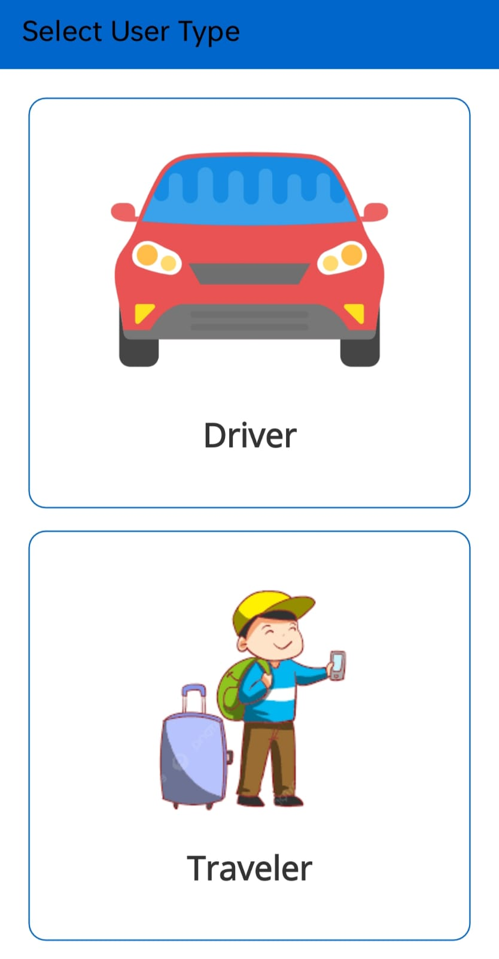
Select your role: Driver or Traveler

What is this App?
This app connects Drivers and Travelers easily.
Drivers can register, share their details, and earn credits.
Travelers can find drivers by city and contact them directly.

How to Get Started
- Register or log in to the app
- Accept Terms & Conditions
- Choose your role:
  - Driver
  - Traveler
- Read the guide below based on your role

Guide for Drivers

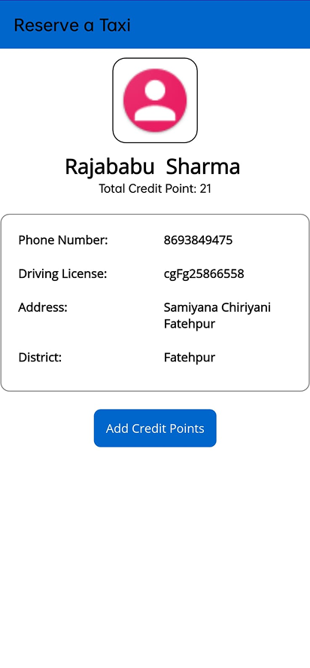
Driver profile and credit points screen

Step 1: Create Your Account
- Register as a Driver
- Log in using your registered details

Step 2: Complete Your Driver Profile
Inside the Drive page, you can see:
- Profile photo
- Phone number
- Driving license details
- Address and district
This information helps travelers trust and contact you.

Step 3: Credit Points System
- As a new driver, you get free credit points for 30 days
- Credit points are used daily
- Credits will gradually reduce and can reach zero

Step 4: Renew Credit Points
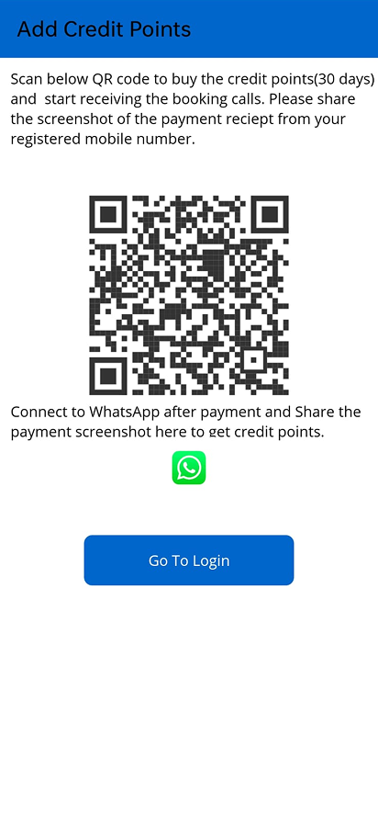
Scan QR code to renew credit points
- After 30 days, credits must be renewed
- Pay by scanning the QR code
- Once payment is successful:
  - Credits are renewed
  - Your profile remains visible to travelers

Important Notes for Drivers
- Keep your details updated
- Renew credits on time to stay active
- Ensure your contact number is correct

Guide for Travelers

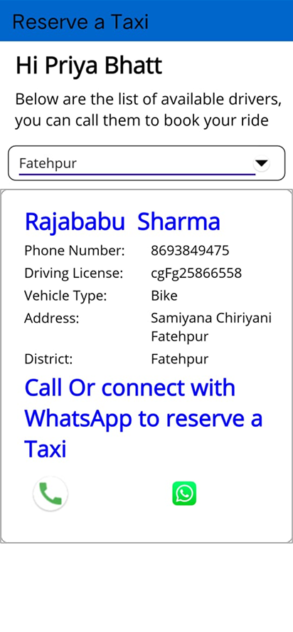
View drivers and contact via Call or WhatsApp

Step 1: Create Your Account
- Register as a Traveler
- Log in using your credentials

Step 2: Select City
- Choose the city where you need a driver
- The app will show available drivers in that city

Step 3: View Driver Details
Inside the Traveler page, you can see:
- Driver profile
- Basic driver details
- Contact options

Step 4: Contact the Driver
You can contact the driver using:
- Phone call
→ Redirects to your phone dialer
- WhatsApp
→ Opens WhatsApp with a pre-filled message
Choose the option that is most convenient for you.

Important Notes for Travelers
- Contact drivers directly through the app
- Confirm details before travel
- City selection helps you find nearby drivers faster

Need Help?
If you face any issues:
- Check your internet connection
- Ensure profile details are complete
- Contact support if the issue continues

Call us on: +91 8693849475 for any help/support.
You can also visit to our website to know more about us and to log complaints and to give suggestions.
Website: https://intellicstech.com

