## User Creation

First create user for authentication to the StockTake application.

* Click on add user button to open add new user screen.
* Enter username and password.
* Click save to add username and password.

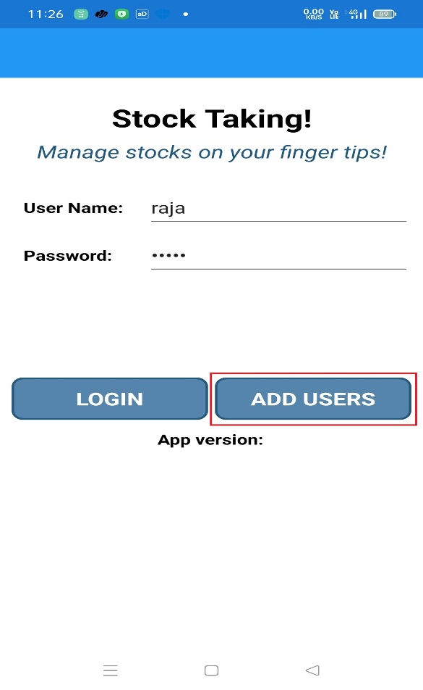

## Home Page

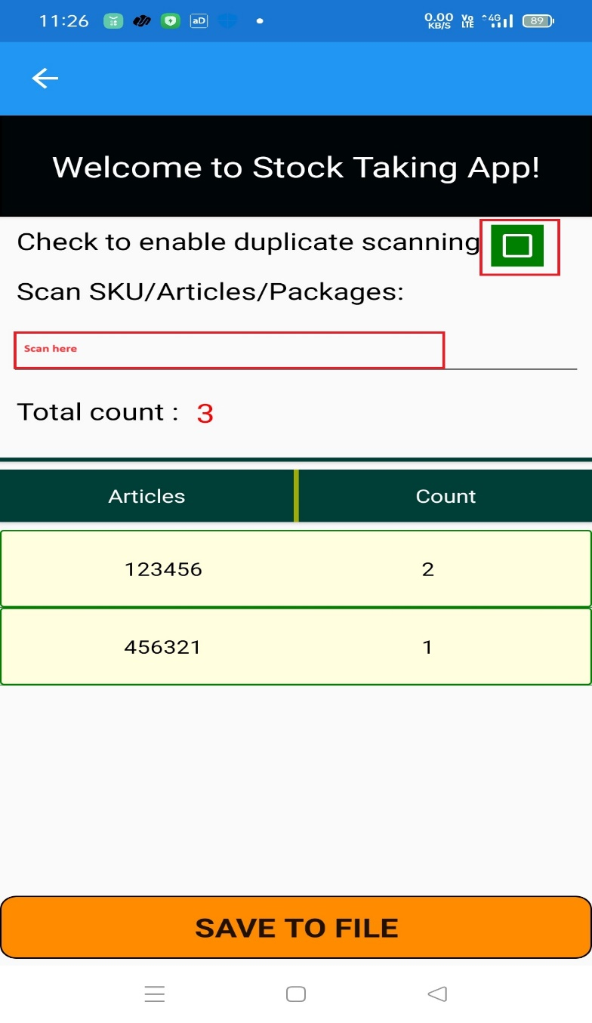

Scan barcode items here

Check this check box to enable scanning duplicate items.

## Download Reports

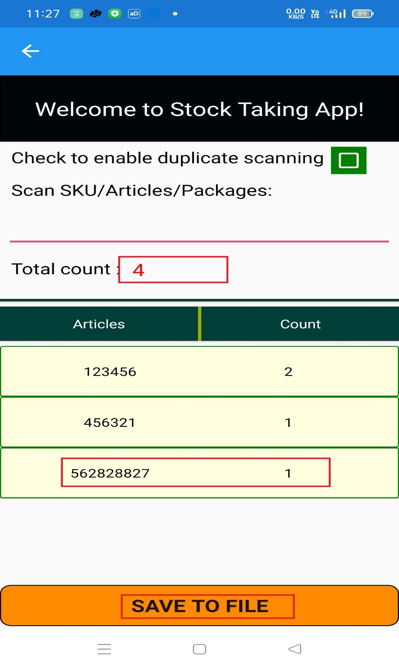

Click Save to File button to download reports in .csv file in download folder of the scanner.

Here you can see the total scanned items.