**Analyzing Chicago Crime Characteristics towards understanding its Side-Effects and Dependencies**

**Why this project:**

In the past, the role of law enforcement officers was focused on arresting thieves and criminals, issuing citations, and testifying in court. Recent researches showed that crime prevention is more cost-effective and leads human life quality to improve by assigning resources (e.g. money, time, efforts, etc) to public safety improvement, education system and health care (physical and mental).

In the last two decades, police are becoming aware of crime consequences and treating crime as a form of pollution that should be removed from places/communities gradually. Hence, analyzing the crime, their characteristics and consequences is inventible for determining their causes and develop/implement a set of strategies. In general, crime has four types of consequences:

1. victimization of third parties
2. official responses cost such as medical institutions, medical examiners, prosecutors, courts, public defenders, etc.
3. new crimes that are facilitated by high-crime places in their surroundings
4. cost to the friends and family of offenders

After applying the designed strategies, it is vital to evaluate the effectiveness of them. To assess the successfulness of a strategy fairly, both reduction of frequency of crime occurring and fading-rate of its side effects should be considered. Therefore, defining metrics that measure crimes’ consequences is necessary as well.

**The goal of this project**: As aforementioned, prevention and reduction of crimes have become the priority of governments. Therefore, in this project, I aim to analyze crime characteristics, dependencies and consequences. Also, I plan to define metrics denoting the safety level of each area which can be used for business investment purposes as well.

**Project Overview:**

The majority of the crime happens in a few places [Pierce, Spaar, and Briggs, 1988]. The theory of Iron law of troublesome places demonstrates that the crime location-dependency is even more visible when places were disaggregated into similar categories—such as apartment buildings, bars, juvenile libraries, schools [Eck et al. (2011)]. Although recent researches showed that high-crime places tend to stay that way [Spelman (1995)], it does not mean that there is no chance for those places to change. But, we can say if there is a serious crime problem in a place, most likely we will observe the same problem in subsequent years. The place-focused crime reduction approach was limited to allocating police patrol resources to places with more crime (Braga and Weisburd, 2010), but now the place-based crime analysis became an approach for designing crime reduction policies. Here, I defined three metrics that can be used for defining crime potentiality for a place:

**Crime rate ():** this parameter shows the rate of each crime type () defined as ratio of the recorded crime type *i* to all recorded crimes

**Place-based crime rate**: This metric shows the potentiality of each crime type for each place which is defined as the ratio of number of crime type *i* recorded in *jth* place to total number of recorded crime type *i.*

**Place-based crime indicator:** This metric is defined as the ratio of place-based crime rate for crime type *i*,and place *j* to ith crime’s rate.

The place-based crime indicator shows which crimes happen more than usual (crime rate in general) in each place. This metric helps us to understand the criticality of crimes per place and prioritize the strategies. Also, we can use these metrics to determine the new crimes facilitated by high-crime places in their surroundings and other crime’s side effect such as victimization of third parties. For example, crimes with high place-based crime indicator occurring in the same area can be used to estimate the crimes’ consequences. One of the candidate metrics to measure a crime’s consequences is conditional crimes.

Crimes can be seen even in public places such as libraries, bus stations, schools, airports or even governmental buildings. In this project, I plan to consider location-based analysis as well. In this approach, the popular crime in public places will be investigated. This approach can improve

Resources allocation strategies efficiently by detecting potential locations for each crime or each location’s potential crimes. In addition, we can define a risk assessment score that reflects public safety in each location. To this end, we can compare the ratio of each crime type in all target locations with the ratio of each crime to all crimes.

Crimes can be seen even in public places such as libraries, bus stations, schools, airports or even governmental buildings. In this project, I plan to consider location-based analysis as well. In this approach, the popular crime in public places will be investigated. This approach can improve

 Resources allocation strategies efficiently by detecting potential locations for each crime or each location’s potential crimes. In addition, we can define a risk assessment score that reflects public safety in each location. To this end, we can compare the ratio of each crime type in all target locations with the ratio of each crime to all crimes.

The other approach to analyze crime characteristics is time-based analysis. The probability of happening of each crime type varies in hours of a day. For example, theft usually occurs during work hours when people are not home. Therefore, here I aim to define a time-based crime indicator for each crime type in each hour of a day. This score can be used to define the safety risk score of a specific area at each hour of a day.

**Datasets:**

For this project, I plan to utilize open-source Chicago crime datasets available at: ([https://data.cityofchicago.org/)](https://data.cityofchicago.org/Public-Safety/)) for:

* Crimes 2001 to present
* Chicago Crime 2014, 2015 and 2016
* [Sex Offenders](https://catalog.data.gov/dataset/sex-offenders-938b3)Strategic Subject List

These datasets contain recent crimes occurred in Chicago city. In these datasets, crimes are divided into 35 categories. For each crime, date, time, location, location description, crime description and police district data are available.

### Exploratory Analysis:

The first step, in my exploratory analysis, is finding the most frequent crimes in Chicago City. The crime ratio shows the popularity of a crime. Theft, Battery, criminal damages and narcotics with crime ratio of 21.07%, 18.27%, 11.4%, and 10.40% respectively are the four most popular crimes in Chicago city.

**Place-Based Analysis:** What are the potential places for each crime? By finding the potential places for each crime we can be useful for designing crime reduction and prevention strategies. For example, by finding the places that most robberies occur, we can place resources, such as officers and hidden cameras more efficiently to reduce these crimes. By initial analyzing of the Chicago crime records, I found that district one has public indecency (with placed-based crime indicator of 3215) as its first potential crime while district twenty and four have liquor law violation (with placed-based crime indicator of 953) and domestic violation (with placed-based crime indicator of 10922) respectively as the first potential crime.

 Also by grouping records based on crime types, I found that theft crimes usually occur in districts of 1, 12, 14, 18 and 19, while drug-related crimes most likely occur in districts of 10, 11 and 15. As shown in Figure 1, the crime distribution is not uniform and some districts have more recorded crimes. Also, in this figure, we can see the distribution of crime type is not uniform as well. For example, narcotics crimes occur in the city downtown.

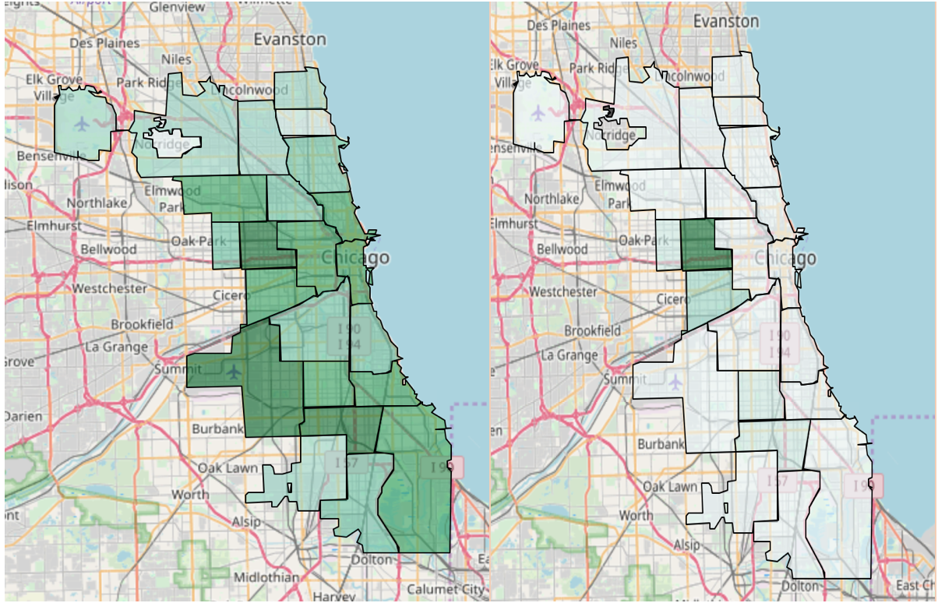

Figure 1. Total crimes per district vs Narcotics crime per district

Based on the Chicago crime dataset, the probability of seeing battery and narcotics crimes in the 11th district is almost two times more than other crimes in recent years, while theft is the most serious issue in district one.

**Location-Based Analysis:** As explained, a new approach that I want to consider for crime analysis is location-based analysis. To this end, I want to answer this question: what are the more common crimes in each public place? This dataset contains a location description field. Therefore, we can find which types of crime are more likely to happen in public places, such as schools or train. Thus, we can improve safety efficiently for public places. In the initial evaluation, I considered 5 public places including school, library, governmental building, airport, and taxi. As shown in Figure 2, the battery is the major crime in school while deceptive practice crime is common in taxis.

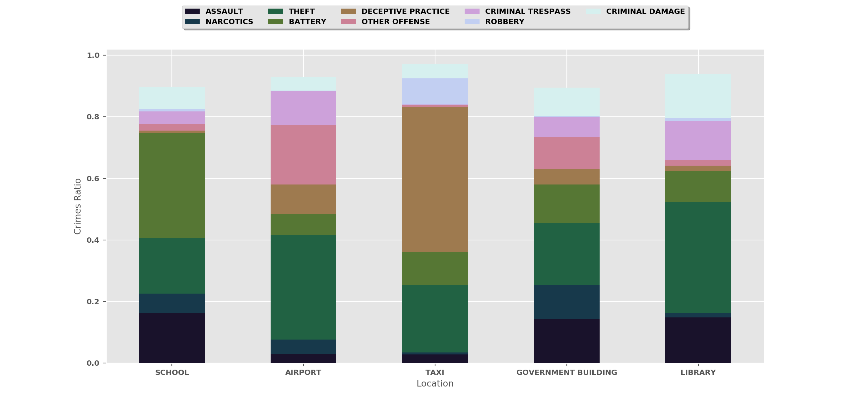

Figure Popular crimes in public places

**Time-Based Analysis:** What time of day does each crime mostly likely occur? Detecting critical time for each crime can be useful for police to allocate resources properly. For example, based on my initial observation, the chance of a crime occurring from 3 am to 6 am is less than other times. Also, the peak time of each crime is different. Theft’s peak time is noon-7pm while deceptive participate crime most likely occurs in 9 am-noon

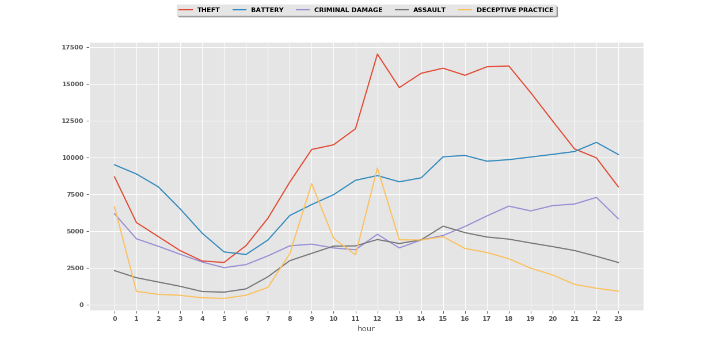

**Business Benefits:**

The public safety score for each area can be useful for many businesses, such as real states. This score can help them to sell and rent properties more efficiently. Also, the public safety score can benefit many governmental decisions, such as finding the best locations for schools, hospitals, social consultants and police offices.

**Future Work:**

The initial exploratory has shown that each area has its own specific criminal problems. Therefore, each area or district needs specific crime reduction and public safety improvement strategies.

In this project, I plan to investigate and characterize the relationships between the place, time and crime type. Accordingly, it is possible to define meaningful scores that represent the public safety of each area as well as the prosperity of each strategy. To define these scores, I aim to consider different criteria, such as the place crime-potentiality, the degree of crime (simple or not, weapon used in the criminal behavior, etc.) and crime dependencies.

**References:**

Pierce, Glenn, Susan Spaar, and LeBaron Briggs. 1988. *The Character of Police Work: Implications for the Delivery of Police Service: Final Report to the National Institute of Justice*. Boston, MA: College of Criminal Justice, Northeastern University.

Weisburd, David L., Laura A. Wyckoff, Justin Ready, John E. Eck, Josh Hinkle, and Frank Gajewski. 2006. Does crime just move around the corner? A controlled study of displacement and diffusion in two crime hot spots. *Criminology*, 44: 549–592.

Spelman, William. 1995. Criminal careers of public places. In (John E. Eck and David L. Weisburd, eds.), *Crime and Place*. *Crime Prevention Studies*, Vol. 4. Monsey, NY: Criminal Justice Press.

Weisburd, David L. 1997. *Reorienting Crime Prevention Research and Policy: From the Causes of Criminality to the Context of Crime*. NCJ 165041. Washington, DC: National Institute of Justice.