**Name:** Raja Danyal Mushtaq **Email:** rajadanyal.fui@gmail.com

**Hand-on Exercise:** 01 **Batch:** 05 Freelancing

1: Mentioned five in demand and most selling skills of freelance industry

Following are the most selling skills of freelance industry

1. Web App Development
2. Web Scrapping
3. WordPress website builder
4. Content Writing
5. Data Entry (Excel ,Copy paste)

2: Choose a skill in which you want to pursue your freelance career

I want to pressure my freelancing career in Web Development.

3: Search top rated freelancer relevant to your skillset on fiverr.com and check his/her profile and gigs

Profile: <https://www.fiverr.com/mukeshshah280>

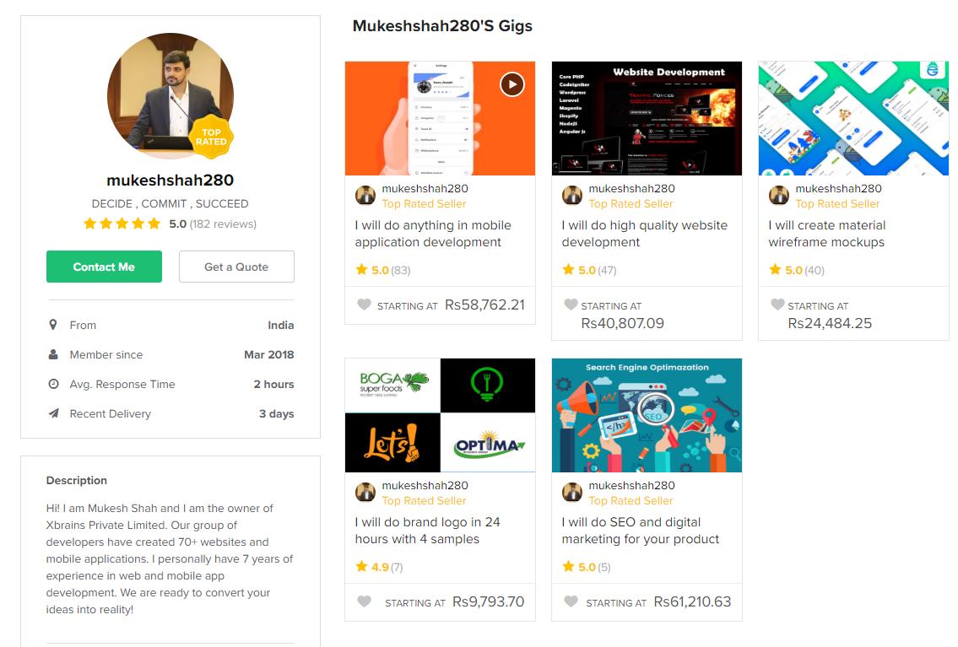

**About the Gig**

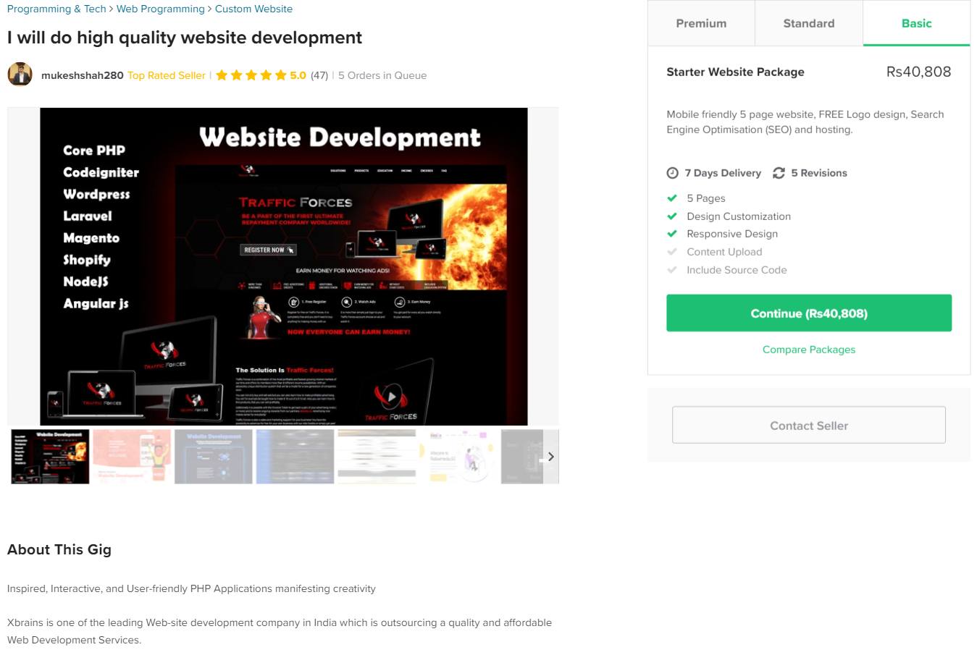

4: Read the profile description of the selected freelancer carefully and note down the main points that he/she has written in his/her profile description.

1. Proficient
2. Dependability
3. Consistency
4. Make sure to get best quality and service