**Name:** Raja Danyal Mushtaq **Email:** rajadanyal.fui@gmail.com

**Hand-on Exercise:** 02 **Batch:** 05 Freelancing

1. Mention your core skill. (only one)

Web Development

1. Write title of your particular service that you want to offer to the potential client. (include keyword relevant to your skill in the title)

I will do professional web development in 1 days

**Tags**

**Registration Pages**

**Login Pages**

**Admin Panel Integration**

**MYSQL export into CSV and PDF format**

**Basic Curd Application**

**Visual Code**

1. Write a brief description of your service including the details of your work, tools and techniques.

PHP web applications for **small**, **medium** and **big companies**.   
From **beginner**level apps to **expert**and **complex** level apps.   
  
This gig provides the best quality and highly secured PHP websites and web applications   
  
This gig covers most of the demanding features in php. They are as following:

1. Admin Panels / Admin Back-ends
2. Basic CRUD Applications
3. Excel and CSV Imports to MySQL
4. MySQL Exports to Excel and CSV.
5. Laravel Applications
6. Set the price of your service. (between $5 - $30)

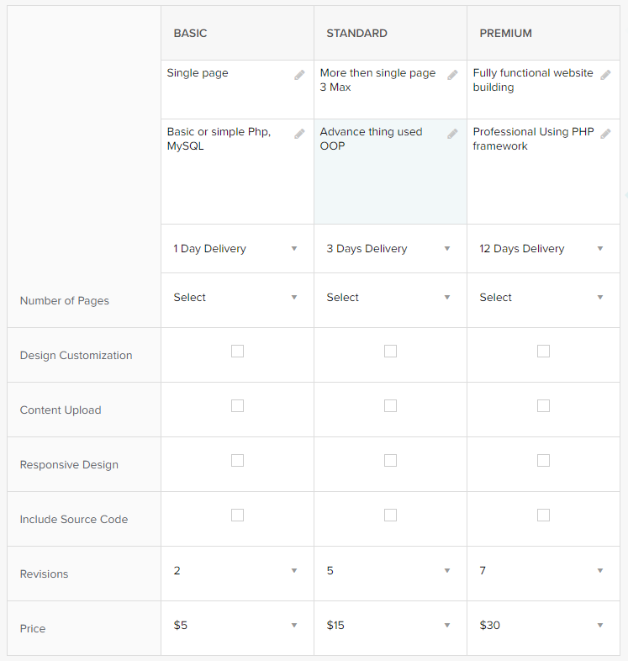

1. Attach a relevant sample and previous work image(s).

