**Name:** Raja Danyal Mushtaq **Email:** rajadanyal.fui@gmail.com

**Hand-on Exercise:** 03 **Batch:** 05 Freelancing

Task 1:

1. To present your portfolio, create a Facebook page using your Real Name or Business Name. (Provide URL*)

**Name**

**Url:** <https://www.facebook.com/Danyaltech-101200128064156/>

1. Update your Real Picture or Business Logo in the profile picture section.



1. Design and add a cover on your Facebook page. Make sure it represents your skill or field of service. (Provide Screenshot*)

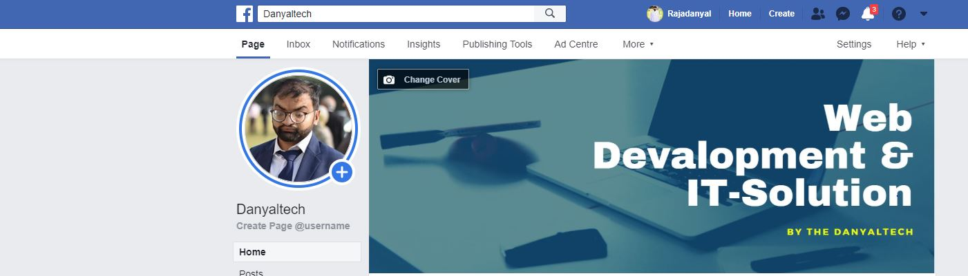

1. Update your details in the “About” section of your Facebook page. (Provide Screenshot*)

**Task2:** 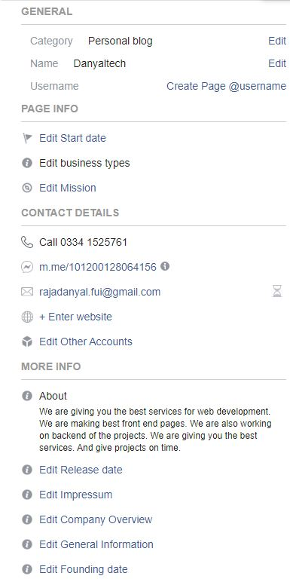

1. Write a portfolio description and briefly describe your previous work details. You can explain the tools and techniques you had used to complete the previous job(s). Be as detailed as possible and expressive, so the potential client will be able to understand that you are good fit for his/her project.

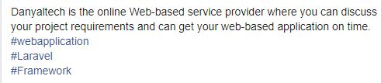

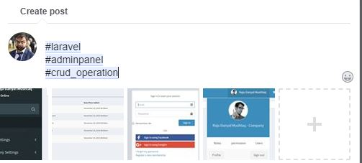

1. Attach a relevant previous or sample work image(s). (Provide Screenshot of Facebook post*)

