Commands

1} shift+pageup and shift+pagedown

2) ctrl for host key default

3)

You need to disable Hypervisior to check new application that use VT-x before ir launch.

So, follow the next steps:

**1)** open command prompt as Administrator

**2)** run bcdedit to check hypervisor status:

bcdedit

**3)** check hypervisor launch type:

[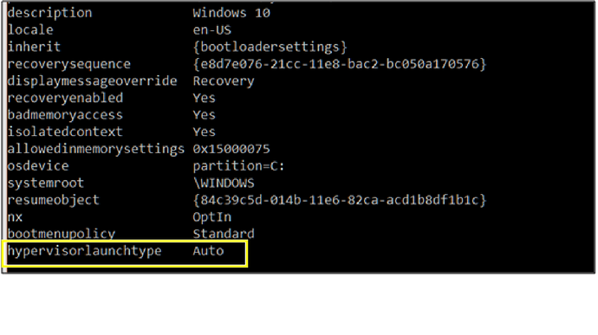](https://i.stack.imgur.com/TTL5f.png)

**4)** if is set to **auto** then disable it:

bcdedit /set hypervisorlaunchtype off

**5)** reboot host machine and launch VirtualBox again

3) disabled Hyper-V: Control Panel\Programs\Programs and Features\ [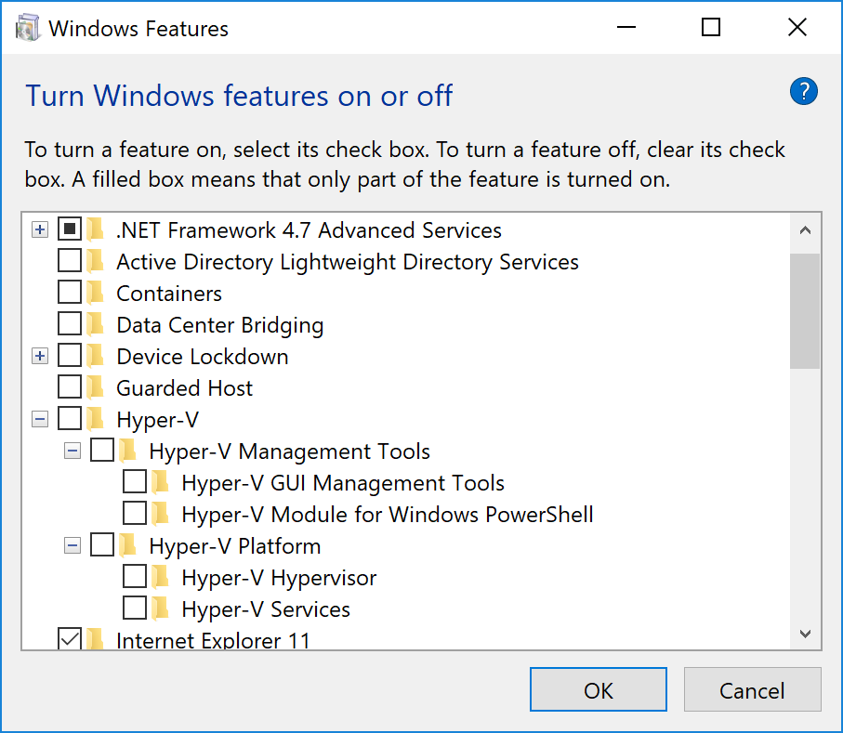](https://i.stack.imgur.com/XcFds.png)

docker@boot2docker:~$ ifconfig

docker0 Link encap:Ethernet HWaddr 02:42:3C:2F:4F:CA

inet addr:172.17.0.1 Bcast:172.17.255.255 Mask:255.255.0.0

UP BROADCAST MULTICAST MTU:1500 Metric:1

RX packets:0 errors:0 dropped:0 overruns:0 frame:0

TX packets:0 errors:0 dropped:0 overruns:0 carrier:0

collisions:0 txqueuelen:0

RX bytes:0 (0.0 B) TX bytes:0 (0.0 B)

eth0 Link encap:Ethernet HWaddr 08:00:27:06:AD:6E

inet addr:10.0.2.15 Bcast:10.0.2.255 Mask:255.255.255.0

inet6 addr: fe80::a00:27ff:fe06:ad6e/64 Scope:Link

UP BROADCAST RUNNING MULTICAST MTU:1500 Metric:1

RX packets:146 errors:0 dropped:0 overruns:0 frame:0

TX packets:162 errors:0 dropped:0 overruns:0 carrier:0

collisions:0 txqueuelen:1000

RX bytes:13662 (13.3 KiB) TX bytes:14427 (14.0 KiB)

eth1 Link encap:Ethernet HWaddr 08:00:27:01:0C:D0

inet addr:192.168.56.6 Bcast:192.168.56.255 Mask:255.255.255.0

inet6 addr: fe80::a00:27ff:fe01:cd0/64 Scope:Link

UP BROADCAST RUNNING MULTICAST MTU:1500 Metric:1

RX packets:104 errors:0 dropped:0 overruns:0 frame:0

TX packets:84 errors:0 dropped:0 overruns:0 carrier:0

collisions:0 txqueuelen:1000

RX bytes:16964 (16.5 KiB) TX bytes:19632 (19.1 KiB)

lo Link encap:Local Loopback

inet addr:127.0.0.1 Mask:255.0.0.0

inet6 addr: ::1/128 Scope:Host

UP LOOPBACK RUNNING MTU:65536 Metric:1

RX packets:0 errors:0 dropped:0 overruns:0 frame:0

TX packets:0 errors:0 dropped:0 overruns:0 carrier:0

collisions:0 txqueuelen:1000

RX bytes:0 (0.0 B) TX bytes:0 (0.0 B)

docker@boot2docker:~$ ifconfig eth1

eth1 Link encap:Ethernet HWaddr 08:00:27:01:0C:D0

inet addr:192.168.56.6 Bcast:192.168.56.255 Mask:255.255.255.0

inet6 addr: fe80::a00:27ff:fe01:cd0/64 Scope:Link

UP BROADCAST RUNNING MULTICAST MTU:1500 Metric:1

RX packets:137 errors:0 dropped:0 overruns:0 frame:0

TX packets:104 errors:0 dropped:0 overruns:0 carrier:0

collisions:0 txqueuelen:1000

RX bytes:19628 (19.1 KiB) TX bytes:22200 (21.6 KiB)

docker@boot2docker:~$ ifconfig docker0

docker0 Link encap:Ethernet HWaddr 02:42:3C:2F:4F:CA

inet addr:172.17.0.1 Bcast:172.17.255.255 Mask:255.255.0.0

UP BROADCAST MULTICAST MTU:1500 Metric:1

RX packets:0 errors:0 dropped:0 overruns:0 frame:0

TX packets:0 errors:0 dropped:0 overruns:0 carrier:0

collisions:0 txqueuelen:0

RX bytes:0 (0.0 B) TX bytes:0 (0.0 B)

docker@boot2docker:~$ ifconfig eth0

eth0 Link encap:Ethernet HWaddr 08:00:27:06:AD:6E

inet addr:10.0.2.15 Bcast:10.0.2.255 Mask:255.255.255.0

inet6 addr: fe80::a00:27ff:fe06:ad6e/64 Scope:Link

UP BROADCAST RUNNING MULTICAST MTU:1500 Metric:1

RX packets:156 errors:0 dropped:0 overruns:0 frame:0

TX packets:173 errors:0 dropped:0 overruns:0 carrier:0

collisions:0 txqueuelen:1000

RX bytes:14502 (14.1 KiB) TX bytes:15337 (14.9 KiB)

docker@boot2docker:~$ ifconfig lo

lo Link encap:Local Loopback

inet addr:127.0.0.1 Mask:255.0.0.0

inet6 addr: ::1/128 Scope:Host

UP LOOPBACK RUNNING MTU:65536 Metric:1

RX packets:0 errors:0 dropped:0 overruns:0 frame:0

TX packets:0 errors:0 dropped:0 overruns:0 carrier:0

collisions:0 txqueuelen:1000

RX bytes:0 (0.0 B) TX bytes:0 (0.0 B)

docker@boot2docker:~$

