GAIKWAD SANDEEP MARUTI
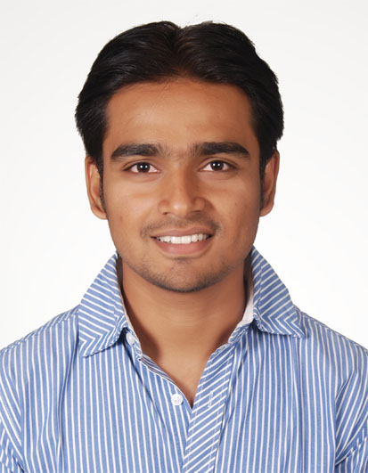
Email : gaikwadsm@hotmail.com
Cell Number : (+91) 9980896633, 9923607323
Permanent Address : 18, ‘Shramsafalya', Parshwanath Colony,
Dhamni road, Sangli (Maharashtra) - 416415

CAREER OBJECTIVE

I want to be a part of competitive environment where my knowledge and skill will be utilized and I can use my potential to make growth of the company with me.
SALARIED PROFICIENCY
- Employer: Aircel Ltd.
- Designation: Graduate Trainee Engineer.
- Duration: 14 July 2014.-15 Jan 2015
- Work Location: Nashik.
- 6 Months Experience.

- Company Profile: Aircel is mobile network operator, which offers voice & data services, 2G, 3G and 4G services, Broadband Wireless Access (BWA), Long Term Evolution (LTE).

- Responsibilities:
- Monitoring daily Network Outages.
- Daily Network traffic monitoring and coordinating with marketing team to increase network traffic along with revenue.
- Handling day to day review and tech review.
- Installation and commissioning of Huawei Base transceiver station.
- To solve technical problems regarding Base Station Controller, Base transceiver station.
- Monitoring Optical Fiber Media and breakdown.
- To solve communication and analytical problems and maintaining good relationship with Infra Provider, Owner and Technician.
- Taking effective actions for resolving Power issues on Site like DG fault, Power Plant Fault.
- Monitoring quality of Radio frequency and Microwave.

EDUCATION

- Engineering Qualification:
- University : Shivaji University, Kolhapur
- Discipline : Electronics Engineering.

Class | College | Year | % Marks
B.E | Dr. J.J.Magdum College of Engineering, Jaysingpur. | 2014 | 63.88

Class | School/College | Year | % Marks
H.S.C | Willingdon College, Sangli | 2008-09 | 61.50
S.S.C | City High School, Sangli | 2006-07 | 69.84
Pre-Engineering Qualification:

COMPUTER & SOFTWARE ABILITIES:

- Operating Systems : Windows XP/7/8, Linux, Ubuntu.
- Programming Languages : JAVA, SQL, JSP, XML, Struts2
- Software : Eclipse, Oracle 10g, MySQL,MS Excel, MS Office,
MS Access Keil, Matlab, Orcad, Proteus.

ACHIEVEMENTS

Won the 1st prize in the event HORIZON 2010, held at Dr. J.J. Magdum College of Engg., Jaysingpur.
Received 1st Prize in Technical Design contest (Techno-Academia) in National level technical symposium ‘VISION 2013' held at Walchand College of Engineering, Sangli.
Received 2nd Prize in ‘µ-Trix' in National level technical symposium ‘VISION 2013' held at Walchand College of Engineering, Sangli.

WORKSHOPS ATTENDED

Sr.No. | Subject | Duration  (Days) | Conducted By | Year
1. | ARM7 (LPC2148) & Interfacing | 20 | Kanaad Services & Training, Sangli | 2013
2. | OS Installation (Windows XP/7/8,Linux/RedHat) | 2 | Phoenix Infocom, Ichalkaranji. | 2013
3. | Transmission Media & GSM Technology | 14 | BSNL, Sangli | 2012
4. | PCB Designing | 2 | Logical Solutions, Kolhapur | 2011
5. | ROBO-Building | 2 | Dept. of Etrx. JJMCOE | 2011

EXTRA-CURRICULAR ACTIVITIES
Worked as Secretary for EESA departmental committee for academic year 2010-11 & 2011-12.
Participated in NASA's Mars Science Laboratory Rover, 2009.
Participated and Shortlisted in the Techno-Academia event of ‘VISION 2012' held at Walchand College of Engg. Sangli.
Participated in National Robotic Contest ‘ROBOCON 2014'

PROJECT WORK

Minor: Remote Operated Home Appliances. (In a group of 2)
To make the appliance turn on/off from a TV, Air Conditioner or DVD remote control.
Major: Mobile Jammer using PIC Microcontroller. (In a group of 3)
Mobile jammer is used to prevent mobile phones from receiving or transmitting signals with the base stations without causing any interference to other communication means.

INTERPERSONAL SKILLS
Leadership Skill
Management Skill
Team Co-ordination Skill

INTERESTS

Travelling
Listening Music

PERSONAL DETAILS

Fathers Name : Shri. Maruti Dhondiram Gaikwad.
Date of Birth : 27th Sept. 1991.
Languages Proficiency : Marathi (Mother tongue), Hindi and English.
BELIEF
The more you start believing yourself, the more you get better in the things you are doing.
DECLARATION
I hereby ensure that all above mentioned data is true to the best of my knowledge.
Date:
Place:

Sandeep Maruti Gaikwad.

