Tourism Experience Analytics
Classification, Prediction, and Recommendation System
Project Documentation Report

1. Problem Statement & Objectives
Tourism agencies and travel platforms want to use data to personalize recommendations, predict user satisfaction, and understand traveler behavior. This project delivers three components against a real transaction dataset:
- Regression — predict the rating (1-5) a user will give an attraction.
- Classification — predict a user's visit mode (Business, Couples, Family, Friends, Solo).
- Recommendation — suggest attractions personalized to a user's history, with a fallback for new users.
All three are deployed together in a Streamlit application described in Section 6.

2. Data Preparation
Ten source tables were provided (Transaction, User, City, Country, Region, Continent, Item, Updated_Item, Type, Mode). Inspection surfaced concrete data-quality issues, not just theoretical ones:
Issue | Where found | Resolution
AttractionCityId does not map into City.xlsx's ID space — IDs 1/2/3 resolve to Cameroon/Chad cities, but every attraction is in Indonesia | Item.xlsx | Manually mapped IDs 1/2/3 to Bali, Malang (East Java), and Yogyakarta, verified against the AttractionAddress text field
4 missing CityId values | User.xlsx | Filled with 0 ("Unknown"), consistent with the existing placeholder convention used elsewhere in the schema
19 users with RegionId = 0 | User.xlsx | Labelled "Unknown" rather than dropped, to avoid losing otherwise-valid user records
1,698-row table with mixed int/string AttractionTypeId, zero overlap with real transactions | Updated_Item.xlsx | Excluded from the pipeline — it is never joined to any transaction and cleaning it would not improve any downstream model
Transaction table, referential keys elsewhere | All other tables | Verified consistent: no nulls, no duplicate TransactionIds, all foreign keys resolve correctly

The Item.xlsx city-ID bug is worth calling out specifically: a naive join (which the project's own instructions would produce) silently mislabels every Bali attraction as being in Douala, Cameroon. It only surfaces if you check the joined output against source addresses rather than trusting the schema.
Final cleaned dataset: 52,930 transaction-level records across 33,530 users and 30 attractions, zero missing values after cleaning.

3. Feature Engineering
Beyond the raw joined fields, engineered features were added: average rating by user, average rating by attraction, average rating by city, user's total visit count, user's favourite attraction type, and favourite visit month.
These are computed with K-fold out-of-fold (OOF) target encoding, not a naive lookup. Worth documenting the mistake and the fix, because it's the kind of error that produces an impressive-looking but false result: a first attempt used leave-one-out (LOO) encoding — (group sum minus the row's own rating) / (group count minus 1). That formula technically excludes each row's own value, but because Rating only takes 5 discrete values and group sizes are moderate, the encoding is close to invertible: a tree model can reconstruct a row's own rating from the tiny numeric fingerprint the subtraction leaves behind. This produced a Random Forest with train R² = 0.50 that collapsed to test R² = 0.007 on held-out data — a classic overfitting signature caught by comparing train and test performance directly, and confirmed by checking that the true achievable signal from attraction-grouping alone is R² ~0.09 on both splits (verified with a plain groupby-mean lookup, no model involved).
Fixed with 5-fold out-of-fold encoding plus Bayesian smoothing toward the global mean: each training row's aggregate is computed from the other 4 folds only, never from a formula involving its own value. Re-verified after the fix: train R² and test R² for the same single-feature test came out to 0.092 and 0.091 respectively — consistent, as they should be.

4. Exploratory Data Analysis

4.1 Rating and Visit Mode Distributions
Ratings are heavily skewed toward positive: 79% of all ratings are 4 or 5, and only 6% are 1 or 2. Visit mode is severely imbalanced — Couples account for 41% of visits, while Business trips are only 1.2%.
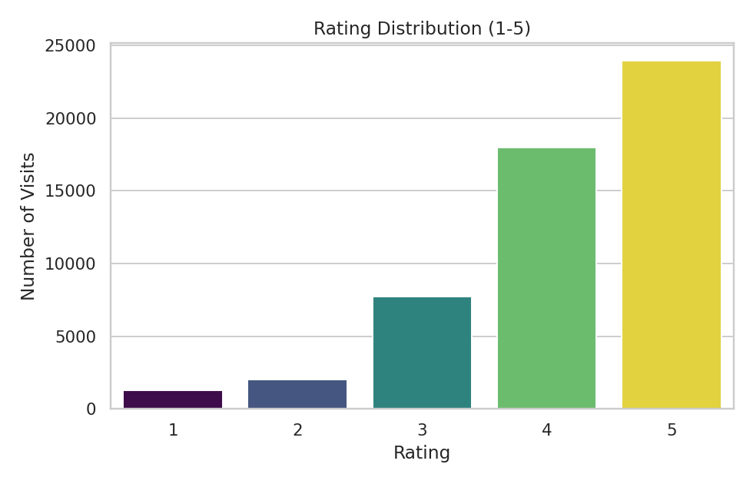
Figure 1. Rating distribution — skewed toward 4-5.
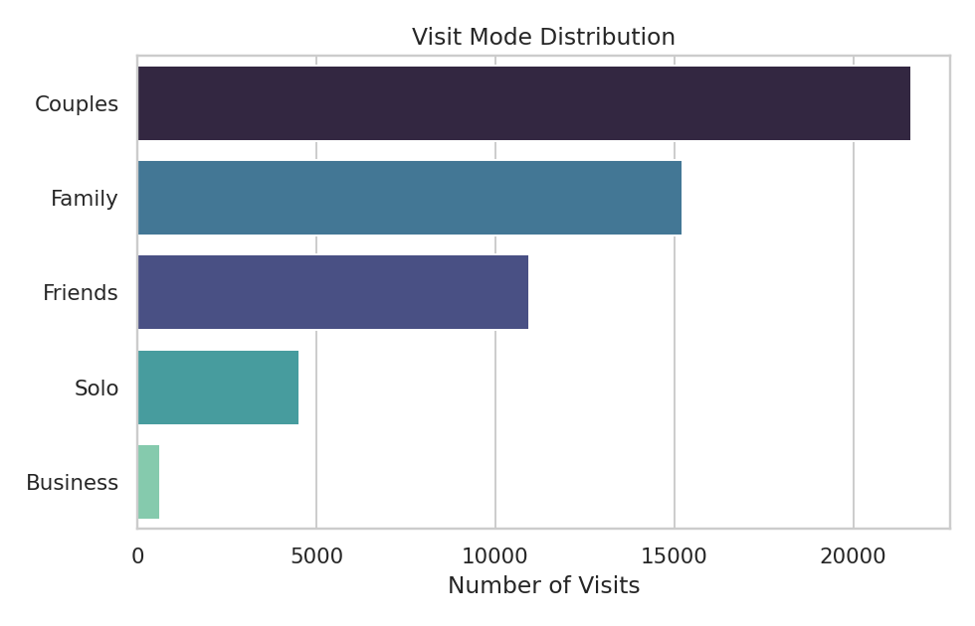
Figure 2. Visit mode distribution — Business is a rare class.

4.2 Attraction Performance
Water Parks (4.65 avg) and Nature & Wildlife Areas (4.27 avg) are the highest-rated attraction categories; Historic Sites (3.54) and Beaches (3.85) rate lowest despite Beaches being high-volume.
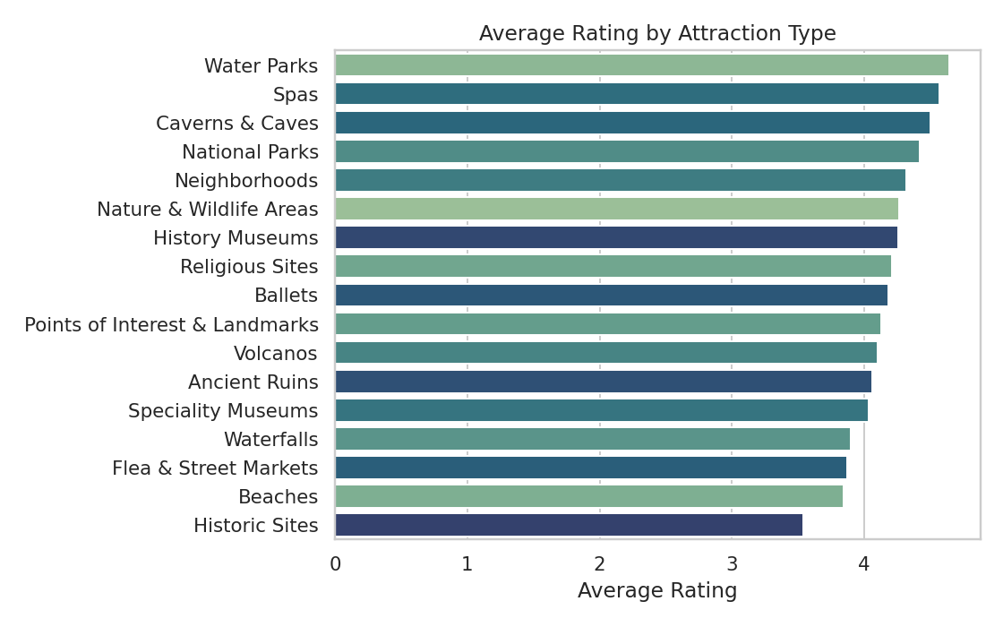
Figure 3. Average rating by attraction type.
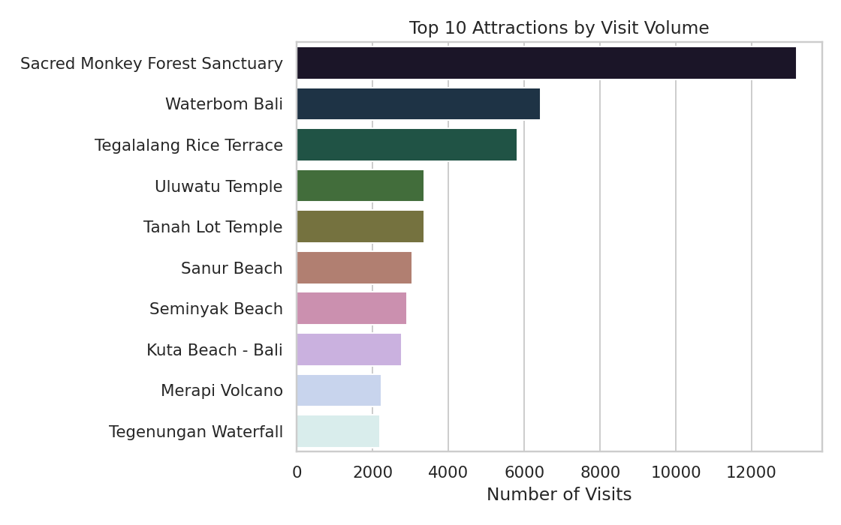
Figure 4. Top 10 attractions by visit volume.

4.3 Time Trends
Visit volume shows a clear COVID-19 collapse: from 9,444 visits in 2017 down to 529 in 2020 and just 35 in 2021, before a partial 2022 recovery. This is a real external shock in the data, not noise — any year-over-year trend model must account for it.
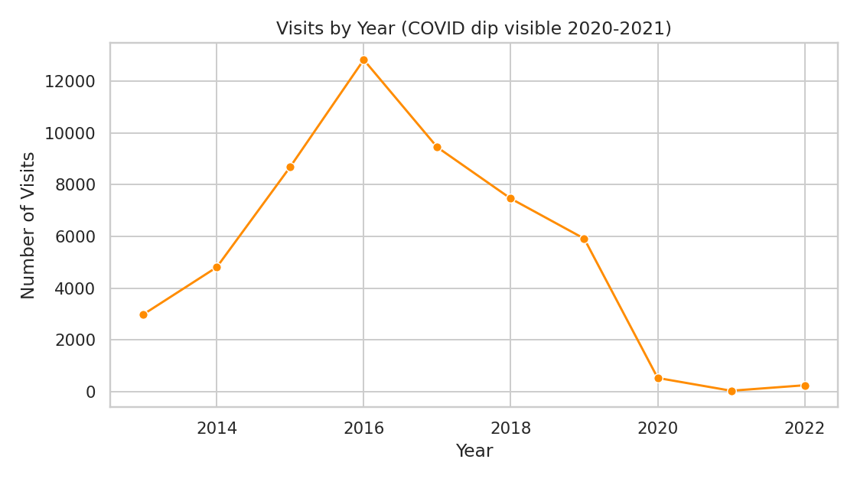
Figure 5. Visits by year — COVID-19 impact clearly visible.
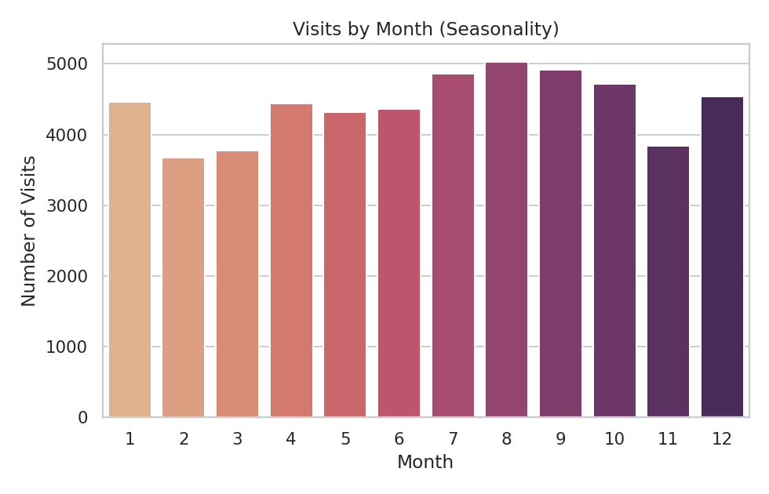
Figure 6. Visits by month — seasonality pattern.

4.4 User Geography
Asia (15,693 visits), Australia & Oceania (14,852), and Europe (13,278) dominate the user base; Africa is a small minority (920 visits, 1.7%) — any model or business decision segmented by continent should treat the African segment's numbers as low-confidence due to small sample size.
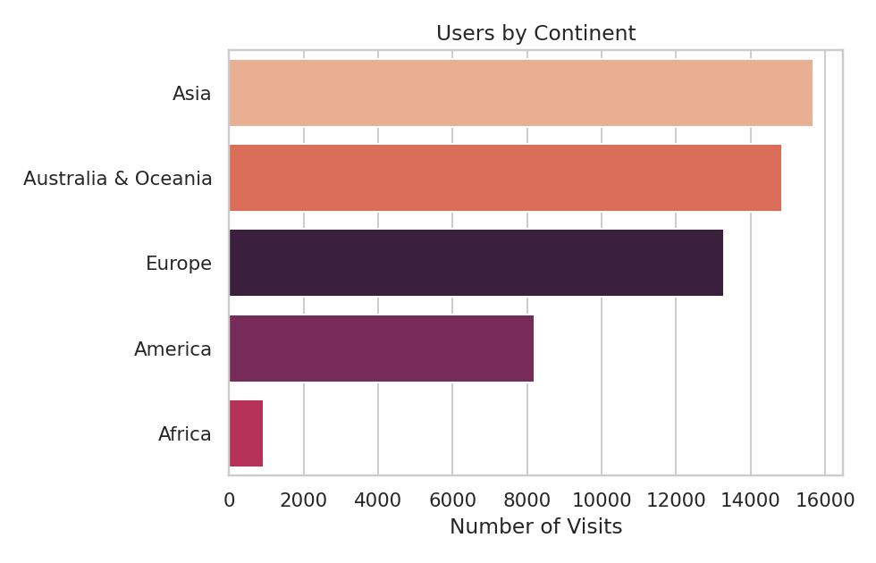
Figure 7. Visit volume by user continent.

4.5 Cross-cutting Patterns
Business travelers rate attractions highest on average (4.31) and Solo travelers lowest (4.09), though the spread across modes is modest — visit mode alone is a weak rating predictor, consistent with the regression results in Section 4.
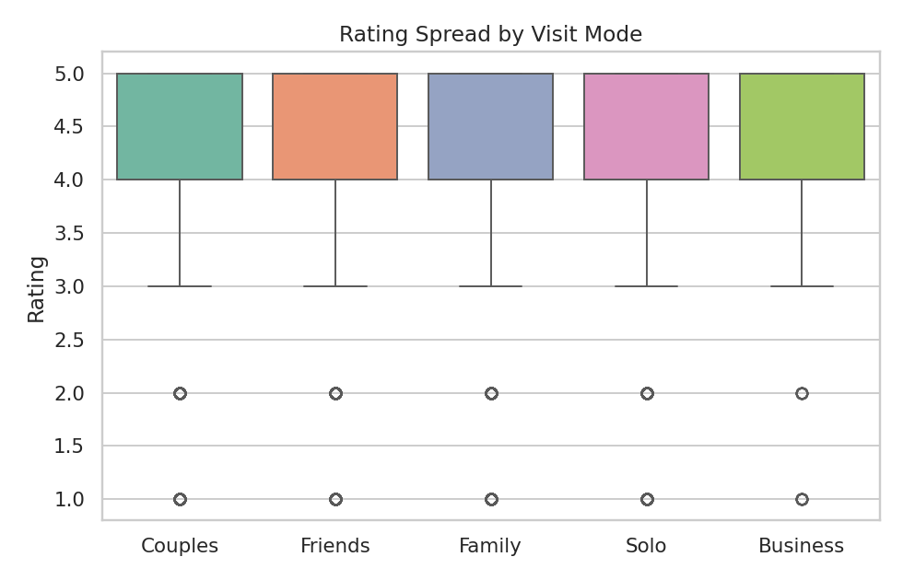
Figure 8. Rating spread by visit mode.
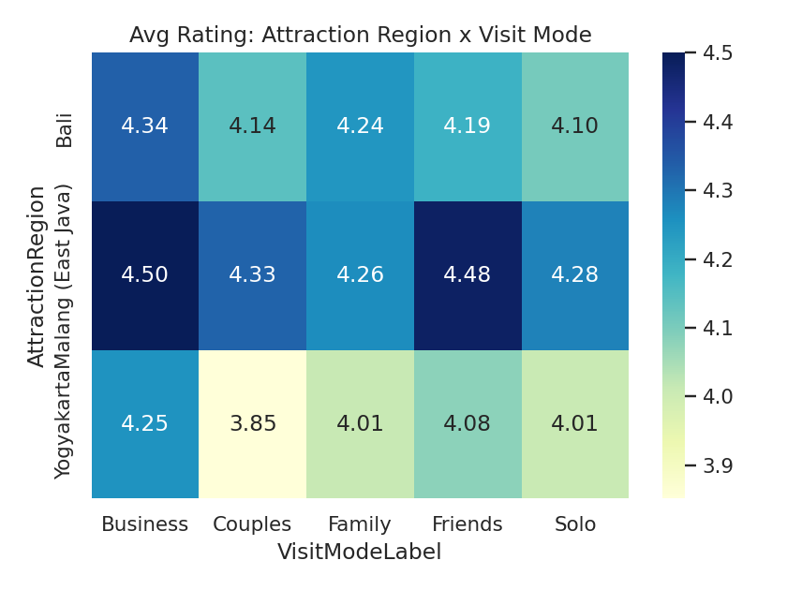
Figure 9. Average rating by attraction region x visit mode.
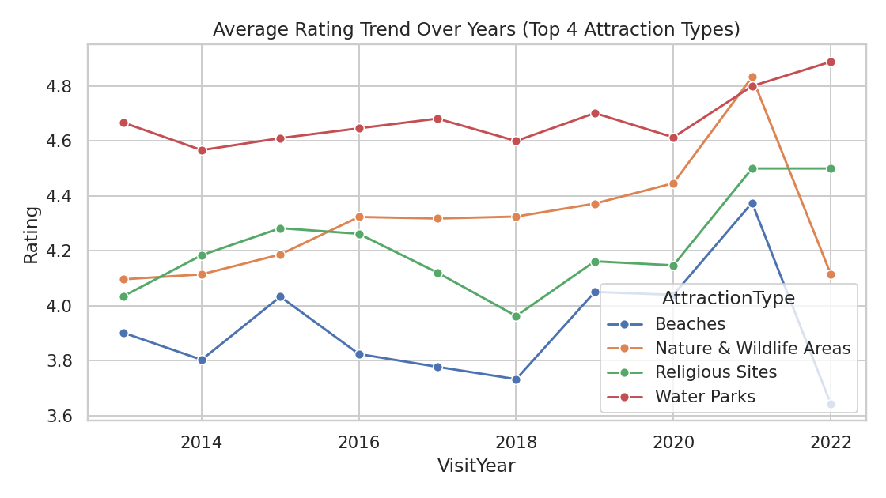
Figure 10. Rating trend over years for the top 4 attraction types — stable, no major drift.
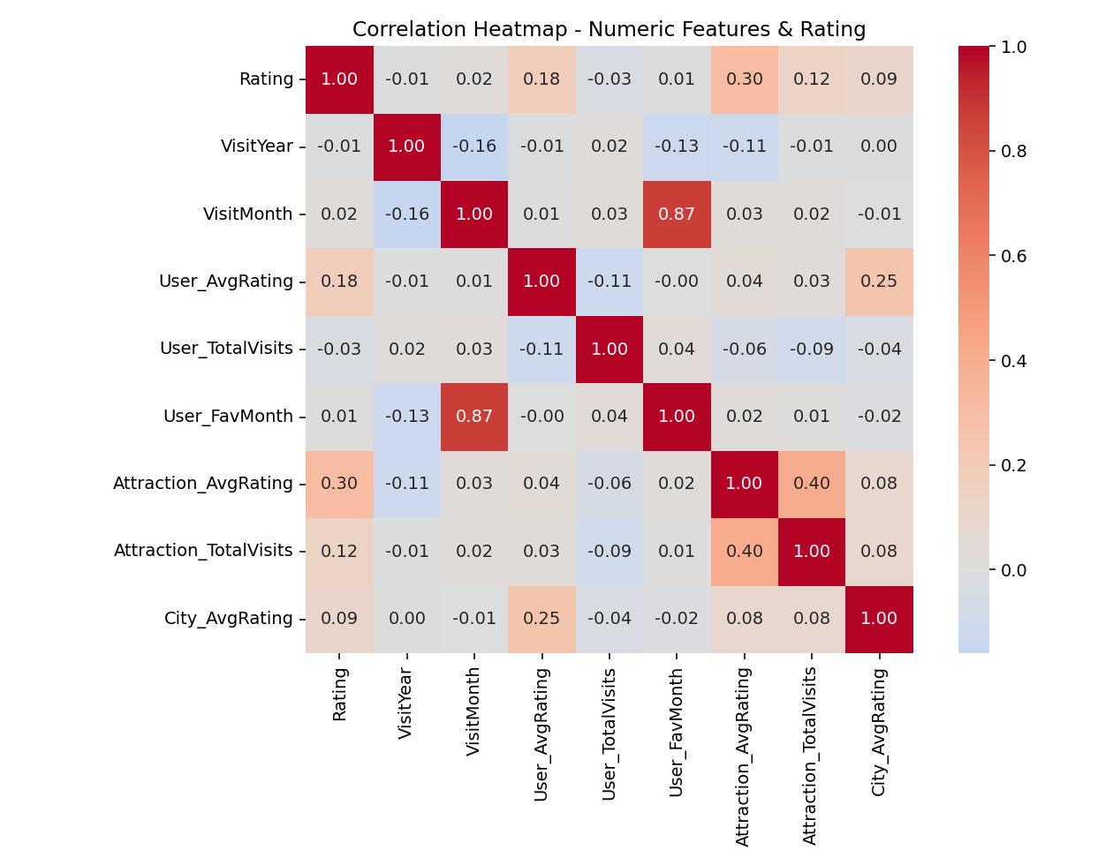
Figure 11. Correlation heatmap of numeric and engineered features against Rating. Attraction_AvgRating and User_AvgRating (the leak-checked engineered features) correlate more strongly with Rating than any raw demographic field.
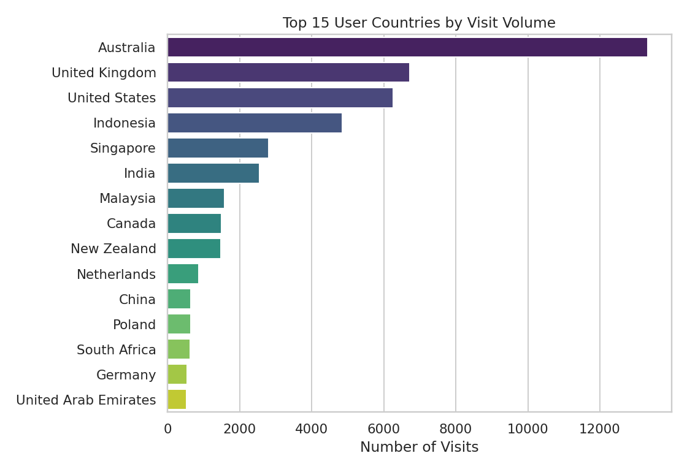
Figure 12. Top 15 user countries by visit volume — Australia dominates, consistent with the continent-level view in Figure 7.

5. Model Performance

5.1 Classification — Visit Mode Prediction
Four algorithms were trained and compared on identical train/test splits (80/20, stratified), using demographic, attraction, and the engineered features from Section 3. Class weighting was applied throughout to counter the severe imbalance.
Model | Train Acc. | Test Acc. | Test Macro F1 | Test Macro Prec. | Test Macro Recall
LightGBM | 0.571 | 0.406 | 0.312 | 0.312 | 0.337
XGBoost | 0.615 | 0.403 | 0.306 | 0.306 | 0.322
Random Forest | 0.475 | 0.401 | 0.293 | 0.322 | 0.349
Logistic Regression | 0.308 | 0.316 | 0.245 | 0.280 | 0.344

Result: adding engineered features did not meaningfully move macro-F1 (still ~0.31, matching the demographics-only baseline). This is a useful negative result, not a wasted step — it confirms the earlier finding wasn't an artifact of a thin feature set. Per-class breakdown for the best model (LightGBM):
Class | Precision | Recall | F1 | Support
Business | 0.06 | 0.20 | 0.09 | 130
Couples | 0.53 | 0.45 | 0.49 | 4,290
Family | 0.51 | 0.48 | 0.50 | 3,079
Friends | 0.30 | 0.28 | 0.29 | 2,171
Solo | 0.16 | 0.27 | 0.20 | 916

Interpretation: Business-mode prediction remains unusable (6% precision). This is a data-availability ceiling, not a tuning failure: reliable Business-mode prediction would need features like booking channel, trip duration, or group size, none of which exist in this dataset.

5.2 Regression — Rating Prediction (with engineered features)
Same approach, four algorithms plus a naive mean-predictor baseline for reference. This is after the leave-one-out leakage bug described in Section 3 was found and fixed — these numbers are the corrected, verified results.
Model | R² | MAE | RMSE
Random Forest | 0.162 | 0.688 | 0.888
LightGBM | 0.161 | 0.689 | 0.889
Linear Regression | 0.130 | 0.708 | 0.905
XGBoost | 0.084 | 0.718 | 0.929
Baseline (predict mean) | 0.000 | 0.759 | 0.970

Interpretation: the best model (Random Forest) explains 16.2% of rating variance — a genuine, verified improvement over the demographics-only baseline (R² 0.107 in the first iteration of this project). The improvement is driven almost entirely by Attraction_AvgRating and User_AvgRating (see feature importance in the Regression notebook). Still modest in absolute terms — most rating variance is driven by factors not captured in this dataset (individual expectations, crowding, weather, service quality on the day). This model should be read as directional, not a precise satisfaction predictor.

6. Recommendation System
A 3-tier hybrid design was used because of how the user base is actually distributed: 33,530 users but only 30 attractions, and 68% of users have exactly one rating — too little for collaborative filtering to work from, but enough for a content signal.
- Users with 2+ ratings (~32% of users): hybrid score blending item-based collaborative filtering (cosine similarity on the user-item rating matrix, weight 0.7) with content-based similarity on attraction type and region (weight 0.3).
- Users with exactly 1 rating: pure content-based filtering — recommend attractions similar in type/region to the one thing they've rated, since a single data point carries almost no collaborative signal.
- Users with 0 ratings (true cold start): Bayesian-adjusted popularity ranking, which discounts attractions with very few ratings so one 5-star review can't dominate the top of the list.
This 3-tier structure is necessary rather than a design preference — a pure collaborative filter would have nothing to recommend for the majority of the user base.

7. Streamlit Application
A four-tab Streamlit app (streamlit_app/streamlit_app.py) ties all three components together for end users:
- Overview — key dataset metrics, distribution charts, and both model-comparison tables rendered live.
- Predict Visit Mode — user selects demographics and an attraction (engineered features like Attraction_AvgRating are looked up automatically, not typed in), gets a predicted visit mode with class probabilities.
- Predict Rating — same inputs plus visit mode, returns a predicted rating.
- Recommend Attractions — enter a UserId (or leave blank for a new user) to get recommendations from the appropriate tier: hybrid CF+content, content-only, or popularity, depending on that user's rating history.

8. Business Insights
Use Case | Finding | Recommended Action
Personalized Recommendations | 68% of users are one-time visitors with no rating history | Prioritize the popularity/content-based fallback tiers in production — they serve the majority of real users, not the pure collaborative filter
Tourism Analytics | Water Parks and Nature & Wildlife attractions outperform Beaches and Historic Sites on satisfaction despite lower or comparable volume | Beaches draw the most visits but underperform on rating — worth investigating service/crowding issues rather than assuming volume equals satisfaction
Customer Segmentation | Visit mode is not reliably predictable from geography and attraction type alone (macro-F1 0.31, unchanged by feature engineering) | Don't build marketing segments on this model's output as-is; it would misclassify Business and Solo travelers most of the time
Customer Retention | COVID-19 caused a >94% visit collapse (2019 to 2020); 2022 shows partial recovery only | Any retention or demand forecast must model the COVID discontinuity explicitly rather than fitting a single trend line across it

9. Limitations & Honest Assessment
- Classification performance is weak in absolute terms (macro-F1 0.31) and didn't improve with additional engineered features — treat it as a decision-support signal, not a precise prediction.
- Regression improved genuinely with engineered features (R² 0.107 to 0.162) but is still modest — most rating variance is driven by factors outside this dataset.
- The recommender can only ever suggest 30 attractions — real coverage is far narrower than the catalogued 1,698 in Updated_Item.xlsx, which has no transaction history to learn from.
- Business-mode classification is not production-usable in its current form (6% precision).
- Africa (1.7% of the user base) and Business trips (1.2% of visits) are both too sparse for reliable subgroup conclusions — any insight drawn from them should be treated as low-confidence.
- A first attempt at feature engineering leaked (documented in Section 3) and was caught and fixed before being used in any reported result. Anyone extending this pipeline with new aggregated features should re-run the same train-vs-test overfitting check before trusting the numbers.

10. Deliverables
Delivered in the folder structure below, matching the project's suggested layout:
- data/raw/ — original source Excel files
- data/cleaned/ — master_clean.csv, users_clean.csv, attractions_clean.csv, master_features.csv (with engineered features and train/test split flag)
- notebooks/ — EDA.ipynb, Regression.ipynb, Classification.ipynb, Recommendation.ipynb (all executed, zero errors)
- models/ — visitmode_classifier.pkl, rating_regressor.pkl, recommender.pkl, plus classification_model_comparison_v2.csv and regression_model_comparison_v2.csv
- streamlit_app/ — streamlit_app.py, the deployed application
- reports/ — this documentation report (Tourism_Analytics_Report.docx)
- charts/ — all 12 saved EDA/correlation figures
- Source code: clean_data.py, feature_engineering.py, train_classification_v2.py, train_regression_v2.py, build_recommender.py, eda_visuals.py
- requirements.txt — pinned dependency list for reproducing the environment

