CDI COLLEGE
DATA ANALYTICS WITH CAPSTONE

ASSIGNMENT REPORT

COURSE CODE: BDA400
COURSE NAME: DATA SCIENCE TOOLS AND TECHNIQUES
ASSIGNMENT: ASSIGNMENT 2 - TECHNICAL ANALYSIS USING R, PRELIMINARY STAGE

STUDENT NAME: DINESH KUMAR SANSOYA
INSTRUCTOR NAME: VARUN SINGH

GITHUB REPOSITORY LINK:
https://github.com/rajadksansoya-web/TechnicalAnalysis

====================================================================
STEP 1: GITHUB ACCOUNT AND REPOSITORY SETUP
====================================================================
• Created a professional GitHub account for managing data science projects.
• Initialized a new public repository named 'TechnicalAnalysis' to version control all assignments for the BDA400 course.
• Configured the repository with a default README.md file.

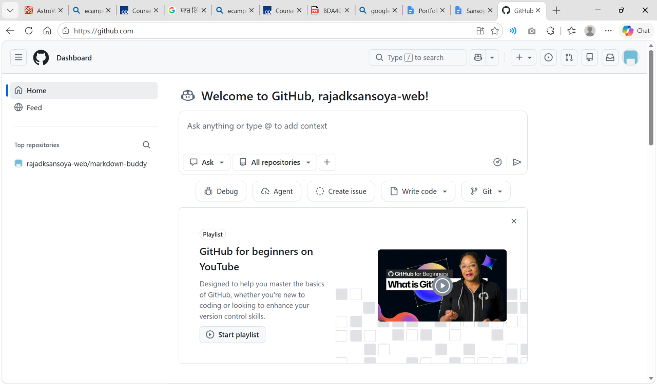
====================================================================
STEP 2 & 3: RSTUDIO AND PACKAGES INSTALLATION
====================================================================
• Downloaded and installed R and RStudio Desktop IDE environment.
• Executed the package installation command to download required financial packages from the CRAN mirror.
• Installed packages: 'quantmod' (Quantitative Financial Modelling Framework) and 'TTR' (Technical Trading Rules).

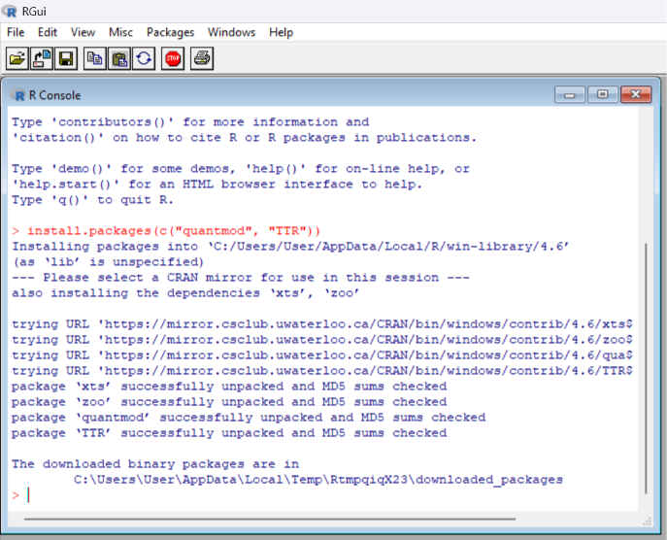
====================================================================
STEP 4 & 5: PROJECT CONFIGURATION AND DATA IMPORT
====================================================================
• Created a custom asset configuration file named 'portfolio.txt' containing the target portfolio tickers (AAPL, MSFT, AMZN, GOOG).
• Developed an automated R utility function named 'load_stock_data()' using the readLines framework.
• Integrated the function with Yahoo Finance API via 'getSymbols' to download historical stock data dynamically.

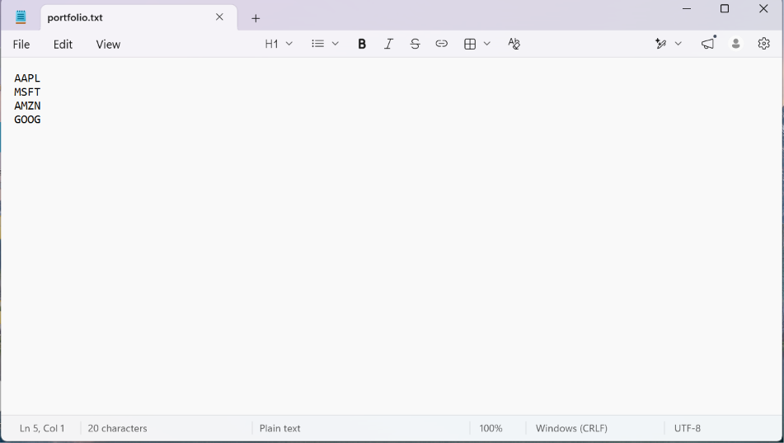
====================================================================
STEP 6 & 7: COMPUTING STATISTICS AND DATA DISPLAY OUTPUT
====================================================================
• Developed a custom R function named 'calculate_statistics()' to compute descriptive statistics on closing stock prices.
• Safely handled missing parameters using 'na.rm = TRUE' to process continuous stock streams.
• Calculated required core metrics: Mean, Median, and Standard Deviation (SD) for each individual asset.
• Integrated the 'TTR' library to dynamically compute the latest 20-day Simple Moving Average (SMA).
• Rendered a professional interactive financial rollup table displaying all descriptive statistics.
• Generated custom high-resolution visualizations including a 6-month Candlestick series with an integrated 20-day blue SMA overlay.



