|  |
| --- |
| Assignement 4  Realised by Samira |

Consider the tasks T1(3, 0.5), T2(4, 1.5, 3), T3(7, 1.0, 5) and the EDF scheduler. A sporadic job arrives at t=50 having the execution time of 10 and a relative deadline of 30. Create the sporadic task in SimSo by selecting: ”generate task set” and then list of act. Dates to the release time

-Use SimSo to schedule the task set and provide a report answering the following questions:

* What is the minimum/maximum/average response time of all tasks?
* Is any task missing the deadline? Which task? Where?
* Is the sporadic job meeting its deadline?
* What is the response time for the sporadic job?

**Solution :**

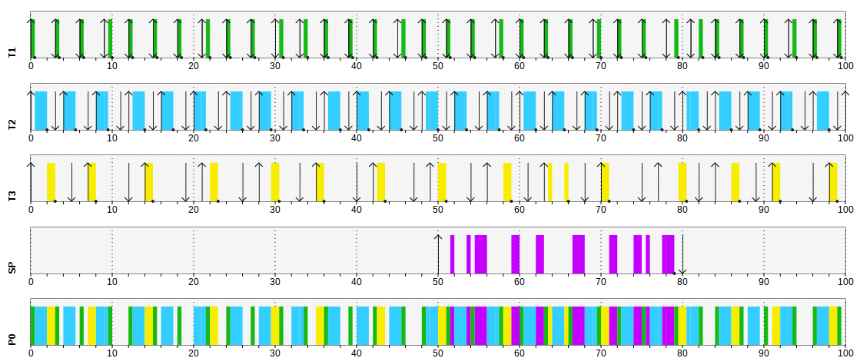**EDF scheduler :**

**What is the minimum/maximum/average response time of all tasks?**

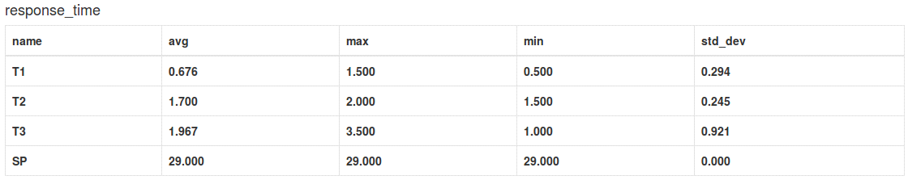

**Is any task missing the deadline? Which task? Where?**

All the tasks havn't miss their deadline

**Is the sporadic job meeting its deadline?**

Yes, the sporadic job meet its deadline

**RM scheduler :**

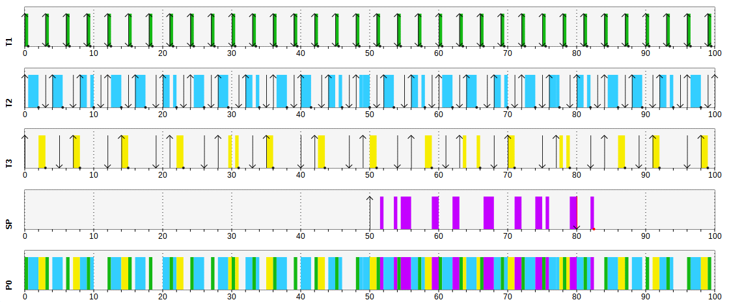

**What is the minimum/maximum/average response time of all tasks?**

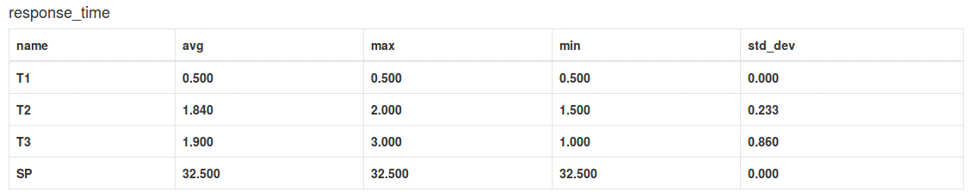

**Is any task missing the deadline? Which task? Where?**

Yes, the sporadic job misses its deadline



**Is the sporadic job meeting its deadline?**

No, the sporadic job didn't meet the deadline

**What is the response time for the sporadic job?**

32.5

**Which scheduler is better is better in this example; EDF or RM?**

The EDF scheduler is better in this example

**Programming assignement**

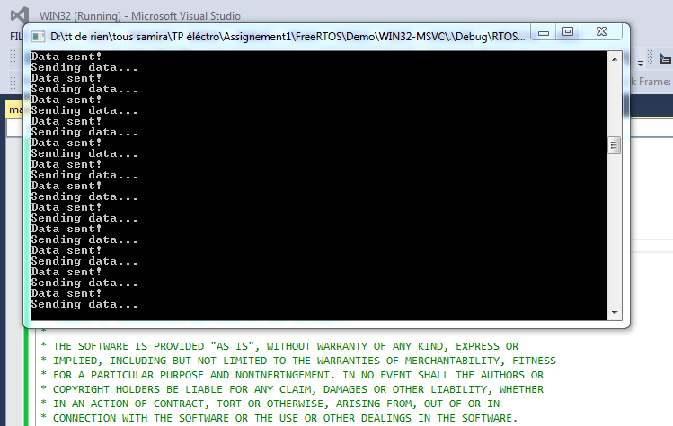

Yes,the system can handle all the aperdiodic tasks because all those tasks have started and finished succefully.

The response tie is 2 s