Home Page before login:

User Registration Page

Login Page

Home Page after login:

My Profile Page:

Purchase Steps:

1. Cart Page

1. Purchase Summary

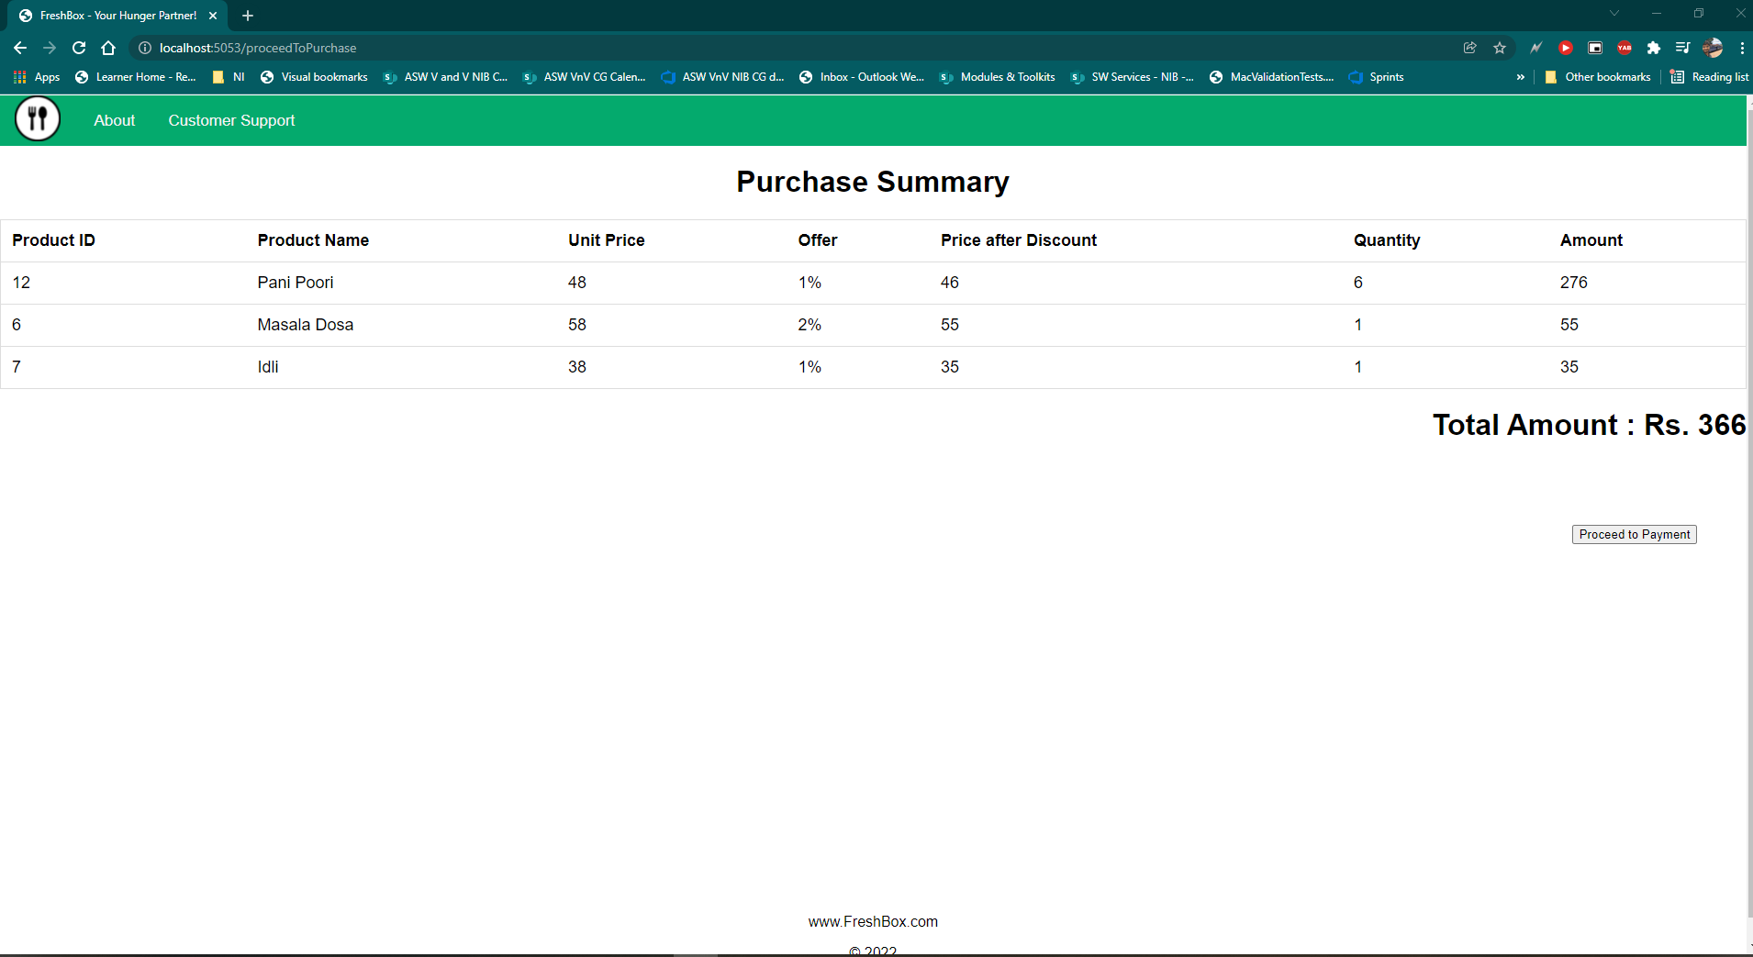

1. Payment Gateway

1. Order details after payment:

Admin Login form

Admin Dashboard:

Food Dashboard:

Search Option and sorting

Edit Food Option

Add Food Item

Cuisines:

Add Cuisines:

