SportyShoes.com

Project Developer : Rajagopal – rajagopal016@gmail.com

GitHub : <https://github.com/rajagopal016/selfLearnExerciseFiles/tree/main/SpringJDBC_12092021>

Sprint Planning :

The Project was split into three sprints each of a week time. Specific features were planned for every sprint through Sprint Planning meeting and the same was reviewed in Sprint Retrospective.

Sprint 1

* Requirement reading and understanding
* Infrastructure requirements reviews and setup- Eclipse, MYSQL 8.0.26 and MYSQL Work Bench, Java JDK16, Spring boot were chosen to be used
* Database table designing
* ER Diagram
* Class Designing
* Application Flow

Sprint 2

* HTML Designing of Home page, and Admin Dashboard
* HTML Designing of password change
* HTML designing of Product add
* Back end controller designing and completion of product display and product Add
* Backend controller design and completion of admin password change
* Testing

Sprint 3

* Backend controller design and completion of user display and purchase display
* Testing
* Review
* Documentation
* Release

Project Details:

SportyShoes.com is a shop that sells shoes in India. It has now expanded it’s sales to online store and hence this Java Powered application is designed to cater it’s ecommerce website.

**Home Page:**

The application has a home page [*http://localhost:9092*](http://localhost:9092) *or* [*http://localhost:9092*](http://localhost:9092)*/home or* [*http://localhost:9092*](http://localhost:9092)*/index* . It is the landing page for the admin. It has input fields for admin login. The fields are validated, and all inputs are mandatory. Incorrect password will lead to login failure. Inappropriate inputs will be handled and application will not crash.

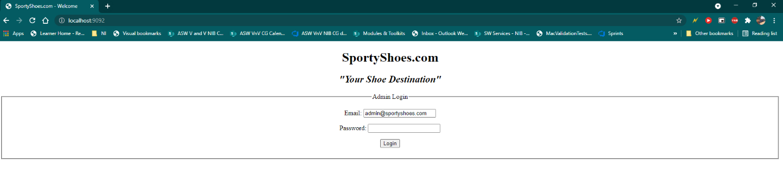

**Admin Dashboard: (http://localhost:9092/loginController)**

Admin dashboard has the options to browse Users, products, purchase and change admin password.

**Users Database: (http://localhost:9092/userController)**

User Database page displays all users who have registered and an option to search users is provided

**Products Database: (http://localhost:9092/listProducts)**

Product/Shoe Database page displays all products that are added and an option to categorize the shoes is provided

**Add Shoes: (http://localhost:9092/addProducts)**

Add shoes option is provided to add new shoes to the DB. Inappropriate inputs will be handled and application will not crash. It has fields for name, category, price, availability and all fields are mandatory.

**Purchase Database: (http://localhost:9092/listPurchase)**

Purchase Database provides a list of purchases made by the customers, it has facility to filter by category and date.

**Admin Password Change: (**[**http://localhost:9092/changePasswordForm**](http://localhost:9092/changePasswordForm)**, http://localhost:9092/changePassword)**

Admin Password change form provides fields for admin to change password. New Password and Confirm password should be same and mandatory. Inappropriate inputs will be handled and application will not crash.

**Flow Chart:**

Database Tables:

Products Table:

Purchase Table:

Users Table:

Core Concepts Used:

1. Servlet
2. HTML
3. JSP
4. Session Management
5. Controller
6. Hibernate
7. MySQL
8. Spring Boot
9. Spring

Classes:

SpringJdbc12092021Application.java – Main Application

AppConfig.java – Contains DB config for spring

EProductController – Controller for Product operations

IndexController – Controller for Home Page

UserController – Controller for User operations

PurchaseController – Controller for Purchase operations

EProductDAO, PurchaseDAO, UserDAO – DAO for respective tables

EProduct.java, User.java, Purchase.java – Entity models for respective tables

adminDashboard.html – Admin Dashboard html codes

changeFailed.html – for password change failure

changePasswordForm.html – form for admin password reset

changeSuccess.html - for password change success

index.html – homepage

listProducts.html – lists all products with search option

listUsers.html – lists all users with search option

NewShoe.html – form to add new shoe

Saved.html – new shoe save success page

Saved.html – new shoe save fail page