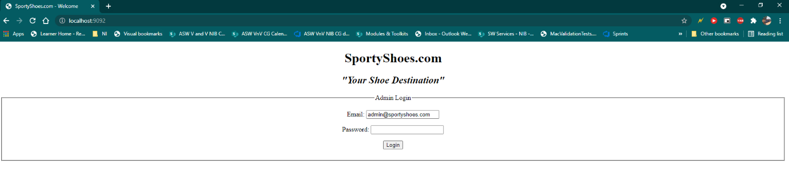Home Page or Admin Login Page

Admin Dashboard

Users Database

User Search

Shoes Database

Categorizing Shoes

Add Shoes Form

Purchase Database

Filter by Date and Category

Admin Password Change

