more command in Linux with Examples

**more** command is used to view the text files in the command prompt, displaying one screen at a time in case the file is large (For example log files). The more command also allows the user do scroll up and down through the page. The syntax along with options and command is as follows. Another application of more is to use it with some other command after a [pipe](https://www.geeksforgeeks.org/piping-in-unix-or-linux/). When output is large, we can use more command to see output one by one.

**Syntax:**

***more [-options] [-num] [+/pattern] [+linenum] [file_name]***

*[-options]: any option that you want to use in order to change the way the file is displayed.  
Choose any one from the following-:  
(-d, -l, -f, -p, -c, -s, -u)  
[-num]: type the number of lines that you want to display per screen.  
[+/pattern]: replace pattern with any string that you want to find in the text file.  
[+linenum]: use the line number from where you want to start displaying the text content.  
[file_name]: name of the file containing the text that you want to display on the screen.*

**while viewing the text file use these controls:**

*Enter key: to scroll down line by line.  
Space bar: To go to the next page.  
b key: To go to back one page.*

**options used with more command**  
**-d :**use this command in order to help the user to navigate. It displays “[Press space to continue, ‘q’ to quit.]” and displays “[Press ‘h’ for instructions.]” when wrong key is pressed.  
**Example:**

**Input :**

more -d sample.txt

**Output :**

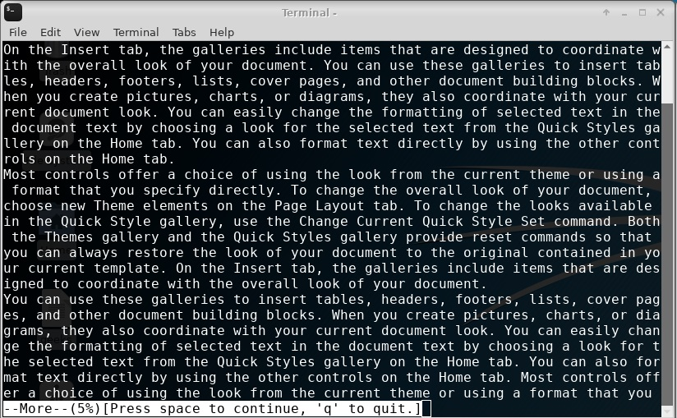

**-f :**this command does not wrap the long lines and displays them as such.  
**Example:**

**Input :**

more -f sample.txt

**Output :**

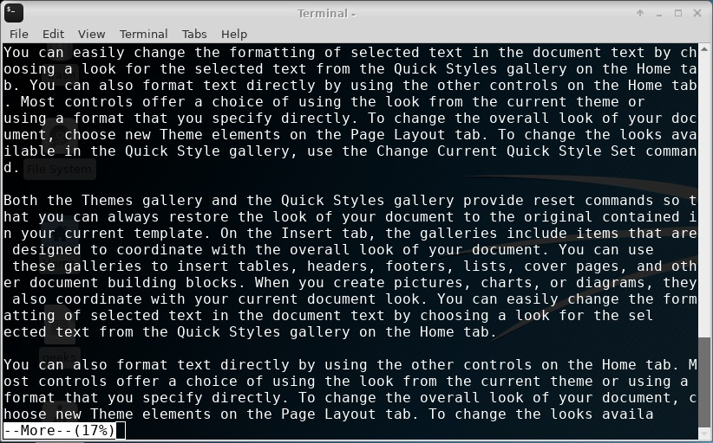

**-p :**this command clears the screen and then displays the text.  
**Example:**

**Input :**

more -p sample.txt

**Output :**

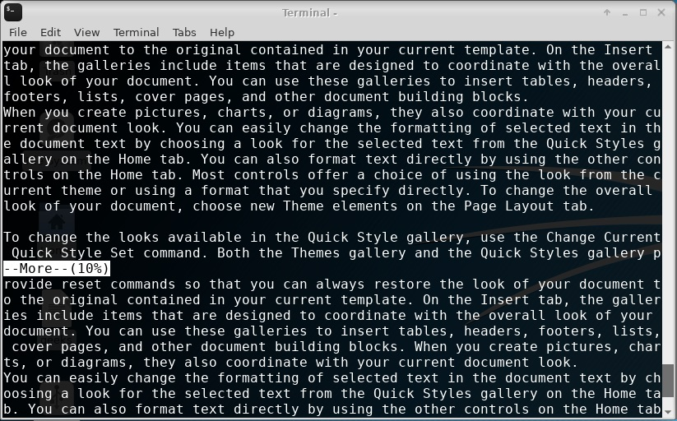

**-c :**this command is used to display the pages on the same area by overlapping the previous displayed text.  
**Example:**

**Input :**

more -c sample.txt

**Output :**

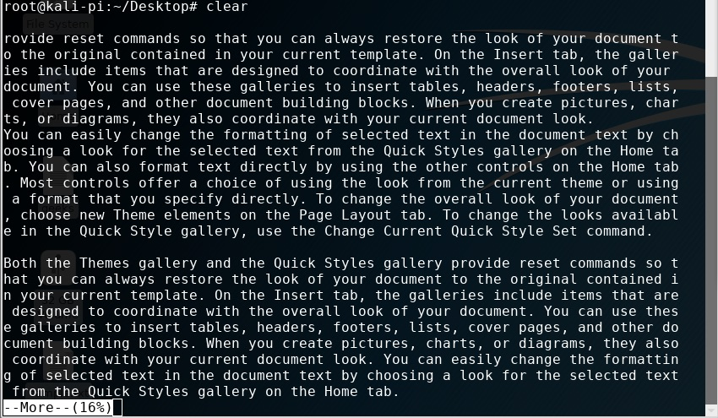

**-s :**this command squeezes multiple blank lines into one single blank line.  
**Example:**

**Input :**

more -s sample.txt

**Output :**

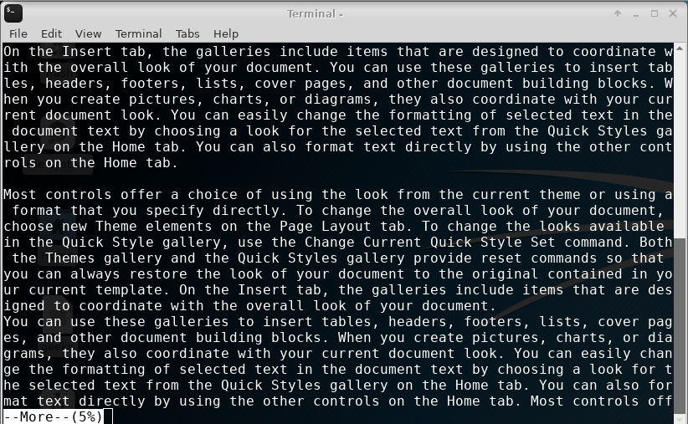

**-u :**this command omits the underlines.  
**Example:**

**Input :**

more -u sample.txt

**+/pattern :**this command is used to search the the string inside your text document.You can view all the instances by navigating through the result.  
**Example:**

**Input :**

more +/reset sample.txt

**Output :**

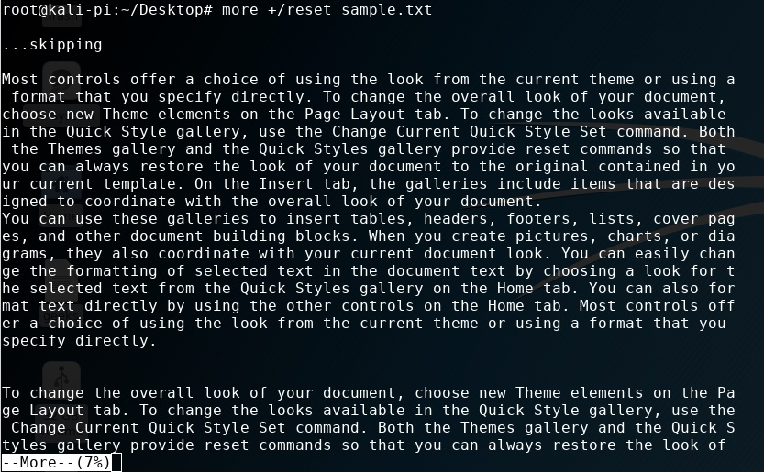

**+num :**this command displays the text after the specified number of lines of the document.  
**Example:**

**Input :**

more +30 sample.txt

**Output :**

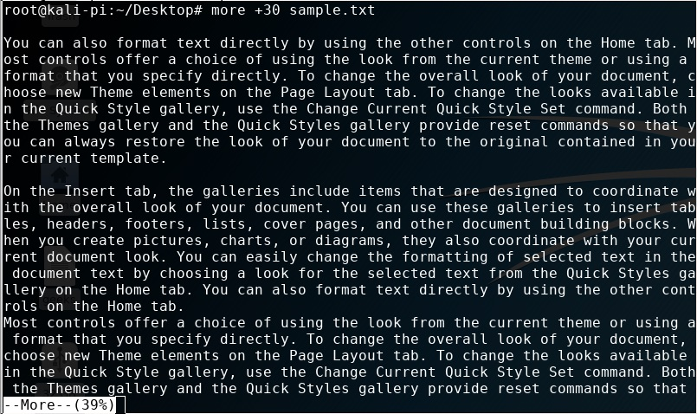

**Using more to read long outputs**  
We use more command after a pipe to see long outputs. For example, seeing log files, etc.

cat a.txt | more

# less command in Linux with Examples

Less command is linux utility which can be used to read contents of text file one page(one screen) per time. It has faster access because if file is large, it don’t access complete file, but access it page by page.

For example, if it’s a large file and you are reading it using any text editor, then the complete file will be loaded to main memory, but less command don’t load entire file, but load it part by part, which makes it faster.

**syntax :**

less filename

**Note :** I’m using [dmesg](https://www.geeksforgeeks.org/dmesg-command-linux-driver-messages/) output as input to less command in following examples.

For Example : If you want to read contents of [dmesg command](https://www.geeksforgeeks.org/dmesg-command-linux-driver-messages/), it’s better to use it with less command

dmesg | less

Output :

[ 0.000000] microcode: microcode updated early to revision 0x21, date = 2017-11-20

[ 0.000000] random: get_random_bytes called from start_kernel+0x42/0x504 with crng_init=0

[ 0.000000] Linux version 4.13.0-26-generic (buildd@lgw01-amd64-031) (gcc version 5.4.0 20160609 (Ubuntu 5.4.0-6ubuntu1~16.04.5)) #29~16.04.

2-Ubuntu SMP Tue Jan 9 22:00:44 UTC 2018 (Ubuntu 4.13.0-26.29~16.04.2-generic 4.13.13)

[ 0.000000] Command line: BOOT_IMAGE=/boot/vmlinuz-4.13.0-26-generic.efi.signed root=UUID=993a37f2-7ea9-43a3-b652-5b26bb879797 ro quiet splash vt.handoff=7

[ 0.000000] KERNEL supported cpus:

[ 0.000000] Intel GenuineIntel

[ 0.000000] AMD AuthenticAMD

[ 0.000000] Centaur CentaurHauls

[ 0.000000] x86/fpu: Supporting XSAVE feature 0x001: 'x87 floating point registers'

[ 0.000000] x86/fpu: Supporting XSAVE feature 0x002: 'SSE registers'

[ 0.000000] x86/fpu: Supporting XSAVE feature 0x004: 'AVX registers'

[ 0.000000] x86/fpu: xstate_offset[2]: 576, xstate_sizes[2]: 256

[ 0.000000] x86/fpu: Enabled xstate features 0x7, context size is 832 bytes, using 'standard' format.

[ 0.000000] e820: BIOS-provided physical RAM map:

[ 0.000000] BIOS-e820: [mem 0x0000000000000000-0x000000000006efff] usable

[ 0.000000] BIOS-e820: [mem 0x000000000006f000-0x000000000006ffff] reserved

[ 0.000000] BIOS-e820: [mem 0x0000000000070000-0x0000000000087fff] usable

[ 0.000000] BIOS-e820: [mem 0x0000000000088000-0x00000000000bffff] reserved

[ 0.000000] BIOS-e820: [mem 0x0000000000100000-0x0000000094d5ffff] usable

[ 0.000000] BIOS-e820: [mem 0x0000000094d60000-0x0000000095d5ffff] reserved

[ 0.000000] BIOS-e820: [mem 0x0000000095d60000-0x000000009a36efff] usable

[ 0.000000] BIOS-e820: [mem 0x000000009a36f000-0x000000009aebefff] reserved

[ 0.000000] BIOS-e820: [mem 0x000000009aebf000-0x000000009afbefff] ACPI NVS

[ 0.000000] BIOS-e820: [mem 0x000000009afbf000-0x000000009affefff] ACPI data

[ 0.000000] BIOS-e820: [mem 0x000000009afff000-0x000000009affffff] usable

[ 0.000000] BIOS-e820: [mem 0x000000009b000000-0x000000009f9fffff] reserved

[ 0.000000] BIOS-e820: [mem 0x00000000e0000000-0x00000000efffffff] reserved

[ 0.000000] BIOS-e820: [mem 0x00000000fe101000-0x00000000fe112fff] reserved

[ 0.000000] BIOS-e820: [mem 0x00000000feb00000-0x00000000feb0ffff] reserved

[ 0.000000] BIOS-e820: [mem 0x00000000fec00000-0x00000000fec00fff] reserved

[ 0.000000] BIOS-e820: [mem 0x00000000fed00000-0x00000000fee00fff] reserved

[ 0.000000] BIOS-e820: [mem 0x00000000ffc00000-0x00000000ffffffff] reserved

[ 0.000000] BIOS-e820: [mem 0x0000000100000000-0x000000025f5fffff] usable

[ 0.000000] NX (Execute Disable) protection: active

[ 0.000000] e820: update [mem 0x93c97018-0x93ca7057] usable ==> usable

[ 0.000000] e820: update [mem 0x93c97018-0x93ca7057] usable ==> usable

[ 0.000000] e820: update [mem 0x93c8a018-0x93c96057] usable ==> usable

[ 0.000000] e820: update [mem 0x93c8a018-0x93c96057] usable ==> usable

:

**mostly used Options :**

*-E : causes less to automatically exit the first time it reaches end of file.  
-f : forces non-regular file to open.  
-F : causes less to exit if entire file can be displayed on first screen  
-g : highlight the string which was found by last search command  
-G : suppresses all highlighting of strings found by search commands  
-i : cause searches to ignore case  
-n : suppresses line numbers  
-p pattern : it tells less to start at the first occurrence of pattern in the file  
-s : causes consecutive blank lines to be squeezed into a single blank line*

**Command Usage with options :**

dmesg | less -p "failure"

The above command tells less to start at first occurrence of pattern “failure” in the file.

Output :

[ 368.748104] wlp2s0: failed to remove key (1, ff:ff:ff:ff:ff:ff) from hardware (-22)

[ 372.254014] wlp2s0: authenticate with a0:55:4f:27:bd:01

[ 372.257112] wlp2s0: send auth to a0:55:4f:27:bd:01 (try 1/3)

[ 372.261055] wlp2s0: authenticated

[ 372.264307] wlp2s0: associate with a0:55:4f:27:bd:01 (try 1/3)

[ 372.270621] wlp2s0: RX AssocResp from a0:55:4f:27:bd:01 (capab=0x431 status=0 aid=199)

[ 372.272312] wlp2s0: associated

[ 372.357068] wlp2s0: Limiting TX power to 30 (30 - 0) dBm as advertised by a0:55:4f:27:bd:01

[ 682.255302] wlp2s0: disassociated from a0:55:4f:27:bd:01 (Reason: 1=UNSPECIFIED)

[ 682.304134] wlp2s0: failed to remove key (1, ff:ff:ff:ff:ff:ff) from hardware (-22)

[ 685.809837] wlp2s0: authenticate with a0:55:4f:27:bd:01

dmesg | less -N

It will show output along with line numbers  
Output :

1 [ 0.000000] microcode: microcode updated early to revision 0x21, date = 2017-11-20

2 [ 0.000000] random: get_random_bytes called from start_kernel+0x42/0x504 with crng_init=0

3 [ 0.000000] Linux version 4.13.0-26-generic (buildd@lgw01-amd64-031) (gcc version 5.4.0 20160609 (Ubuntu 5.4.0-6ubuntu1~16.04.5)) #2 3 9~16.04.2-Ubuntu SMP Tue Jan 9 22:00:44 UTC 2018 (Ubuntu 4.13.0-26.29~16.04.2-generic 4.13.13)

4 [ 0.000000] Command line: BOOT_IMAGE=/boot/vmlinuz-4.13.0-26-generic.efi.signed root=UUID=993a37f2-7ea9-43a3-b652-5b26bb879797 ro qu 4 iet splash vt.handoff=7

5 [ 0.000000] KERNEL supported cpus:

6 [ 0.000000] Intel GenuineIntel

7 [ 0.000000] AMD AuthenticAMD

8 [ 0.000000] Centaur CentaurHauls

9 [ 0.000000] x86/fpu: Supporting XSAVE feature 0x001: 'x87 floating point registers'

10 [ 0.000000] x86/fpu: Supporting XSAVE feature 0x002: 'SSE registers'

11 [ 0.000000] x86/fpu: Supporting XSAVE feature 0x004: 'AVX registers'

12 [ 0.000000] x86/fpu: xstate_offset[2]: 576, xstate_sizes[2]: 256

less -F filename

eg. less -F /home/mandeep/test/first.erl

It will not give any output, since file can be displayed in single screen.

### **1. Less Command – Search Navigation**

Once you’ve opened a log file (or any file) using **less file-name**, use the following keys to search. Please note that the match will be highlighted automatically by default.

### **Forward Search**

* / – search for a pattern which will take you to the next occurrence.
* n – for next match in forward
* N – for previous match in backward

### **Backward Search**

* ? – search for a pattern which will take you to the previous occurrence.
* n – for next match in backward direction
* N – for previous match in forward direction

**Tip:** If you dont bother about which direction the search is happening, and you want to search file path, or URL, such as “/home/ramesh/”, you can use backward search (?pattern) which will be handy as you don’t want to escape slashes each time.

Search Path

In forward: /\/home\/ramesh\/

In backward: ?/home/ramesh/

### **2. Less Command – Screen Navigation**

Use the following screen navigation commands while viewing large log files.

* CTRL+F – forward one window
* CTRL+B – backward one window
* CTRL+D – forward half window
* CTRL+U – backward half window

### **3. Less Command – Line navigation**

In a smaller chunk of data, where you want to locate particular error, you may want to navigate line by line using these keys:

* j – navigate forward by one line
* k – navigate backward by one line

### **4. Less Command – Other Navigations**

The following are other navigation operations that you can use inside the less pager.

* G – go to the end of file
* g – go to the start of file
* q or ZZ – exit the less pager

### **5. Simulate tail -f inside less pager – Press F**

Once you’ve opened a file using less command, any content that is appended to the file after that will not be displayed automatically. However, you can **press F**less command will show the status ‘**waiting for data**‘. This is as similar to ‘tail -f’.

Also, refer to our earlier article about [how to view multiple logs files using tail -f](https://www.thegeekstuff.com/2009/09/multitail-to-view-tail-f-output-of-multiple-log-files-in-one-terminal/).

### **6. Less Command – Count magic**

Similar to Vim editor navigation command, you can give 10j to scroll 10 lines down, or 10k to go up by 10 lines.

* 10j – 10 lines forward.
* 10k – 10 lines backward.
* CTRL+G – show the current file name along with line, byte and percentage statistics.

### **7. Other useful Less Command Operations**

* v – using the configured editor edit the current file.
* h – summary of less commands
* &pattern – display only the matching lines, not all.

### **8. Open any types of files using less command**

As we discussed in our earlier article, you can use less command to [Open & view 10 different file types](https://www.thegeekstuff.com/2009/04/linux-less-command-open-view-different-files-less-is-more/).

### **9. Less Command – Marked navigation**

When you are viewing a large log file using less command, you can mark a particular position and return back to that place again by using that mark.

* ma – mark the current position with the letter ‘a’,
* ‘a – go to the marked position ‘a’.

### **10. Less Command – Multiple file paging**

**Method 1:** You can open multiple files by passing the file names as arguments.

$ less file1 file2

**Method 2:** While you are viewing file1, use :e to open the file2 as shown below.

$ less file1

:e file2

**Navigation across files**: When you opened more than two files ( for e.g – less * ), use the following keys to navigate between files.

* :n – go to the next file.
* :p – go to the previous file.