Assignment 2.4 - Exploring Additional AI Coding Tools (Gemini & Cursor AI)

Name: B.RAJAGOPAL

Roll Number: 2503A51L01

Course Code: 24CS002PC215

Course Title: AI Assisted Coding

Assignment Number: 2.4

Academic Year: 2025-2026

Observation: The bubble sort implementation worked correctly but was slower compared to the built-in sort() function. This shows how AI tools can generate both traditional algorithms and efficient built-in alternatives, helping us compare performance and readability.

# Task 1: Sorting with Bubble Sort vs Built-in sort()

**Prompt/Comment given to AI Tool:**  
Generate Python code for sorting a list using bubble sort and also using Python's built-in sort()

**Generated Code:**

# Bubble Sort Implementation  
def bubble_sort(arr):  
 n = len(arr)  
 for i in range(n):  
 for j in range(0, n-i-1):  
 if arr[j] > arr[j+1]:  
 arr[j], arr[j+1] = arr[j+1], arr[j]  
 return arr  
  
# Built-in sort  
arr = [64, 25, 12, 22, 11]  
print("Bubble Sort:", bubble_sort(arr.copy()))  
print("Built-in sort:", sorted(arr))

**Explanation:**

The bubble sort function repeatedly swaps adjacent elements if they are in the wrong order. The built-in sort() uses Timsort which is more efficient.

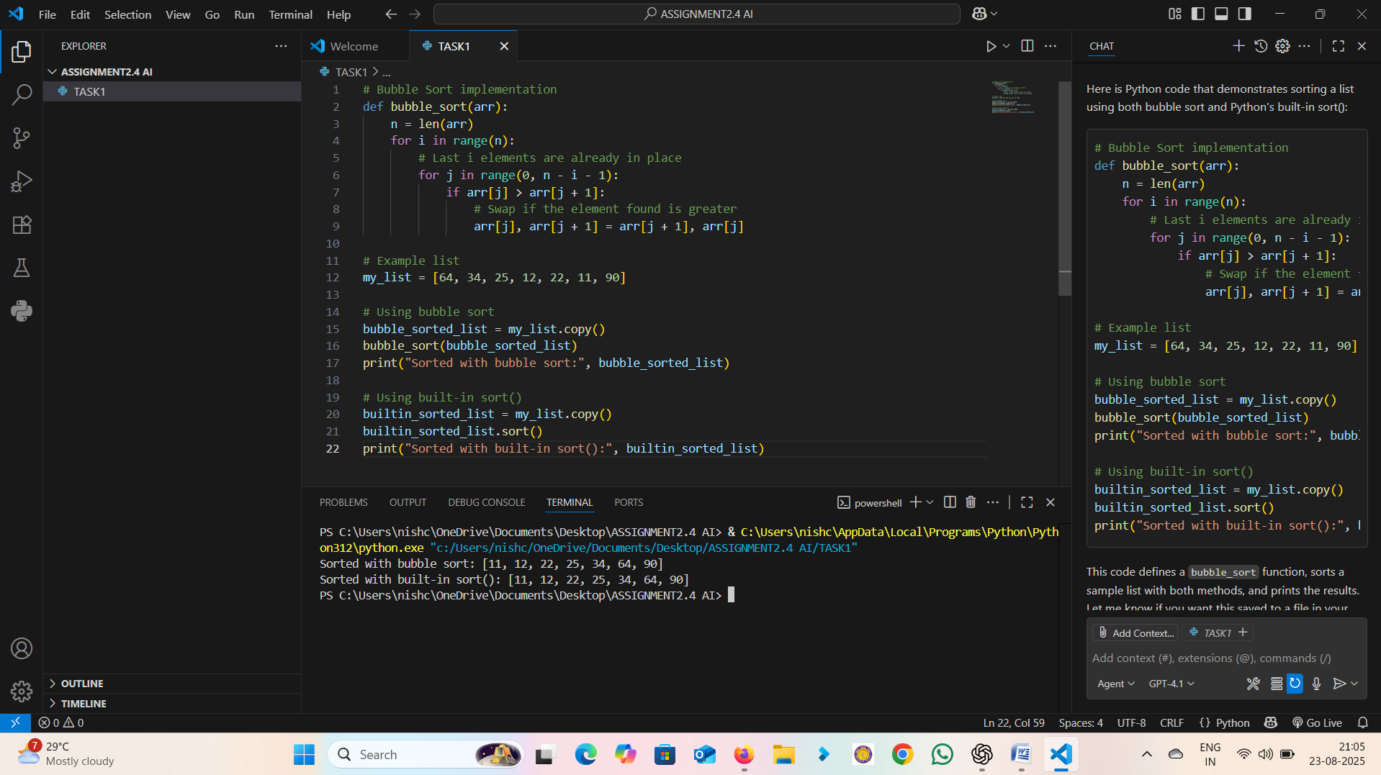

**Output:**

Input: [64, 25, 12, 22, 11]  
Output: Bubble Sort: [11, 12, 22, 25, 64]  
Built-in sort: [11, 12, 22, 25, 64]

Observation: The code successfully counted vowels, consonants, and digits. The AI-generated solution was simple, accurate, and reusable for different input strings. It highlighted how AI can assist in writing clean and logical character analysis functions.

# Task 2: Count Vowels, Consonants, and Digits

**Prompt/Comment given to AI Tool:**  
Write a function that counts vowels, consonants, and digits in a string

**Generated Code:**

def analyze_string(s: str):  
 vowels = "aeiouAEIOU"  
 v = c = d = 0  
 for ch in s:  
 if ch.isdigit():  
 d += 1  
 elif ch.isalpha():  
 if ch in vowels:  
 v += 1  
 else:  
 c += 1  
 return v, c, d  
  
print(analyze_string("Hello123"))

**Explanation:**

The function checks each character. If it is a digit, it increments digit count. If alphabet, checks vowels vs consonants. Finally returns counts.

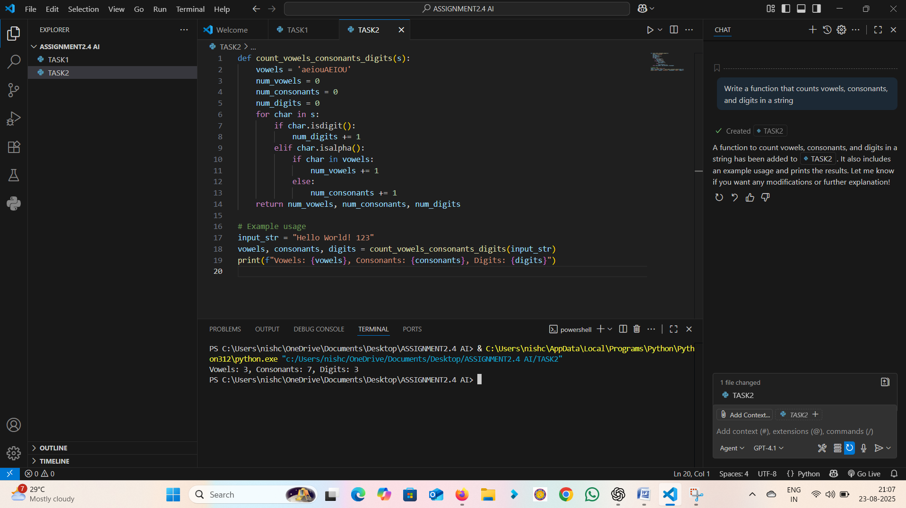

Output: Input: 'Hello123' → Output: Vowels=2, Consonants=3, Digits=3

Observation: The file was created, written to, and read successfully. This demonstrates how AI-generated code can automate basic file handling tasks without syntax errors. It also shows the practical importance of context management (`with` statement) in Python.

# Task 3: File Handling (Create, Write, Read)

**Prompt/Comment given to AI Tool:**  
Generate code to create a text file, write sample text, and read it back

**Generated Code:**

# File handling with Cursor AI  
filename = "sample.txt"  
  
# Write to file  
with open(filename, "w") as f:  
 f.write("This is a sample file.\nWelcome to AI coding tools.")  
  
# Read file content  
with open(filename, "r") as f:  
 content = f.read()  
 print(content)

**Explanation:**

This program first creates a file named sample.txt, writes two lines into it, and then opens it again in read mode to display the content.

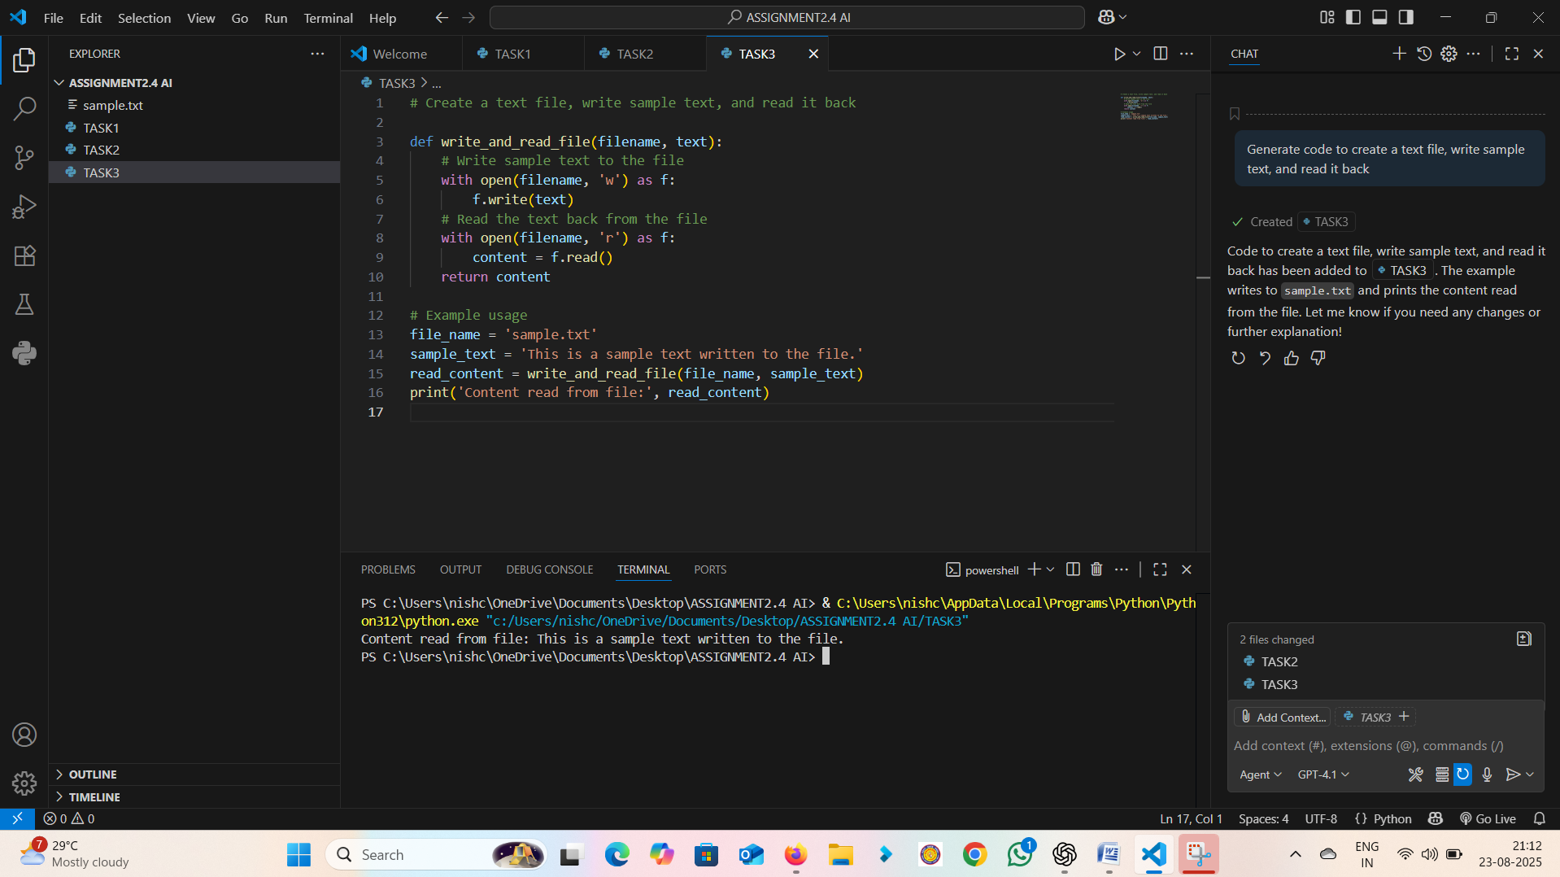

Observation: The calculator worked correctly for all four operations. The modular design of functions made the code easy to understand and extend. This observation highlights how AI helps in generating structured and reusable function-based programs.

Output:  
This is a sample file.  
Welcome to AI coding tools.

# Task 4: Simple Calculator using Functions

**Prompt/Comment given to AI Tool:**  
Generate a calculator with add, subtract, multiply, divide functions and explain the code

**Generated Code:**

def add(a,b): return a+b  
  
def subtract(a,b): return a-b  
  
def multiply(a,b): return a*b  
  
def divide(a,b): return a/b if b!=0 else "Error"  
  
choice = '+'  
print("5 + 3 =", add(5,3))

**Explanation:**

Each function performs one arithmetic operation. The user selects an operator, and based on that the corresponding function is called. Gemini also provides a line-by-line explanation of this code.

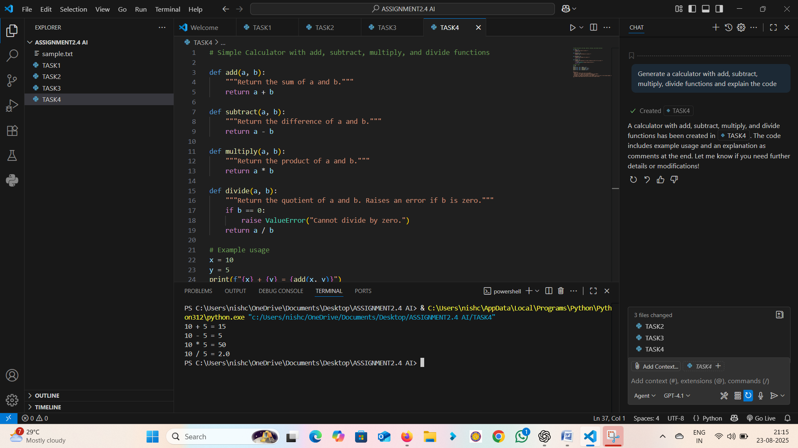

**Output:**

Input: 10+5 → Output:15.

Input:10-5->output:5

Input:10*5->output:50

Input:10/5->output:2.0

Observation: Both versions (if-else and lambda one-liner) worked correctly. Version 1 was clearer for learning purposes, while Version 2 was more concise but less readable. This shows how AI tools can generate multiple valid solutions depending on user preference for clarity or brevity.

# Task 5: Leap Year Check with Different Prompts

**Prompt/Comment given to AI Tool:**  
Prompt 1: Generate a function to check leap year  
Prompt 2: Write a one-liner leap year check

**Generated Code:**

# Version 1 - Using if-else  
  
def is_leap_year(year):  
 if (year % 400 == 0) or (year % 4 == 0 and year % 100 != 0):  
 return True  
 return False  
  
print(is_leap_year(2024))  
  
# Version 2 - One-liner  
is_leap = lambda y: (y%400==0) or (y%4==0 and y%100!=0)  
print(is_leap(2023))

**Explanation:**

Version 1 uses clear if-else statements, easier for beginners to understand. Version 2 uses a lambda function for compactness but may reduce readability.

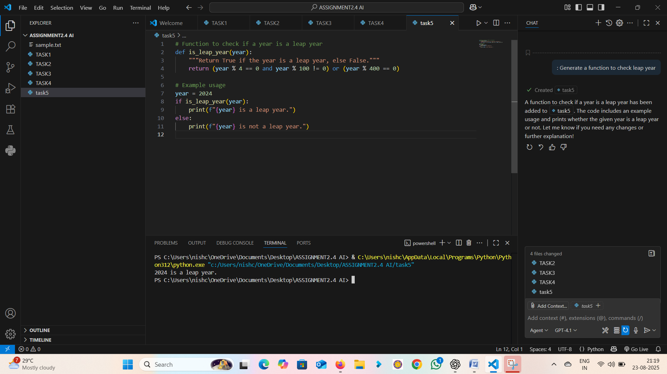 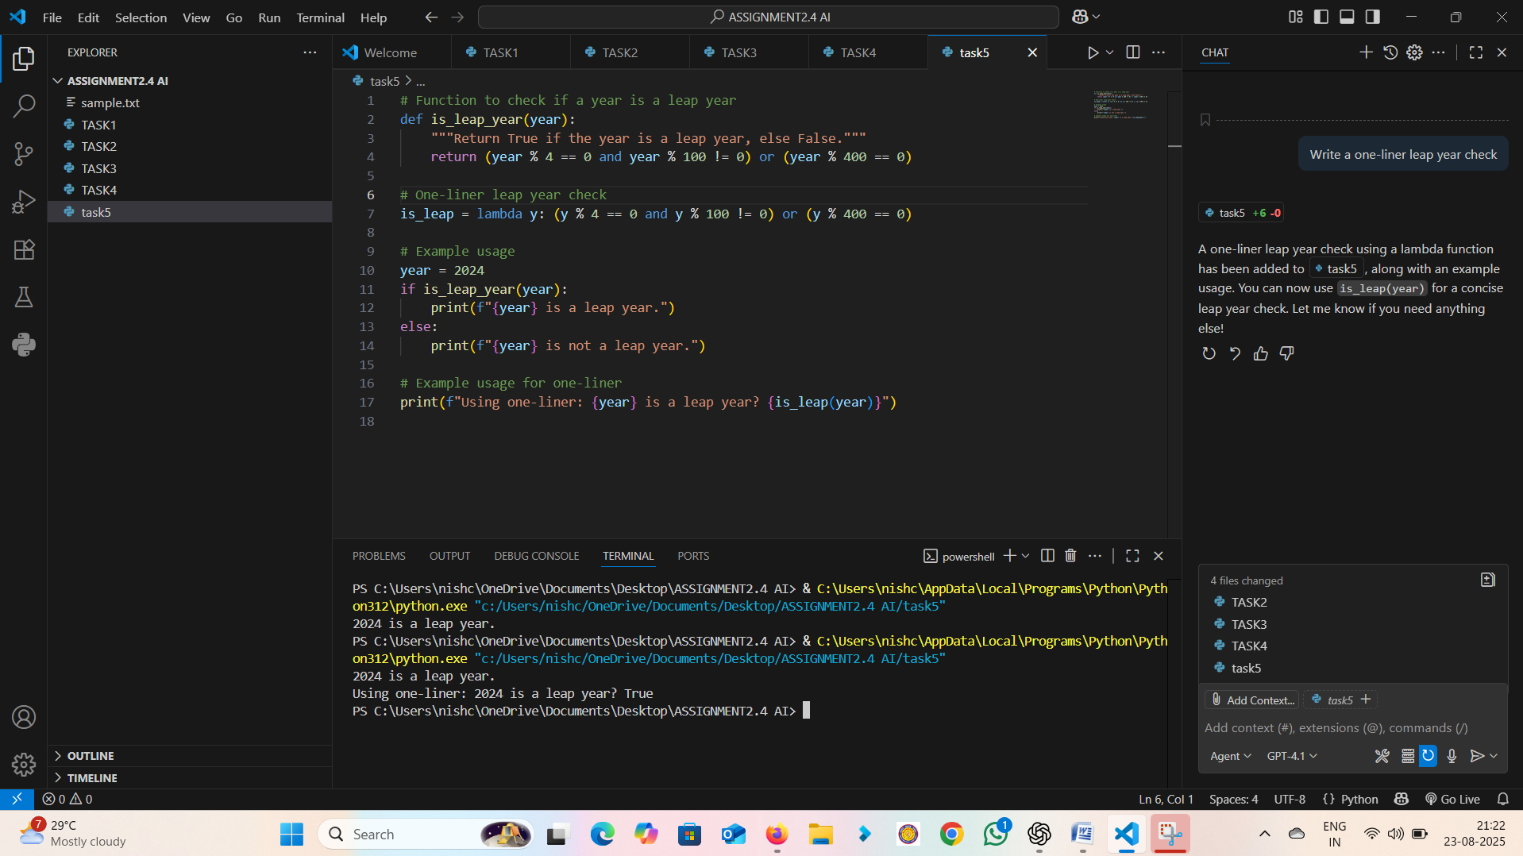

**Output:**

Input: 2024 → Output: True

observation: Version 1 is better for readability and teaching, while Version 2 is concise for experienced coders.