**Building Chatbot with IBM Cloud Watson Assistant**

**Step1**: login to IBM cloud and go to Watson assistant then create a chatbot by providing

1. Region
2. Instance
3. Plan(default)

Then Click the launch tool as shown as below

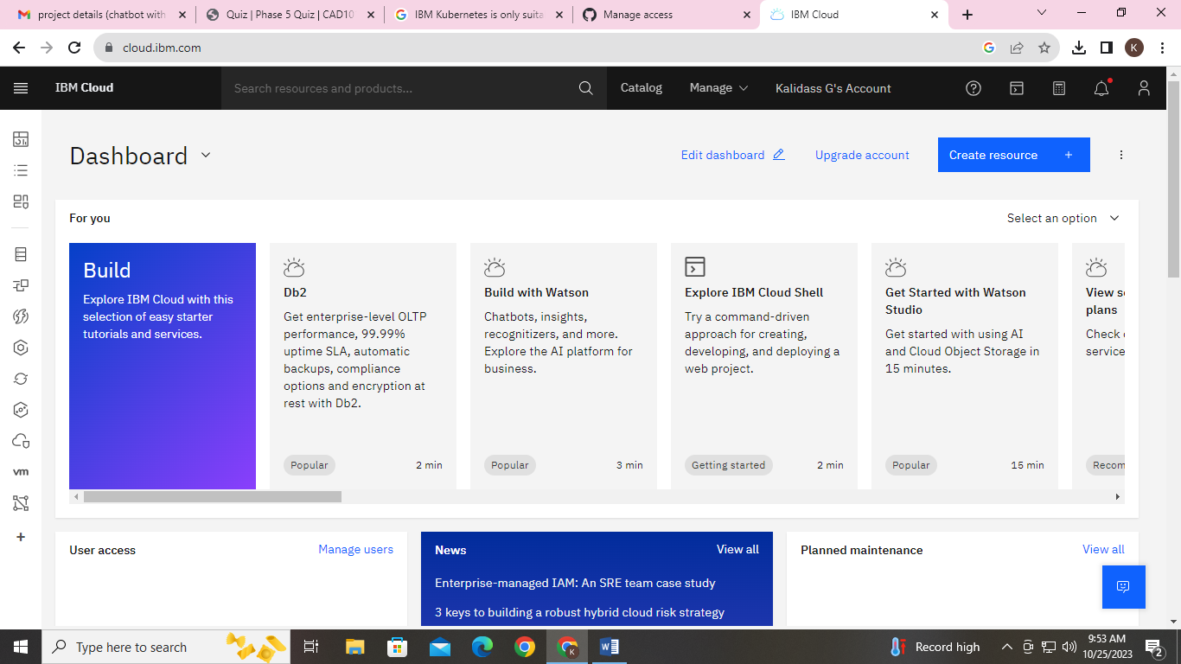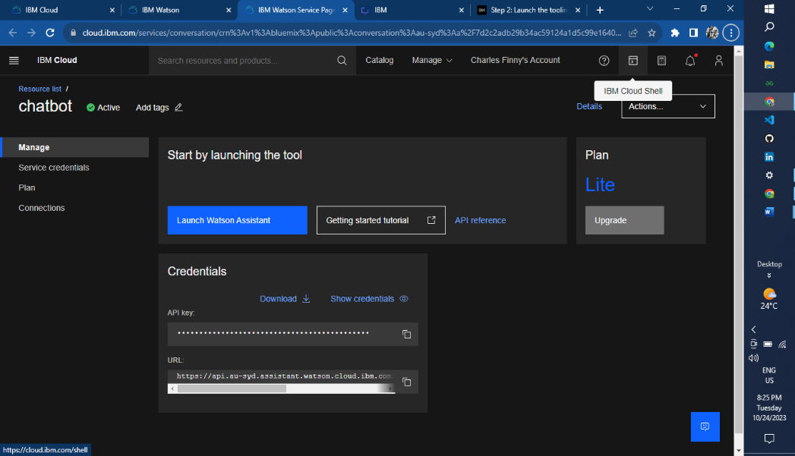

**Persona Design And Conversational Flow**

**Persona Design**

**Name:** SupportBot

**Description:**

* + - * SupportBot is a friendly and efficient virtual assistant dedicated to providing exceptional customer service.
      * It's designed to assist customers with their inquiries, concerns, and needs.
      * SupportBot is always polite, professional, and responsive, aiming to make every interaction a positive experience for customers.

**Appearance:**

* + - * SupportBot is represented as a sleek and modern chat interface with the company's branding.

**Communication Style:**

* + - * SupportBot communicates in a clear and concise manner.
      * It uses proper grammar and avoids overly technical language unless necessary.
      * The chatbot is adaptable and can shift its tone to match the customer's mood, whether they're formal, casual, or in need of reassurance.

**Conversational Flow**

**Response Configuration**

**Intents and Entities**

1. Greeting
2. Frequently asked questions
3. Password reset
4. Forgot password
5. Two-step verification
6. Add e-mail id
7. How to change profile settings
8. Account visibility
9. How to create a channel
10. How to edit connective peoples
11. Creating a new account
12. Deleting an account

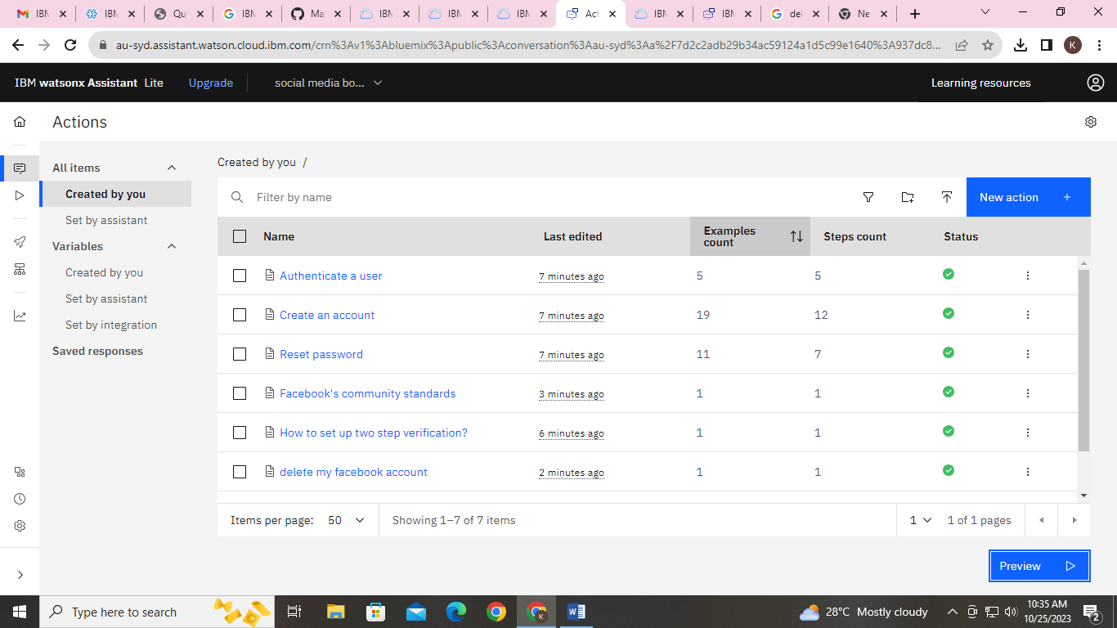

**Response code for a chatbot**

The code is **no need** to be used in Simple Watson Assistant Chatbot the process will done by the actions itself.

For our easy identification the JSON code as follows

{

"greeting": "Hello! How can I help you today?",

"common_queries": [

{

"query": "What are the supported file formats for profile pictures?",

"answer": "You can upload profile pictures in formats like JPEG, PNG, and GIF ."

},

{

“query”:”How to set up two step verification?”,

“answer”: tap Settings > Scroll down and tap Password and security> tap Use two-factor authentication. [You may be asked to enter your password at this point.].

},

{

"query": "How can I change my password?",

"answer": "To change your password, go to Settings > Security and Login > Change Password."

},

{

"query": "How do I recover a hacked account?",

"answer": "If your account is hacked, visit the Help Center for steps on account recovery."

},

{

"query": "How can I report a post or user?",

"answer": "To report a post or user, click on the three dots (...) on the post and select 'Find support or report profile.' Follow the prompts to report the issue."

},

{

"query": "How do I enable two-factor authentication?",

"answer": "You can enable two-factor authentication by going to Settings > Security and Login > Use two-factor authentication."

},

{

"query": "How can I create a Facebook Page?",

"answer": "To create a Page, click on the '+' sign at the top right of your Facebook account and select 'Page.' Follow the steps to set up your Page."

},

{

"query": "What are Facebook's community standards?",

"answer": "Facebook's community standards outline the rules and guidelines for using the platform. You can find them in the Help Center."

}

{

“query”:”how to delete my facebook account ?”,

“answer”:” tap Settings & privacy, then tap Settings > Personal and account information> Account ownership and control > Deactivation and deletion.”

}

],

"fallback": "I'm sorry, I couldn't understand your query. Please feel free to ask again or type 'help' for more options."

}

Like as the response configuration of the chatbot build with the JSON code.

**Greeting message**

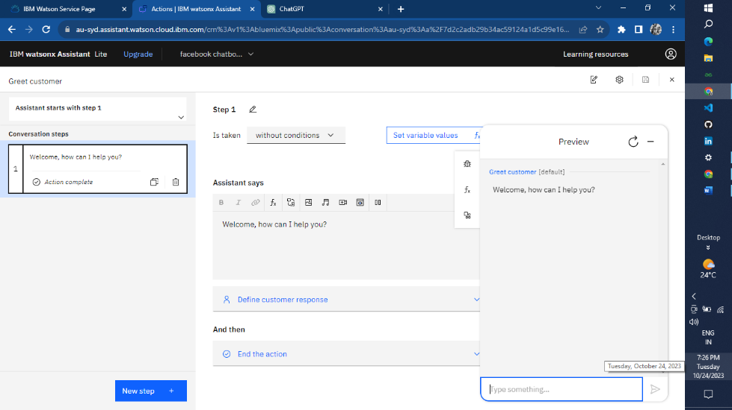

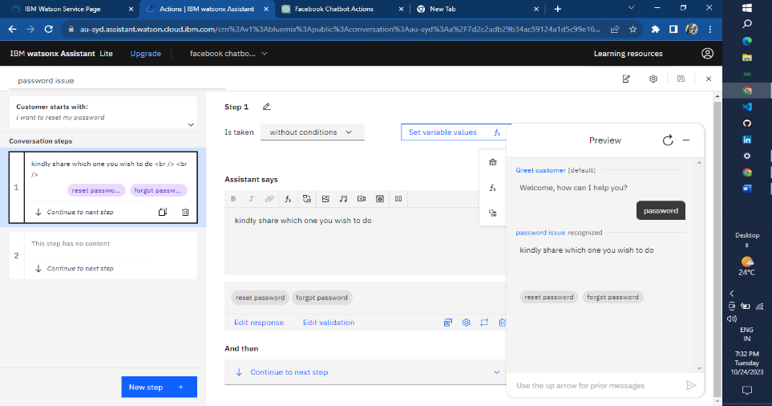

**Password Reset**

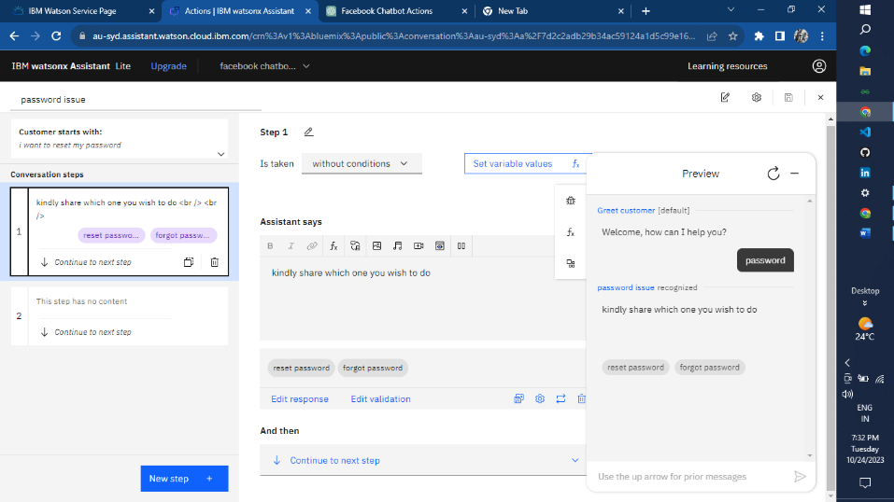

**Creating Facebook account**

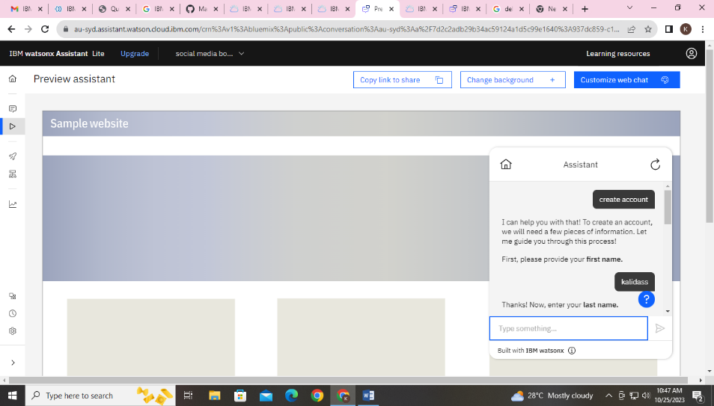

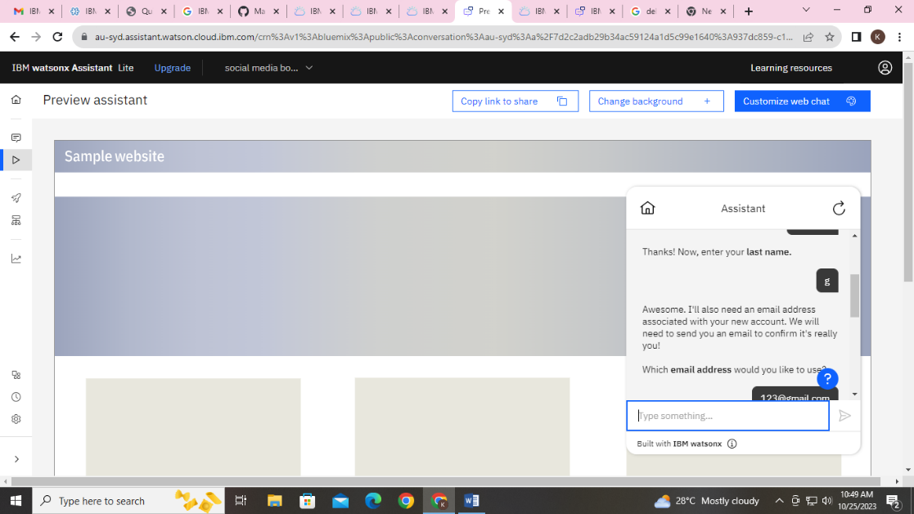

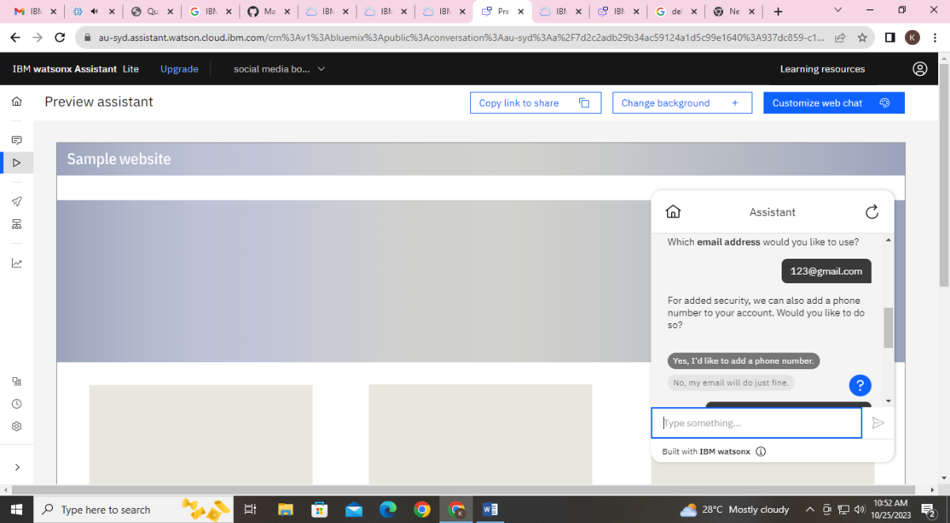

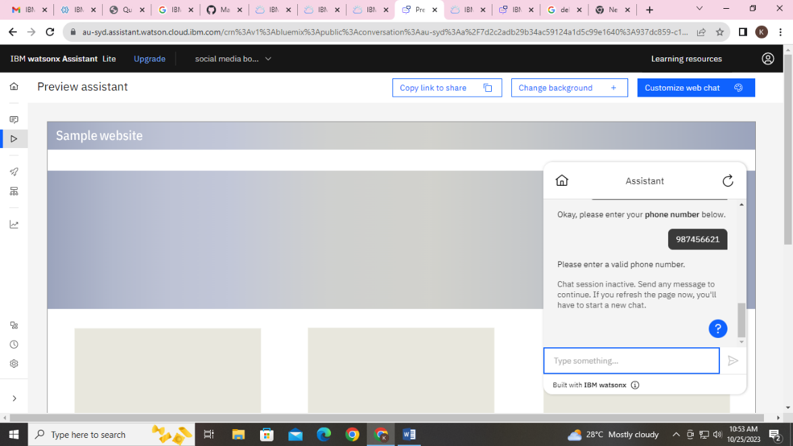

**Frequently asked questions**

