***CONTACT MANAGER***

***SYNOPSIS***

***Group 4***

By : Deverakonda Uday Kumar - 120101019

Himanshu Goyal - 120101029

Radhika Patodiya - 120101054

Raja Kumar - 120101055

Sankalp Bihani - 120101088

# 

# ***Introduction***

The contact manager is a software that will enable users to easily and reliably manage his/her contacts. It will allow user to store, retrieve and update contact information, which is stored in custom fields. It will have contact-centric databases that provide a fully integrated tracking of all information and communication activities linked to contacts. The contact manager software will be much easier to use and diverse in facilities than usual paper based contact listing. It will support multiple users to manage their contacts in a secure manner

.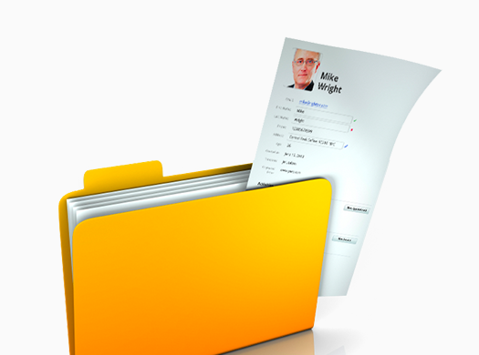

# 

# *Scope of the document*

This software is designed targeting the general users. It will be useful for all the people looking to easily and efficiently manage all their contacts and all related information like address, date of births etc.. The software will also provide the user with calendar option to set reminders/alarms for the described events.

# *Objective*

The objective of this project is to create an interactive software to efficiently and reliably manage contacts and related information for multiple users.

# *Tools/Platform*

The software will be developed in Visual C++ using Visual Studio 2010 environment. Targeted Operating system is Windows 7/8.

# *Input and Output*

Since the software is targeted to be interactive and user-friendly most input will involve mouse and keyboard while output will be screen generated. (Other data required for smooth functioning of the software will not be available directly to the user)

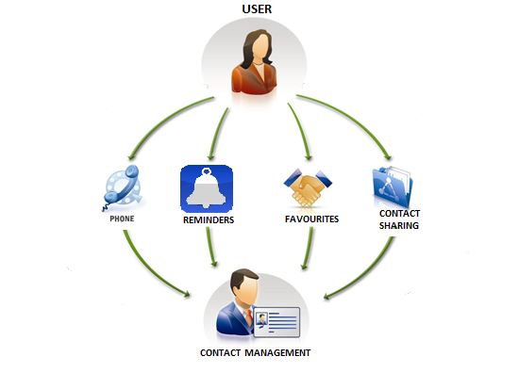

# *Work Flow*

The software will support the features enumerated below:

## Register

* + Every new user has to register himself to create his own account. The new user enters some basic information like username, date of birth, password, etc. to create his account.

## Login

* + User logs in to view and manage his contacts i.e. to gain access to his account.

## Account Recovery

* + In case user forgets his password, he will be able to reset it after answering a series of questions and verification of his identity. Since storing password in raw format is insecure, user will never be able to retrieve his old password.

## Basic Contact Management

* + After logging in, the user will be able to access his data. He can update, delete or add a new record.
  + Customisation options like forming groups, custom fields, will be provided to user for a better user experience. User may specify his/her relation with the contact.

## Reminders, Alerts and Notifications

* + The user can also set up one time or recurring alerts or reminders as required. Reminders/alerts can be set for meetings, birthdays, anniversaries, etc. as required using the calendar feature for ease of access.
  + The software will also allow the user to show some notifications for past reminders or some secondary events.
  + This will also allow the user to look-up for the upcoming events.

## Data Recovery

* + The user can recover data that is deleted by mistake. The software will make backups for this purpose. However after a stipulated amount of time data will be deleted permanently.
  + User can choose to not create any backups to save disk space.

## Importing and Exporting Contacts

* + The user may export contact to a software specific format (our custom secure format) to transfer his/her contacts to another machine.
  + The user may also choose to create a generic file (like csv) from the data for some other purposes.

## Customising database

* + The user will be able to modify some trivial database settings like character encoding, backup frequency, maximum size, etc. Advanced features and root access will not be available to user for security reasons.

## Contact Sharing

* + The user will have the option to share his contacts with other users using the same software. A different section for shared contacts will be provided to the users in which the publicly/privately shared contacts will be displayed.
  + User may set option to allow editing of shared contact (public ownership).

## Favourite

* + The user will have an option to maintain the most important and frequently used contacts for easy and quick access of information.
  + Software may analyze user history and automatically add contacts depending on the frequency of look-ups.

# *USES*

This contact management software is helpful for all the categories of users, proving beneficial for both corporate and domestic uses. This is an efficient and user friendly method to store and manage one’s contacts and other relevant information. With the various features like favourites, reminders and multiple user-login, this software can prove to be an effective way to organise and maintain the contact-database.

