# Timesheetperson_nameDocumentation

Timesheetperson_name Timesheet organisers top10

Timesheetperson_name title categories scatter

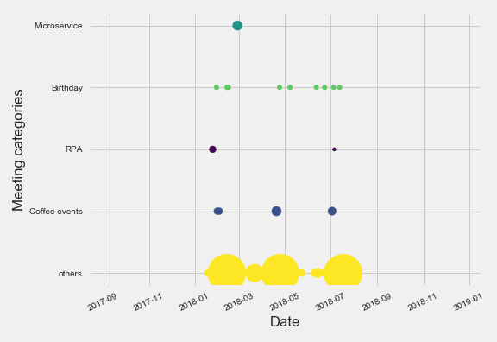

Timesheetperson_name top10 maximum date

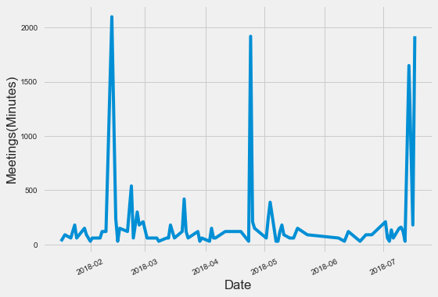

# inboxperson_nameDocumentation

Timesheetperson_name Timesheet organisers top10

Timesheetperson_name title categories scatter



Timesheetperson_name top10 maximum date



inboxperson_namesubject categories scatter

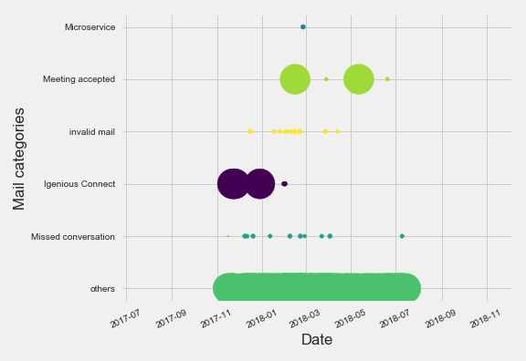

inboxperson_nametop10 daywise mails

