Visualizing the popularity of the keywords by using no of google search per keyword

No of Keywords to be compared 1

visualizing the popularity

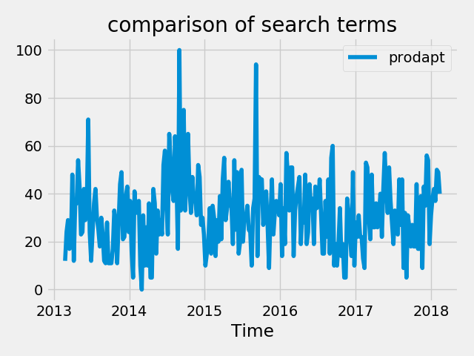

visualizing the popularity by region

