# inboxDocumentation

inboxsubject categories scatter

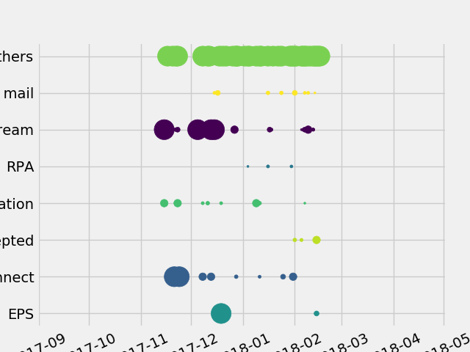

inboxtop10 daywise mails

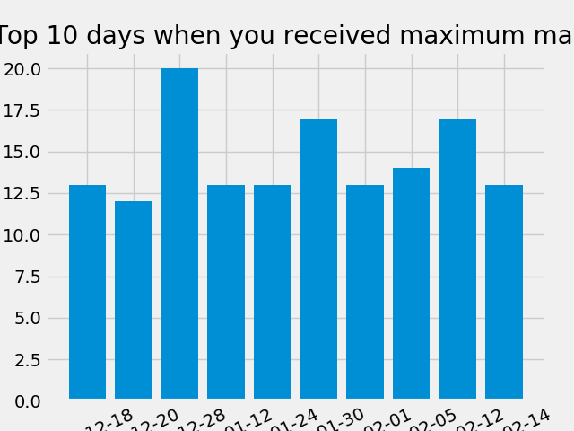

inboxtop10 senders

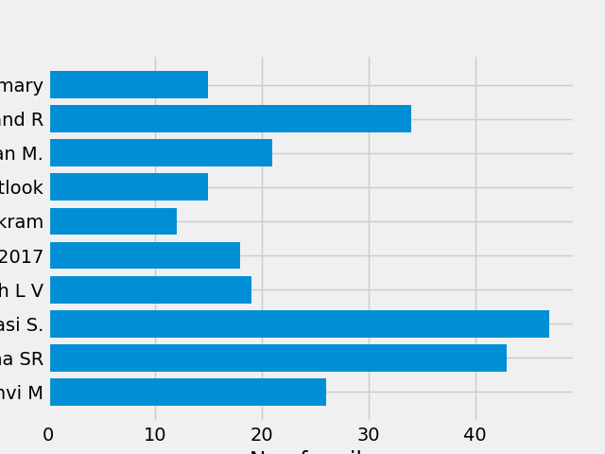

# sentboxDocumentation

inboxsubject categories scatter



inboxtop10 daywise mails



inboxtop10 senders



sentboxsubject categories scatter

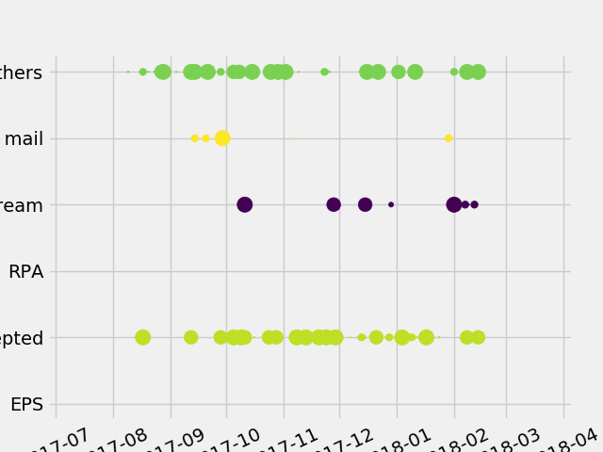

sentboxtop10 daywise mails

