**JIRA Installation and Implementation**

**Jira Installation:- UBUNTU 14.04**

Prerequisites:-- 1.JAVA

2.LAMP SERVER

3.RAM Requirements min 4 GB require(as per my analysis)

Steps to install java&apache&mysql:-

1 sudo apt-get update

2 sudo apt-get install oracle-java8-installer –here we need to accept the oracle license---select **yes**

3 sudo apt-get install oracle-java8-set-default

4.java –version ###to check the java version details

5.Sudo apt-get install apache2

6.sudo apt-get install mysql-server-5.6 ### to install mysql database

configuring database to create jira admin user and jira database

7. sudo mysql –u root –p

Here we need to change bind address in my.cnf file

Go to **/etc/mysql**—and find ## bind address## line in **my.cnf** file 127.0.0.1 to 0.0.0.0

And then restart mysql server once

**Sudo service mysql restart**

8. CREATE DATABASE jiradb CHARACTER SET utf8 COLLATE utf8_bin;

9. GRANT SELECT,INSERT,UPDATE,DELETE,CREATE,DROP,ALTER,INDEX on jiradb.* TO 'jirauser'@'%' IDENTIFIED BY 'password';

**10**.FLUSH PRIVILEGES;

11.exit;

Validate that the database was setup correctly by logging back in:

mysql \--user=jirauser \--password=password \--database=jiradb

Installation for JIRA:--

1.wget <http://www.atlassian.com/software/jira/downloads/binary/atlassian-jira-software-7.3.0-x64.bin>

2. sudo chmod -R 700 atlassian-jira-6.1.5-x64.bin

3. sudo ./atlassian-jira-software-7.3.0-x64.bin

Follow the instructions while installing jira as a service.

And now we need to download the JDBC connector to connect mysql database to jiradb

To download…

1.wget http://dev.mysql.com/get/Downloads/Connector-J/mysql-connector-java-5.1.40.tar.gz

2. tar -zxvf mysql-connector-java-5.1.40.tar.gz

3. cd mysql-connector-java-5.1.40/

4. sudo cp -a mysql-connector-java-5.1.40-bin.jar /opt/atlassian/jira/lib/

5. cd /opt/atlassian/jira/bin/

6.sudo ./stop-jira.sh

7.sudo ./start-jira.sh

<http://Ipaddress:8080>

here we need to configure the database to jira

After that jira dashboard looks like below …

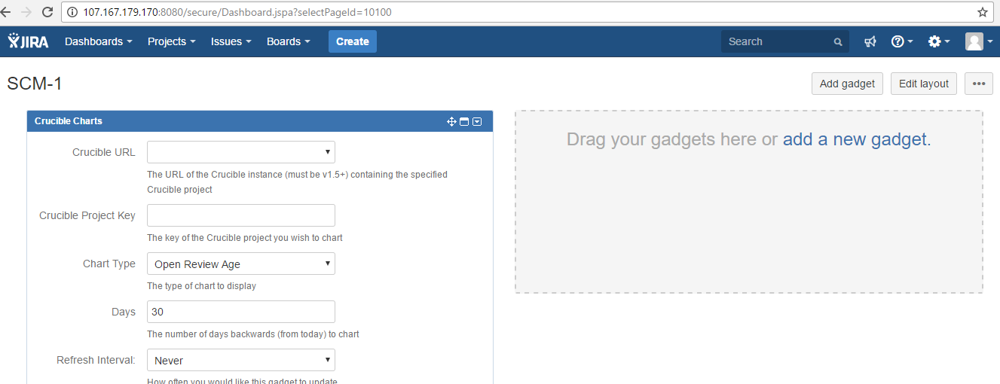

How to create project?

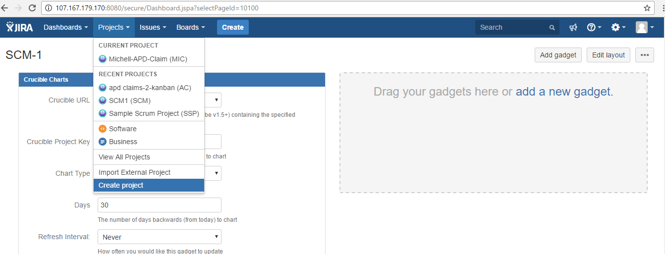

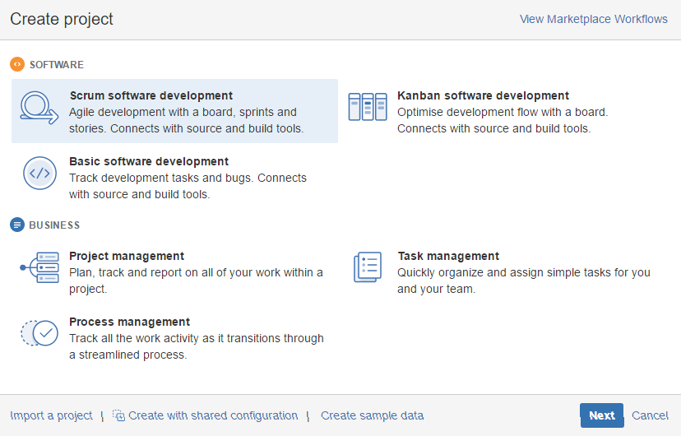

Select one workflow as per your Requirement …

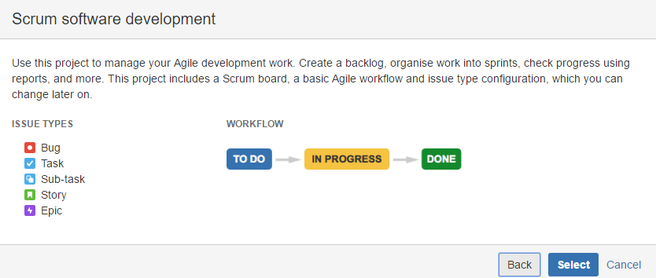

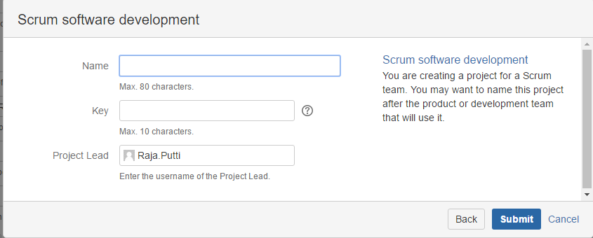

Here we need to give project name and then submit…

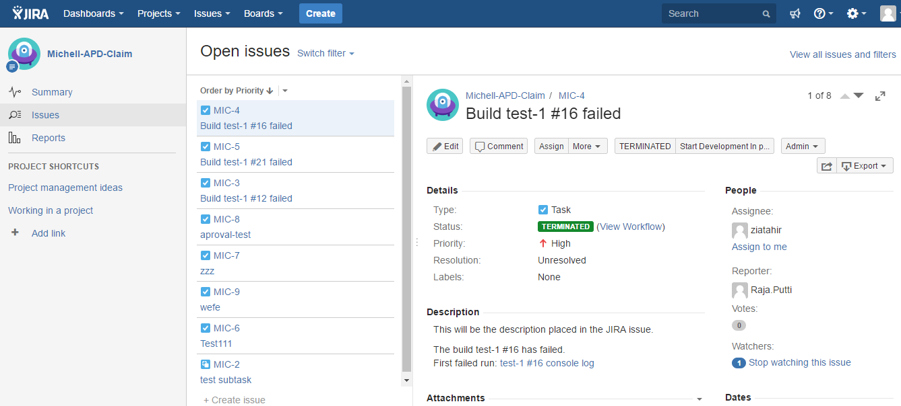

How to create An issues?

Select CREATE option At top of jira task bar

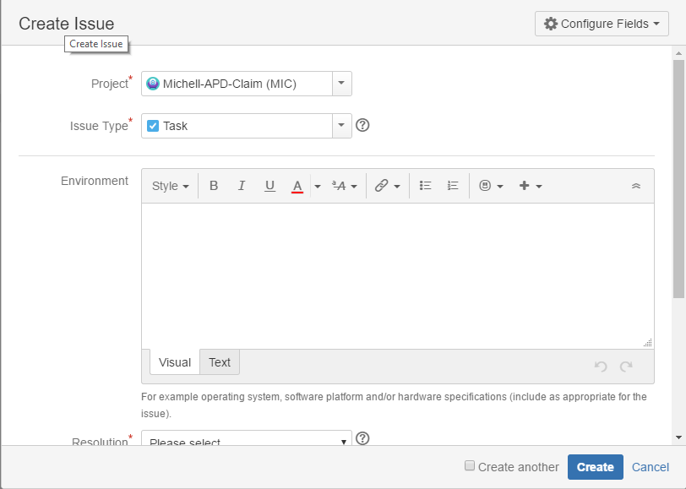

How to create users and groups ?

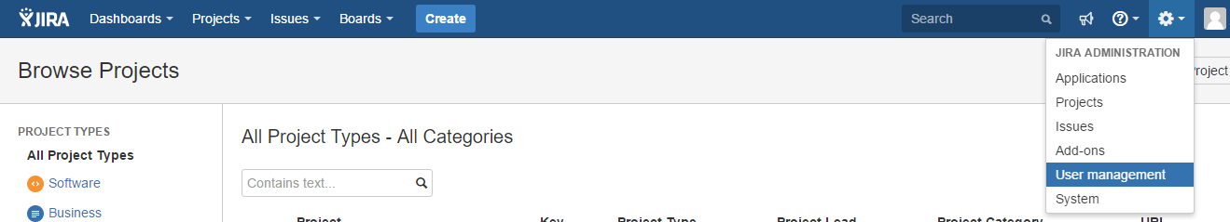

Go to **create user** option

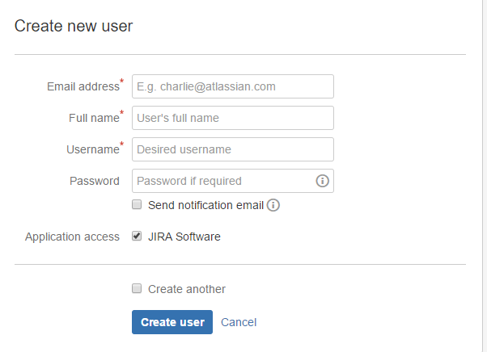

Here we can create Users and Groups …

How to configure Jira with Jenkins?

Go to applications---

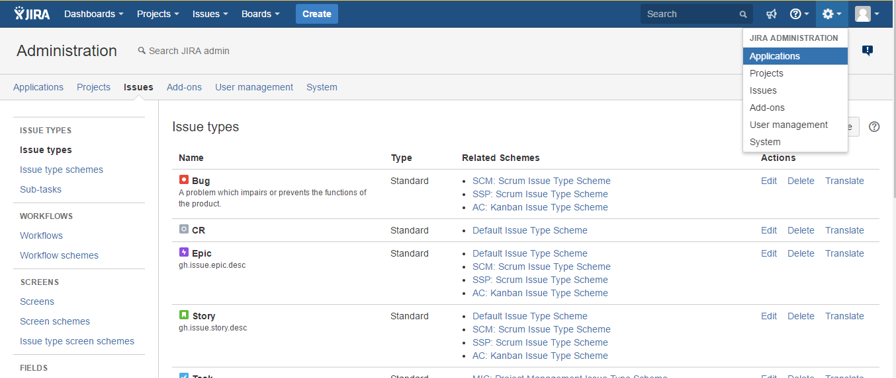

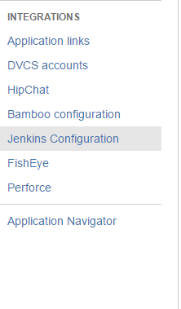

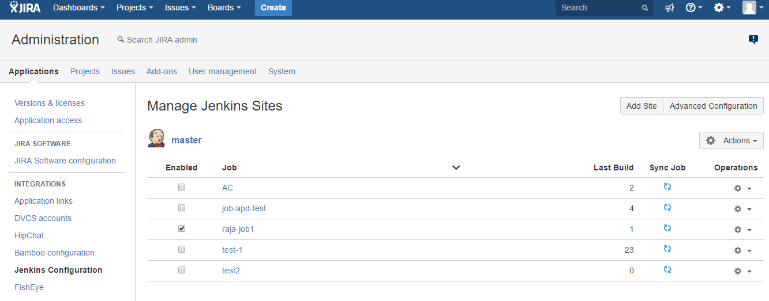

Here we need to configure jira with Jenkins for seeing no.of buildsin for job…….

Configure jira in Jenkins…----to see build status and we can make automatic **build failure** issues in jira….for this we need add **jira plugin** in jenkins---

How to create custom workflows?

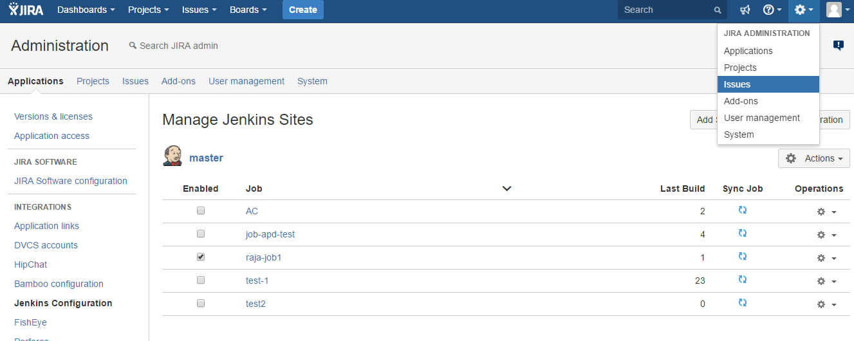

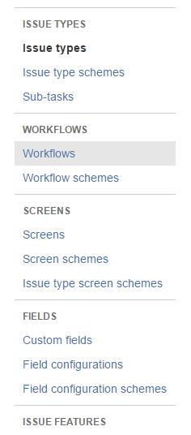

Go to Add workflow option at left corner…

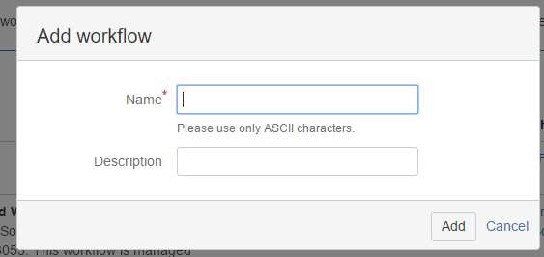



Here we can draw our custom workflow (Transition and status)as per your reqirement….