Python –pip-boto3 installation and connecting to aws instances

Python –pip-boto3 installation

<https://github.com/BurntSushi/nfldb/wiki/Python-&-pip-Windows-installation>

After that we have to download secret keys from AWS account

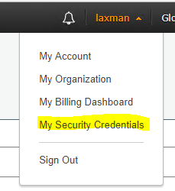

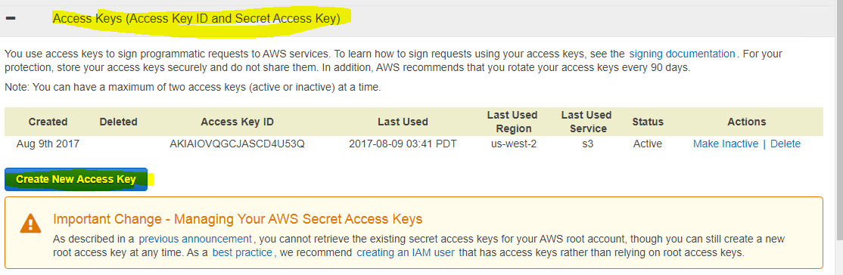

Downloaded files

Create Directory .AWS at your home directory

copy downloaded secret keys into .aws folder

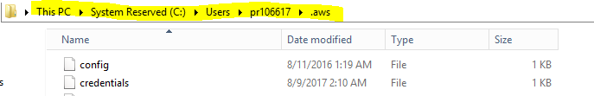

**Config** :-- this file contains region and output elements



So,if you want to connect different region instead of **us-west-2** we have to change the region name .

By default it’s **us-west-2**

**Credentials:--** This file contains secret key and access id

