Title: Reimagining Uber SOS Button: Empowering Women's Safety

**Purpose:**

This project was triggered by the growing concern over women’s safety during Uber rides, particularly in late-night or remote settings where delays in customer care responses and complaints about the SOS button being unhelpful in distress have raised alarms. Women riders need real, fast, and human-centred assistance to feel secure and valued in moments of distress. The proposed solution is a smart SOS button for women in distress in Uber’s app, connecting riders to nearby Guardian Drivers—trusted, highly rated drivers selected based on customer feedback—who provide rapid intervention. This feature aims to enhance safety, rebuild trust in Uber’s drivers and brand, and reduce incident escalations.

**Background and Rationale:**

Uber has consistently faced challenges related to rider safety, with incidents of harassment and assault, particularly involving women, raising significant public concern and media attention. These issues are not isolated: Uber’s 2021 Safety Report documented thousands of such incidents, highlighting a systemic gap in real-time rider protection and accountability. Addressing these concerns is critical to maintaining user trust, ensuring platform credibility, and reinforcing Uber’s brand promise of safe mobility. The proposed SOS feature, powered by a trusted network of “Guardian Drivers,” provides a rapid-response, data-driven mechanism that leverages Uber’s existing technology and high-rated driver base to offer timely intervention, support, and deterrence in distress scenarios.

**Problem Statement:**

Women riders on Uber often lack real-time safety support during distress or harassment. The current SOS system is reactive and slow, offering limited assurance when immediate help is needed. This gap leaves riders vulnerable and erodes trust. There's a clear opportunity to build a proactive, rider-centric feature that enables rapid intervention and restores confidence through trusted support.

**Data and ML Insights**

Conducted a *Latent Dirichlet Allocation (LDA)* topic modelling analysis on textual feedback collected from Uber riders who reported incidents or triggered the SOS feature during rides, sourced from platforms like Twitter (X). The model automatically grouped feedback into latent topics based on patterns in word co-occurrence and distribution across user-generated documents, identifying key concern areas: safety issues, customer support delays, and refund-related dissatisfaction.

**Key Themes Identified:**  
Out of hundred customer complaints the three primary themes identified:

* **Customer Support** (59 complaints)
* **Safety Issues** (42 complaints)
* **Refund Issues** (10 complaints)  
  Safety-related complaints formed a substantial portion (≈37%) of all SOS feedback.

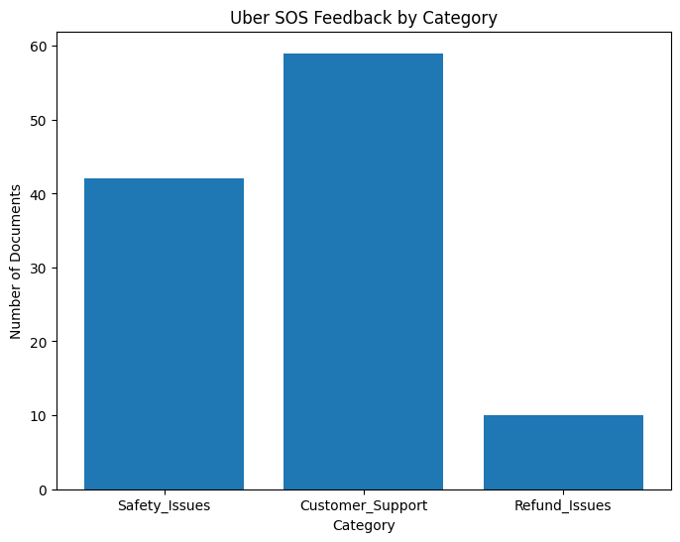

Upon analysis, it was found that the **"Safety Issues"** theme contains a majority of complaints from women, which is deeply concerning. When viewed from the perspective of risk to women passengers—especially in situations where their emergency calls go unanswered or receive delayed responses—it highlights a critical gap in the current SOS system. This raises serious questions about the **reliability and effectiveness of Uber’s SOS feature**, indicating that riders may not have a dependable mechanism to rely on during emergencies.

**Market Analysis:**

|  |  |  |  |  |
| --- | --- | --- | --- | --- |
| **Criteria** | **Uber** | **Rapido** | **Ola** | **Namma Yatri** |
| **Women-Specific Safety Features** | • SOS button connects to emergency contacts or 911 in some regions.  • Real-time trip sharing with trusted contacts.  • Safety toolkit includes ride check alerts for unusual stops.  • Weakness: Limited proactive intervention during rides. | • SOS button with post-ride confirmation calls for women riders.  • Trip sharing and emergency contact integration.  • Women driver onboarding initiative (12% of Delhi fleet).  • Weakness: Basic feature set, no in-ride escalation. | • SOS button with live location sharing and guardian contact setup.  • Emergency contact alerts.  • Weakness: Reactive SOS, no in-ride alternate driver option. | • SOS button with local police integration in Bangalore.  • Basic trip sharing and emergency contact features.  • Weakness: No advanced safety tech. |
| **Customer Care Model** | • In-app ticket system with chatbot and email support.  • Dedicated safety team, but escalation often requires follow-up.  • Weakness: Slow response, no dedicated human support for in-ride issues. | • Direct human callback for SOS complaints prioritizing women riders.  • In-app chat support with regional teams.  • Weakness: Limited scalability for non-SOS queries, inconsistent across cities. | • In-app support with Ola Care (chat and call).  • Regional care centres for escalations.  • Weakness: Inconsistent response times, especially during peak hours. | • Localized help centres with offline escalation via driver unions.  • Email-based support.  • Weakness: Slow, lacks real-time support. |
| **Response Time & Process** | • Often delayed; no real-time in-ride follow-up.  • Post-ride escalation with driver deactivation for severe complaints.  • Weakness: Delays undermine trust in emergencies. | • Fast response via call if flagged.  • Proactive check-in.  • Weakness: Inconsistent outside metro cities, no in-ride intervention. | • Delayed and inconsistent during ride.  • Weakness: No proactive in-ride support. | • Varies by city; generally inconsistent.  • Community-based escalation, often offline.  • Weakness: Unreliable for urgent needs. |
| **Trust & Accountability Mechanisms** | • Rigorous driver background checks and annual re-verification.  • Rider feedback affects driver status.  • User report system with human review.  • Safety toolkit promotes transparency.  • Weakness: Limited driver accountability during rides. | • Driver history and ratings visible to riders.  • Weakness: Trust eroded by inconsistent safety responses. | • Guardian contact system and driver removal for poor ratings.  • Weakness: Limited algorithmic oversight for real-time issues. | • Local driver vetting via unions.  • Emphasizes community trust.  • Weakness: Minimal centralized accountability, driver quality varies. |
| **Gaps** | • SOS button lacks proactive escalation or alternate driver dispatch.  • No personalized safety follow-up.  • App-dependent AI-generated responses.  • Limited visibility into SOS outcomes. | • Post-ride confirmation only, no real-time intervention.  • No mid-trip reroutes or intervention feature.  • No audio/location capture during distress.  • Basic driver vetting. | • Guardian contact passive; no real-time intervention.  • SOS delays action until after reporting.  • No intelligent risk detection.  • No rider-controlled escalation. | • Minimal gender-specific focus.  • SOS tied only to local law enforcement.  • No tech-enabled safety system.  • Inconsistent UX and safety standards. |

**User Personas**

**1: Sarah Mehta, 28 – Urban Professional (Rider)**

**Demographics**: Female, 28, lives in a 2BHK in Koramangala, Bangalore, works as a product marketing associate at a fintech startup.

**Background**: Sarah moved to Bangalore from Pune three years ago for her job. She works late, often until 9 PM, and relies on Uber for her 12-km commute home to avoid crowded buses. She takes 4–6 Uber rides weekly, mostly at night, and occasionally books cabs for weekend outings with friends. She’s single, lives with a roommate, and values her independence but is hyper-aware of safety risks in the city.

**Goals & Motivations**:

* Get home safely without the constant anxiety of “what if” scenarios.
* Feel confident that Uber has her back if a driver makes her uncomfortable.
* Trust the app enough to focus on her music or work emails during rides, not on vigilance.

**Pain Points**:

* Gets uneasy when drivers take longer routes, like via poorly lit roads, but hesitates to confront them.
* Finds the current SOS button unhelpful—clicking it feels like shouting into a void with no immediate response.
* Avoids reporting minor harassment (e.g., inappropriate comments) due to fear of retaliation or a lengthy complaint process.

**Behaviour & Habits**:

* Always shares her ride link with her roommate or best friend via WhatsApp before getting in.
* Prefers Uber Go for affordability but checks driver ratings obsessively, rejecting rides below 4.7 stars.
* Sits diagonally behind the driver, keeps her phone ready, and avoids small talk to stay alert.

**Quote**: “I just want to hop in an Uber and feel like I’m in safe hands, not like I’m rolling the dice every night.”

**Needs from Product**:

* Real-time confirmation that her SOS alert is being acted upon (e.g., a trusted driver is dispatched).
* Ability to switch to a vetted Guardian Driver mid-ride if she feels unsafe, without confrontation.
* A secure, accessible log of ride events (e.g., route, driver behaviour) for peace of mind or future reference.

**User Persona 2: Amit Verma, 35 – Guardian Driver (Trusted Uber Partner)**

**Demographics**: Male, 35, lives with his family in a modest flat in Dwarka, Delhi NCR, full-time Uber driver with a 4.9-star rating.

**Background**: Amit has driven for Uber for six years, supporting his wife and two kids. A former auto-rickshaw driver, he switched to Uber for better earnings and flexibility. Known for his calm demeanour, he’s earned glowing reviews for professionalism, especially from female riders. Fluent in Hindi, with conversational English, he takes pride in being a reliable driver in Delhi’s chaotic traffic.

**Goals & Motivations**:

* Ensure women riders feel safe and respected, especially during late-night trips.
* Earn a Guardian Driver badge to stand out and attract more rides, boosting his income.
* Protect his livelihood by avoiding misunderstandings or false complaints that could jeopardize his rating.

**Pain Points**:

* Feels frustrated that riders don’t know his high rating or track record before the ride, leading to initial mistrust.
* Lacks clear instructions from Uber on handling SOS situations, leaving him unsure how to assist distressed riders effectively.
* Worries about rare but damaging false accusations, as Uber’s complaint process feels opaque and driver-unfriendly.

**Behaviour & Habits**:

* Accepts 90% of night rides, sticking to well-lit, patrolled routes when possible, to reassure passengers.
* Uses a dashcam he bought himself and greets riders with a polite “Good evening, ma’am/sir” to set a professional tone.
* Checks the Uber Driver app for rider feedback after every trip, anxious about maintaining his 4.9 rating.

**Quote**: “I drive with care, but I wish riders knew I’m someone they can trust from the moment they book me.”

**Needs from Product**:

* A visible Guardian Driver badge in the app to signal his trustworthiness to riders before the trip starts.
* Clear, step-by-step protocols for responding to SOS alerts, including training on de-escalation and rider support.
* A transparent system to reward his high ratings and protect him from unfair complaints, ensuring job security.

**Requirements:**

|  |  |  |  |  |
| --- | --- | --- | --- | --- |
| **ID** | **USER STORY** | **FUNCTIONAL REQUIREMENTS** | **REQUIREMENT DETAILS** | **PRIORITY** |
| REQ-1 | Sarah: I want to discreetly trigger an SOS alert within the Uber app, so I can signal an emergency without drawing attention. | Two-Tap SOS Activation | Enable a floating SOS button that activates upon two consecutive taps during an ongoing ride. | MUST HAVE |
| REQ-2 | Sarah: I want Uber to immediately assign a trusted Guardian Driver with all the information related to them, so I know that help is on the way from a verified, reliable person. | Guardian Driver Assignment | Identify the nearest Guardian Driver based on proximity and eligibility, and send their profile to the rider. | MUST HAVE |
| REQ-3 | Amit: I want a clear handover process from the original driver during an SOS event, so I can quickly and safely assist the rider. | Ride Handover Process | 1. Notify original driver to stop.2. Alert Guardian Driver of the pickup location and coordinate the rider’s transfer.3. Send the rider information about the newly assigned Guardian Driver. | MUST HAVE |
| REQ-4 | Sarah: I want to receive a quick call from Uber Safety Team after triggering SOS, so I feel supported and reassured while waiting. | Emergency Call from Uber Safety Team | Trigger a call from Uber's Safety Team to the rider within 30 seconds of SOS activation. | MUST HAVE |
| REQ-5 | Sarah: I want to chat with the Guardian Driver or Safety Team directly after SOS, so I can communicate any updates or concerns. | In-App Chat with Guardian or Support | Enable real-time secure chat between the rider and Guardian Driver or Safety Team post-SOS activation. | MUST HAVE |
| REQ-6 | UBER: I want to notify the original driver of the SOS complaint, so that accountability is enforced and repeat offenses are prevented. | Complaint Notification to Original Driver | Send in-app and SMS warning to original driver about misconduct; flag them for internal review and temporarily pause ride acceptance. | MUST HAVE |
| REQ-7 | UBER: I want to collect rider feedback after SOS rides, so we can assess and improve the Guardian Driver program. | Rider Feedback on SOS Experience | Prompt rider to rate the Guardian Driver and SOS experience after the ride. Include a feedback dashboard for the internal safety review team. | MUST HAVE |
| REQ-8 | UBER: I want to only tag trustworthy drivers as Guardians, so that we ensure the safest intervention for riders in distress. | Guardian Driver Selection Criteria | Tag drivers as Guardian if they have 4.8+ rating, clean driving history, strong user feedback, and completed safety training. Demote if complaints arise. | MUST HAVE |
| REQ-9 | UBER: I want to ensure the rider has reached her location safely even after the completion of the Guardian Driver ride. | Uber Safety Confirmation Call | Ask the Uber Support team to ensure the rider has reached her home safely. | COULD HAVE |
| REQ-10 | Sarah: I want my ride to be recorded and tracked during SOS, so I can provide evidence later if required. | Audio & Location Recording | Start continuous audio recording and high-precision GPS tracking as soon as SOS is triggered. | COULD HAVE |
| REQ-11 | Sarah: If no Guardian Driver is nearby, I want Uber to still protect me via alternate actions like call and surveillance, so I don’t feel abandoned. | Fallback if No Guardian Available | Trigger fallback actions: audio/location monitoring + Safety Team call + ride tracking if no Guardian Driver is available nearby. | COULD HAVE |

**UI/UX WIREFRAMES AND PROTOTYPES:**

1. Low fidelity: This is a low-fidelity wireframe that illustrates the redesigned of Uber SOS experience tailored for women riders

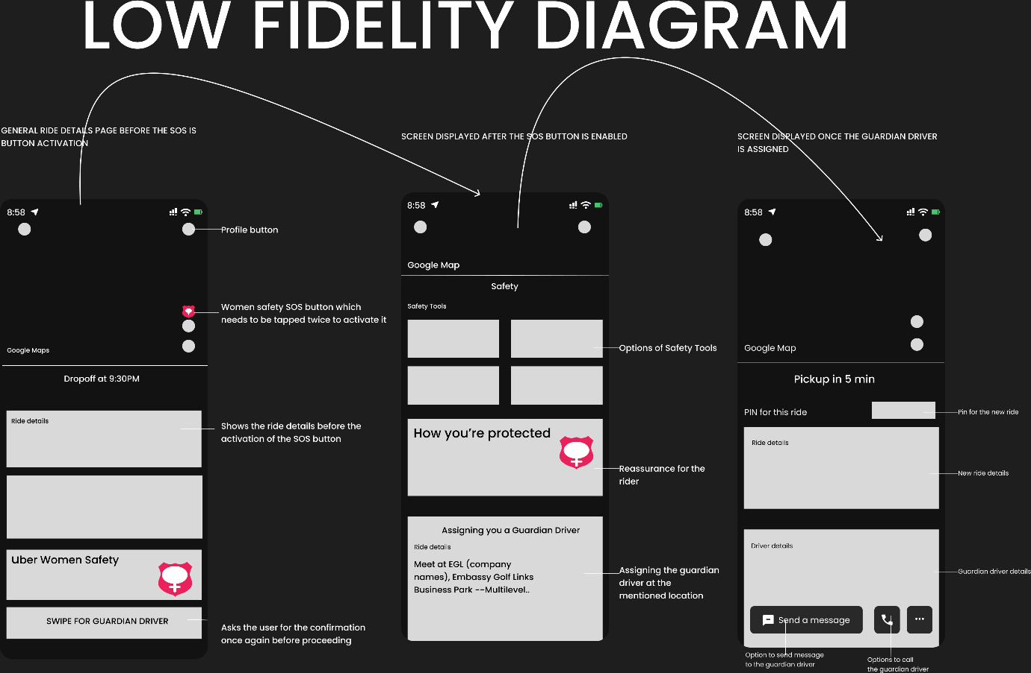

1. Women Safety SOS Button

Positioned prominently on the ride screen, the SOS button is activated via a double-tap gesture, ensuring discretion while preventing accidental triggers. The shield icon, incorporating a female symbol, reinforces that this is a gender-specific safety intervention.

2. Guardian Driver

The final action is a "Swipe for Guardian Driver" interaction, requiring deliberate intent. This confirmation layer ensures the Guardian Driver protocol is not misused while remaining easily accessible in emergencies.

2.High Fidelity:  
**User Flow Map:**

Step 1: Pre Guardian Driver Assignment:

* At the beginning the Rider sees usual Uber screen with:
  + Driver name, vehicle info, ratings.
  + Live pickup route on the map.
  + A safety PIN to verify driver identity.

Step 2: In-Ride SOS Activation Screen

* + Taps on the floating SOS shield button.
  + Presented with “Uber Women Safety” panel with a clear CTA: Swipe for Guardian Driver.
  + Message reinforces that the rider will be connected to the safety team.

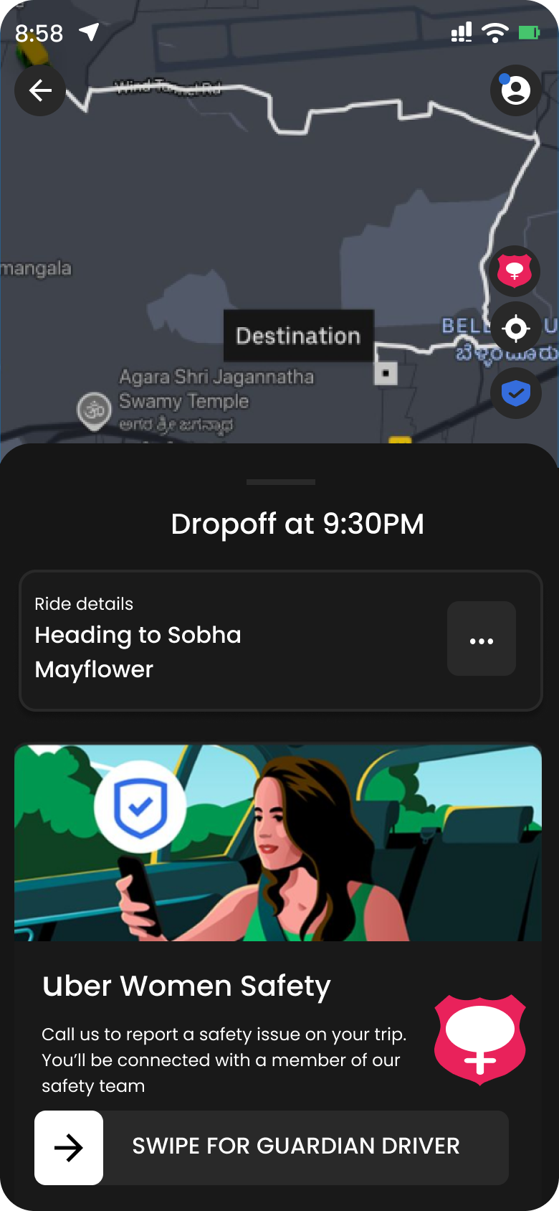

Step 3: Escalation + Guardian Driver Assignment Screen

* + UI confirms Guardian Driver is being assigned.
  + Safety tools (Call 112, Record Audio, Share Trip) are made immediately available.
  + Guardian Driver assignment progress and updated pickup info shown transparently.

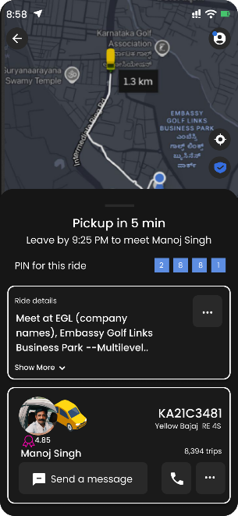

**Key Success Metrics:**

|  |  |  |
| --- | --- | --- |
| **Metric Name** | **Type** | **Description** |
| Guardian Driver Response Time | Efficiency | Time from SOS trigger to Guardian Driver arrival or assignment. Goal: <5 minutes to build trust and operational reliability. |
| Rider Feedback Score | Trust/Quality | Post-SOS satisfaction rating (e.g. 1–5 scale on “felt safer?”). |
| SOS Feature Activation Rate | Adoption | % of eligible users who have used the SOS feature at least once. |

**Dependencies:**

|  |  |  |
| --- | --- | --- |
| **Dependency Area** | **Description** | **Owner/Team** |
| Backend Infrastructure | Logic to assign Guardian Driver, stop original driver, and trigger SOS protocols | Mobility Platform Team |
| Driver Partner Program | Selection, vetting, and training of Guardian Drivers based on criteria | Driver Ops Team |
| Safety Operations Team | 24x7 availability to place emergency calls, assist riders, and escalate urgent support | Risk & Support Team |

**Risks and Mitigation: Regulatory Hurdles and Legal Review**

|  |  |  |  |
| --- | --- | --- | --- |
| **Risk Category** | **Risk Description** | **Potential Impact** | **Mitigation Strategy** |
| Legal / Regulatory | Treating drivers as emergency responders may violate ride-sharing norms in certain regions (e.g. Chandigarh, Delhi) | May result in legal pushback, service bans, or regulatory scrutiny | Reposition Guardian Drivers as “trusted allies,” not official responders; train but don’t label as emergency responders |
| Operational Risk | Delayed Guardian Driver arrival or driver refusal to accept handover | SOS loses credibility, trust erosion | ETA threshold logic, fallback: Safety Team call, in-app monitoring, real-time alerts |
| Privacy & Consent | Audio or location tracking without user consent during SOS situations | Legal non-compliance, user outrage, PR crisis | Explicit opt-in consent, transparent T&Cs, visual indicators for active tracking |

**Go to market strategy:**

|  |  |
| --- | --- |
| **Component** | **Details** |
| Target Audience | • Women riders  • Frequent late-night travellers  • Users in Tier-1 & Tier-2 cities with prior SOS concerns |
| Slogan/Campaign | • Campaign Hashtags:  - #UberWithYou  - #UberButBetter  - #UberIsThereForUsWomen  • Post Stories of women helped by Guardian Drivers on X and Instagram |
| Key Features | • 2-tap SOS button  • Guardian Driver handover  • Audio + location recording during SOS  • Rider feedback loop |
| Adoption Levers | • Guardian Driver Incentives:  - Higher ride allocation and priority matching  - Quarterly safety bonuses  - Free Uber-sponsored training  • Guardian Driver as a Badge of Honor:  - Visible Guardian icon in profile  - Official jacket/sticker/gear  - Recognition in Uber app |
| Metrics for GTM Success | • Rider NPS after SOS  • % of riders who feel “safer” post-ride  • Guardian Driver opt-in rate  • Weekly earnings uplift for Guardian Drivers |

**Questions to ask:**