SQL QUERY GENARATOR
Project Work Report
Submitted to Alagappa University in partial
Fulfillment of the requirement for the award of the
Degree in B.SC COMPUTER SCIENCE
Submitted By
TEAM ID: SWTID-2026-4669
TEAM LEADER:
T.RAJA SRITHAR (Reg.No.2523128024)
TEAM MEMBERS:
NAGA MANIMARAN (Reg.No.2523128019)
PAVITHRAN.P (Reg.No.2523128022)
NANTHA KUMAR.N (Reg.No.2523128020)
PRAVEEN RAJ.J(2523128023)
Under the Naan Mudhalvan Incharge of
Mrs. C. AMIRTHARANI MCA., M.Phil.,

DEPARTMENT OF COMPUTER SCIENCE
CAUSSANEL COLLEGE OF ARTS AND SCIENCE
Accredited With ‘A’ Grade by NAAC
Recognized by UGC Under 2(f) &12(B)
(Co-Education)
(Affiliated to Alagappa University)
Muthupettai-623523
April-2026
TABLE OF CONTENTS
S.No | Content | Page No
1. | Abstract | 3
2. | Introduction | 4
3. | System Analysis | 5-6
4. | System Design | 7-8
5. | System Implementation | 9
8. | System Testing & Screenshots | 10-12
9. | Conclusion & Future Enhancement & Bibiliography | 13
10. | Appendix Souce Code | 14-24
1. ABSTRACT
The SQL Query Generator is a desktop application designed to assist database administrators, developers, and students in generating Complex Structured Query Language (SQL) commands without manually writing code.
In the current technological landscape, interacting with databases is essential, but SQL syntax can be prone to errors such as missing punctuation, incorrect join types, or syntax mismatches. This project utilizes Python and its Tkinter library to provide a Graphical User Interface (GUI) where users can input table names, columns, and conditions. The system processes these inputs and automatically generates syntactically correct SQL queries for operations like SELECT, INSERT, UPDATE, DELETE, and JOINS.
The application also features a "History" module to track previously generated queries and clipboard integration for workflow efficiency. This tool significantly reduces coding time and syntax errors for novice and intermediate SQL users.

2. INTRODUCTION
2.1 Project Overview
The SQL Query Generator is a utility software built using the Python programming language. It abstracts the complexity of writing raw SQL queries by providing a visual interface. Users interact with forms, dropdowns, and text fields, and the software translates these interactions into standard SQL string formats.
2.2 Problem Statement
- Syntax Errors: Beginners often struggle with placing quotes, commas, and parentheses correctly in SQL.
- Time Consumption: Writing repetitive CRUD (Create, Read, Update, Delete) queries manually is time-consuming.
- Memorization: Users must memorize specific syntax for different types of Joins (Inner, Left, Right), which can be confusing.
- Lack of Tools: Most SQL tools are heavy database management systems (like Workbench or pgAdmin); there are few lightweight tools just for generating the code.
2.3 Objectives
- To develop a user-friendly GUI application using Python.
- To automate the generation of standard SQL queries (SELECT, INSERT, UPDATE, DELETE, CREATE).
- To implement a logic builder for complex SQL Joins.
- To provide a history log of generated queries for user reference.
- To ensure the application is lightweight and runs without complex installation procedures.
2.4 Scope of Project
This project is designed for:
- Students: To learn SQL syntax by seeing how inputs translate to code.
- Developers: To quickly draft queries for use in backend code.
- Education: As a teaching aid in computer science laboratories.
- Platform: The application runs on Windows, Linux, and macOS.

3. SYSTEM ANALYSIS

3.1 Existing System

In the existing manual system, a user must open a text editor or a database shell and type commands manually.
- Disadvantage: If a user forgets a semicolon or a quote, the query fails.
- Disadvantage: Debugging long queries (especially Joins) is difficult visually.
- Disadvantage: No local history of what queries were just written.

3.2 Proposed System

The proposed SQL Master Pro system automates the syntax assembly.
- Advantage: The user focuses on logic (e.g., "I want data from Table A and Table B"), not syntax.
- Advantage: Dropdown menus prevent spelling errors in command types.
- Advantage: Automatic formatting ensures keywords are capitalized and spacing is correct.

3.3 Feasibility Study

- Technical Feasibility: The project uses Python, which is open-source and widely supported. No expensive hardware is needed.
- Operational Feasibility: The interface is intuitive (windows, buttons) and requires no special training to operate.
- Economic Feasibility: The development cost is zero as it uses open-source technologies.

3.4 Hardware & Software Requirements

Hardware:
- Processor: Intel i3 or equivalent (Minimum).
- RAM: 4GB (Minimum).
- Hard Disk: 100MB free space.
Software:
- Operating System: Windows 10/11, Linux, or macOS.
- Language: Python 3.6+.
- Libraries: Tkinter (Built-in), standard libraries.

4. TECHNOLOGY STACK

4.1 Python Programming Language

Python was chosen for this project because:
- Rapid Development: Python allows for writing complex logic with fewer lines of code.
- Tkinter Library: Python includes Tkinter, the standard GUI library, which is lightweight and requires no external installation.
- String Manipulation: Python excels at handling strings, which is the core requirement for generating SQL text.
- Cross-Platform: The code runs on any operating system without modification.

- SYSTEM DESIGN

5.1 System Architecture
The system follows a simple Event-Driven Architecture.
- View Layer (GUI): The User Interface (Buttons, Entry fields).
- Controller Layer: Python functions that capture user input.
- Logic Layer: String formatting logic that assembles the SQL.
- Output Layer: Displays the result and saves it to the history list.
5.2 Data Flow Diagram (DFD)

- Level 0: User -> Inputs Details -> [SQL Generator System] -> Outputs SQL Code.
- Level 1:
  - User Selects "Operation" (e.g., SELECT).
  - System validates input (Checks if Table Name is empty).
  - System formats string: COMMAND + COLUMNS + FROM TABLE + CONDITIONS.
  - System appends result to History Array.
  - System displays text to Screen.
5.3 Use Case Diagrams
Actor: User
- Use Cases:
  - Select Database Type.
  - Input Table Details.
  - Generate Basic Query.
  - Generate Join Query.
  - Copy to Clipboard.
  - View History.

5.4 Activity Diagrams
- Start -> User Selects Tab (Basic/Join) -> User Enters Data -> User Clicks "Generate" -> Decision: (Is Data Empty?) ->
  - Yes: Show Error Message -> Return to Start.
  - No: Construct String -> Display SQL -> Add to History -> End.

6. SYSTEM IMPLEMENTATION
6.1 Algorithm Description
The core algorithm for query generation uses String Interpolation.
- Initialize an empty string sql = "".
- Retrieve table_name, columns, conditions from UI.
- Check Operation_Type:
  - If SELECT: sql = "SELECT " + columns + " FROM " + table_name + " WHERE " + conditions
  - If INSERT: sql = "INSERT INTO " + table_name + " (" + columns + ") VALUES (" + conditions + ")"
- Append semicolon ; at the end.
- Return sql.
6.2 Module Description
- Basic Builder Module: Handles single table operations (CRUD). It dynamically changes labels based on the selected operation (e.g., asking for "Values" for INSERT vs "Conditions" for SELECT).
- Join Builder Module: Handles multi-table logic. It takes inputs for Table A, Table B, Join Type, and On Condition.
- History Module: A list data structure that stores every generated query with a timestamp.
6.3 Core Code Explanation
- import tkinter: Used to create the windows and buttons.
- class SQLMasterApp: The main wrapper for the application.
- def generate_query(self): The function triggered by the button click. It fetches data using .get(), performs validation if not table: return, and updates the text area using .insert().

7. SYSTEM TESTING & SCREENSHOTS
7.1 Test Plan
Testing focuses on Input Validation and Output Accuracy. We ensure that if a user leaves a required field empty, the system alerts them instead of crashing.
7.2 Test Cases (Unit & Integration)
TC ID | Test Description | Input Data | Expected Result | Status
TC01 | Empty Table Name | Table: (Empty) | Error Popup: "Table Name is required!" | Pass
TC02 | Generate SELECT | Table: Users, Cols: * | SELECT * FROM Users; | Pass
TC03 | Generate UPDATE | Table: Items, Set: price=10 | UPDATE Items SET price=10; | Pass
TC04 | Join Query | Table A: Users, B: Orders | SELECT ... FROM Users INNER JOIN Orders... | Pass
TC05 | Clipboard Copy | Click Copy Button | SQL copied to system clipboard | Pass

7.3 Screenshots of Results
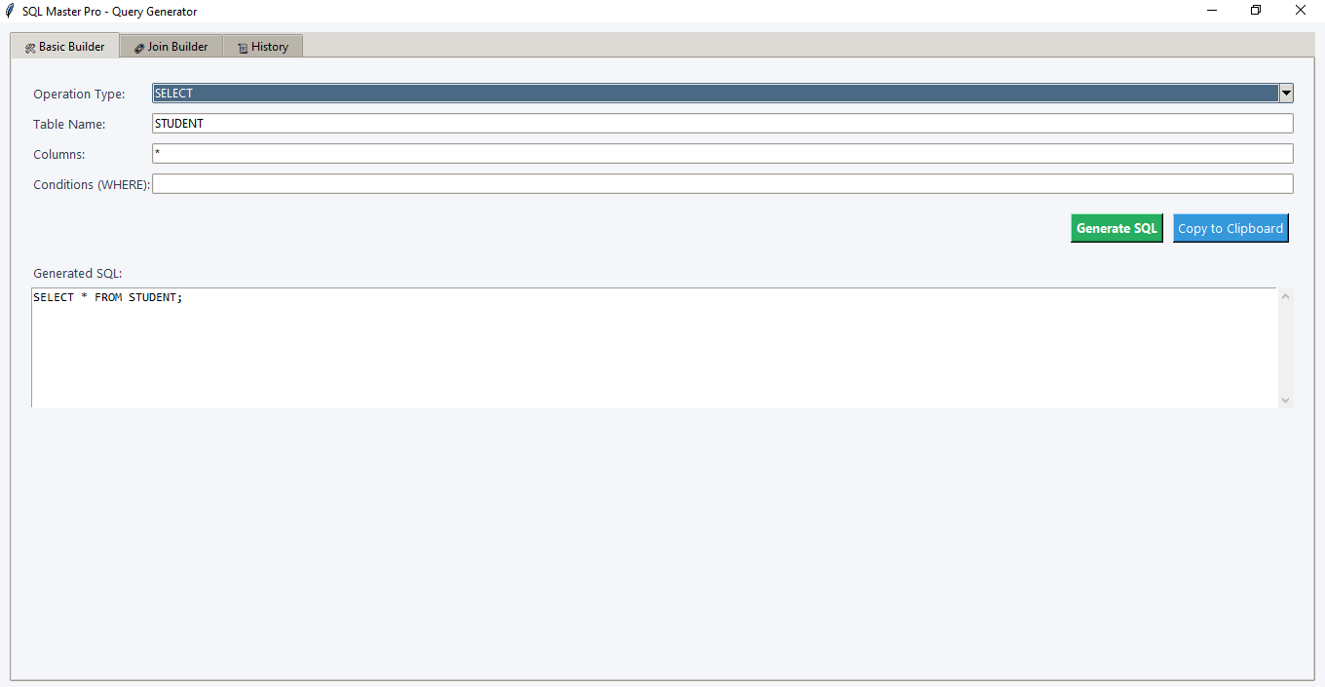
- Screenshot 1: The "Basic Builder" tab showing a generated SELECT query.
- Screenshot 2: The "Join Builder" tab showing a generated INNER JOIN.
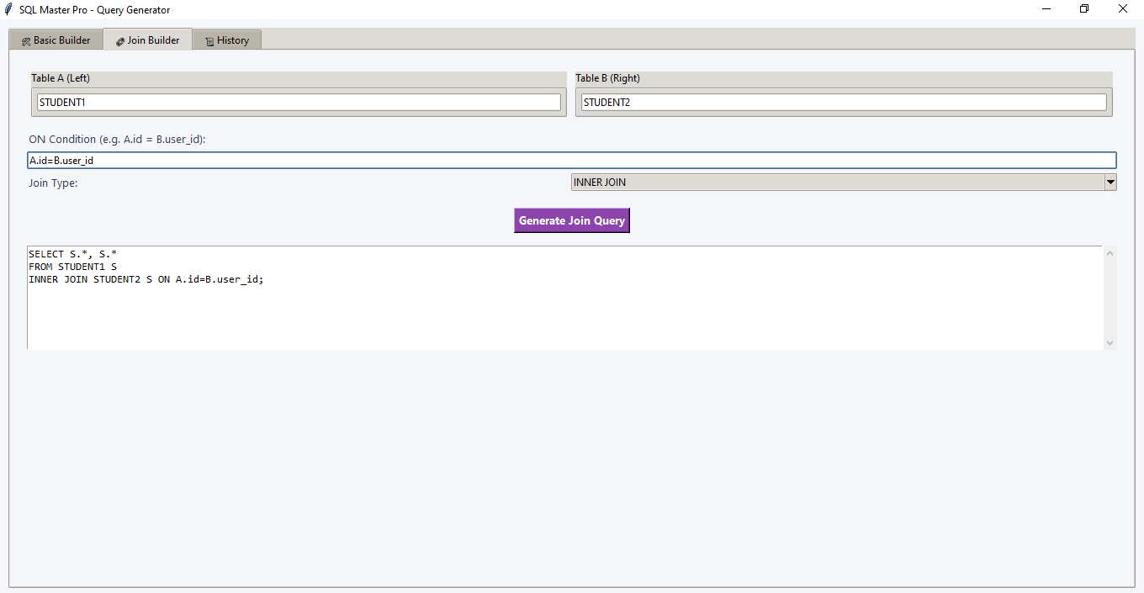

- Screenshot 3: The "History" tab showing the list of past queries.
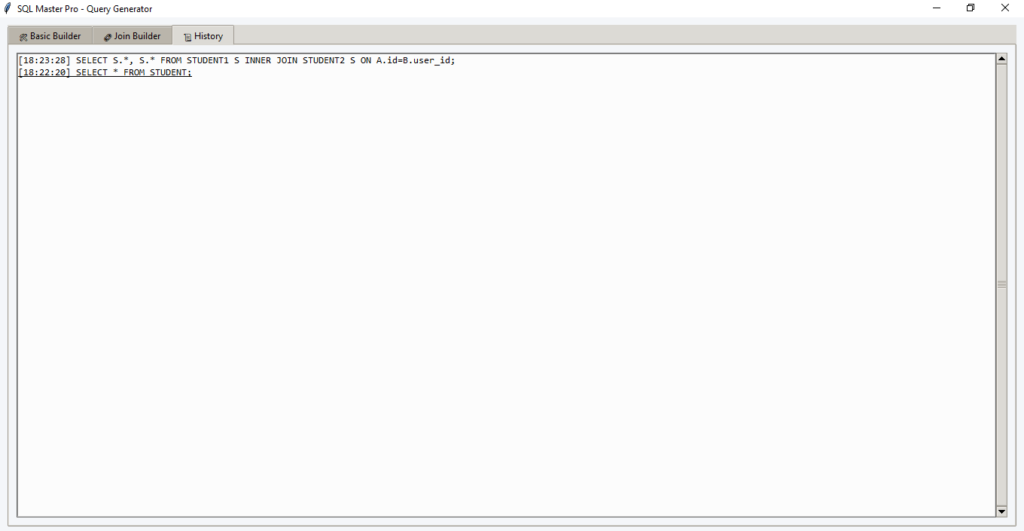

8. CONCLUSION & FUTURE ENHANCEMENT & BIBILIOGRAPHY
Conclusion:
The SQL Master Pro project successfully demonstrates how Python can be used to build utility tools that simplify development tasks. The application meets all initial objectives: it generates correct SQL syntax, prevents common errors, and provides a user-friendly interface. It serves as an excellent tool for educational purposes and rapid prototyping.

Future Enhancements:
- Database Connection: Future versions will connect directly to a live database (MySQL/SQLite) to execute the queries, not just generate them.
- AI Integration: Integrating OpenAI API to allow users to type "Show me users from Delhi" and have the AI generate the SQL automatically.
- Schema Import: Loading table names automatically from a database file.

BIBLIOGRAPHY
- Python Documentation - docs.python.org/3/library/tkinter.html
- W3Schools SQL Tutorial - w3schools.com/sql/
- Tkinter GUI Programming by Example - David Love (Book)
- StackOverflow Community Discussions on Python GUI Development

10. APPENDIX (Source Code)

SqlMaster_Pro.py

import tkinter as tk
from tkinter import ttk, messagebox, scrolledtext
import datetime

# ==========================================
# SQL MASTER PRO - ONE FILE PROJECT
# ==========================================

class SQLMasterApp:
def __init__(self, root):
self.root = root
self.root.title("SQL Master Pro - Query Generator")
self.root.geometry("800x600")

# --- Theme & Styles ---
self.style = ttk.Style()
self.style.theme_use('clam')

# Colors
self.bg_color = "#f4f6f9"
self.sidebar_color = "#2c3e50"
self.accent_color = "#3498db"
self.text_color = "#2c3e50"

self.root.configure(bg=self.bg_color)

# Define Custom Styles
self.style.configure("TFrame", background=self.bg_color)
self.style.configure("TLabel", background=self.bg_color, foreground=self.text_color, font=("Segoe UI", 10))
self.style.configure("TButton", font=("Segoe UI", 10, "bold"), padding=5)
self.style.configure("Header.TLabel", font=("Segoe UI", 16, "bold"), foreground="#2c3e50")

# --- Data Storage ---
self.query_history = []

# --- Main Layout ---
self.create_layout()

def create_layout(self):
# 1. Main Container
main_container = ttk.Frame(self.root)
main_container.pack(fill="both", expand=True, padx=10, pady=10)

# 2. Notebook (Tabs)
self.tabs = ttk.Notebook(main_container)
self.tabs.pack(fill="both", expand=True)

# --- Tab 1: Basic Builder (CRUD) ---
self.tab_basic = ttk.Frame(self.tabs)
self.tabs.add(self.tab_basic, text=" 🛠 Basic Builder ")
self.build_basic_tab()

# --- Tab 2: Join Builder ---
self.tab_join = ttk.Frame(self.tabs)
self.tabs.add(self.tab_join, text=" 🔗 Join Builder ")
self.build_join_tab()

# --- Tab 3: History ---
self.tab_history = ttk.Frame(self.tabs)
self.tabs.add(self.tab_history, text=" 📜 History ")
self.build_history_tab()

# --- Footer ---
footer = tk.Label(self.root, text="SQL Master Pro v1.0 | Ready", bd=1, relief=tk.SUNKEN, anchor=tk.W, bg="#e0e0e0")
footer.pack(side=tk.BOTTOM, fill=tk.X)

# ==========================================
# TAB 1: BASIC BUILDER LOGIC
# ==========================================
def build_basic_tab(self):
frame = ttk.Frame(self.tab_basic)
frame.pack(padx=20, pady=20, fill="both", expand=True)

# Row 0: Operation Selection
lbl_op = ttk.Label(frame, text="Operation Type:")
lbl_op.grid(row=0, column=0, sticky="w", pady=5)

self.var_operation = tk.StringVar(value="SELECT")
self.cb_operation = ttk.Combobox(frame, textvariable=self.var_operation, state="readonly",
values=["SELECT", "INSERT", "UPDATE", "DELETE", "CREATE TABLE"])
self.cb_operation.grid(row=0, column=1, sticky="ew", pady=5)
self.cb_operation.bind("<<ComboboxSelected>>", self.update_basic_ui)

# Row 1: Table Name
ttk.Label(frame, text="Table Name:").grid(row=1, column=0, sticky="w", pady=5)
self.entry_table = ttk.Entry(frame)
self.entry_table.grid(row=1, column=1, sticky="ew", pady=5)

# Row 2: Field 1 (Dynamic Label)
self.lbl_field1 = ttk.Label(frame, text="Columns:")
self.lbl_field1.grid(row=2, column=0, sticky="w", pady=5)
self.entry_field1 = ttk.Entry(frame)
self.entry_field1.insert(0, "*")
self.entry_field1.grid(row=2, column=1, sticky="ew", pady=5)

# Row 3: Field 2 (Dynamic Label)
self.lbl_field2 = ttk.Label(frame, text="Conditions (WHERE):")
self.lbl_field2.grid(row=3, column=0, sticky="w", pady=5)
self.entry_field2 = ttk.Entry(frame)
self.entry_field2.grid(row=3, column=1, sticky="ew", pady=5)

# Row 4: Buttons
btn_frame = ttk.Frame(frame)
btn_frame.grid(row=4, column=1, sticky="e", pady=15)

btn_gen = tk.Button(btn_frame, text="Generate SQL", bg="#27ae60", fg="white", font=("Segoe UI", 10, "bold"), command=self.generate_basic_sql)
btn_gen.pack(side=tk.LEFT, padx=5)

btn_copy = tk.Button(btn_frame, text="Copy to Clipboard", bg="#3498db", fg="white", font=("Segoe UI", 10), command=lambda: self.copy_to_clipboard(self.txt_output_basic))
btn_copy.pack(side=tk.LEFT, padx=5)

# Row 5: Output
ttk.Label(frame, text="Generated SQL:").grid(row=5, column=0, sticky="nw", pady=5)
self.txt_output_basic = scrolledtext.ScrolledText(frame, height=8, font=("Consolas", 10))
self.txt_output_basic.grid(row=6, column=0, columnspan=2, sticky="nsew")

frame.columnconfigure(1, weight=1)

def update_basic_ui(self, event=None):
op = self.var_operation.get()
if op == "SELECT":
self.lbl_field1.config(text="Columns (comma sep):")
self.lbl_field2.config(text="WHERE Clause:")
self.entry_field1.delete(0, tk.END); self.entry_field1.insert(0, "*")
elif op == "INSERT":
self.lbl_field1.config(text="Columns (comma sep):")
self.lbl_field2.config(text="Values (comma sep):")
self.entry_field1.delete(0, tk.END)
elif op == "UPDATE":
self.lbl_field1.config(text="SET (col=val):")
self.lbl_field2.config(text="WHERE Clause:")
self.entry_field1.delete(0, tk.END)
elif op == "DELETE":
self.lbl_field1.config(text="(Leave Empty)")
self.lbl_field2.config(text="WHERE Clause:")
self.entry_field1.delete(0, tk.END)
elif op == "CREATE TABLE":
self.lbl_field1.config(text="Column Definitions:")
self.lbl_field2.config(text="(Leave Empty)")
self.entry_field1.delete(0, tk.END); self.entry_field1.insert(0, "id INT, name VARCHAR(50)")

def generate_basic_sql(self):
op = self.var_operation.get()
table = self.entry_table.get().strip()
f1 = self.entry_field1.get().strip()
f2 = self.entry_field2.get().strip()

if not table:
messagebox.showerror("Error", "Table Name is required!")
return

sql = ""
if op == "SELECT":
sql = f"SELECT {f1} FROM {table}"
if f2: sql += f"\nWHERE {f2}"
elif op == "INSERT":
sql = f"INSERT INTO {table} ({f1})\nVALUES ({f2})"
elif op == "UPDATE":
sql = f"UPDATE {table}\nSET {f1}"
if f2: sql += f"\nWHERE {f2}"
elif op == "DELETE":
sql = f"DELETE FROM {table}"
if f2: sql += f"\nWHERE {f2}"
elif op == "CREATE TABLE":
sql = f"CREATE TABLE {table} (\n {f1}\n)"

sql += ";"
self.display_result(self.txt_output_basic, sql)
self.add_to_history(sql)

# ==========================================
# TAB 2: JOIN BUILDER LOGIC
# ==========================================
def build_join_tab(self):
frame = ttk.Frame(self.tab_join)
frame.pack(padx=20, pady=20, fill="both", expand=True)

# Table A
grp_a = ttk.LabelFrame(frame, text="Table A (Left)")
grp_a.grid(row=0, column=0, sticky="ew", padx=5, pady=5)
self.ent_join_a = ttk.Entry(grp_a); self.ent_join_a.pack(fill="x", padx=5, pady=5)

# Table B
grp_b = ttk.LabelFrame(frame, text="Table B (Right)")
grp_b.grid(row=0, column=1, sticky="ew", padx=5, pady=5)
self.ent_join_b = ttk.Entry(grp_b); self.ent_join_b.pack(fill="x", padx=5, pady=5)

# Join Condition
ttk.Label(frame, text="ON Condition (e.g. A.id = B.user_id):").grid(row=1, column=0, columnspan=2, sticky="w", pady=(10,5))
self.ent_join_on = ttk.Entry(frame)
self.ent_join_on.grid(row=2, column=0, columnspan=2, sticky="ew")

# Join Type
ttk.Label(frame, text="Join Type:").grid(row=3, column=0, sticky="w", pady=5)
self.cb_join_type = ttk.Combobox(frame, values=["INNER JOIN", "LEFT JOIN", "RIGHT JOIN", "FULL JOIN"], state="readonly")
self.cb_join_type.current(0)
self.cb_join_type.grid(row=3, column=1, sticky="ew", pady=5)

# Generate Button
btn_gen = tk.Button(frame, text="Generate Join Query", bg="#8e44ad", fg="white", font=("Segoe UI", 10, "bold"), command=self.generate_join_sql)
btn_gen.grid(row=4, column=0, columnspan=2, pady=15)

# Output
self.txt_output_join = scrolledtext.ScrolledText(frame, height=8, font=("Consolas", 10))
self.txt_output_join.grid(row=5, column=0, columnspan=2, sticky="nsew")

frame.columnconfigure(0, weight=1); frame.columnconfigure(1, weight=1)

def generate_join_sql(self):
ta = self.ent_join_a.get().strip()
tb = self.ent_join_b.get().strip()
on_cond = self.ent_join_on.get().strip()
j_type = self.cb_join_type.get()

if not ta or not tb or not on_cond:
messagebox.showerror("Error", "Please fill in both tables and the ON condition.")
return

# Simple aliasing logic
alias_a = ta[0] if ta else "a"
alias_b = tb[0] if tb else "b"

sql = f"SELECT {alias_a}.*, {alias_b}.*\nFROM {ta} {alias_a}\n{j_type} {tb} {alias_b} ON {on_cond};"
self.display_result(self.txt_output_join, sql)
self.add_to_history(sql)

# ==========================================
# TAB 3: HISTORY LOGIC
# ==========================================
def build_history_tab(self):
frame = ttk.Frame(self.tab_history)
frame.pack(fill="both", expand=True, padx=10, pady=10)

self.list_history = tk.Listbox(frame, font=("Consolas", 10), bg="#fcfcfc")
self.list_history.pack(side="left", fill="both", expand=True)

scrollbar = ttk.Scrollbar(frame, orient="vertical", command=self.list_history.yview)
scrollbar.pack(side="right", fill="y")
self.list_history.config(yscrollcommand=scrollbar.set)

self.list_history.bind('<Double-1>', self.copy_history_to_clipboard)

def add_to_history(self, sql):
timestamp = datetime.datetime.now().strftime("%H:%M:%S")
entry = f"[{timestamp}] {sql.replace(chr(10), ' ')}" # Remove newlines for listbox
self.query_history.append(sql)
self.list_history.insert(0, entry) # Add to top

def copy_history_to_clipboard(self, event):
selection = self.list_history.curselection()
if selection:
index = selection[0]
# Since we insert at 0, the listbox index matches the reverse of our list
# But simpler: just grab the text from the listbox (minus timestamp)
full_text = self.list_history.get(index)
# Basic extraction, or just use the list logic if kept perfectly synced
# Let's clean the timestamp for copy
clean_sql = full_text.split("] ", 1)[1]
self.root.clipboard_clear()
self.root.clipboard_append(clean_sql)
messagebox.showinfo("Copied", "Query copied to clipboard!")

# ==========================================
# UTILITIES
# ==========================================
def display_result(self, text_widget, content):
text_widget.delete(1.0, tk.END)
text_widget.insert(tk.END, content)

def copy_to_clipboard(self, text_widget):
content = text_widget.get("1.0", tk.END).strip()
if content:
self.root.clipboard_clear()
self.root.clipboard_append(content)
messagebox.showinfo("Success", "SQL copied to clipboard!")
else:
messagebox.showwarning("Empty", "Nothing to copy.")

# ==========================================
# APP ENTRY POINT
# ==========================================
if __name__ == "__main__":
root = tk.Tk()
app = SQLMasterApp(root)
root.mainloop()

