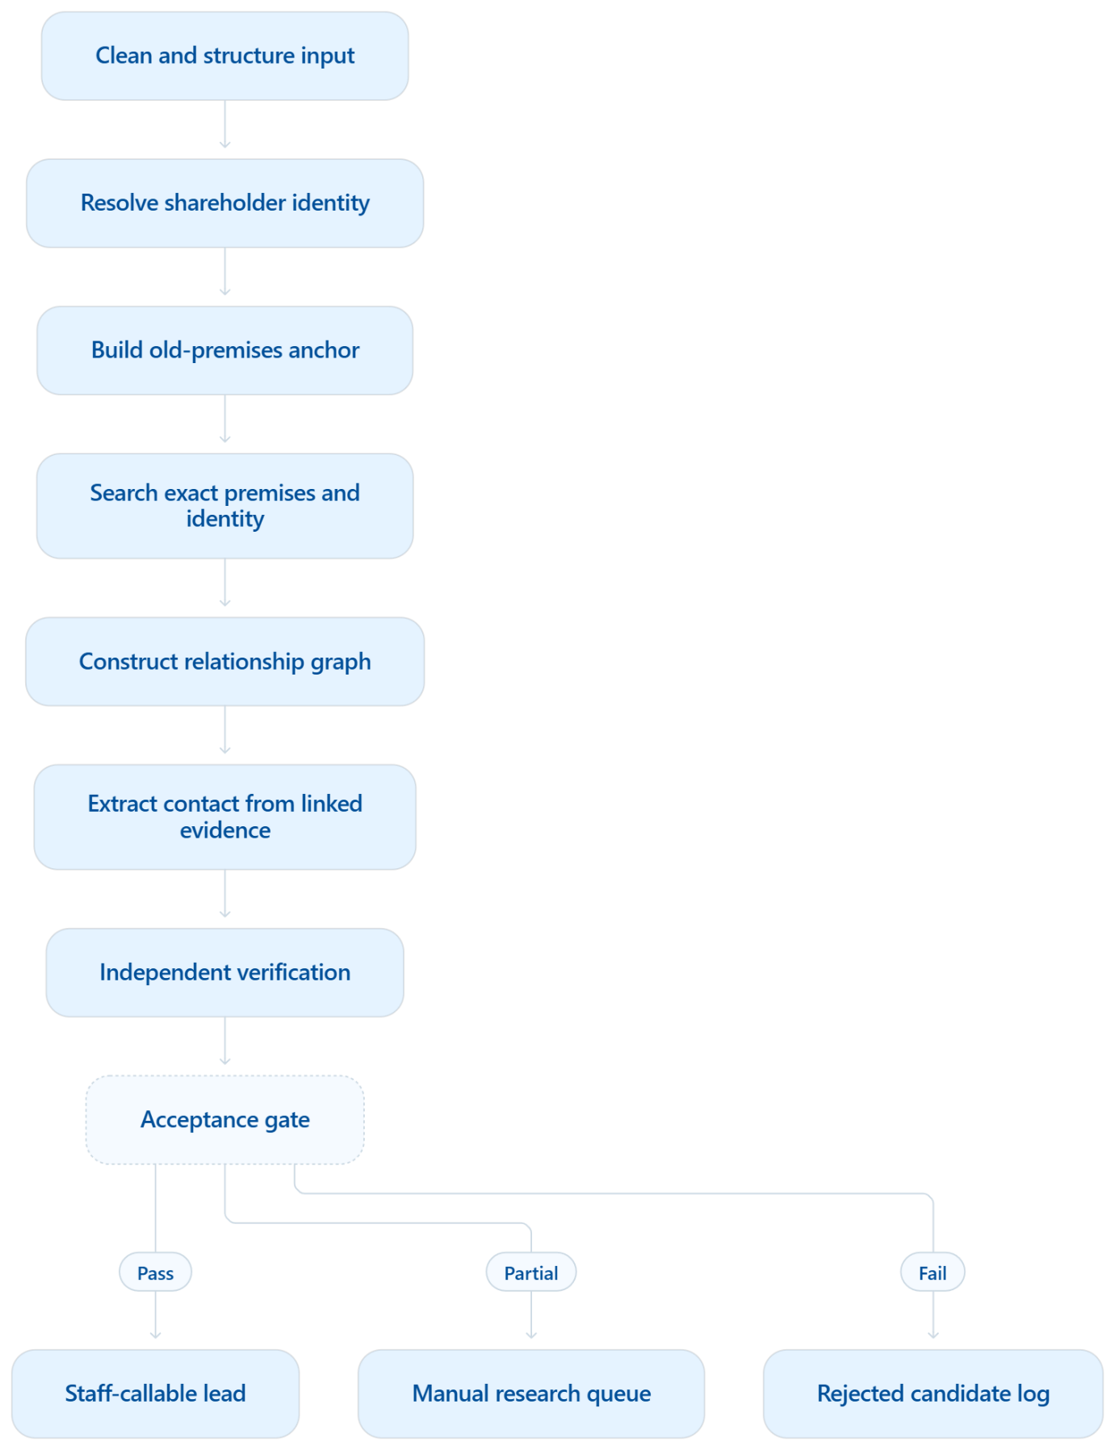

Stage 1: Input gate
No research until:
- name and address have been separated correctly;
- PIN and city are validated;
- care-of/guardian is extracted;
- obvious PDF row-merging is corrected;
- input receives a stable row ID.
Stage 2: Anchor building
Generate separate anchors:
- NAME_ANCHOR
- PREMISES_ANCHOR
- PIN_LOCALITY_ANCHOR
- FAMILY_ANCHOR
- COMPANY_ANCHOR
Do not concatenate everything into one oversized search string.
Stage 3: Premises-first searches
Search in a controlled order:
- exact house/building + locality/PIN;
- exact full name + PIN/locality;
- name + guardian/care-of;
- premises + surname/family;
- business/director/employer linkage;
- current occupier, RWA, neighbour or broker only as an identified proxy route.
Stage 4: Relationship graph
Every contact candidate must answer:
- Who owns this number?
- What is their relationship to the shareholder?
- What connects them to the old premises?
- Is the relationship direct or inferred?
- What source proves each link?
A number without a relationship path must remain rejected.
Stage 5: Evidence-gated acceptance
A direct-person number should ordinarily require:
- full/strong name match; and
- one corroborating address, guardian, company or second-source match.
A proxy number should require:
- verified proxy identity; and
- verified connection to the premises/shareholder; and
- a source containing the number.
No amount of weak source accumulation should substitute for these gates.
Recommended classification
Replace the present generic confidence score with two separate measurements:
Field | Meaning
Relationship strength | How strongly the owner is connected to the shareholder/premises
Contact reliability | How strongly the number is connected to that owner
Final classification should be:
- A — Direct verified: shareholder’s number with strong corroboration.
- B — Strong proxy: verified family/business/premises relationship.
- C — Premises lead: RWA, neighbour, current occupier, broker or business at exact premises.
- D — Research lead: plausible but incomplete; manual verification required.
- Rejected: no demonstrated relationship.
Staff-callable output may include A–C. Category D should remain in the research queue, not be represented as a match.
Developer instructions in priority order
Immediate stop-gap
- Stop bulk production and preserve the current ZIP as an audit snapshot.
- Remove the Excel low-confidence fallback.
- Remove all cached candidates from production output.
- Disable early stopping based solely on the current score.
- Do not label unmatched people as proxies.
- Limit displayed candidates to the best three qualified candidates.
- Mark every output with engine and scoring version.
- Separate candidate found from qualified contact found.
Architecture correction
- Repair PDF/Excel row parsing first.
- Redesign investigation around premises and relationship anchors.
- Restrict extraction to evidence blocks, not whole pages.
- Introduce mandatory gates before scoring.
- Separate direct, family, premises and business pathways.
- Store evidence chains as structured records.
- Require independent verification for high-confidence status.
- Add explicit rejection reasons.
Evaluation correction
Create a locked benchmark containing at least:
- the earlier 48 manually traced cases;
- confirmed correct direct numbers;
- confirmed acceptable proxies;
- known wrong numbers;
- hard cases and “no public lead” cases.
Measure:
- direct-contact precision;
- callable-lead precision;
- coverage;
- wrong-number rate;
- unsupported-proxy rate;
- average qualified leads per case;
- runtime and cost.
Do not use “any phone extracted” as the success metric.
Acceptance threshold I recommend
Before production use:
- at least 90% precision for A/B contacts;
- at least 80% precision for premises leads;
- unsupported wrong-number rate below 5%;
- every output must show a complete evidence path;
- zero low-confidence fallback into “Matched”;
- benchmark must be evaluated blind against staff-confirmed results.
The system does not need to reproduce the staff’s 100% coverage immediately. It should first become conservative and trustworthy. A lower number of defensible leads is far more useful than hundreds of wrong numbers presented as matches.
My overall assessment: approximately 30–35% of the necessary product architecture exists, mainly the UI, batch framework, providers, caching and extraction scaffolding. The core intelligence—the premises relationship model, evidence gates, validation logic and benchmark discipline—still requires redesign. Adding more APIs before this redesign will increase both cost and false positives rather than solve the underlying problem.

