Ingress Controller can be in any namespace. But the Ingress Resource must be in the same Namespace where the application is deployed. For example, if prometheus and grafana are in monitoring namespace, the ingress must also be in the monitoring namespace.

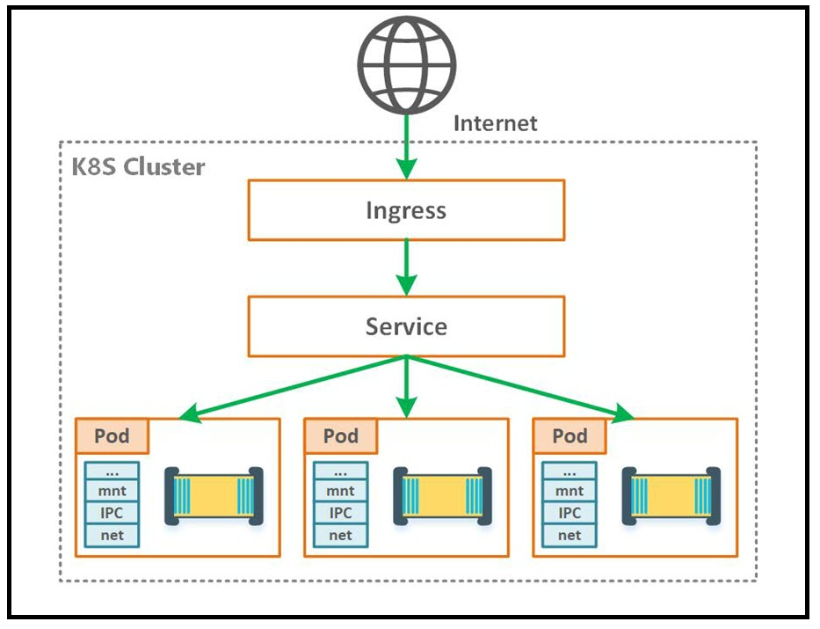

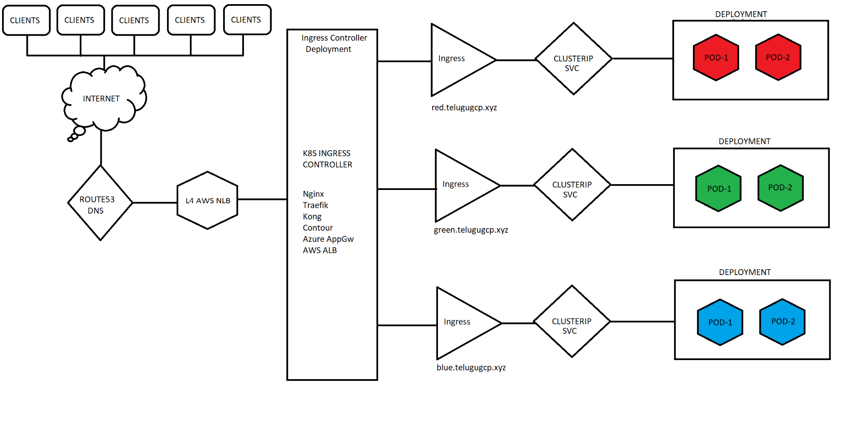

For Batch 08 I have used ingress v1.0.5

Kubectl apply -f https://raw.githubusercontent.com/kubernetes/ingress-nginx/controller-v1.0.5/deploy/static/provider/aws/deploy.yaml

Use the ingress file red-blue-green-ingress.yml

kubectl apply -f <https://raw.githubusercontent.com/kubernetes/ingress-nginx/controller-0.32.0/deploy/static/provider/aws/deploy.yaml>

https://github.com/kubernetes/ingress-nginx

Kubectl apply -f <https://raw.githubusercontent.com/kubernetes/ingress-nginx/controller-v0.44.0/deploy/static/provider/aws/deploy.yaml>

NGinx Ingress Controller 1.0.0, got issue as no address when we run kubectl get ing. This issue is solved by using the annotation for ingress as kubernetes.io/ingress.class: "nginx"

Need to check the notes. Deploy 0.44.0 using above URL.

kubectl apply -f https://raw.githubusercontent.com/kubernetes/ingress-nginx/controller-v1.0.0/deploy/static/provider/aws/deploy.yaml

https://github.com/kubernetes/ingress-nginx

https://medium.com/@madeeshafernando/deploying-multiple-ingress-controllers-in-a-kubernetes-cluster-dc6c7700a795

ku create deploy deploy1 --image=index.docker.io/sreeharshav/rollingupdate:v1

ku create deploy deploy2 --image=index.docker.io/sreeharshav/rollingupdate:v5

ku create deploy deploy3 --image=index.docker.io/sreeharshav/testcontainer:v1

ku create deploy devopsk8s --image=index.docker.io/sreeharshav/testcontainer:v1

ku create deploy apple1 --image=index.docker.io/sreeharshav/testcontainer:v1 -n apple

ku expose deploy deploy1 --port=5000 --target-port=80 --type=NodePort

ku expose deploy deploy2 --port=8000 --target-port=80

ku expose deploy deploy3 --port=9000 --target-port=80

ku expose deploy devopsk8s --port=8200 --target-port=80

ku expose deploy apple1 --port=5000 --target-port=80 -n apple

kubectl create secret tls nginx-tls-default --key="tls.key" --cert="tls.crt"

#Multiple services in the namespace can use the same port type but when we expose using NodePort

#they will have a random node port.

—- - NEW PI FOR INGRESS—-

apiVersion: networking.k8s.io/v1

kind: Ingress

metadata:

name: sreek8s-deploy-ingress

spec:

ingressClassName: nginx

tls:

- hosts:

- www.sreeharshak8s.xyz

secretName: sreeharshak8s

rules:

- host: www.sreeharshak8s.xyz

http:

paths:

- path: /

pathType: Prefix

backend:

service:

name: sreek8s-deploy

port:

number: 8000

—---BELOW IS OLD API—-

apiVersion: extensions/v1beta1

kind: Ingress

metadata:

name: example-ingress

annotations:

ingress.kubernetes.io/rewrite-target: /

spec:

rules:

- host: www.sreek8s.xyz

http:

paths:

- path: /

backend:

serviceName: deploy01

servicePort: 8000

apiVersion: extensions/v1beta1

kind: Ingress

metadata:

name: example-ingress-2

annotations:

ingress.kubernetes.io/rewrite-target: /

spec:

rules:

- host: app1.sreek8s.xyz

http:

paths:

- path: /

backend:

serviceName: deploy2

servicePort: 8000

apiVersion: extensions/v1beta1

kind: Ingress

metadata:

name: example-ingress-3

annotations:

ingress.kubernetes.io/rewrite-target: /

spec:

rules:

- host: app2.sreek8s.xyz

http:

paths:

- path: /

backend:

serviceName: deploy3

servicePort: 9000

apiVersion: extensions/v1beta1

kind: Ingress

metadata:

name: example-ingress4

annotations:

ingress.kubernetes.io/rewrite-target: /

spec:

rules:

- host: sreek8s.xyz

http:

paths:

- path: /

backend:

serviceName: deploy1

servicePort: 5000

apiVersion: extensions/v1beta1

kind: Ingress

metadata:

name: devopsk8s-ingress4

annotations:

ingress.kubernetes.io/rewrite-target: /

spec:

rules:

- host: www.devopsk8s.xyz

http:

paths:

- path: /

backend:

serviceName: devopsk8s

servicePort: 8200

apiVersion: extensions/v1beta1

kind: Ingress

metadata:

name: apple-ingress

annotations:

ingress.kubernetes.io/rewrite-target: /

spec:

rules:

- host: app.devopsk8s.xyz

http:

paths:

- path: /

backend:

serviceName: apple1

servicePort: 8300

apiVersion: extensions/v1beta1

kind: Ingress

metadata:

namespace: apple

name: apple-ingress-2

annotations:

ingress.kubernetes.io/rewrite-target: /

spec:

rules:

- host: japp.devopsk8s.xyz

http:

paths:

- path: /

backend:

serviceName: apple1

servicePort: 5000

apiVersion: extensions/v1beta1

kind: Ingress

metadata:

name: apple-ingress-2

annotations:

ingress.kubernetes.io/rewrite-target: /

spec:

rules:

- host: japp.devopsk8s.xyz

http:

paths:

- path: /

backend:

serviceName: deploy1

servicePort: 5000