<https://letsencrypt.org/docs/rate-limits/>

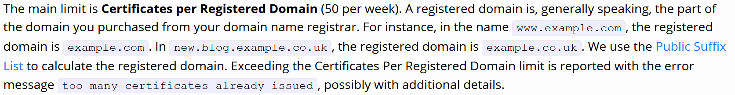

CERTBOT on ubuntu 18.04:

sudo snap install --classic certbot

cd /snap/bin/

cp certbot /usr/local/bin/

./certbot -h

./certbot certonly --manual --preferred-challenges=dns --email mavrick202@gmail.com \

--server https://acme-v02.api.letsencrypt.org/directory --agree-tos -d *.trainingk8s.xyz

#Executing above command will give you a a hostname and txt value to create in the DNS/Route53. Create the record and give the TTL value as 1 min.

Check the record status isins following URL:

https://toolbox.googleapps.com/apps/dig/#TXT/_acme-challenge.telugugcp.xyz

#Wait for few min and give Yes at the prompt .

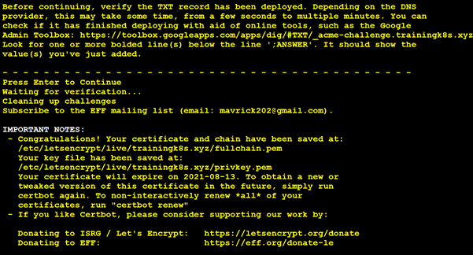

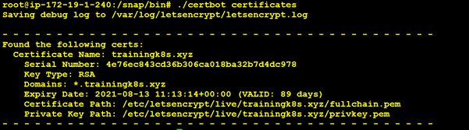

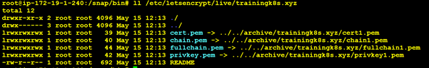

kubectl create secret tls my-tls-secret --cert=cert.pem --key=privkey.pem

Good Video on Traefik:

<https://www.youtube.com/watch?v=6BrFXxbFoh4>

<https://tferdinand.net/en/traefik-2-reverse-proxy-in-kubernetes/>

https://revolgy.com/blog/advanced-api-routing-in-eks-with-traefik-aws-loadbalancer-controller-and-external-dns/