DOwnload Istio and Copy istioctl to /usr/local/bin

curl -L https://istio.io/downloadIstio | sh -

cp istio-1.12.2/bin/istioctl /usr/local/bin/

We need to use AWS NLB as a Ingress Controller. Create a new file with name istio-ingressgateway.yml and copy below to it.

apiVersion: install.istio.io/v1alpha1

kind: IstioOperator

metadata:

name: istio-ingressgateway

spec:

profile: empty # Do not install CRDs or the control plane

components:

ingressGateways:

- name: ingressgateway

namespace: istio-system

enabled: true

k8s:

serviceAnnotations:

service.beta.kubernetes.io/aws-load-balancer-type: "nlb"

label:

istio: ingressgateway

values:

gateways:

istio-ingressgateway:

injectionTemplate: gateway

To Install ISTIO with AWS NLB as a load balancer, run the following command:

*istioctl install --set profile=minimal -f istio-ingressgateway.yml*

*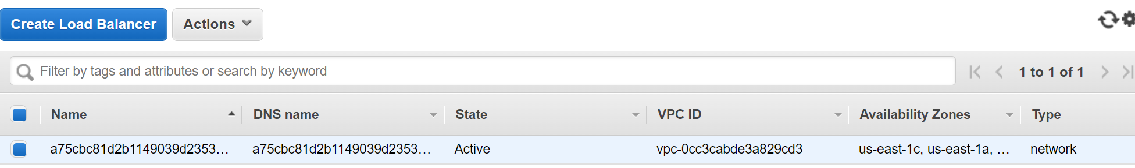*

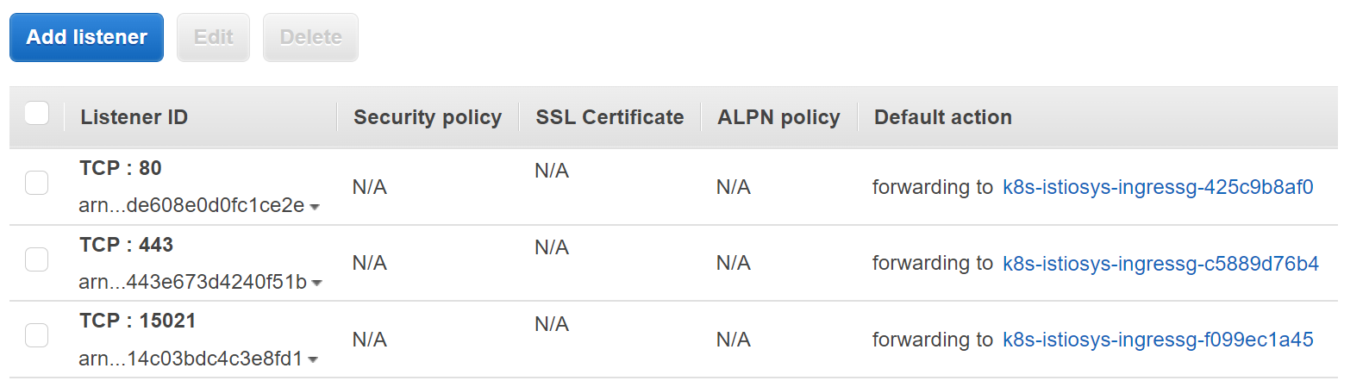

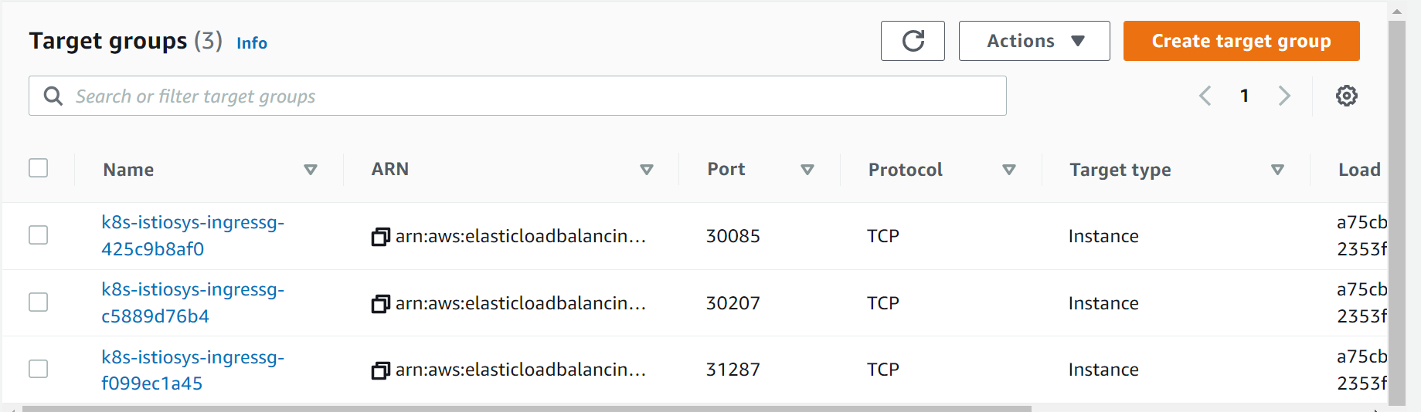

For kiali we need prometheus. Install using the following command:

kubectl apply -f <https://raw.githubusercontent.com/istio/istio/release-1.13/samples/addons/prometheus.yaml>

To Uninstall ISTIO Completely : *istioctl x uninstall --purge*

*istioctl install*

*istioctl profile list*

*kubectl label namespace default istio-injection=enabled*

Deploy votingapp with vote & result as ClusterIP

Instakk Kiali & Jaeger

kubectl apply -f https://raw.githubusercontent.com/istio/istio/release-1.13/samples/addons/kiali.yaml

kubectl apply -f https://raw.githubusercontent.com/istio/istio/release-1.13/samples/addons/jaeger.yaml

istioctl profile list

Dont make any change to gateway.yaml and deploy it ingressGateways, gateway, virtual service.

