**TEST YOUR RESPONSIVE DESIGN WITH GOOGLE CHROME**

**Note**: Resolution sizes to be used to test are:

* 1024x768 for desktop
* 768x1024 (Portrait) for iPad
* 320x480(Portrait) for iPhone

1. Open the html page in Google Chrome.
2. Right click and inspect element.

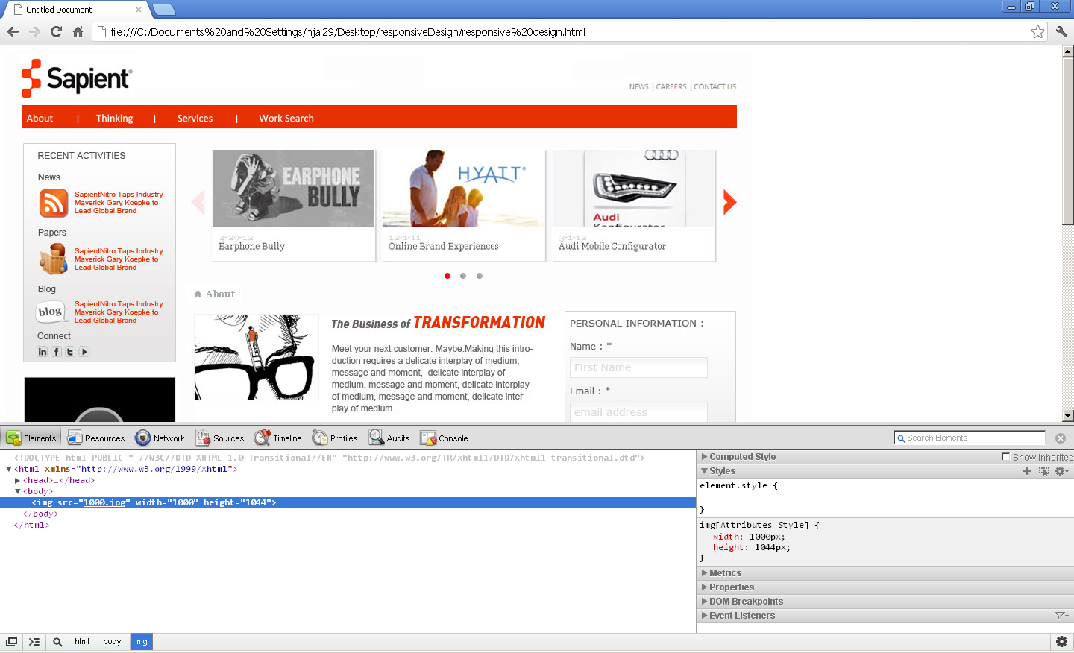

1. Open the settings of firebug from bottom-right corner.  
     
   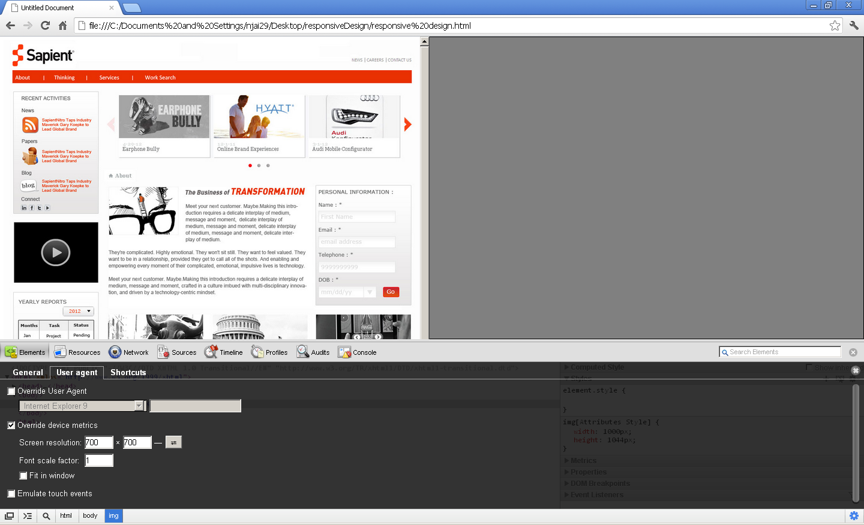
2. Follow the following steps as in screen shot to test.
   1. Switch to User Agent Tab
   2. Check the “override device matrics” option
   3. Provide the desired resolution
   4. Click on the “Go” button and check the result.

