LAB ASSIGNMENT – 2
Name:Greeshma.Rajala
Hall Ticket No: 2303A54022
Batch : 48

Task 1: Statistical Summary for Survey Data Prompt:
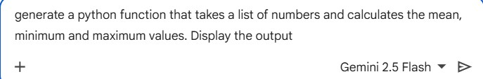
Code & Output:
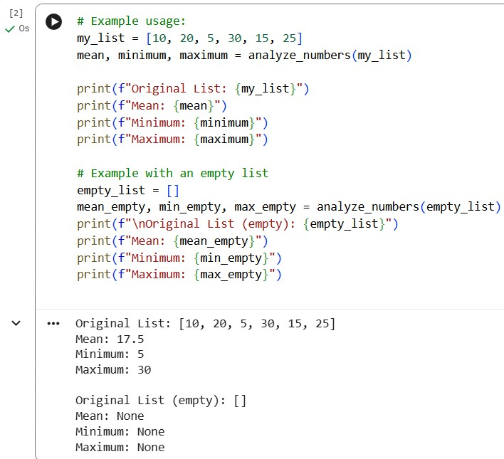
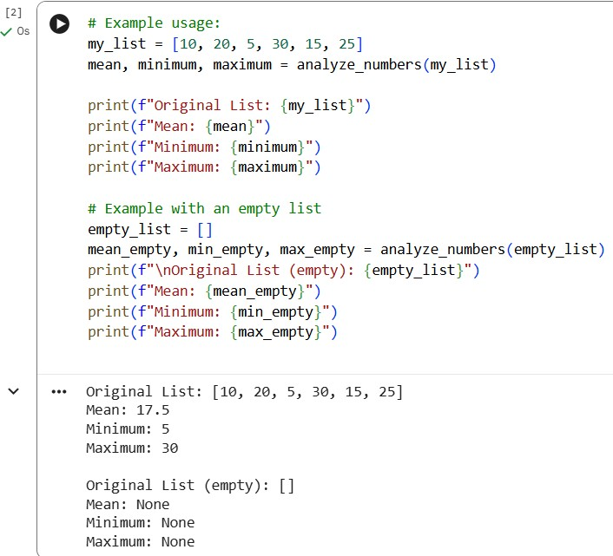
Explanation:
- Gemini produced readable and clear code.
- made effective use of built-in Python functions • The output appeared correctly in Google Colab.

Task 2: Armstrong Number – AI Comparison Prompt:
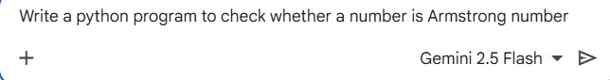
Code:
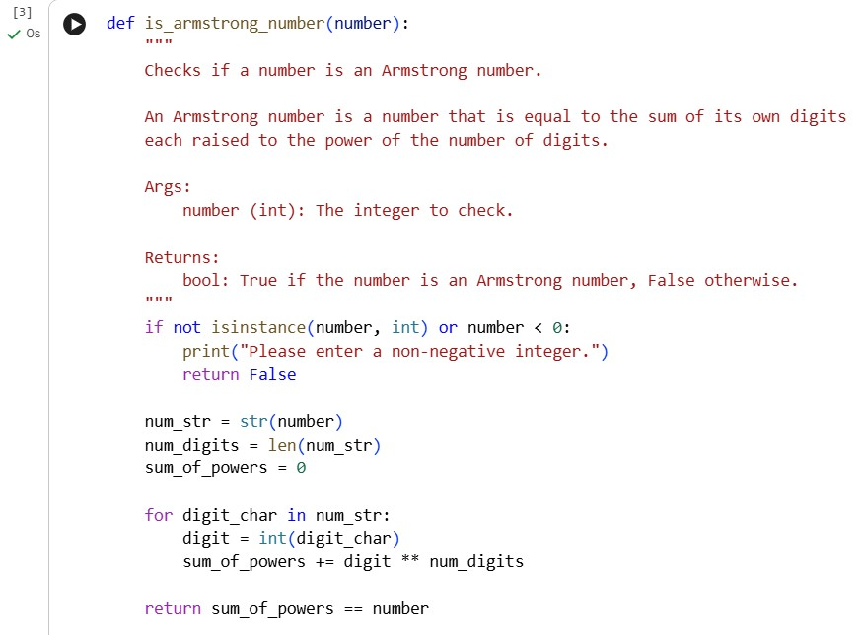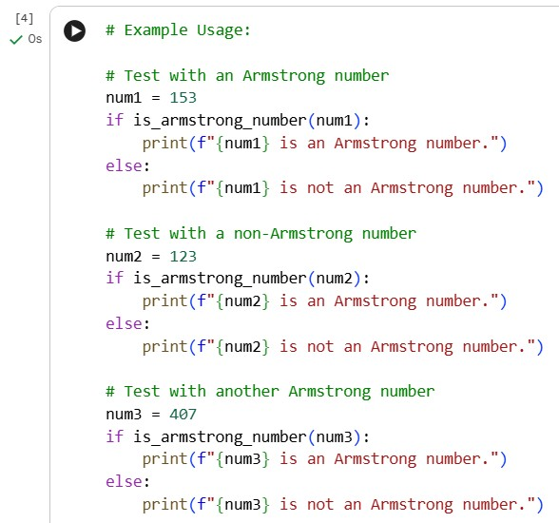

Output:
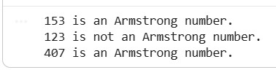
Using GitHub Copilot in VS Code:

Code:
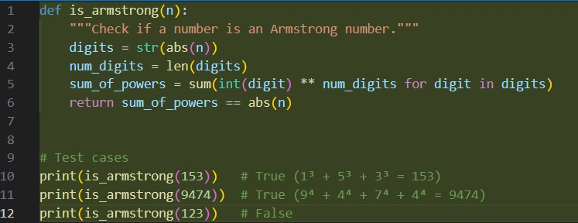
Output:
Explanation:
- Gemini is better at learning the basics.
- Copilot generates code that is more polished and optimised.

Task 3: Leap Year Validation Using Cursor AI Prompt 1:

Code:
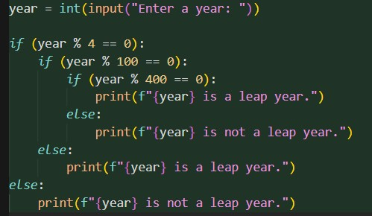
Output:
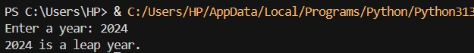
Prompt 2: Optimised version
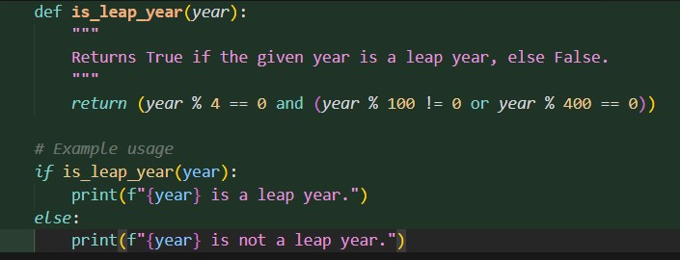
Explanation:
- Version 2 is reusable and modular.
- Cursor AI enhanced structure and documentation
- The second prompt produced code that was more polished and tidy.

Task 4: Student Logic + AI Refactoring (Odd/Even Sum) Own Code:
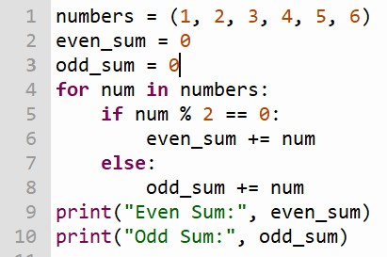
Output:
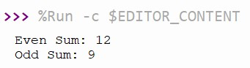
Refactored Code:
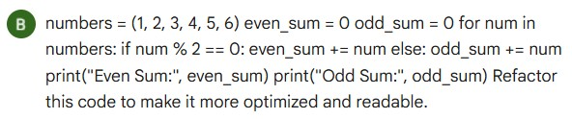
Code & Output:
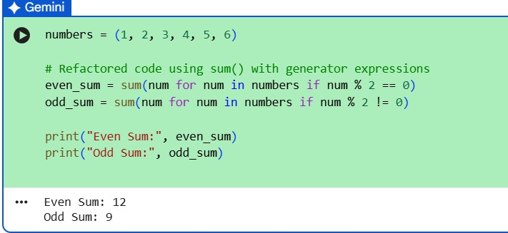
Explanation:
- In refactored code, the number of lines are reduced
- And such codes are very useful for large data sets.

