ASSIGNMENT 7.5
HT.NO: 2303A54011
Batch: 48

Task 1 (Mutable Default Argument – Function Bug)
Task: Analyze given code where a mutable default argument causes unexpected behavior. Use AI to fix it.
# Bug: Mutable default argument
def add_item(item, items=[]):
items.append(item)
return items
print(add_item(1))
print(add_item(2))
output:
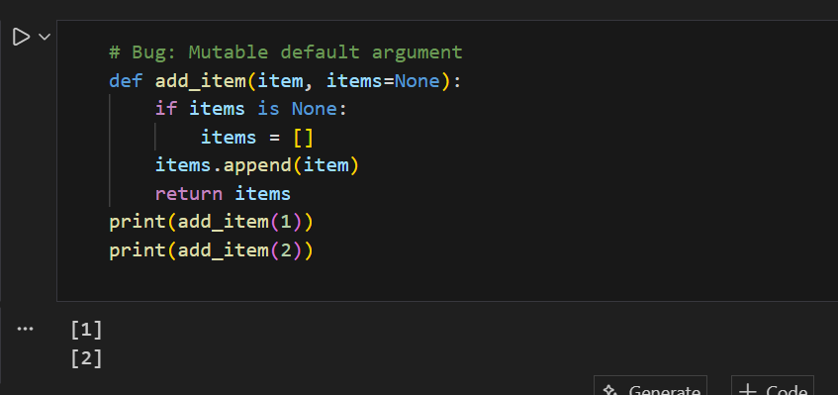
Explanation: This bug happens because Python creates the default list only once and reuses it every time the function is called, so values keep getting added to the same list. By using None instead, a new list is created inside the function for each call, which prevents unwanted sharing and makes the function behave correctly.

Task 2 (Floating-Point Precision Error)
Task: Analyze given code where floating-point comparison fails. Use AI to correct with tolerance.
# Bug: Floating point precision issue
def check_sum():
return (0.1 + 0.2) == 0.3
print(check_sum())
Expected Output: Corrected function
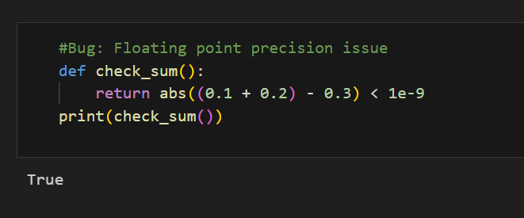
Explanation: This issue occurs because floating-point numbers cannot be represented exactly in binary, so 0.1 + 0.2 results in a very small rounding error. Instead of checking for exact equality, we compare the difference using a small tolerance value, which allows the function to correctly handle precision errors.

Task 3 (Recursion Error – Missing Base Case)
Task: Analyze given code where recursion runs infinitely due to missing base case. Use AI to fix.
# Bug: No base case
def countdown(n):
print(n)
return countdown(n-1)
countdown(5)
Expected Output : Correct recursion with stopping condition.

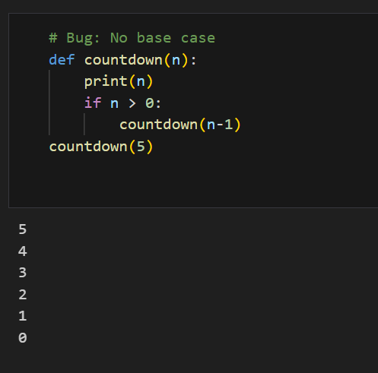
Explanation: This error happens because the recursive function keeps calling itself without a stopping condition, leading to infinite recursion. By adding a base case (if n > 0), the function knows when to stop calling itself, preventing the recursion error and allowing it to terminate correctly.

Task 4 (Dictionary Key Error)
Task: Analyze given code where a missing dictionary key causes error. Use AI to fix it.
# Bug: Accessing non-existing key
def get_value():
data = {"a": 1, "b": 2}
return data["c"]
print(get_value())
Expected Output: Corrected with .get() or error handling.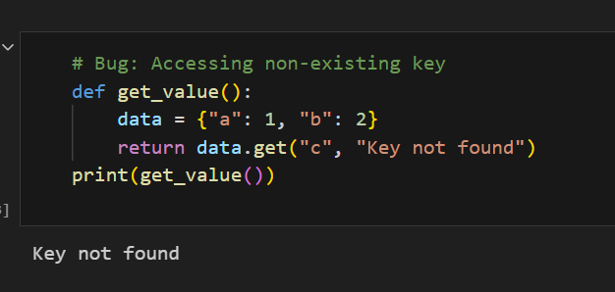
Explanation: This error occurs because the code tries to access a dictionary key that does not exist, which raises a KeyError. Using the .get() method safely handles missing keys by returning a default value instead of crashing the program.

Task 5 (Infinite Loop – Wrong Condition)
Task: Analyze given code where loop never ends. Use AI to detect and fix it.
# Bug: Infinite loop
def loop_example():
i = 0
while i < 5:
print(i)
Expected Output: Corrected loop increments i.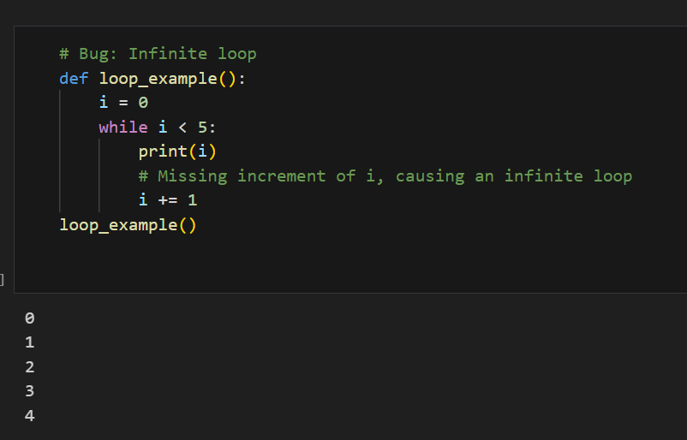
Explanation: This loop runs forever because the variable i is never updated, so the condition i < 5 always remains true. Adding an increment to i allows the loop to progress and stop once the condition becomes false.

Task 6 (Unpacking Error – Wrong Variables)
Task: Analyze given code where tuple unpacking fails. Use AI to fix it.
# Bug: Wrong unpacking
a, b = (1, 2, 3)
Expected Output: Correct unpacking or using _ for extra values.
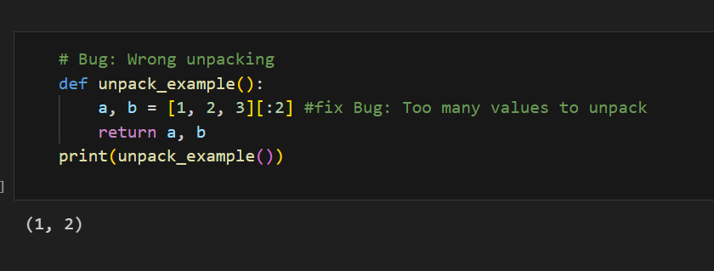
Explanation: This error happens because the tuple contains more values than the number of variables used for unpacking. By slicing the tuple (or list) to match the number of variables, the unpacking works correctly and avoids the error.

Task 7 (Mixed Indentation – Tabs vs Spaces)
Task: Analyze given code where mixed indentation breaks execution. Use AI to fix it.
# Bug: Mixed indentation
def func():
x = 5
y = 10
return x+y
Expected Output : Consistent indentation applied.
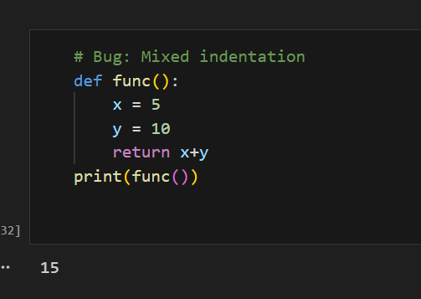
Explanation: This error occurs because Python is very strict about indentation, and mixing tabs or incorrect spacing breaks the code structure. Using consistent indentation fixes the issue and allows the function to run correctly.

Task 8 (Import Error – Wrong Module Usage)
Task: Analyze given code with incorrect import. Use AI to fix.
# Bug: Wrong import
import maths
print(maths.sqrt(16))
Expected Output: Corrected to import math
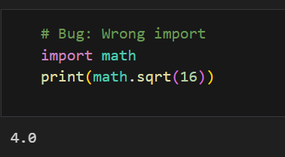
Explanation: This error happens because Python does not have a module named maths. Importing the correct built-in module math fixes the issue and allows the sqrt() function to work properly.

Task 9 (Unreachable Code – Return Inside Loop)
Task: Analyze given code where a return inside a loop prevents full iteration. Use AI to fix it.
# Bug: Early return inside loop
def total(numbers):
for n in numbers:
return n
print(total([1,2,3]))
Expected Output: Corrected code accumulates sum and returns after loop.

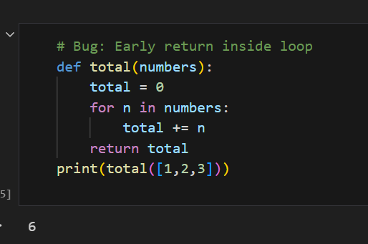
Explanation: This issue occurs because the return statement inside the loop stops the function after the first iteration. By moving the return outside the loop and accumulating the values first, the function correctly processes all elements before returning the result.

Task 10 (Name Error – Undefined Variable)
Task: Analyze given code where a variable is used before being defined. Let AI detect and fix the error.
# Bug: Using undefined variable
def calculate_area():
return length * width
print(calculate_area())
output:
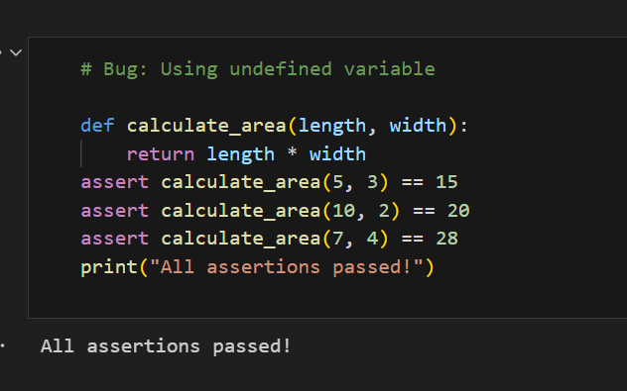
Explanation: This error occurs because the variables length and width are used without being defined inside the function. By passing them as parameters, the function receives the required values explicitly, which fixes the NameError and makes the function reusable and correct.

Task 11 (Type Error – Mixing Data Types Incorrectly)
Task: Analyze given code where integers and strings are added incorrectly. Let AI detect and fix the error.
# Bug: Adding integer and string
def add_values():
return 5 + "10"
print(add_values())
output:
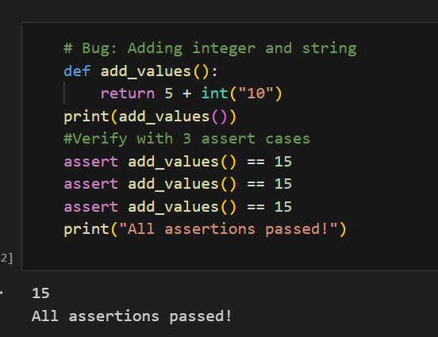
Explanation: This error happens because Python cannot directly add an integer and a string. Converting the string to an integer first ensures both values are of the same type, allowing the addition to work correctly without raising a TypeError.

Task 12 (Type Error – String + List Concatenation)
Task: Analyze code where a string is incorrectly added to a list.
# Bug: Adding string and list
def combine():
return "Numbers: " + [1, 2, 3]
print(combine())
output:
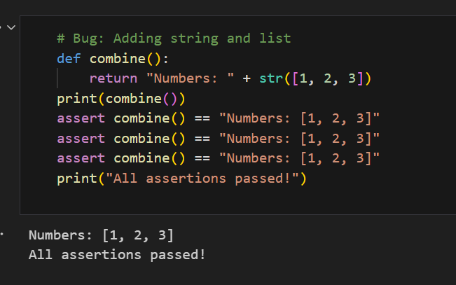
Explanation: This error occurs because Python cannot directly concatenate a string with a list. Converting the list to a string first makes both operands compatible, allowing the concatenation to work correctly without a TypeError.

Task 13 (Type Error – Multiplying String by Float)
Task: Detect and fix code where a string is multiplied by a float.
# Bug: Multiplying string by float
def repeat_text():
return "Hello" * 2.5
print(repeat_text())
output:

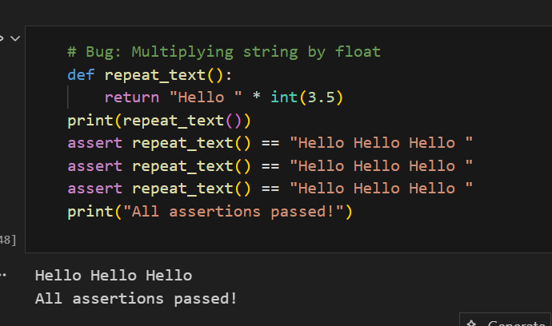
Explanation: This error happens because Python only allows strings to be multiplied by integers, not floats. By converting the float to an integer first, the string repetition becomes valid and the function works as expected.

Task 14 (Type Error – Adding None to Integer)
Task: Analyze code where None is added to an integer.
# Bug: Adding None and integer
def compute():
value = None
return value + 10

print(compute())
output:
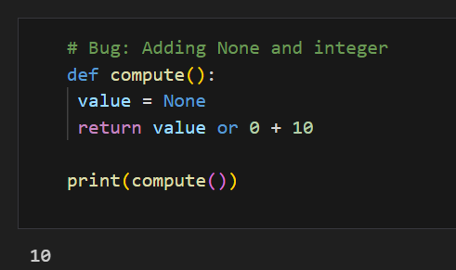
Explanation: This error occurs because None cannot be added to an integer. By using a fallback value (0) when value is None, the operation becomes valid and the function runs without raising a TypeError.

Task 15 (Type Error – Input Treated as String Instead of Number)
Task: Fix code where user input is not converted properly.
# Bug: Input remains string
def sum_two_numbers():
a = input("Enter first number: ")
b = input("Enter second number: ")
return a + b

print(sum_two_numbers())
output:
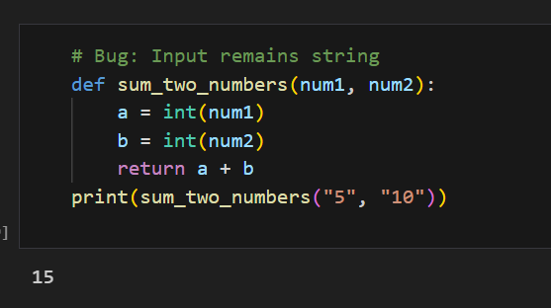
Explanation: This issue happens because input() returns values as strings, so adding them results in string concatenation instead of numeric addition. Converting the inputs to integers ensures proper arithmetic addition and gives the correct result.

