**CBA: Practice Problem Set 5**

**Topics: Confidence Intervals for Proportions**

1. The Java computer language, developed by Sun Microsystems, has the advantage that its programs can run on types of hardware ranging from mainframe computers all the way down to handheld computing devices or even smart phones. A test of 100 randomly selected programmers revealed that 71 preferred Java to their other most used computer languages. Construct a 95% confidence interval for the proportion of all programmers in the population from which the sample was selected who prefer Java.

Ans:

Given that x̄ = 71, n = 100, Z1-α=1.96

Formula:

Standard error of the mean = SEM = √x(N-x)/N3 = 0.045

α = (1-CL)/2 = 0.025

Standard normal deviate for α = Z1-α = 1.960

Proportion of positive results = P = x/N = 0.710

Lower bound = P - (Zα*SEM) = 0.621

Upper bound = P + (Zα*SEM) = 0.799

1. A small British computer-game firm, Eidos Interactive PLC, stunned the U.S.- and Japan-dominated market for computer games when it introduced Lara Croft, an Indiana Jones-like adventuress. The successful product took two years to develop. One problem was whether Lara should have a swinging ponytail, which was decided after taking a poll. If in a random sample of 200 computer-game enthusiasts, 161 thought she should have a swinging ponytail (a computer programmer’s nightmare to design), construct a 95% confidence interval for the proportion of enthusiasts who would like here to have a swinging ponytail, in this market. If the decision to incur the high additional programming cost was to be made if *p>* 0.90, was the right decision made (when Eidos went ahead with the ponytail)?

Ans:

n=161, p=0.90

std. error=SQRT ((0.90*0.10)/161) =0.023

95 % Interval Confidence:

=0.90+-1.96(0.023) = 0.90+-0.04 (86% to 94% )

1. According to a survey published in the *Financial Times,* 56% of executives at Britain’s top 500 companies are less willing than they had been five years ago to sacrifice their family lifestyle for their career. If the survey consisted of a random sample of 40 executives, give a 95% confidence interval for the proportion of executives less willing to sacrifice their family lifestyle.

Ans:

Given, p=0.56, n=40

Std. error =(p(1-p)/n) (1/2) = (0.56(1-0.56)/40)0.5 = 0.0785

1. A survey of 5,250 business travelers worldwide conducted by OAG Business Travel Lifestyle indicated that 91% of business travelers consider legroom the most important in-flight feature. (Angle of seat recline and food service were second and third, respectively.) Give a 95% confidence interval for the proportion of all business travelers who consider legroom the most important feature.

Ans:

Given: p=0.91, n=5250, Z1-α/2 = 1.96

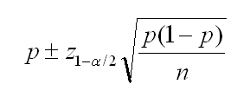

=0.91-1.96*SQRT ((0.91*0.09)/5250) < P < 0.91+1.96*SQRT ((0.91*0.09)/5250)

=0.91-0.0077 < P < 0.91+0.0077

=0.90 < P < 0.92

Conclusion is that 95% confidence interval for the proportion of all business travelers who consider legroom the most important feature is between 90% to 92%.

1. According to *Money,* 60% of men have significant balding by age 50.24 If this finding is based on a random sample of 1,000 men of age 50, give a 95% confidence interval for the proportion of men of 50 who show some balding.

Ans:

P1=0.6, P2=0.4, n1=1000, n2=50, Z=1.96

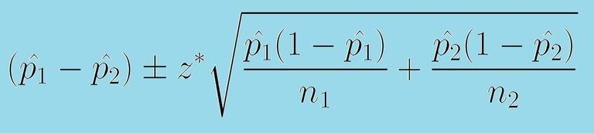

= (0.6-0.4)-1.96*SQRT ((0.6*0.4)/1000+(0.4*0.6)/50) < P < (0.6-0.4) +1.96*SQRT ((0.6*0.4)/1000+(0.4*0.6)/50)

=0.2-1.96*0.07 < P < 0.2+1.96*0.07

=0.2-0.1372 < P <0.2+0.1372

=0.06 < P < 0.34

95% confidence interval for the proportion of men of 50 who show some balding is

between 6%-34%.