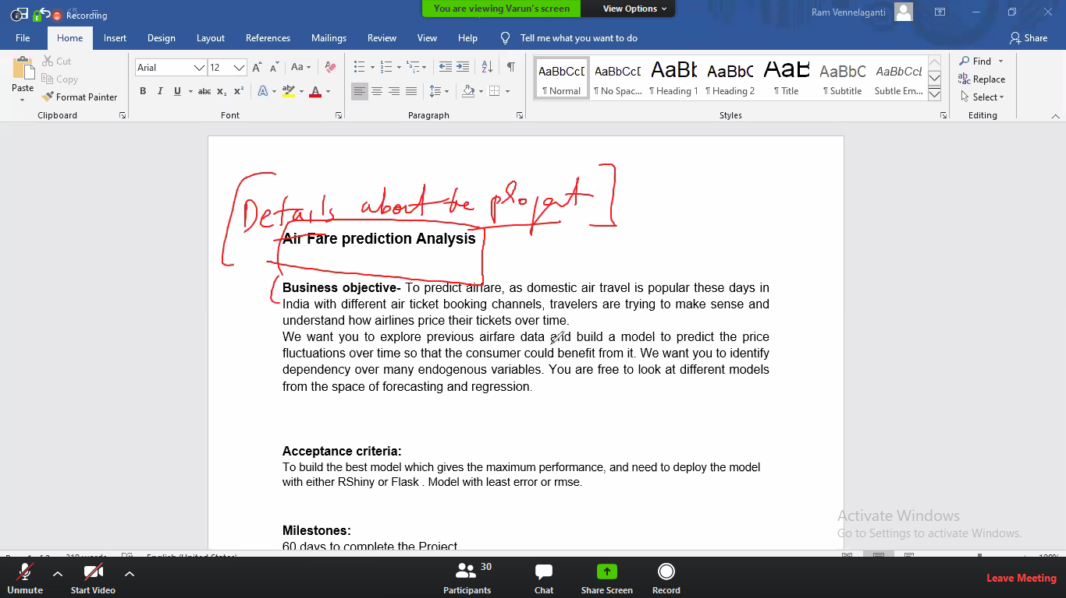

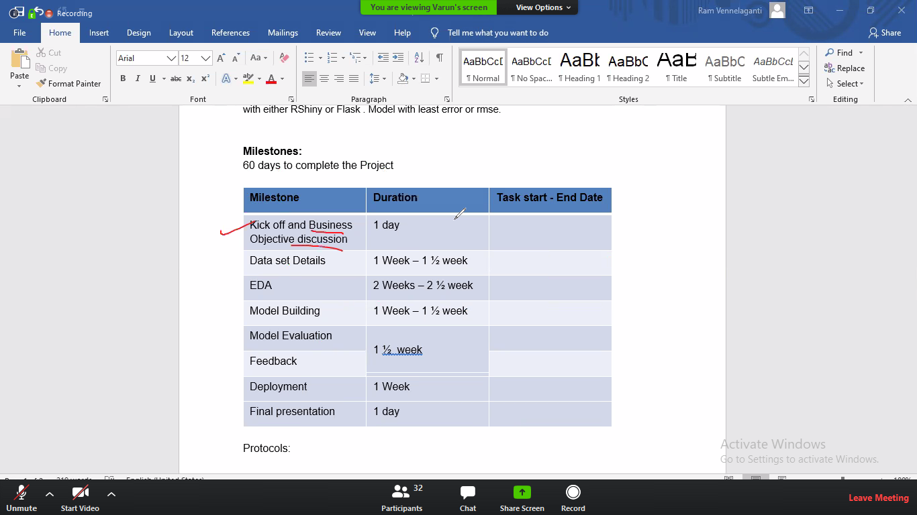

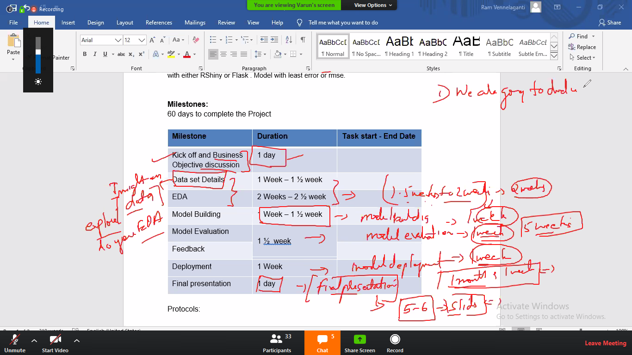

Varun

Munmun

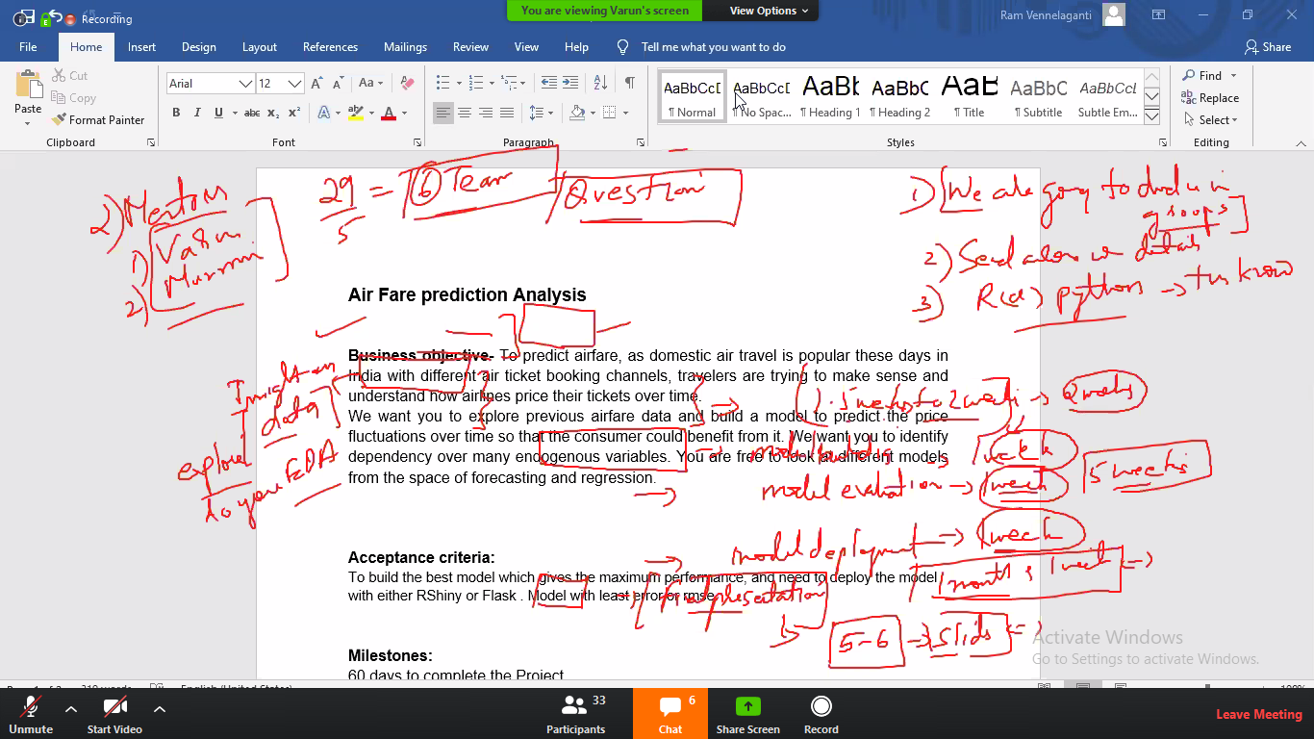

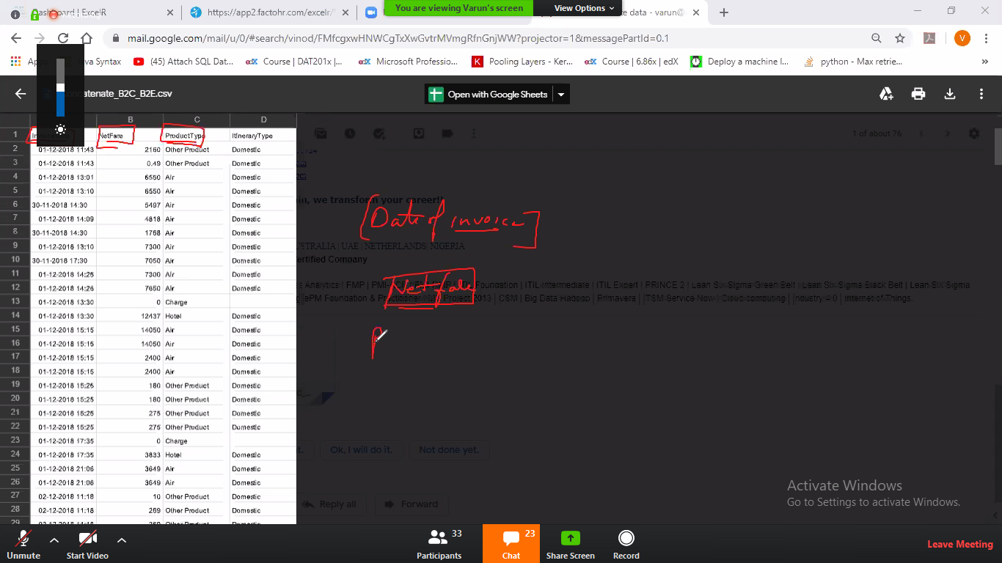

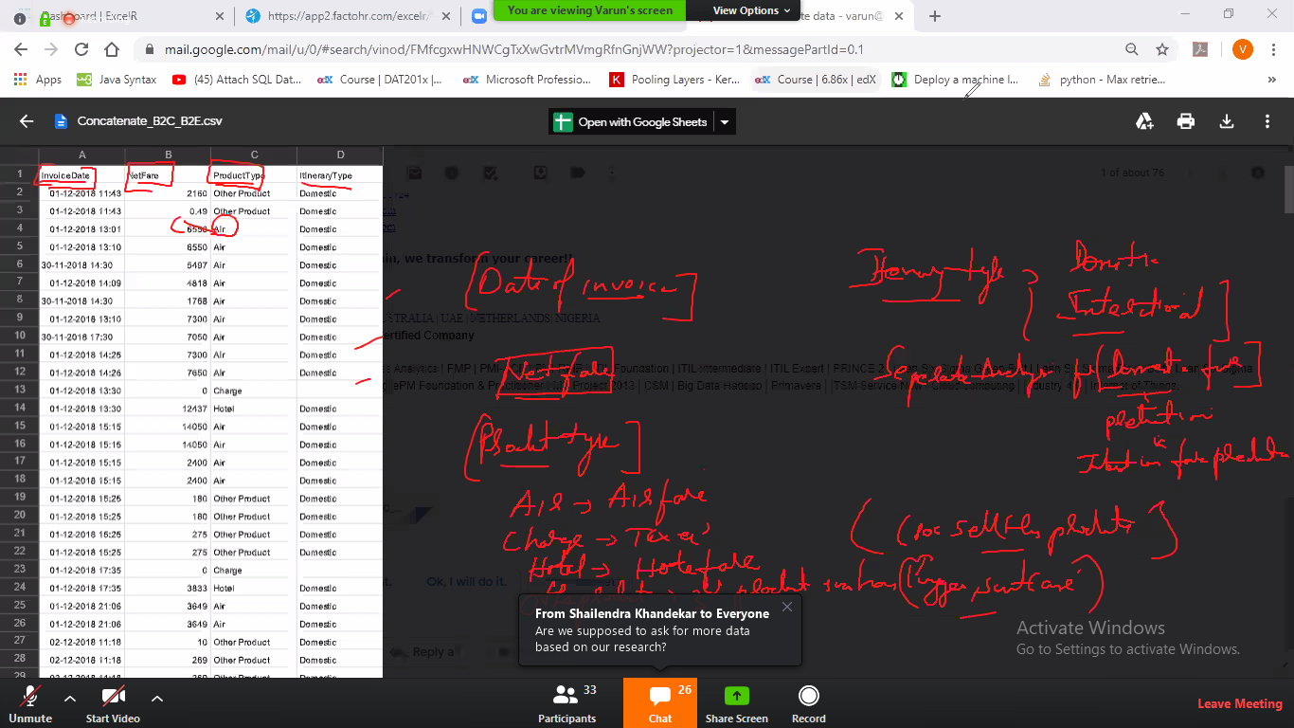

From Anupama to Everyone: 07:00 PM

hi s

From Anup Prakash to Everyone: 07:00 PM

hello

From Milind to Everyone: 07:00 PM

hello...

From Shailendra Khandekar to Everyone: 07:00 PM

hiThis is Neha

From Girish Warke to Everyone: 07:00 PM

hi

From Anupama to Everyone: 07:05 PM

hi mr varun will u share the doc one which u explaining right now as well ?

From Shailendra Khandekar to Everyone: 07:05 PM

Who is going to use this model?travel agency?

From Anupama to Everyone: 07:05 PM

ok tq

From Shailendra Khandekar to Everyone: 07:08 PM

how many groups?

From Akanksha to Everyone: 07:10 PM

I guess the groups should be formed based on who is going to work on R or python

From Shailendra Khandekar to Everyone: 07:10 PM

agree

From Pooja kumari to Everyone: 07:10 PM

yeah

From Arun Ailani to Everyone: 07:11 PM

ya..lets seen talk with each other

From Md Nadeem to Everyone: 07:12 PM

changing seat arrangement from now onwards will effect the priceshow to inculcate that change?

From Anupama to Everyone: 07:12 PM

ya right

From Dibyanjan Patra to Everyone: 07:12 PM

insights will be shared for a group or indivisually?

From Munmun to Everyone: 07:12 PM

we are not into that.. initially you need to build model based on dataset provided..

From Sai Rahul’s iPhone to Everyone: 07:13 PM

ok

From Arun Ailani to Everyone: 07:13 PM

if in job??at dat tymcoz my shift timing is 1-10pm

From Sai Rahul’s iPhone to Everyone: 07:14 PM

so this jobwill be distributed or should everyone build their own model?

From Shailendra Khandekar to Everyone: 07:14 PM

only 4 columns?

From Munmun to Everyone: 07:16 PM

next time when we post schedule of meeting on group at that time you just remind us about your job timing either we will change meeting time or you can contact varun or me job will be distributed among team members... so if we will have 6 teams we will have 6 models at the end

From Shailendra Khandekar to Everyone: 07:16 PM

Are we supposed to ask for more data based on our research?I mean more variables

From Sai Rahul’s iPhone to Everyone: 07:18 PM

so is this model building should be done individually person to person or by group?ok

From Akanksha to Everyone: 07:21 PM

Not sure to understand how there will be 6 models

From Shailendra Khandekar to Everyone: 07:22 PM

sure..

From Sai Rahul’s iPhone to Everyone: 07:22 PM

ok

From Me to Everyone: 07:22 PM

Please divide groups by your sides....because it will be take time with our side

From Akanksha to Everyone: 07:22 PM

right

From Pooja kumari to Everyone: 07:22 PM

true

From Sai Rahul’s iPhone to Everyone: 07:23 PM

yes

From Dibyanjan Patra to Everyone: 07:23 PM

right

From Akanksha to Everyone: 07:23 PM

It will be good if you form the groups since you have all our details

From tushar Singh to Everyone: 07:23 PM

yea we don't know anyone so!

From Girish Warke to Everyone: 07:23 PM

I am agree with itwe don't knw anyone

From Sai Rahul’s iPhone to Everyone: 07:23 PM

ok

From Sujini to Everyone: 07:24 PM

Is this video uploaded

From Sai Rahul’s iPhone to Everyone: 07:24 PM

tq

From Akash Nh to Everyone: 07:24 PM

what is the project duration ?

From Shailendra Khandekar to Everyone: 07:24 PM

ok. Thank you

From Sai Rahul’s iPhone to Everyone: 07:25 PM

so ultimately goal is to predict variable which influence the price for domestic and international

From Milind to Everyone: 07:26 PM

Does every group is reqired to work on R and Python both ?

From Sai Rahul’s iPhone to Everyone: 07:26 PM

yes ok

From Akanksha to Everyone: 07:26 PM

I am working in python . Who all are there for python?

From Milind to Everyone: 07:26 PM

ok..thks..

From Dibyanjan Patra to Everyone: 07:26 PM

me

From Girish Warke to Everyone: 07:26 PM

I am also working in python

From Pooja kumari to Everyone: 07:26 PM

same here..

From Shailendra Khandekar to Everyone: 07:27 PM

I am for R

From Sai Rahul’s iPhone to Everyone: 07:27 PM

any docs to fill online?

From Anupama to Everyone: 07:27 PM

varun.. wr will share the data??? through WhatsApp??

From Dibyanjan Patra to Everyone: 07:27 PM

I am also comfortable wid python

From Simarjeet Singh to Everyone: 07:27 PM

python only

From Shailendra Khandekar to Everyone: 07:27 PM

send it on email

From Akanksha to Everyone: 07:27 PM

ok

From Anupama to Everyone: 07:27 PM

ok tq

From rajat singhal to Everyone: 07:27 PM

ok thank u