Hi’
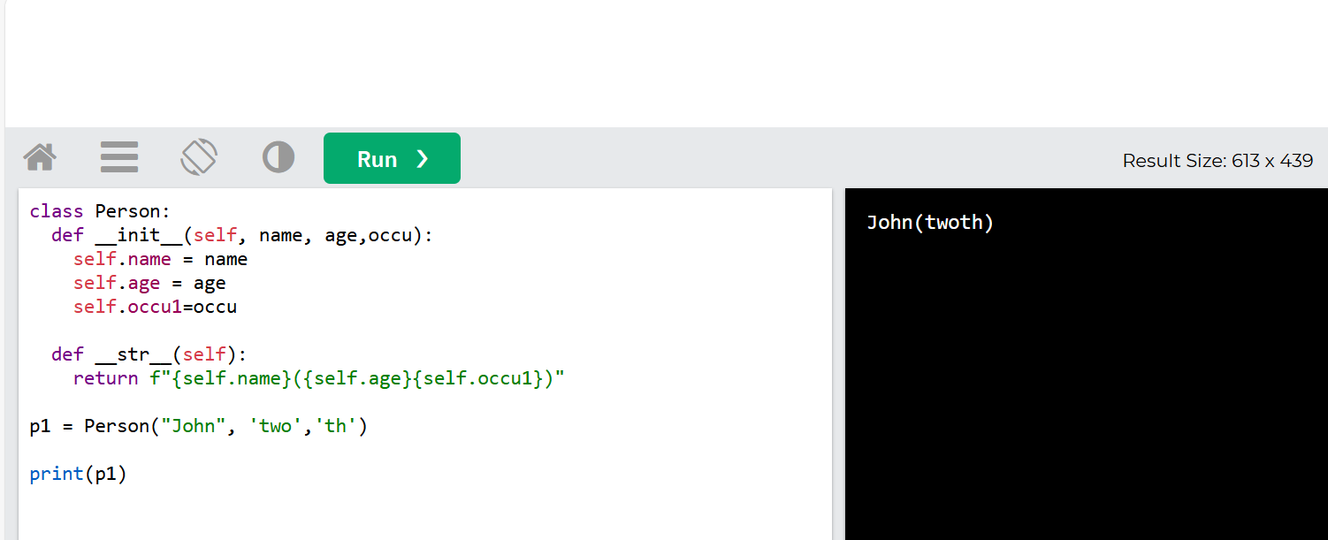

: The __init__() function is called automatically every time the class is being used to create a new object.

The self parameter is a reference to the current instance/object of the class, and is used to access variables/properites that belong to the class.

you can call it whatever you like, but it has to be the first parameter of any function in the class

Use the pass keyword when you do not want to add any other properties or methods to the class.

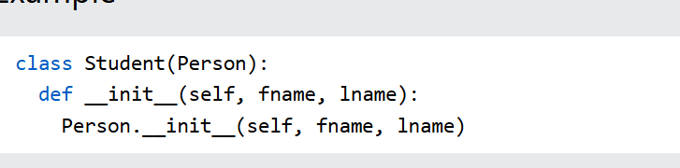
The child's __init__() function overrides the inheritance of the parent's __init__() function.
To keep the inheritance of the parent's __init__() function, add a call to the parent's __init__() function: 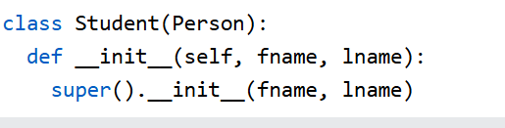By using the super() function, you do not have to use the name of the parent element, it will automatically inherit the methods and properties from its parent. 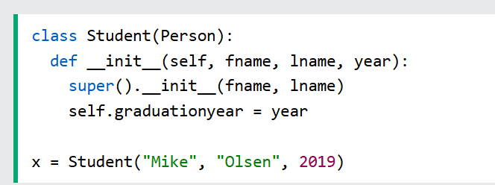
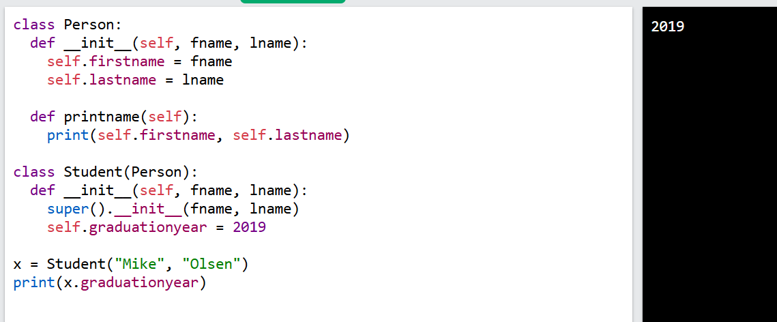

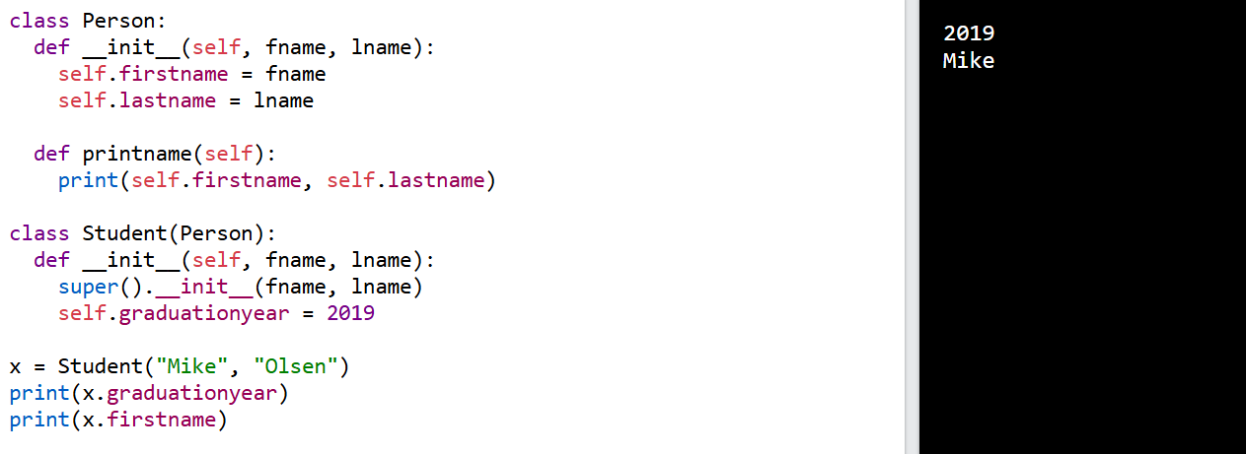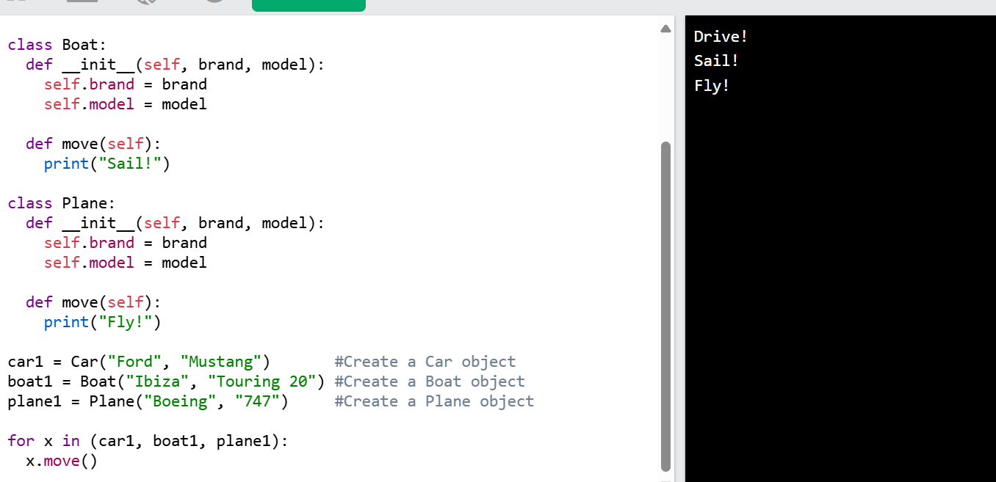
The nonlocal keyword is used to work with variables inside nested functions.
The nonlocal keyword makes the variable belong to the outer function.
What is a Module?
Consider a module to be the same as a code library.
A file containing a set of functions you want to include in your application.

Create a Module
To create a module just save the code you want in a file with the file extension .py:
When using a function from a module, use the syntax: module_name.function_name.

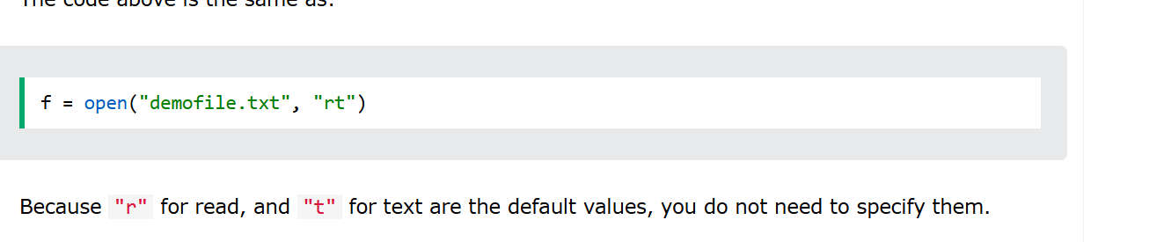
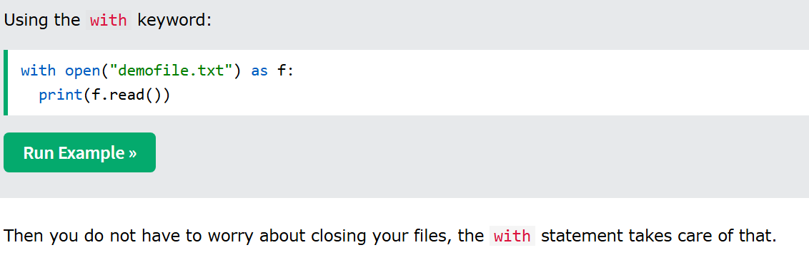
"a" - Append - will append to the end of the file
"w" - Write - will overwrite any existing content
"r" - Read - Default value. Opens a file for reading, error if the file does not exist
"a" - Append - Opens a file for appending, creates the file if it does not exist
"w" - Write - Opens a file for writing, creates the file if it does not exist
"x" - Create - Creates the specified file, returns an error if the file exists
In addition you can specify if the file should be handled as binary or text mode
"t" - Text - Default value. Text mode
"b" - Binary - Binary mode (e.g. images)
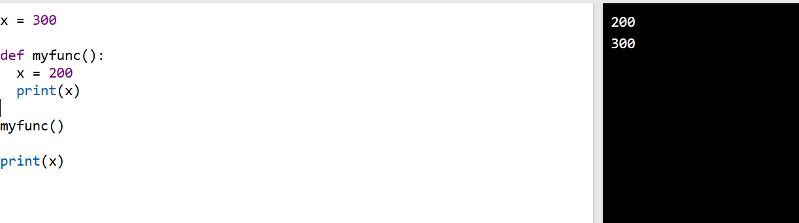
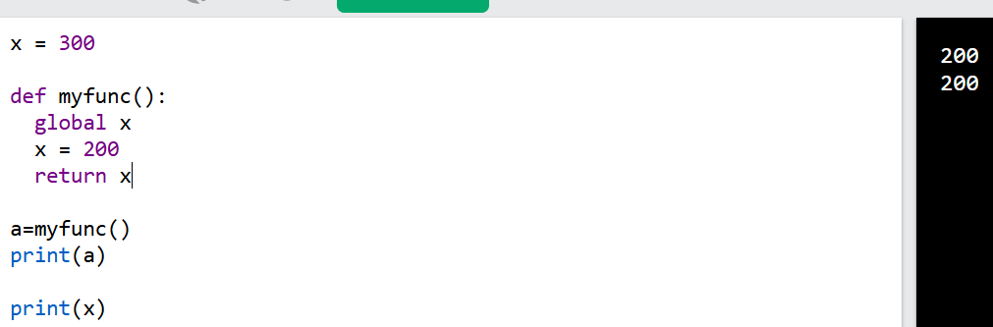

Python naming
Python Naming Conventions
Adhering to naming conventions in Python ensures your code is clean, readable, and maintainable. Below are the key guidelines:
1. Variables and Functions
- Use snake_case: Words are lowercase and separated by underscores.
  - Example: user_name, calculate_total.
2. Constants
- Use UPPERCASE_WITH_UNDERSCORES for constants.
  - Example: PI = 3.14, MAX_LIMIT = 100.
3. Classes
- Use PascalCase: Each word starts with an uppercase letter.
  - Example: UserProfile, OrderDetails.
4. Private Variables/Methods
- Prefix with a single underscore _ to indicate it’s intended for internal use.
  - Example: _internal_variable, _helper_function.
5. Special Methods
- Use double underscores (__) for special or "magic" methods.
  - Example: __init__, __str__.
6. Modules and Packages
- Use lowercase for module names, and lowercase_with_underscores for packages if needed.
  - Example: math, data_processing.
7. Avoid Reserved Keywords
- Do not use Python's reserved keywords (e.g., class, def, return) as names.
By following these conventions, your Python code will align with the widely accepted PEP 8 style guide, making it easier for others to understand and collaborate.
--
Folder Name | Purpose
src/ | Main source code of your application
tests/ | Unit and integration tests
docs/ | Documentation files
data/ | Input/output data files
config/ | Configuration files (e.g., YAML, JSON)
scripts/ | Utility or automation scripts
utils/ | Helper functions or shared utilities
notebooks/ | Jupyter notebooks (for data science projects)

my_project/
├── src/
│ ├── __init__.py
│ └── main.py
├── tests/
│ └── test_main.py
├── docs/
├── data/
├── config/
├── scripts/
├── utils/
└── README.md
-

