Here is the example of an
Elasticsearch kNN search for "pink shoe" using Cosine Similarity, demonstrating the internal mathematics, semantic clustering, and the effect of k=1 and num_candidates=2.
apply cosine similarity

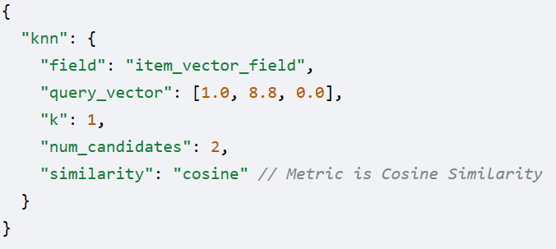
Knn-The HNSW algorithm structures these vectors into a graph to optimize nearest-neighbor retrieval.
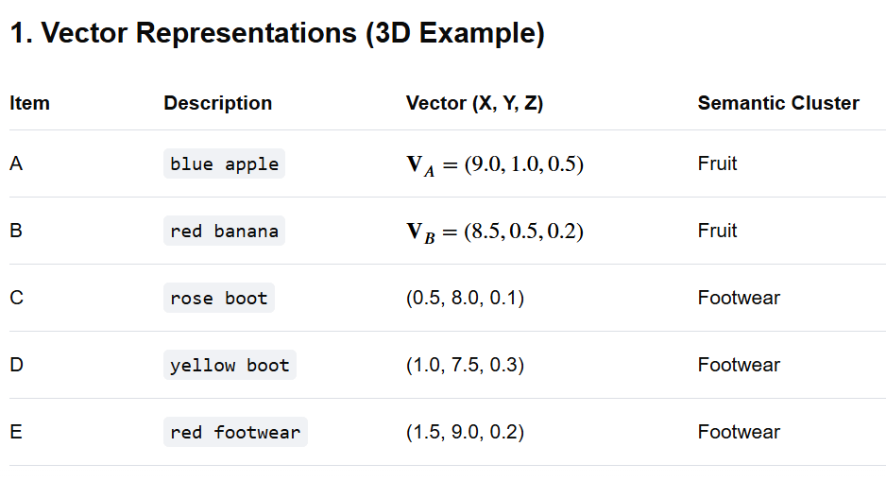
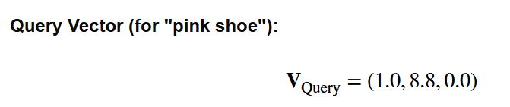
3. Internal Processing (HNSW & num_candidates: 2)
The HNSW algorithm identifies the two most promising vectors (
$$V_{E}$$
𝐕𝐸
,
$$V_{C}$$
𝐕𝐶
) within the footwear semantic cluster and proceeds to calculate their precise cosine similarity. The rest are ignored.
4. Mathematical Similarity Score Calculation (Cosine Similarity)
Cosine similarity measures the angle between vectors (a score from -1 to 1, where 1 is identical).
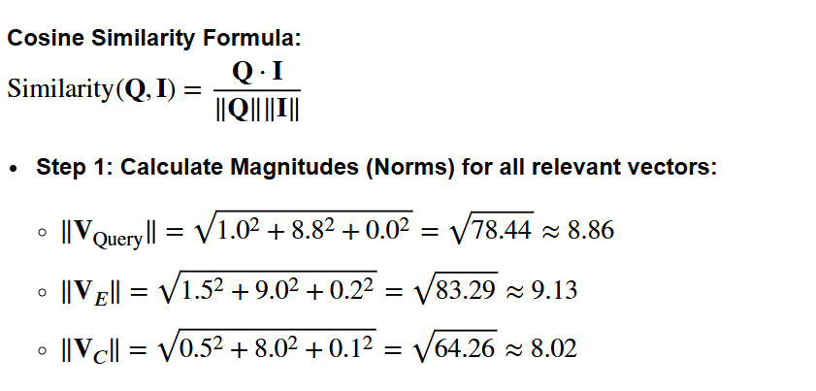
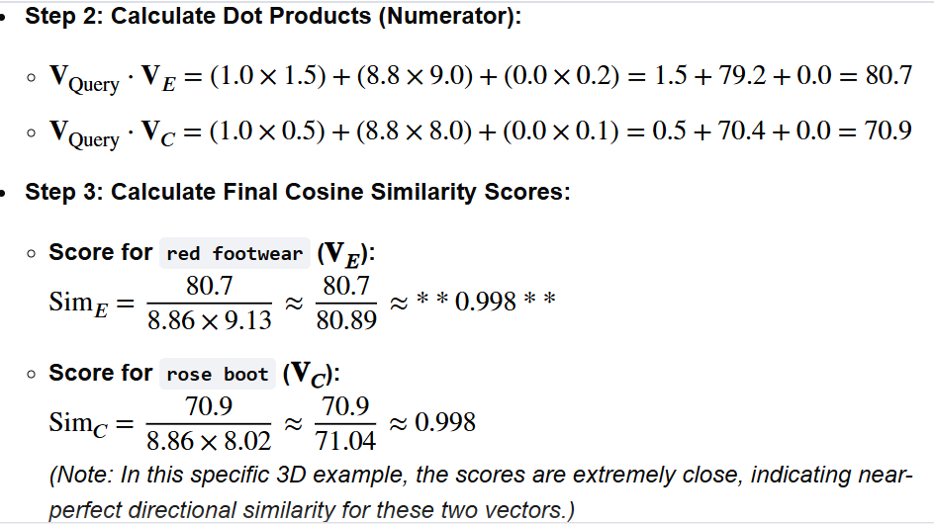

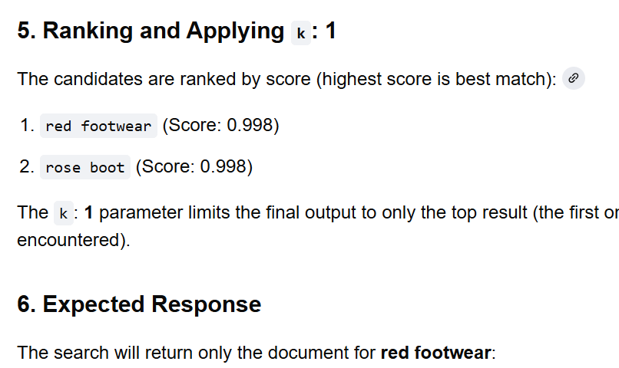
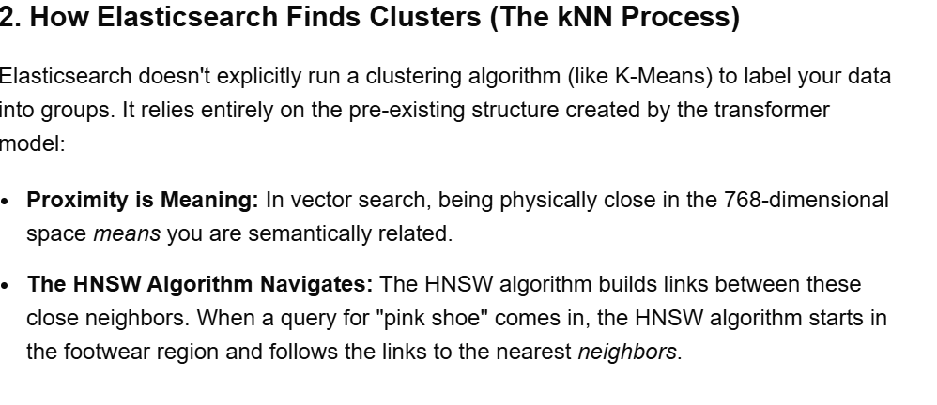
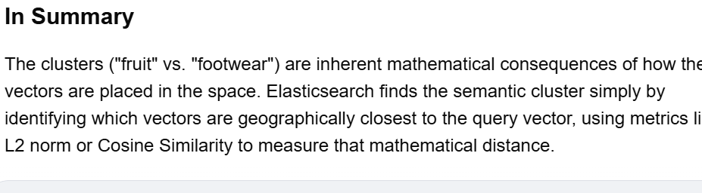--
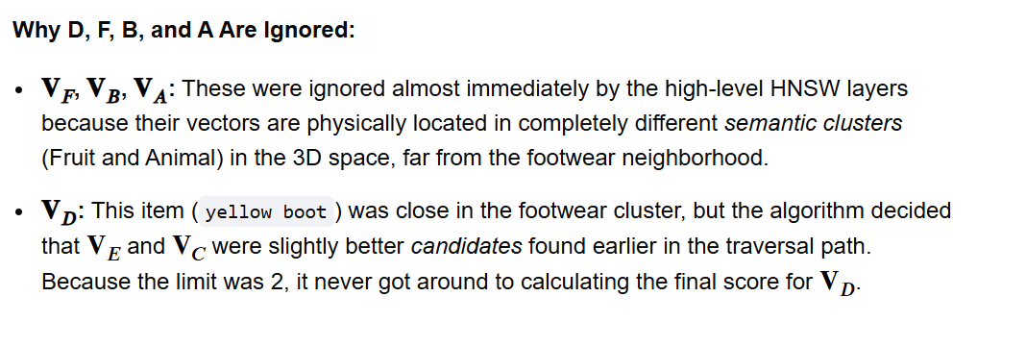
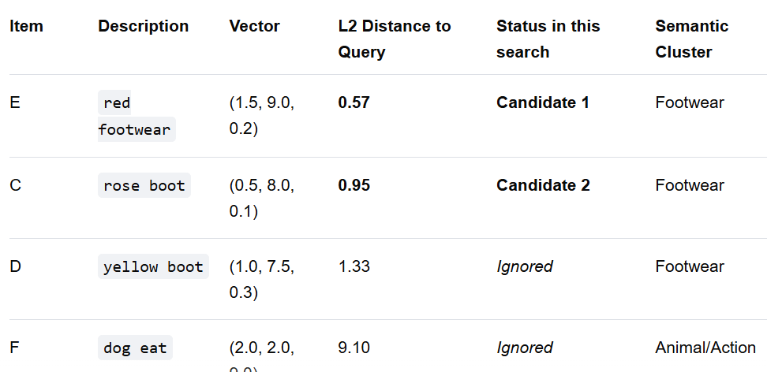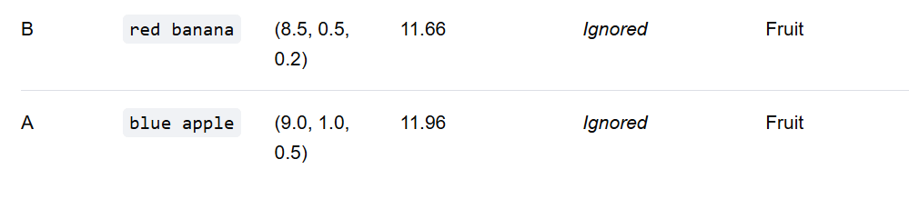
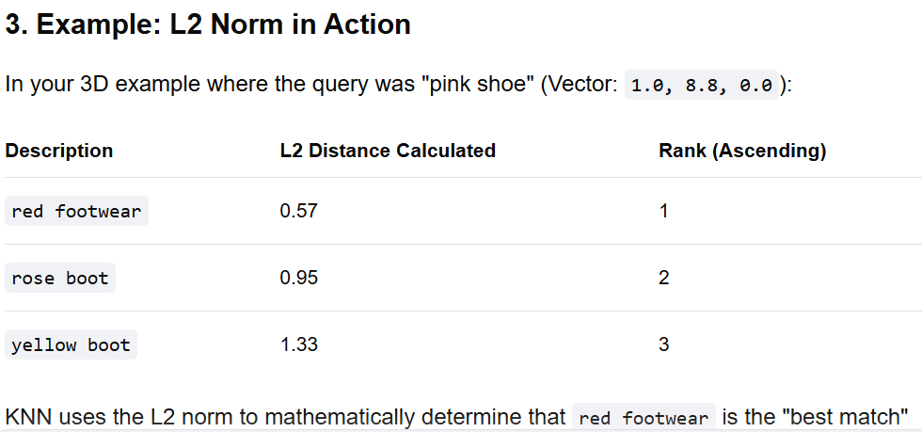
ull example of an Elasticsearch kNN search for "pink shoe" using 3D vector representations, demonstrating the internal mathematics (Euclidean distance), the effect of k=1 and num_candidates=2, and the semantic clustering.
