Vector DATABASE
- Google use semantic search not only matched exact keyword but also understand intent of user query ( using the context) to perform the search.
Example: calories in apple apple fruit, revenue in appleapple company google retrieve crt result.
- Search internally uses embeddings. Word embedding, sentence embedding meaning numeric representation (vectors)of text.
How embeddingsone way different properties/features of words(name entity recognization)
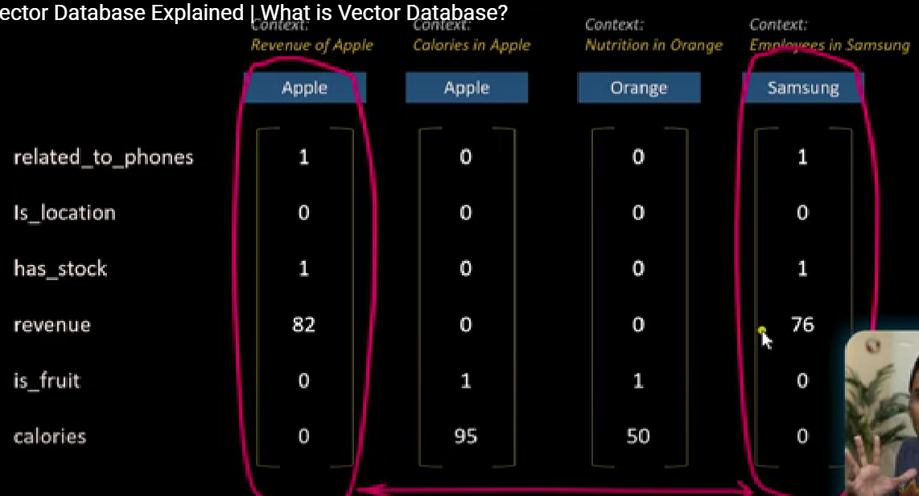 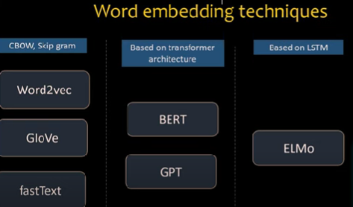
text based ai application create millions of vector u need to store them..traditionally use mysql(relational database)
how generate embeddingsopen api embeddings and then save database
Search query u will generate embedding—that embedding compared with stored embeddings and will try to retrieve relevant documents. use cosine similarity to retrieve the matching vector and get related context.
Linear search—one by one
Cosine similarity close to 1 or more than 0.5 u will put that vector into result.. and store result vector. L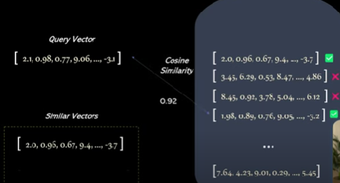 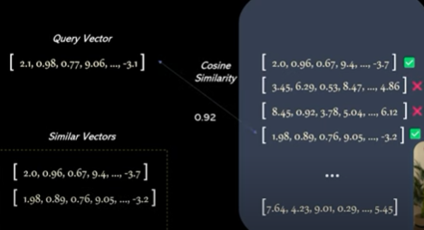
Database index-help search things faster 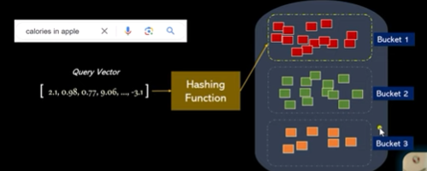 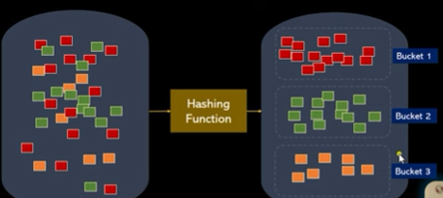
VDB--Hashing function create buckets of similar looking embeddings
Vector database technique LSH locality sensitive hasing..one bucket only compare..
vector database benefits fast search, optimized storage
Locality Sensitive Hashing (LSH):
- LSH is a technique used in approximate nearest neighbor (ANN) search. It’s essential for efficient similarity search in large datasets.
- Companies like Google, Amazon, Spotify, and Uber rely on similarity search for core functions.
- LSH allows us to perform sub-linear searches by reducing the number of comparisons.
- When a query comes in, the hashing function maps the query vector to a specific “bucket.” For example, if the query vector represents a dog, it goes to the “dog bucket.”
- From there, a linear search is performed within the bucket to find the candidates most similar to the query
Speeding Up Searches:
- Hash-based indexing, including LSH, speeds up searches for nearby neighbors in vector databases.
- LSH quickly converts query vectors into hash tables, facilitating fast similarity comparison

https://www.pinecone.io/learn/vector-database/

GENERATIVE AI
Llmfoundation models-use text nlp, vision DALLE2 which takes text data then used that to generate custom image,models for code like copilot that can help complete code(train triallions of data-unstructed, unsupervised manner)generative ai-generate something in new.
Model tuning small amount of data add foundation model and update parameter of model
Low data labels-foundation model apply—prompt engineering process—sentence positive or negative sentiment..
Foundation model—try to generate next word once it will finish generate words of sentence and the next word would be answer of ur classification problem.
Advantage performance, productivity gains(unabled data,low volume of data tune and prompt result get)
Disadvantage 1. compute cost expensive-more data difficult to train small enterproce difficult to train foundation model on their own. To get inference u require gpu-host these nideks and run inference more costly than traditional approaches.2. Trust(internet-data biase,hate speech,toxic info)
RAG
Why llmthis technique to enrich llm with ur private data. U cant ask chatgpt to search for a document on ur google drive with a content related to ur mom’s bdy.
Open ai has trained their models on public sources.so it can’t give answer for our own data. This is why u need RAG
How rag works?
1st u need to embedded ur prive data(all google drive files),then when we want search over our vector store, take search query embed it as well and perform some sort of similarity search to find most similar embedding to out search query.
The simplest similarity is measure cosine similarity-measure the cosine of the angles between each pair of embeddings . calculates the cosine similarity between the query vector and the document's vector,The most similar documents (highest scores) will be returned first..or just use retrievers for that task. Finally retrieved info is fed into llm as an additional context to ur prompt.
Stop words:

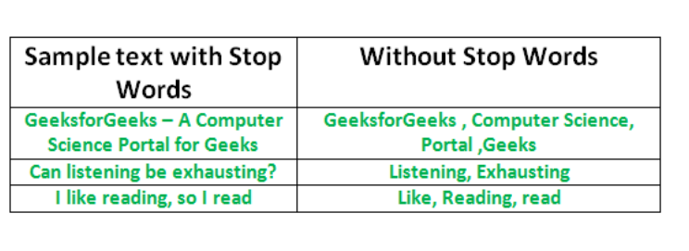
stop words in English are “a,” “the,” “is,” “are,” etc.
Stop words are commonly used in Text Mining and Natural Language Processing (NLP) to eliminate words that are so widely used that they carry very little useful information.
https://www.h2kinfosys.com/blog/nltk-regular-expressions/
u/s- https://github.com/pemagrg1/Text-Pre-Processing-in-Python/blob/master/Preprocess.py

Transformer architecture at a senior level (4+ years), you must focus on how it solved the sequential processing bottleneck of RNNs/LSTMs using Parallelism and Attention.
Here is the technical breakdown structured for an interview.

1. The Core Innovation: "Attention is All You Need"
"The Transformer is a sequence-to-sequence architecture that replaces recurrence with Self-Attention. Unlike LSTMs, which process tokens one-by-one (O(n) time complexity), Transformers process the entire sequence simultaneously, allowing for massive parallelization during training."
2. Key Components (The Technical Pillars)
A. Positional Encoding
- The Concept: Since Transformers process all tokens at once, they have no inherent sense of word order.
- The Term: Positional Encodings (using Sine and Cosine functions) are added to the input embeddings to inject information about the relative or absolute position of tokens in the sequence.
B. Multi-Head Self-Attention (The "Brain")
- The Mechanism: For every token, the model creates three vectors: Query (Q), Key (K), and Value (V).
- The Calculation: It uses Scaled Dot-Product Attention:
$$\text{Attention}(Q,K,V)=\text{softmax}(\frac{QK^{T}}{\sqrt{d_{k}}})V$$
Attention(𝑄,𝐾,𝑉)=softmax𝑄𝐾𝑇𝑑𝑘√𝑉
- Why "Multi-Head"? By using multiple "heads," the model can simultaneously attend to different parts of the sentence (e.g., one head focuses on grammar, another on coreference resolution).
C. Layer Normalization & Residual Connections
- The Term: Add & Norm.
- The Purpose: To prevent the Vanishing Gradient problem in deep stacks, Transformers use Residual (Skip) Connections. Layer Normalization is applied to stabilize the hidden state dynamics and speed up convergence.
D. Feed-Forward Networks (FFN)
- Each transformer block contains a position-wise fully connected feed-forward network. It applies two linear transformations and a non-linear activation (usually ReLU or GELU).

3. The Encoder-Decoder Architecture
- Encoder (e.g., BERT): Focuses on Bi-directional context. It sees the whole sentence at once. Best for NLU (Natural Language Understanding) tasks like NER or Sentiment Analysis.
- Decoder (e.g., GPT): Focuses on Unidirectional/Causal context. It uses Masked Self-Attention to ensure that a token can only attend to previous tokens (preventing "cheating" during text generation).

4. Interviewer "Pro-Tips" (Advanced Concepts)
When the interviewer asks, "Why is the
$$\sqrt{d_{k}}$$
𝑑𝑘√
there in the denominator?"
Answer: "That is the Scaling Factor. If
$$d_{k}$$
𝑑𝑘
(the dimension) is large, the dot products grow large in magnitude, pushing the softmax function into regions where gradients are extremely small. Scaling prevents this gradient vanishing."
When they ask about Complexity:
Answer: "Self-attention has a Quadratic Complexity
$$O(n^{2}⋅d)$$
𝑂(𝑛2⋅𝑑)
relative to sequence length (
$$n$$
𝑛
). This is why long-context windows (like 128k tokens) are computationally expensive and why we see optimizations like FlashAttention or Sparse Attention in 2025."

5. Summary Checklist for the Interview
If you mention these terms, you confirm your 4 years of expertise:
- Scaled Dot-Product Attention (The math).
- Parallelization (The advantage over RNNs).
- Quadratic Scaling (The limitation).
- Causal Masking (The difference between Encoder and Decoder).
- Softmax Bottleneck (Why we need Scaling factors)
- 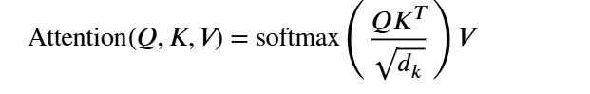
Folder-package file-module
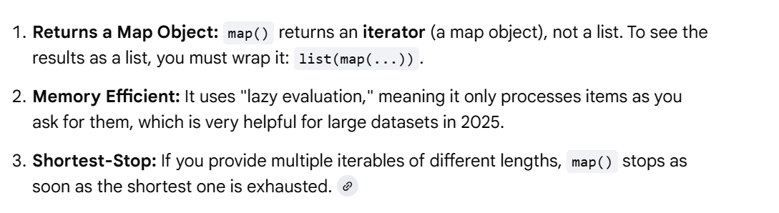

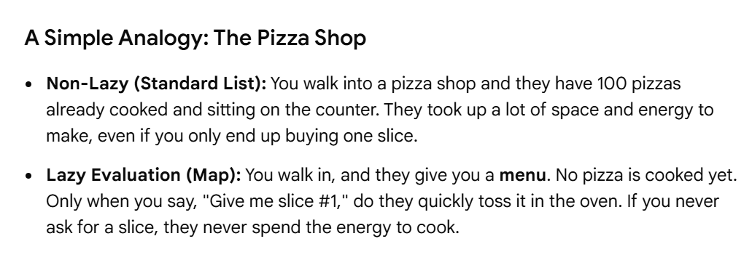

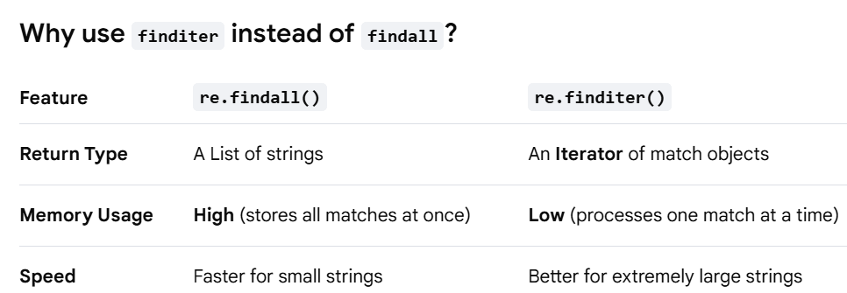
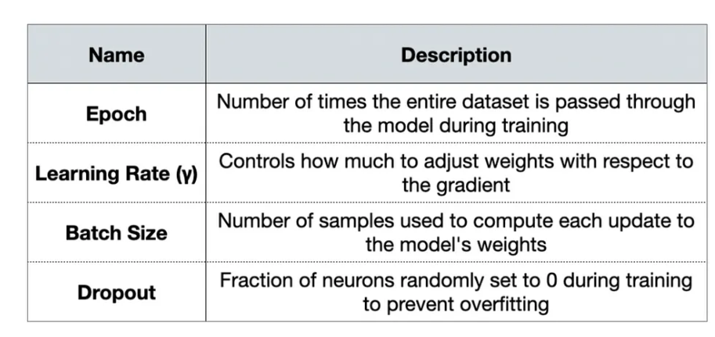
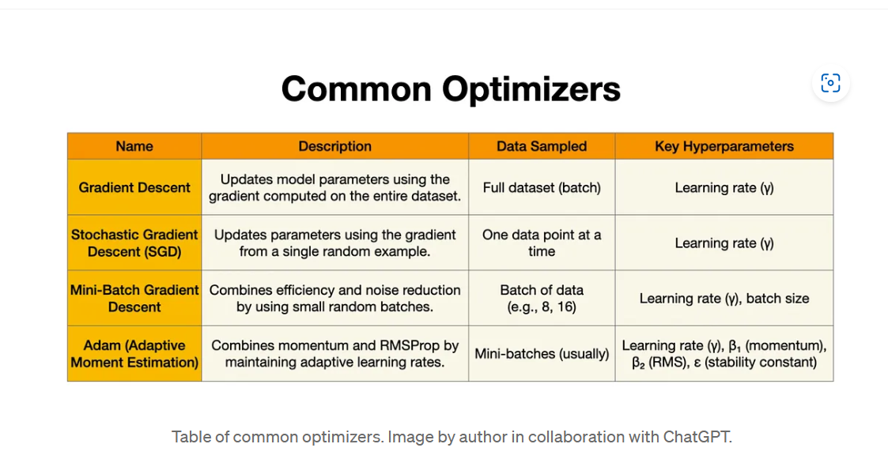
LOGSTIC REGRESSION
Video https://www.youtube.com/watch?v=2dHflWd_5uE
Linear Regression in 3 Minutes
Linear Regression with all Maths formulas explained in தமிழ் #machinelearning #datascience
1.supervised ml model 2. classicficatiob problem solve=usually used binary task-y/n t/f 0/1 3.propabality based 4. Sigmoid function- The algorithm uses a sigmoid function to translate the input values to a likelihood scale on a 0-1 scale

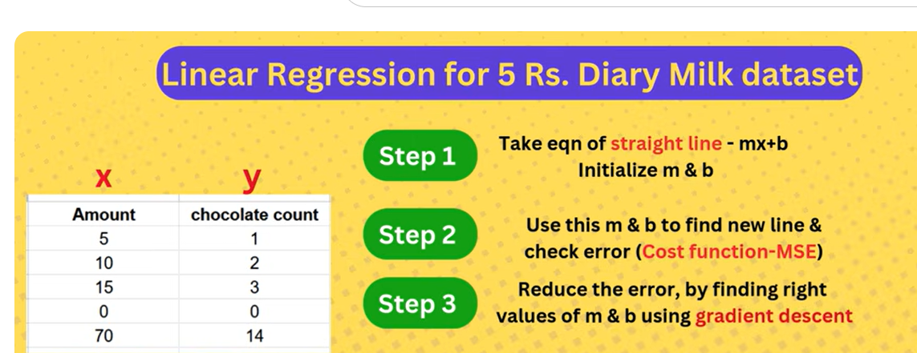

https://www.tutorialspoint.com/machine_learning/machine_learning_logistic_regression.htm
It provides insights into relationships between variables (e.g., how much one variable influences/contribute another).
https://www.kaggle.com/code/nargisbegum82/step-by-step-ml-linear-regression
What? Why? How? of Overfitting & Underfitting in Tamil #machinelearningintamil #datasciencetamil regularization overfit l1, l2
Code https://www.youtube.com/watch?v=k16T6uSaJMg
Rushi https://github.com/aishwaryanr/awesome-generative-ai-guide/blob/main/interview_prep/60_gen_ai_questions.md 60 genai interview
https://github.com/a-tabaza/genai_interview_questions llm,rag,chunkstrategies
https://github.com/Devinterview-io/llms-interview-questions
Linear regression models the linear relationship between a dependent variable ($Y$) and one or more independent variables ($X$) by fitting a straight line, $\hat{y} = \beta_0 + \beta_1x_1$, that minimizes the sum of squared residuals. Key concepts include estimating coefficients using least squares, evaluating fit with $R^2$ or RMSE, and validating assumptions of linearity, homoscedasticity, and independence. [1, 2, 3, 4, 5]

Core Components and Terms
- Dependent Variable (): The outcome or target variable being predicted.
- Independent Variable (): The predictor or feature variable.
- Regression Coefficients: Slope ($\beta_1$) indicates the change in $Y$ given a one-unit change in $X$; Intercept ($\beta_0$) is the value of $Y$ when $X=0$.
- Residuals (Errors): The difference between the actual observed value and the predicted value ($\text{actual} - \text{predicted}$).
- Ordinary Least Squares (OLS): A method to find the "best-fit" line by minimizing the sum of squared residuals.
- Simple Linear Regression: One dependent and one independent variable ($Y = \beta_0 + \beta_1X + \epsilon$).
- Multiple Linear Regression: One dependent and multiple independent variables ($Y = \beta_0 + \beta_1X_1 + \dots + \beta_nX_n + \epsilon$). [1, 2, 3, 6, 7]
Assumptions for Valid Linear Regression
- Linearity: Relationship between $X$ and $Y$ is linear.
- Independence: Observations are independent.
- Homoscedasticity: The spread of residuals (error) is constant across all levels of the independent variables.
- Normality: Residuals follow a normal distribution.
- No/Low Multicollinearity: In multiple regression, independent variables should not be too highly correlated. [1, 4, 8, 9]
Model Evaluation Metrics
- -squared (): Proportion of variance in $Y$ explained by $X$.
- Adjusted -squared: $R^2$ adjusted for the number of predictors, preventing overestimation in multiple regression.
- Mean Squared Error (MSE): Average squared difference between predicted and actual values.
- Root Mean Squared Error (RMSE): Square root of MSE, indicating prediction error in the same units as $Y$.
- Mean Absolute Error (MAE): Average absolute difference between predicted and actual values. [2, 8, 9, 10]
Key Techniques and Diagnostics
- Gradient Descent: Optimization algorithm to minimize the cost function (sum of squared errors)
- Residual Plot: Graph to detect heteroscedasticity or non-linearity (errors should be randomly distributed).
- Regularization (Ridge/Lasso): Techniques to prevent overfitting by punishing high-value coefficients,
- Outliers: Data points that differ significantly from others, which can disproportionately affect the lineKey Concepts Overview Table
Concept [3, 14, 15] | Description
Best Fit | Minimizes total squared residual error.
Line Equation | $\hat{y} = \beta_0 + \beta_
-
https://allen.in/jee/maths/linear-regression check interview
--
- Hypothesis − We assume that there is a linear relation between input and output.
- Cost Function − Define a loss or cost function. The cost function quantifies the model's prediction error. The cost function takes the model's predicted values and actual values and returns a single scaler value that represents the cost of the model's prediction.
- Optimization − Optimize (minimize) the model's cost function by updating the model's parameters.
https://share.google/zhIuZW1Vujxkg1IJ8
https://www.tutorialspoint.com/machine_learning/machine_learning_multiple_linear_regression.htm

regularization https://www.geeksforgeeks.org/machine-learning/regularization-in-machine-learning/

cnn https://www.geeksforgeeks.org/machine-learning/introduction-convolution-neural-network/
--
Here is the cleanest, simplest, and interview-ready explanation of Linear Regression vs Logistic Regression — exactly what interviewers expect. ✅

✅ Linear Regression vs Logistic Regression (Interview-Ready Explanation)
✅ 1. Purpose / What It Predicts
Linear Regression
- Predicts continuous numeric values
- Example outputs:
  - Price of a house
  - Medical charges
  - Temperature
  - Sales amount
Output is a number.
Logistic Regression
- Predicts categories (classification)
- Mostly binary:
  - Spam / Not spam
  - Diabetes / No diabetes
  - Will churn / Won’t churn
  - Fraud / Not fraud
Output is a probability (between 0 and 1), later converted to 0/1.

✅ 2. Output Formula
Linear Regression Equation
$$y=b_{0}+b_{1}x_{1}+b_{2}x_{2}+…+b_{n}x_{n}$$
- Produces any number: positive, negative, big, small
Logistic Regression Equation
$$p=\frac{1}{1+e^{-(b_{0}+b_{1}x_{1}+...+b_{n}x_{n})}}$$
- Uses Sigmoid function
- Squashes outputs between 0 and 1
- Threshold:
  - 0.5 → Class 1
  - <0.5 → Class 0

✅ 3. When to Use Which
✅ Use Linear Regression When:
- Target is a continuous number
- Example:
  - Predict insurance charges
  - Predict sales revenue
  - Predict height, weight
✅ Use Logistic Regression When:
- Target is categorical
- Example:
  - Predict if customer will churn (yes/no)
  - Predict default on loan
  - Predict disease (yes/no)
  - Classify email spam

✅ 4. Loss Function Difference
Linear Regression
Uses Mean Squared Error (MSE).
Logistic Regression
Uses Log Loss / Binary Cross Entropy.

✅ 5. Type of Relationship Modeled
Linear Regression
- Finds best straight line through the data
Logistic Regression
- Finds best S-shaped curve (sigmoid) to separate classes

✅ 6. Range of Output
Model | Output Range
Linear Regression | (-∞ to +∞)
Logistic Regression | (0 to 1)

✅ 7. Interview-Ready Summary (Use This Answer)
“Linear Regression is used to predict continuous numeric values, such as prices or sales.
Logistic Regression is used for classification problems, where the output is a probability mapped between 0 and 1 using the sigmoid function.
Linear Regression gives a number; Logistic Regression gives a class (0 or 1).”

✅ 8. Simple Real-World Example
✅ Linear Regression Example:
Predict insurance cost:
Input → age, BMI, children
Output → charges (number)
✅ Logistic Regression Example:
Predict whether a person will get diabetes:
Input → glucose level, BMI, age
Output → 1 (diabetes) or 0 (no diabetes)

The sigmoid function is an S-shaped function that converts any number into a probability between 0 and 1. Logistic Regression uses sigmoid to map the output of the linear equation into a probability for binary classification.”
Why Sigmoid Is Used in Logistic Regression
✔ Because output must be a probability
Probabilities must be between 0 and 1.
Sigmoid converts this:
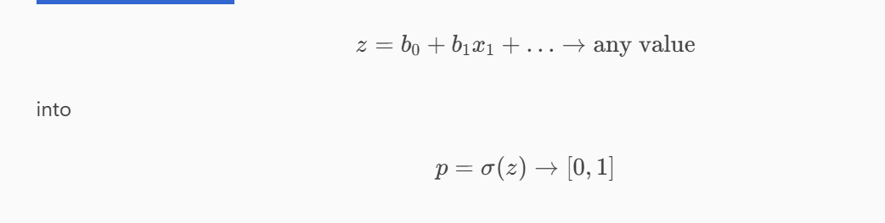

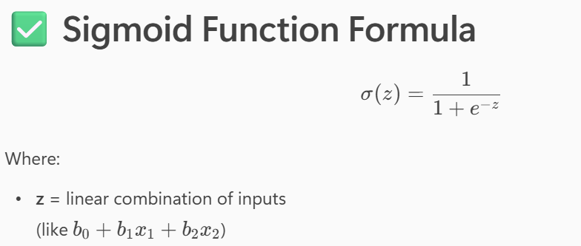Apply threshold:
- if p > 0.5 → class = 1
- if p < 0.5 → class = 0
- It squeezes (compresses) output like this:
- Large negative value → close to 0
- 0 → 0.5
- Large positive value → close to 1
Interview-Ready One-Line Definition
“Binary cross entropy measures the difference between actual labels (0 or 1) and predicted probabilities. It strongly penalizes confident wrong predictions, making it ideal for logistic regression.”

✅ Why Cross Entropy Instead of MSE?
Interviewers love this question.
✅ MSE does not work well with probabilities
✅ Log loss gives:
- Faster convergence
- Better gradients
- Smooth probability optimization
✅ Cross entropy + sigmoid = perfect combo for classification.
Very Simple Analogy
Think of Log Loss like a teacher:
- If your answer is a little wrong → small punishment
- If your answer is completely opposite → big punishment
That’s why logistic regression learns effectively.
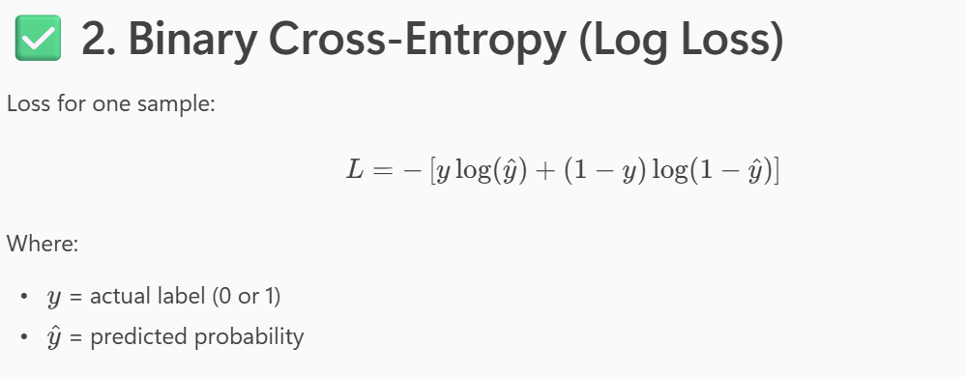
gradient = (prediction − actual)?- loss function
- If model predicts too high, gradient is positive → weights decrease
- If model predicts too low, gradient is negative → weights increase
This makes gradient descent “push” the model toward the correct output.
✅ Example
Actual $y=1$
Predicted $\hat{y}=0.2$
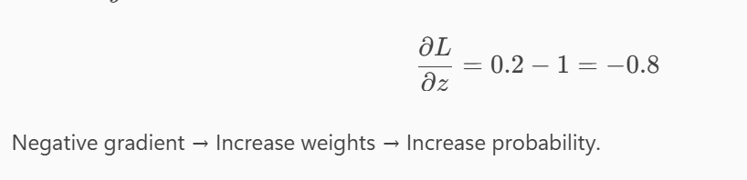
In logistic regression, the derivative of the log loss with respect to z simplifies to $\hat{y}-y$. This makes gradient descent easy. We update each weight as $w_{i}:=w_{i}-α(\hat{y}-y)x_{i}$. This pushes the prediction toward the correct class.”
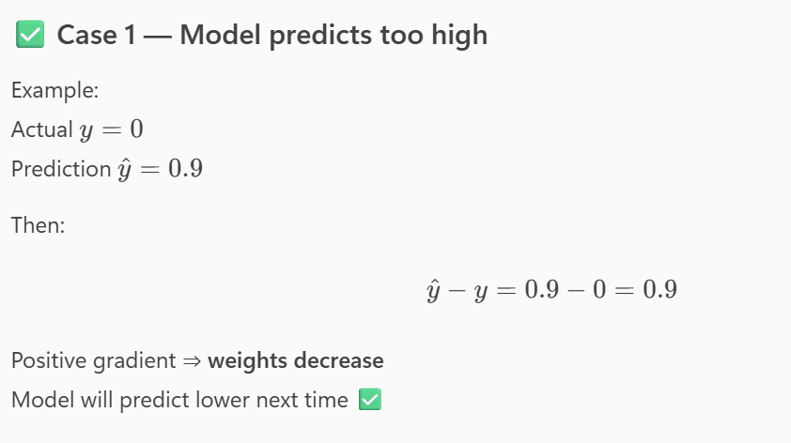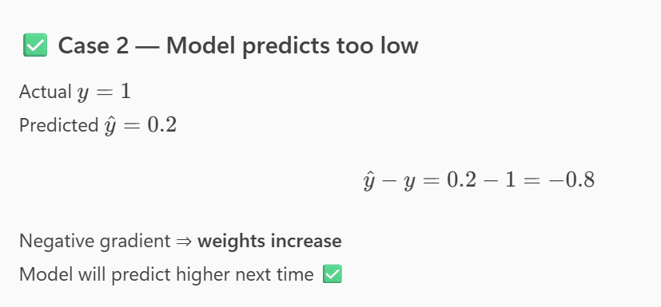

Linear Regression
- Models a straight-line relationship between X and y.
- Best when the relationship is linear.
Polynomial Regression
- Models a curved or non-linear relationship between X and y by adding powers of X (X², X³…).
- Best when the relationship is non-linear.
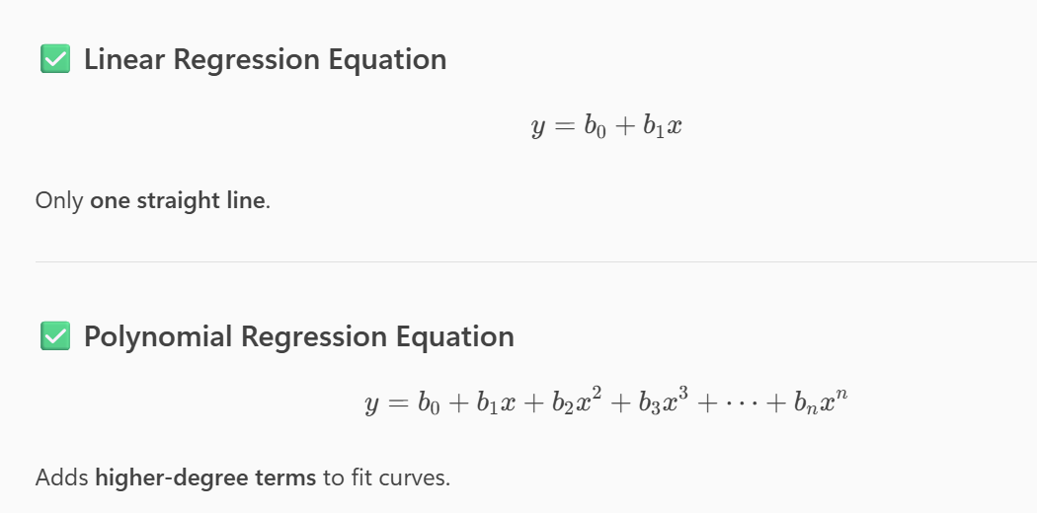
When to Use Which?
✅ Use Linear Regression when:
- Data points roughly form a straight line
- Relationship is simple
- Example: height vs weight (mostly linear)
✅ Use Polynomial Regression when:
- Data forms a curve
- Linear regression underfits the data
- Example:
  - Growth curve
  - Temperature vs time
  - Insurance charges vs age (often curved)

✅ 4. Model Complexity
Model | Shape | Complexity | Overfitting Risk
Linear Regression | Straight line | Low | Low
Polynomial Regression | Curve | Higher | High (if degree too large)
How Polynomial Regression Works
Polynomial Regression is NOT a separate model.
It is still Linear Regression, but applied on transformed features.
Example: X → [X, X², X³]
Model learns coefficients for each.
Interview-Ready Simple Answer
Linear Regression fits a straight line, while Polynomial Regression fits a curved line by adding higher-degree terms like X², X³. Polynomial Regression is used when data is non-linear. Both use the Linear Regression algorithm, but Polynomial Regression transforms the input features before fitting.
eXample
• Ads spent vs revenue
• Website visits vs conversion rate
At some point, spending more gives lower returns → curve.
Predicting Growth Curves
- Population growth
- Bacteria growth
- Plant height with time
The growth pattern is not linear—it bends upward or downward.
- Polynomial Regression is used when the relationship between variables is non-linear but still smooth and predictable.
- Polynomial Regression fails when degree is too high OR data is not suitable.
Overfitting happens when the model learns:
✅ Training data
❌ Noise
❌ Random fluctuations
❌ Outliers
It fits the training data too perfectly but fails on new data.

✅ Example
If you draw a curve that touches every point, it becomes:
- Too wavy
- Too complex
- Overfitted
Training accuracy = 100%
Test accuracy = very bad
- Degree 1 → straight line
- Degree 2 → one bend
- Degree 5 → many bends
- Degree 20 → extremely wiggly
If degree = 5, 10, 15…
The curve becomes too wiggly and tries to fit every point.
More bends = more overfitting.
When Relationship is Not Polynomial
Polynomial Regression fails for relationships like:
- Sinusoidal waves
- Step functions
- Exponential but with noise
- Classification boundaries
Better alternatives:
✅ Decision Trees
✅ Random Forest
✅ SVM
✅ Neural Networks
❌ 3. When Data Contains Too Many Features
Polynomial features explode:
Example with 10 features and degree = 3 →
Number of features = 286
This causes:
- Large memory usage
- Slow training
- Overfitting
When Data Has Sharp Changes or Noise
Polynomial Regression cannot handle:
- sudden jumps
- irregular patterns
- noisy data
Since it fits a smooth curve, it cannot adapt to random data.
Interview-Ready Summary (Say This)
“Polynomial Regression is used in real life for modeling curved relationships such as medical cost prediction, machine failure curves, marketing ROI, and physics-based curves. It fails when the degree is too high, when data is noisy, or when relationships are not polynomial. Overfitting occurs because higher-degree polynomials try to fit every point, including noise, which reduces test performance.”
Lasso Regression - Beginner Friendly Guide
Introduction
Lasso Regression (Least Absolute Shrinkage and Selection Operator) is a type of linear regression that uses L1 regularization.
Key Points:
- L1 regularization adds a penalty equal to the absolute value of the coefficients.
- It can shrink some coefficients to exactly zero, which helps in feature selection.
- Useful when you have many features and want to find the most important ones.
Transformer https://www.geeksforgeeks.org/machine-learning/getting-started-with-transformers/
https://www.datacamp.com/tutorial/how-transformers-work

