Weather Data Analysis and Visualization Using Python
1. 📌 Project Overview
This project focuses on performing an end-to-end data analysis on a weather dataset using Python. The primary goal is to extract meaningful insights from raw data through systematic steps including data loading, cleaning, analysis, and visualization.
The system processes historical weather data to identify trends, patterns, and distributions. It generates visual outputs such as line charts and histograms to improve interpretability.
This project demonstrates practical implementation of data analysis concepts and helps in understanding real-world data handling techniques.
2. ⚙️ Setup Instructions
Follow the steps below to run the project:
Prerequisites:
- Python 3.x installed
- VS Code or any Python IDE
Installation:
- Clone the repository:
- Install required libraries:
pip install -r requirements.txt
- Run the program:
python main.py
output:
- Visualizations will be saved in visualizations/
- Analysis report will be saved in report/
3. 🗂️ Code Structure
The project follows a modular structure for better readability and maintainability.
weather_analysis_project/
│── data/
│── visualizations/
│── report/
│── main.py
│── requirements.txt
│── README.md
main.py Functions:
- load_data()
  - Loads dataset and handles file errors
- clean_data()
  - Removes missing values
  - Formats column names
  - Converts date columns
- analyze_data()
  - Generates statistical summary using pandas
- visualize()
  - Creates:
    - Line chart (time-based trend)
    - Histogram (data distribution)
- main()
  - Controls full execution pipeline

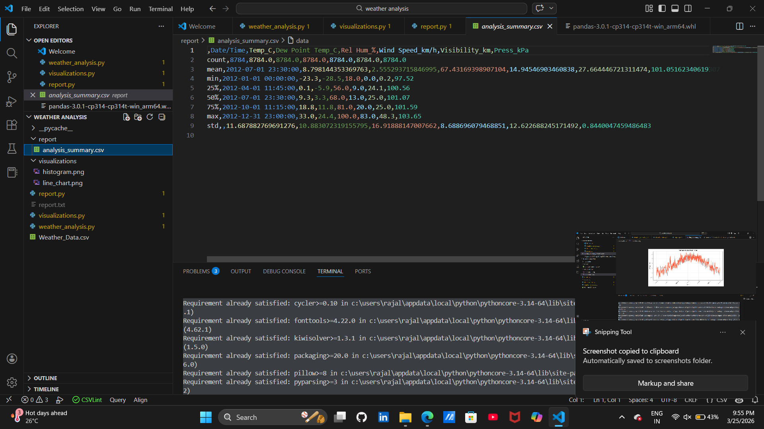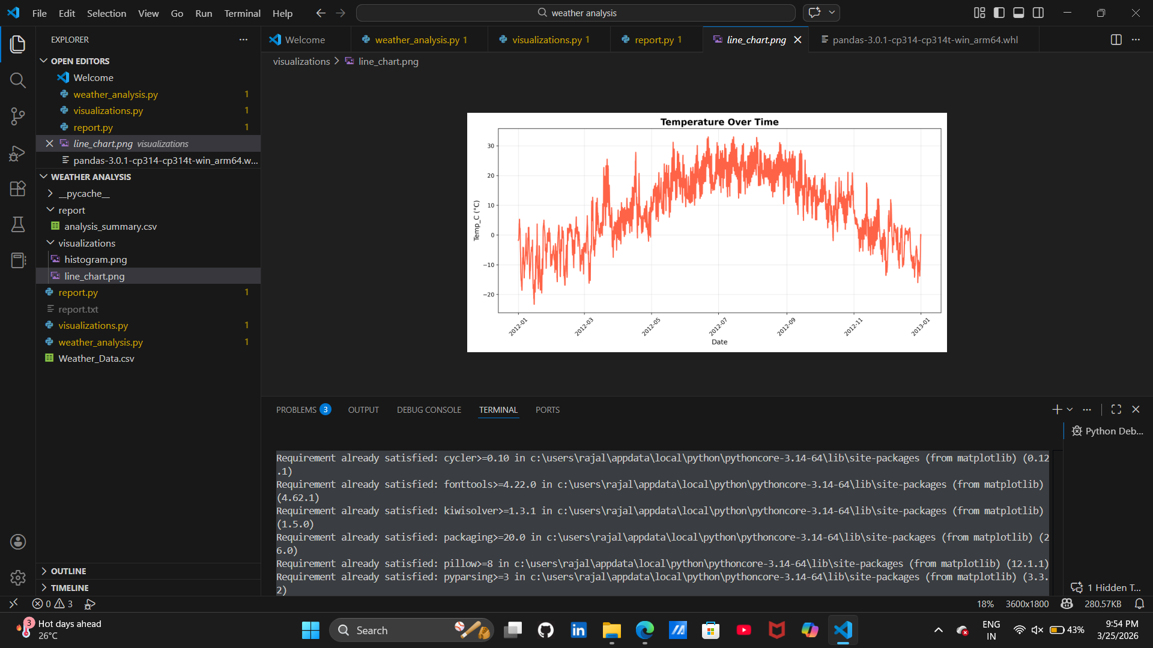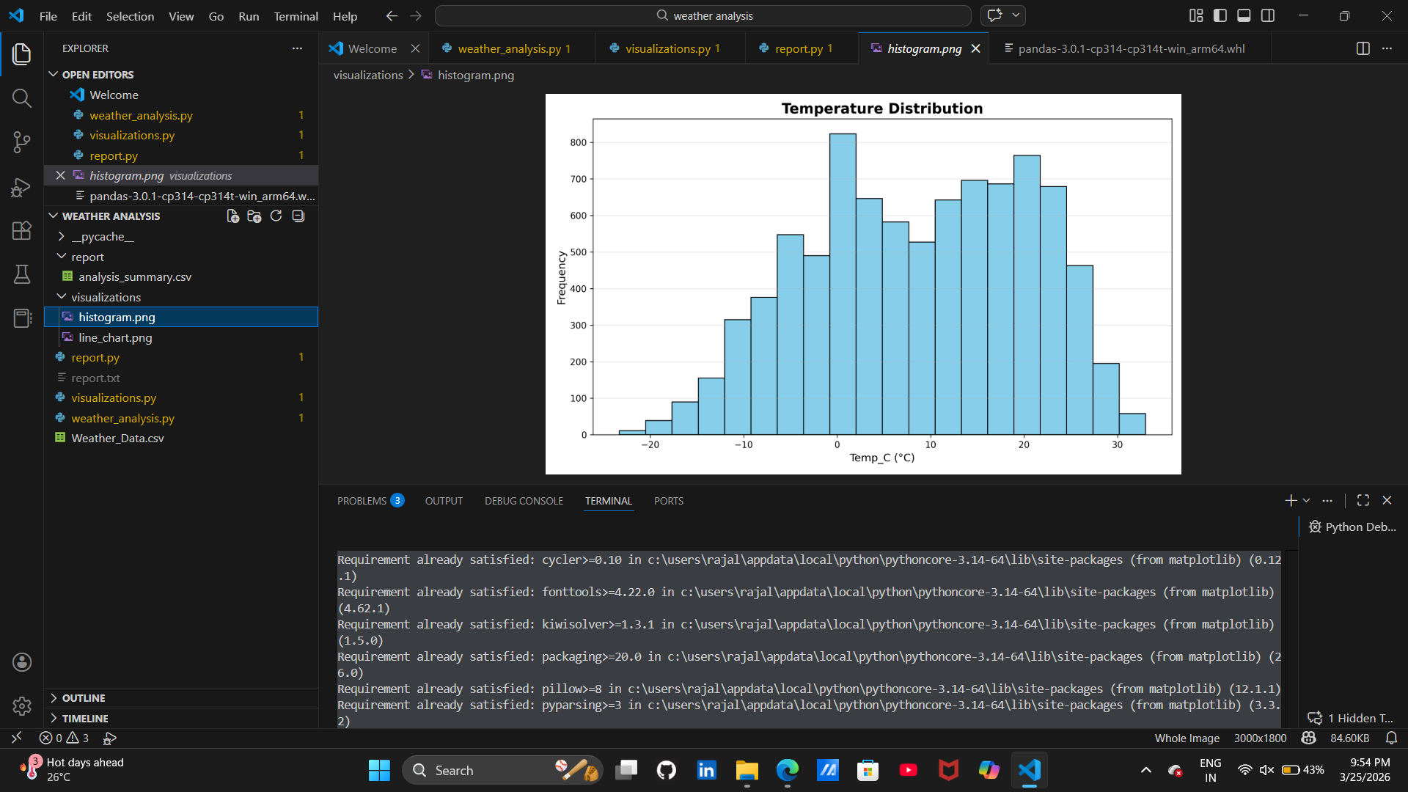
4. 📊 Visual Documentation
The project includes two main types of visualizations:
1. Line Chart
- Displays temperature variation over time
- Helps identify seasonal trends and fluctuations
2. Histogram
- Shows distribution of temperature values
- Helps understand frequency and spread of data
These visualizations improve understanding of patterns and support data-driven conclusions.
5. ⚙️ Technical Details
- Programming Language: Python
- Libraries Used:
  - Pandas → Data manipulation and analysis
  - Matplotlib → Data visualization
  - NumPy → Numerical operations (optional)
Key Concepts Used:
- Data Cleaning
- Data Transformation
- Descriptive Statistics
- Time-Series Analysis
- Data Visualization Techniques
Error Handling:
- File loading exceptions
- Empty dataset validation
- Safe date conversion
- Handling missing values

6. 🧪 Testing Evidence
The project was tested under multiple conditions to ensure reliability:
Test Cases:
- Valid Dataset
  - Output generated successfully
  - Charts and report created
- Missing Values
  - Handled using dropna()
  - No crash occurred
- Invalid File Path
  - Error message displayed properly
- Empty Dataset
  - Program detects and stops execution
Output Verification:
- Checked generated charts for correctness
- Verified statistical summary values
- Confirmed file creation in respective folders

