**Injury Prevention in Health Information Management Department**

HITT 2343 Quality Assessment and Performance

10th December 2017

By

Rajalaxmi Polarpu

And

Team

**Mission Statement**

Our mission is to create a safe work environment that values and supports our employees. Objective of the project is to ensure that policies and procedures are adhere to at the highest standards and promote the highest quality of service delivered in a stable work environment. Our facility aims to keep our employees safe in the workplace, maintain confidentiality, and to treat them fair and without bias in all respects.

**Analysis of Problem**

After a PI review conducted by the Risk Management team, it was noted that the Record Center had submitted three (3) incident reports of employees injured while performing their job in the center within the last 6 months. Several of these injuries has resulted in the employee not being able to return to work for several months or being placed on lite duty, which hinders the workflow in the Records Center. The following incidents have resulted in Sentinel Events:

* Staff using a chair in place of a step ladder to reach top shelving in order to file records.
* Staff carrying storage boxes that were over packed with records
* While purging shelves staff was pulling to many charts at one time.
* Staff not wearing appropriate footwear while filing.
* Storage boxes are kept on the floor which blocks pathway.

**Sentinel Events or Quality Indicators**

Fall injuries are the most common type of injuries at work place. According to the National Safety Council (NSC), slip and fall injuries account for over 20% of all workplace injuries. A fall occurs when someone loses their balance and footing while walking or climbing.

Fall injuries affect the work process as well as financial aspects of a department or organization. The cost related to fall injuries at work place includes medical expenses, legal service cost, investigation of the accident, implementing preventive measures, and replacing or repairing damaged property. It even affects the employee adversely as the employee is away from work and may suffer financial difficulties during the recovery period.

1. Our facility has hybrid records, which is a combination of paper and electronics records. All the paper files are stored using terminal digital order filing which allows organizing and retrieving files in a systematic flow.

On March 9th, 2017; 3.00pm; 55-year-old Mrs. Smith, who works as a HIM technician was looking for a file for a release of information request. The file was on the top shelf, which she could not reach so she climbed on an office chair with wheels (not locked) trying to carefully balance herself to reach the top shelf. While getting down after retrieving the file, she lost her balance and fell down. She had a swollen forearm and bruises on her hands cause for trying to break her fall. After examination, she found that she fractured her right radius and ulna.

A similar incident happened in 2014 at Saddleback Valley Unified School District.

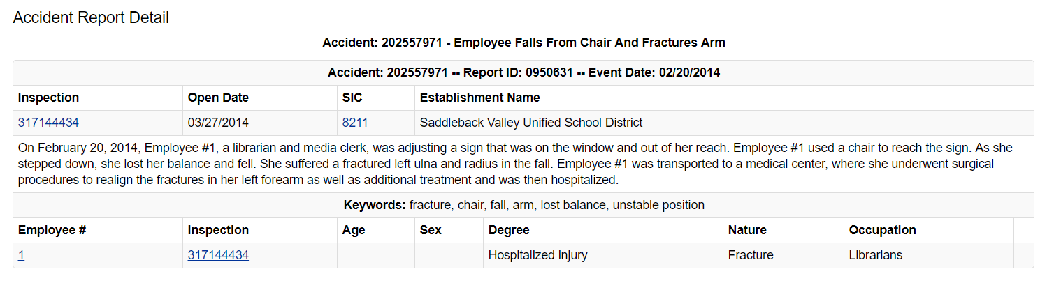

1. It is the facility’s policy to store 1year of patient records on-site. Records more than a year old are moved to the 3rd party storage area. Files are being stored on the shelves and extra files are being stored in boxes left on the floor. Keeping boxes on the floor blocks the pathway, and is a safety hazard. On July 5th, 2017 Mr. Johnson, who works as a HIM technician was arranging files on the shelves. While doing his job, he tripped on a box that was left on the floor and fell down, putting all the load on his left shoulder. After examination, he found that he had shoulder joint dislocation.

A similar incident happened at the Pauley Company.

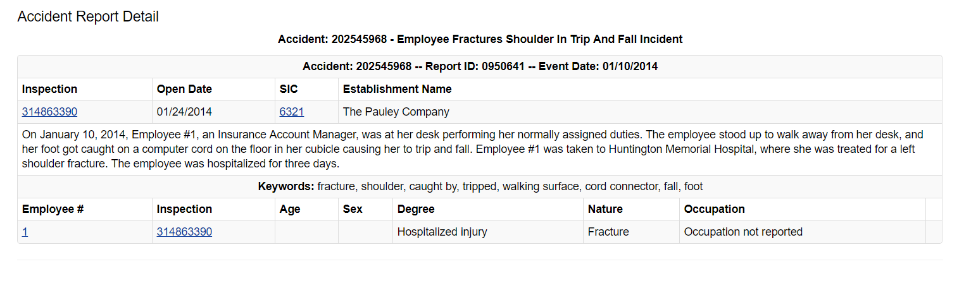

1. HIM employees carry or lift storage boxes loaded with files to put them on the shelves. Sometimes, boxes are overloaded with files weighing more than 15 pounds. Lifting these boxes from the ground to a higher level, such as a table or shelf might cause muscle and back sprain, shoulder injury, wrist injury, spinal injury, or other injuries related to heavy lifting, especially is the proper lifting techniques are not utilizied. On Sept 14th, Mrs. Jones who works as an HIM technician was moving boxes to the delinquency room for storage purposes. While moving one of the heavy boxes, she lost her balance and fell down, and injured her hip.

A similar incident happened in Volt Services group.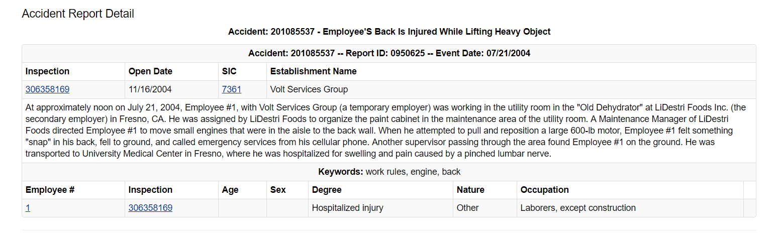

**Benchmarks**

Our goal is to prevent injuries from occurring as a result of work performed within our facility. We have established a program of trainings which include safety and hazard preventions to inform our staff of the correct actions they should be taking while working in our facility. The training courses will allow for a safer and healthier place to work each day. All facility staff will be required to complete an annual safety program course each year and all new employees will be required to take the course during orientation. Using benchmark information provided by three references have allow us to determine where we should be in regards to incidents that occur yearly within our facility.

**OSHA Benchmark Report**

Every year OSHA collects work-related injury and illness data from employers within specific industry and employment size specifications. The data is used by OSHA to calculate establishment-specific injury and illness incidence rates. Comparing the incidence rates at your establishment with other businesses operating in the same industry sector can help you identify problem areas in the workplace and track progress made in preventing work-related injuries and illnesses.

**3.4**

**1.6**

**0.6**

**2.1**

**23.8**

**71.4**

**0.0**

**71.4**

0.0

10.0

20.0

30.0

40.0

50.0

60.0

70.0

80.0

TRC Rate

DAFWII Rate

TR Rate

DART Rate

**DEFINITIONS**

**TRC Rate:** Total Recordable Case Rate. The TRC Rate is thenumber of recordable injuries and illnesses occurring per 100 equivalent full-time workers.

**DART Rate:** Days Away, Restricted work activity, and/or job Transfer Rate. The DART Rate is the number of recordable cases involving days away from work, restricted work activity or transfers to another job per 100 equivalent full-time workers

**DAFWII Rate:** Days Away From Work Injury and Illness Rate. The DAFWII Rate is the number of recordable cases involving days away from work per 100 full-time equivalent employees

**TR Rate:** job Transfer and/or Restricted work activity Rate. The TR Rate is the number of recordable cases involving restricted work activity or transfers to another job per 100 full-time equivalent employees

**The Economics Daily – U.S. Bureau of Labor Statistics**

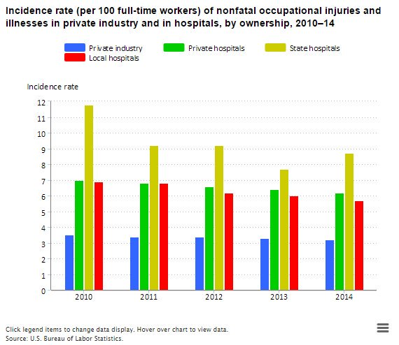

**News Release from the Bureau of Labor Statistics**

**EMPLOYER-REPORTED WORKPLACE INJURIES AND ILLNESSES – 2016**

For release 10:00 a.m. (EST) Thursday, November 9, 2017

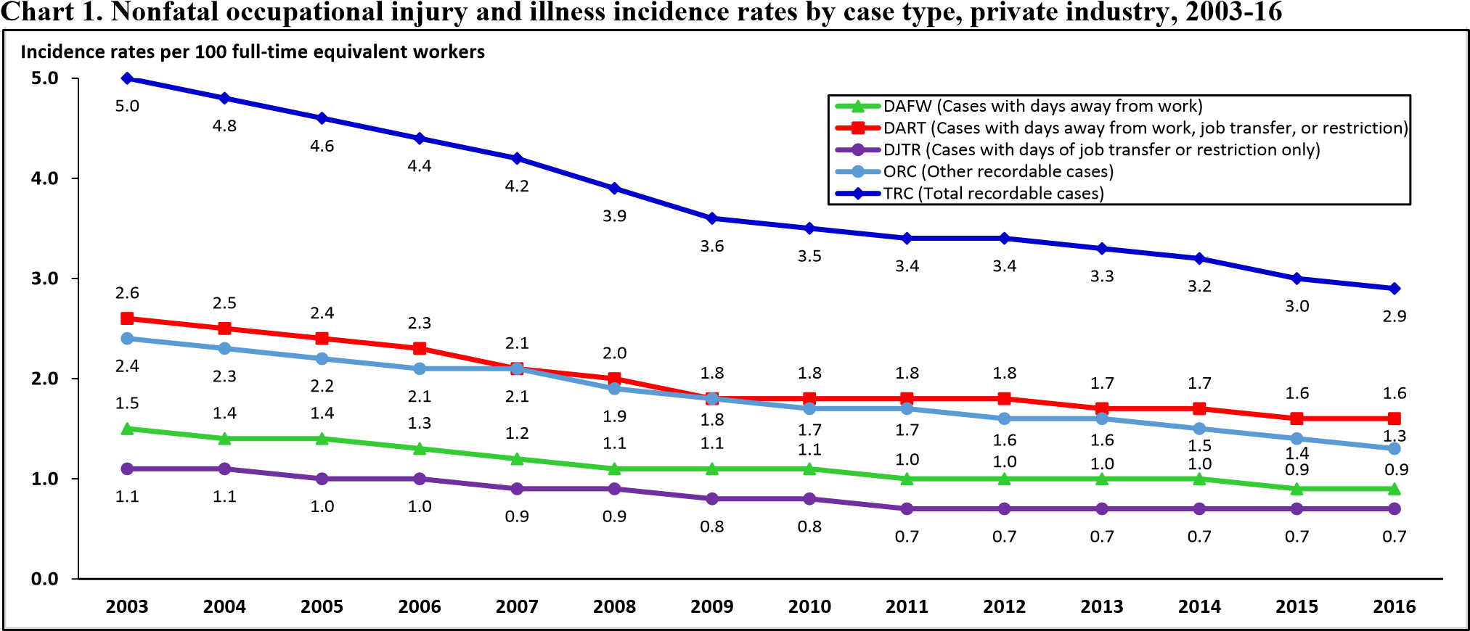

**Data Display**

Over the past 6 months, three incident reports have been submitted from the HIM department for employee injuries. Data display tools were created to reflect the reasons why they were occurring, and what risk management can offer to help prevent these sentinel events from happening again. The below Pie chart explains the major reasons for the workplace injuries.

|  |  |  |  |  |  |
| --- | --- | --- | --- | --- | --- |
| Quarter | Workplace Injury | Reasons | % |  |  |
| 1st Qtr | 8.2 | Slips, Trips, and Falls with office equipment | 58% |  |  |
| 2nd Qtr | 3.2 | Unnecessary overexertion | 23% |  |  |
| 3rd Qtr | 1.4 | Housekeeping failed to remove unnecessary equipment in the office 10% | | | |
| 4th Qtr | 1.2 | Employee Distractions | 9% |  |  |

**Prevention Techniques**

1. Provide training to all employees
2. Reinforcing all new policies and procedures, repeatedly.
3. Talking about safety weaknesses
4. Managers and supervisors must focus on their own specific workplace injuries
5. Monitor the facility’s practices and review for any changes

**Fishbone Diagram**

**Effect**

**Causes**

**Methods**

**Manpower**

Overexertion of the employee – Possibly the number one reason employees get injured while on the workplace

Poor Housekeeping

Taking unnecessary shortcuts

Lack of Safety training

Not following proper instructions

Employee is seriously injured in the workplace- may result in significant cost to both the employee and employer; With the proper training, future incidents can be prevented.

Slips, trips, and falls with office equipment

**Machinery**

**Material**

Employee Distracted by other things. Cell phone or conversations etc.

**Customers**

**Internal Customers**

HIM department consists of HIM Technician, Medical Coder, and HIM Manager.

1. **HIM Technician**: Injury could affect patient chart completing process and Release of information process.
2. **Medical Coder**: Injury could affect billing and reimbursement process.
3. **HIM manager**: Injury could affect court orders (subpoena), monthly/quarterly reports, and audit procedure.
4. **Physicians**: They come to HIM dept. to sign patient charts which are stored in delinquency room. Injury could affect patient care.

**External Customers**

1. **Patients**: Patient care could be affected if physician is injured.

**Interview and/or Survey**

**Workplace Health and Safety Survey – Internal**

Please check the box that describes your role in the workplace

Employee  Manager  Management  Others

**1. Workplace Hazards**: Physical hazards are the most common type hazards in workplace.

|  |  |  |  |  |  |  |  |
| --- | --- | --- | --- | --- | --- | --- | --- |
| How often do you do in your job? | | Never | Daily | Weekly | Monthly | Quarterly | Yearly |
| 1.1 | Lift, carry, or push items heavier than 20lbs |  |  |  |  |  |  |
| 1.2 | Repetitive movement of hands or wrists (Sorting, assembling, pulling) |  |  |  |  |  |  |
| 1.3 | Use of ladder or step chair |  |  |  |  |  |  |
| 1.4 | Contact with pathogens, chemicals, flammable liquids or gases |  |  |  |  |  |  |

**2. Workplace Policies and Procedures:** A company safety policy is a written document that shows an employer’s commitment to a safe workplace.

|  |  |  |  |  |
| --- | --- | --- | --- | --- |
| At Workplace | | Yes | No | Not Sure |
| 2.1 | Is there a written health and safety program in your workplace? | ☐ | ☐ | ☐ |
| 2.2 | Is there safety training for new employees, changing jobs or using recent technology? |  |  |  |
| 2.3 | Are your health and safety responsibilities reviewed with you by manager or employer? |  |  |  |
| 2.4 | Would you report manager or employer if see something unsafe at workplace? |  |  |  |
| 2.5 | Do you take necessary precaution while doing job? |  |  |  |

**3. Establish a Health and Safety committee**: Health and safety committee is a group of employees and managers working together to create a safer workplace.

|  |  |  |  |  |
| --- | --- | --- | --- | --- |
| Health and Safety Committee at workplace | | Yes | No | Not Sure |
| 3.1 | Is there a health and safety committee at workplace? |  |  |  |
| 3.2 | Are the names of health and safety committee members posted? |  |  |  |
| 3.4 | Do you feel that the employer has a clear plan for preventing workplace injury and illness? |  |  |  |
| 3.5 | Do you feel that other employees follow safety rules? |  |  |  |
| 3.6 | Do you feel health and safety committee takes prompt action when safety concerns are addressed? |  |  |  |

**4. Learn from experience:** Finding out root cause of any incident helps to take necessary measures to prevent the incidents from happening again.

|  |  |  |  |  |
| --- | --- | --- | --- | --- |
| Learn from Experience | | Yes | No | Not Sure |
| 4.1 | If an employee is hurt, does manager starts investigation immediately? |  |  |  |
| 4.2 | Are the investigation results shared with employees? |  |  |  |
| 4.3 | Are preventive measures implemented to prevent incident again? |  |  |  |

**5. Establish a return-to-work program**: Preventing injuries at workplace is the best outcome for everyone. If an injury occurs, there should be a return-to-work program for injured employees. A return-to-work program should review injured employee’s abilities, and get him/her to the workplace in a safe and timely manner.

|  |  |  |  |  |
| --- | --- | --- | --- | --- |
| Return-to-work Program | | Yes | No | Not Sure |
| 5.1 | Does your workplace have a return-to-work program? |  |  |  |
| 5.2 | Is it easy to follow company’s return-to-work process? |  |  |  |
| 5.3 | Is meaningful work found for injured employee while he/she is recovering? |  |  |  |

**Design of new Process**

To ensure the safety of all employees, we will require all employees to adhere to the following:

**Policy and Procedure**

**Policy:**

* The safety of our patient’s and employees is of top priority. Our facility takes pride in ensuring that all patients are taken care of to the best of our ability, and that our employees perform their duties in the safest yet effective manner possible. Any employee who witnesses or is involved in any type of incident is responsible for reporting the incident in a timely manner.

**What is an incident?**

* An incident is any happening involving a patient or employee that is not consistent with the routine operation of the facility or the routine care of a patient. It may be an accident or near-accident involving a patient, visitor or an employee, a situation that could cause an accident. It can also involve a situation where the patient has a dissatisfaction with our practice.

**Procedures:**

1. Employee Injuries:
   1. In an emergency, the employee must immediately be taken to the emergency room of the organizations choice. (If not already located in a hospital facility) The employee or other personnel must complete the incident form
   2. Notification of the incident must be given to the Manager in charge.
   3. Submit completed Incident Report to Human Resources within 24 hours of the incident.
   4. Employee's supervisor completes Workers' Compensation Claim Report and submit to Human Resources within 24 hours of the incident.
   5. If not an emergency, employee seeks medical care from an approved Workers' Compensation Panel health care provider. Please see Human Resources if you are unclear on where to locate a provider that will accept TWC.
2. Follow-up requirements:
   1. After the employee supervisor has submitted the completed incident report form to the Human Resources department within 24 hours, all questions should be forwarded to the HR department. All information is kept confidential. The HR department will then forward the incident form to the CEO.
   2. CEO will determine any further action and provide completed incident report to Human Resources. The CEO can make any necessary changes to the organization’s operations that can help prevent a similar incident from occurring.
   3. Human Resources will maintain files, provide it to the Safety Committee, and submit reports as necessary for liability insurance, workers' compensation claims or other requirements.

**New Health Information Management Policy and Procedure - * Revised per CEO and Board of Directors**

Policy –

All HIM Personnel is responsible for ensuring the safety of themselves as well as other in the workplace. It is important to take note that all HIM staff will have to go and file back paper charts at a different site within the unit. After close review of previous incidents, the CEO, Risk manager, HR staff, Safety Committee and the Board of directors have agreed that there should always be two people present on site when it comes to filing back paper charts. The office manager has ordered new ladders that would be appropriate for the staff to use.

**Updated Procedure:**

1. To prevent any similar occurrences from happening again, the HIM director will be responsible for ensuring that there will always be at least two technicians when filing charts.
2. Each technician may only file two charts at a time before going back for two or more. Two charts will be the limit.
3. If the employee feels as though they cannot perform the duty, please notify your manager, and do not attempt to perform the job task.
4. Employees must be sure that they are wearing appropriate closed toed shoes that will be sturdy and comfortable to be able to step on and off a ladder.
5. When an incident occurs, please notify the manager on site, and/or a medical provider immediately.
6. All staff are responsible for adhering to the facility requirements of incident reporting. The incident form can be found on the share drive within your PC.
7. At the discretion of all HIM managers, they will continue to monitor and set new policies in place to prevent any incidents from happening again.
8. Physical Requirements: *How much on-the-job time is spent on the following physical activities? Identify the amount of time by checking the appropriate boxes below. Does job require that weight be lifted or force be exerted? If so, show the amount by checking the appropriate amount.*

|  |  |  |  |  |  |
| --- | --- | --- | --- | --- | --- |
| **AMOUNT OF TIME** | | | | | |
|  | **NONE** | **Under 1/3** | **1/3 to 2/3** | **Over 2/3** |  |
|  | | | | | **Select lbs. amount** |
| Lifting |  |  |  |  | Up to 10 lbs.  Up to 25 lbs.  Up to 50 lbs.  Up to 100 lbs.  More than 100 lbs. |
| Reaching |  | X | |  |  |
| Climbing or Balance |  | X | |  |  |
| Pushing/Pulling |  | X | |  |  |
| Driving |  | X | |  |  |
| Carrying |  | X | |  |  |
| Sitting |  |  |  | X |  |
| Walking |  |  |  | X |  |
| Tasting/Smelling | X |  |  |  |  |
| Bending |  | X | |  |  |
| Finger/Hand Dexterity |  |  |  | X |  |
| Talking/Hearing |  |  |  | X |  |

*Regarding the employee, please keep in mind that only the required administrative personnel review all incidents. All information is kept private and at the discretion of the employee. All questions should be forwarded to the HR department or to the Risk manager. The incident will be taken into consideration, and please expect changes to come forth. Incidents will not interfere with the employee’s benefits, salary, or current position within the company. The company has the right to perform a drug screen to assure that the employee is complying with all federal and company rules. This is done for the safety of all employees and patients.

**Assessment of new Process after trial run**

**Assessment of Process:** After the new process was implemented for a year, below is the current findings compared to the National Workplace incidents reported in 2016. The process appears to have helped compared to the national averages but there is still much needed improvement.

**Set new assessment date for process**

New Process date will be set to the first Quarter of 2018, and will be reviewed quarterly thereafter. This will help to ensure the processes in place are working and helping to prevent workplace injury as much as possible, as well as providing insight for areas of improvement.

**References**

Sentinel events or quality indicator

* Scott, W.E “ Falls at work- Protect yourself and your employees”: *National Safety Council*, June 8th 2009, PowerPoint File. Accessed 14 Nov 2017
* Jennifer L. bell, James W. Collins, Laurie Wolf, Raoul Gronqvist, Sharon Chiou, Wen-Ruey Chang, Gary S. Sorock, Theodore K. Courtney, David A. Lombardi & Bradley Evanoff (2008) Evaluation of a comprehensive slip, trip and fall prevention programme for hospital employees, Ergonomics, Vol. 51 (12), pp. 1906-1925,

DOI: 10.1080/00140130802248092

* Wen-Ruey Chang, Sylvie Leclercq, Thurmon E. Lockhart & Roger Haslam (2016) State of Science: Occupational slips, trips and falls on the same level, Ergonomics, Vol. 59 (7), pp. 861-883,
* G. Gauchard, N. Chau, J. M. Mur & P. Perrin (2001) Falls and Working individuals: role of extrinsic and intrinsic factors, Ergonomics, Vol. 44 (14), pp. 1330-1339,

DOI: 10.1080/00140130110084791

* Hazards and risks associated with manual handling in the workplace. Web. http://www.osha.mddsz.gov.si/resources/files/pdf/E-fact_14_-_Hazards_and_risks_associated_with_manual_handling_in_the_workplace.pdf. Accessed 14 Nov 2017.
* “Slips, Trips & Falls in the Workplace.” Web. https://www.issa.com/regulatory/safety--health-portal/osha-assistance-for-cleaning-industry/slips-trips--falls-in-the-workplace.html#.Wh-ZwUpKtPb. Accessed 14 Nov 2017.

Benchmark

* “Hospital Workers Suffered 294,000 Nonfatal Workplace Injuries and Illnesses in 2014: The Economics Daily.” *U.S. Bureau of Labor Statistics*, U.S. Bureau of Labor Statistics, www.bls.gov/opub/ted/2016/hospital-workers-suffered-294000-nonfatal-workplace-injuries-and-illnesses-in-2014.htm#bls-print.
* “UNITED STATES DEPARTMENT OF LABOR.” *Occupational Safety and Health Administration*, 9 Nov. 2017, www.osha.gov/oshstats/work.html.
* "OSHA Benchmarking Report." May 2014. Web. <http://cdn2.hubspot.net/hub/146188/file-2088732679-pdf/docs/OSHA_Benchmarking_Report_-_2014_5_>.

Survey/Interview

* “Preventing Workplace Injury: Getting started Survey.” Web. ,ttps://www.wcb.ns.ca/Portals/wcb/WCB_Survey_2010.pdf. Accessed 14 Nov. 2017.
* “Worklace healh and safety survey”, Web .https://www.iwh.on.ca/system/files/documents/ohs_vulnerability_measure_questionnaire_2016.pdf. Accessed 14 Nov 2017.