**Final Project No#5: Install Apache Website with 1GB volume**

## Student: Rajalaxmi Polarpu

## Assignment:

## Installing Apache website with 1GB volume in Singapore region.

#### Solution:

1. **Launching an EBS backed Instance in Singapore Region.**

Launced **Amazon Linux AMI 2014.03.2 (HVM)** - ami-a6b6eaf4 In Singapore region.

InstanceName:Linux_Apache

Public DNS: ec2-54-251-165-146.ap-southeast-1.compute.amazonaws.com

Root Device: /dev/xvda

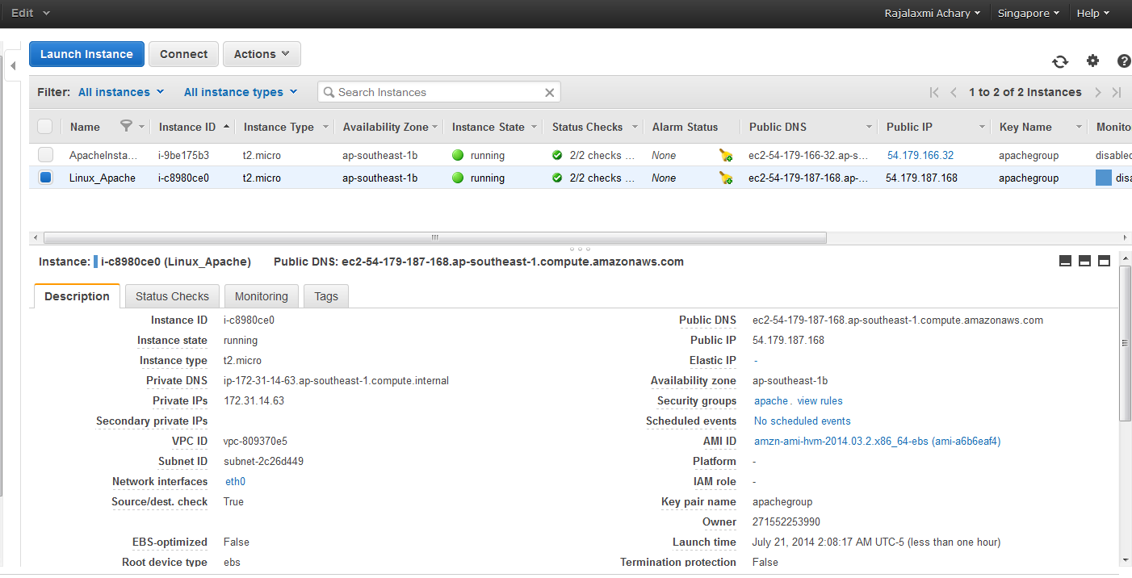

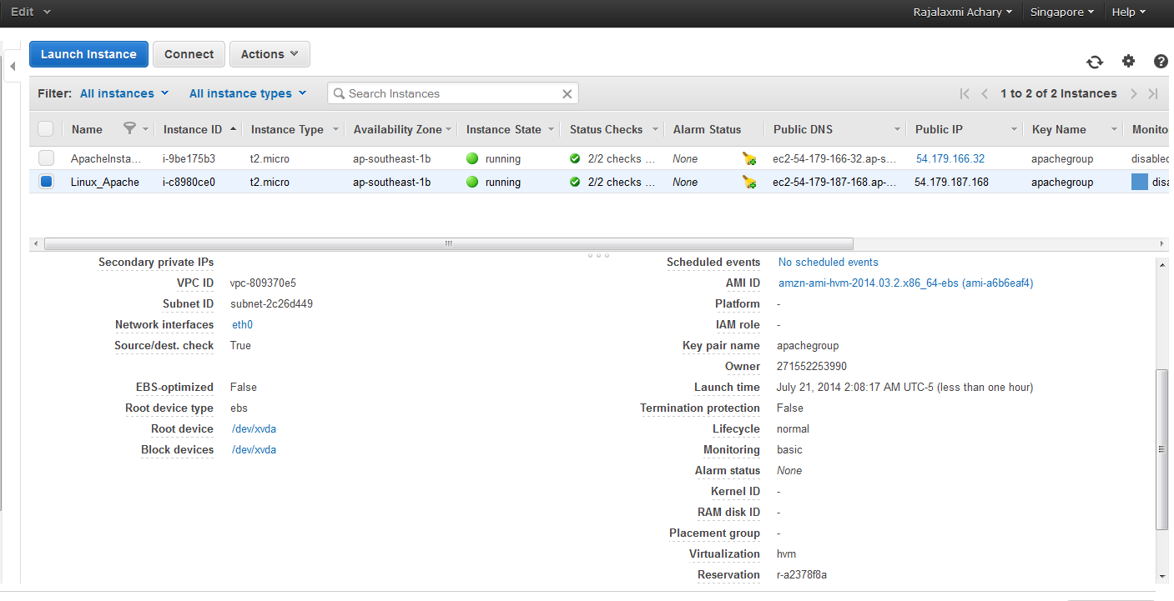

Associted Elastic IP Address: [54.251.165.146](https://console.aws.amazon.com/ec2/v2/home?region=ap-southeast-1#Addresses:search=54.251.165.146)

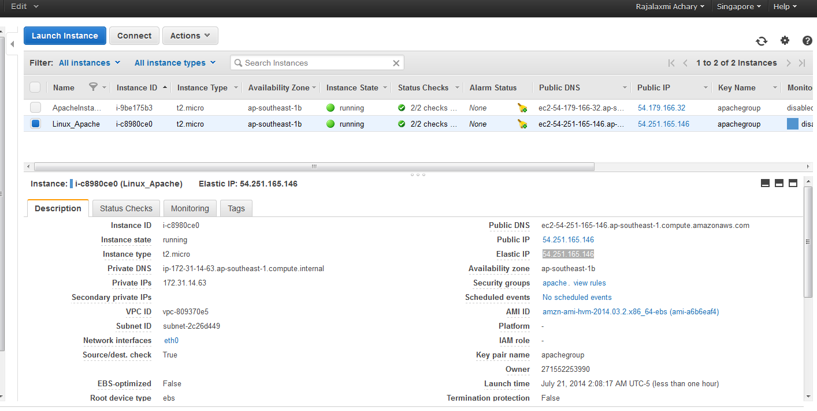

**Root Device EBS Size is 8GB**

In putty lsblk command displays disk devices and mounts points.

df –h command displays information about total space and available space on a file system.

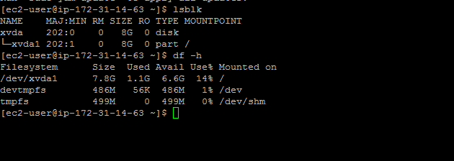

1. **Attach 1GB EBS Volume to the Instance**

Creating New EBS volume new_volume of 1GB.

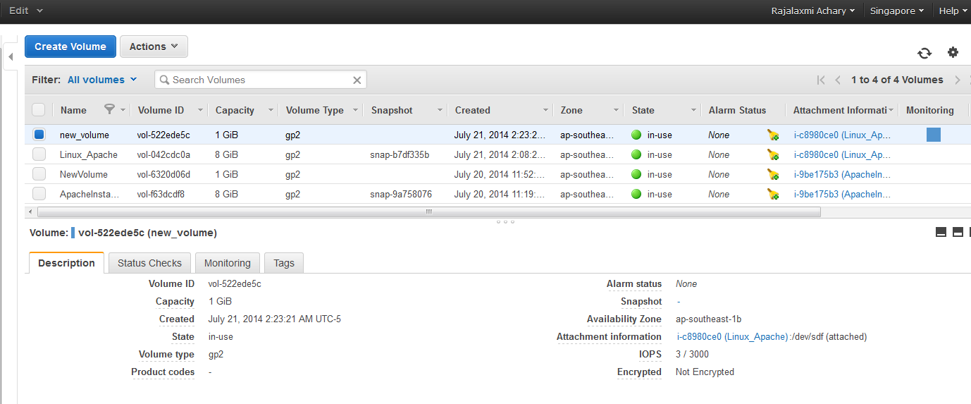

Attached new_volume to EC2 Linux_Apache Instance.

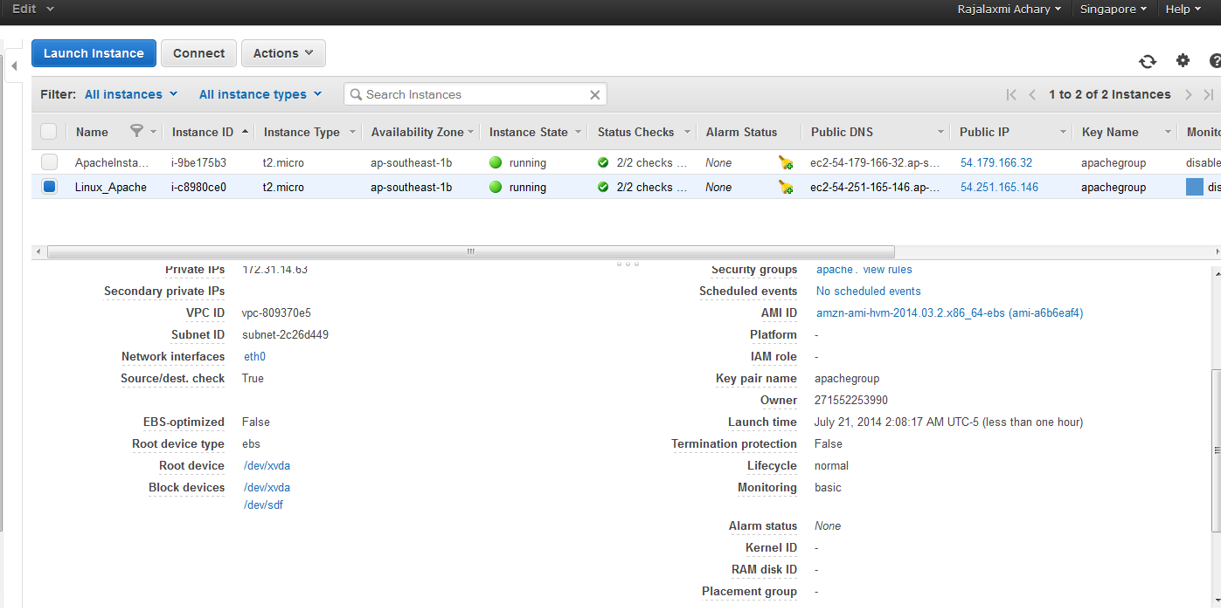

Showing new EBS volume attached to the Instance through putty

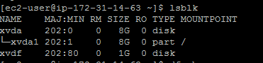

New_volume block device (xvdf or sdf) is not mounted. We have to check whether any file system is present or not.

sudo file –s /dev/xvdf command will list the files if present , otherwise it will return data if volume is empty.



As the above command returns data, new_volume is empty, we have to format the file system in block device.

sudo mkfs –t ext4 /dev/xvdf command is used to format the file system.

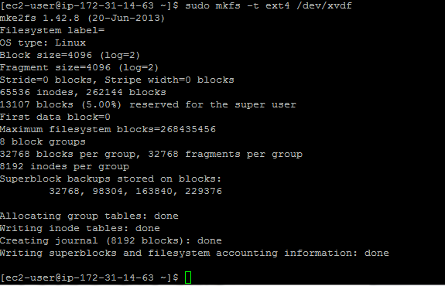

After formatting file system, we have to create a mount point directory (newvolume) for the new_volume. The mount point is where the volume is located in the file system tree and we can read and write files to after mounting the volume.

sudo mkdir /newvolume command is used to create newvolumedata directory.

Sudo mount /dev/xvdf /newvolume command is used to mount the volume at the location we created.

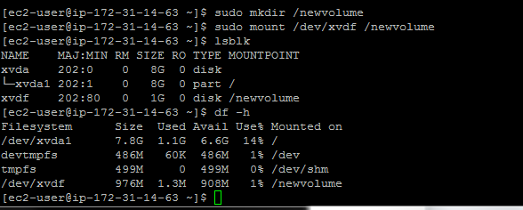

To mount new_volume on system reboot, we have to add entry for the device to the /etc/fstab file.

Created backup of /etc/fstab file for safety. Below command is used to copy the /etc/fstab file.

sudo cp /etc/fstab /etc/fstab.orig

After copying the file, edited the /etc/fstab file.

Sudo nano /etc/fstab command is used to do editing. Entered the below entry in fstb file.

/dev/xvdf /newvolume ext4 defaults 0 2

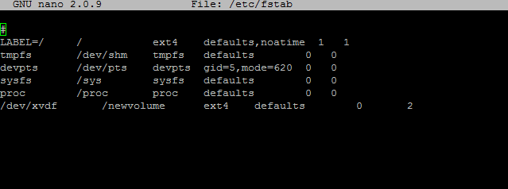

After adding the entry to the fstab file, sudo mount –a command is used to mount all file systems in /etc/fstab. If the above command does not produce an error, the /etc/fstab file is working fine and newvolume file system will be mounted automatically at the next boot.

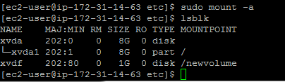

Now configured the permission (read,write and execute) on newvolumedata directory.

Sudo chmod 0777 /newvolume

1. **Installing Apache web server**

Before Installing Apache, we have to update the package database of the Linux installation.

Sudo yum –y update

To install apache server, below command is used.

Sudo yum –y install httpd

Sudo service httpd start

DocumentRoot is: /var/www/html

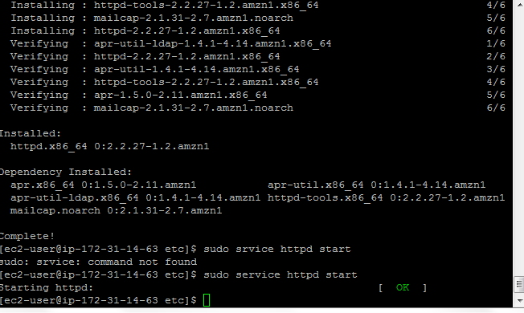

Here is the default page for Apache Server,

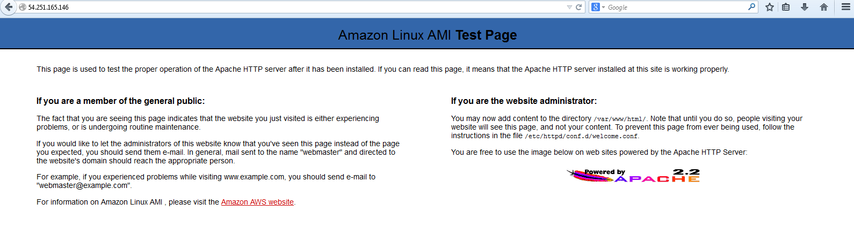

Chkconfig httpd on command is used to configure the Apache web server to start at each system boot.

Chkconfig –list httpd command is used to confirm service enable.

1. **Move Apache to an EBS Volume**

Before moving to EBS volume, we have to stop the services and copy all the original files.

Sudo cp -R /var/www /var/www.orig

Created var directory inside newvolume and www directory inside var directory.

Sudo mkdir var

Sudo mkdir www

Sudo chmod 777 /newvolume/var

Sudo chmod 777 /newvolume/var/www

Sudo chmod 777 /newvolume/var/www/html

Moving Apache server to newvolume and creating symbolic link to it.

Sudo mv /etc/var/www/* /newvolume/var/www

Sudo ln –s /newvolume/var/www /var/www

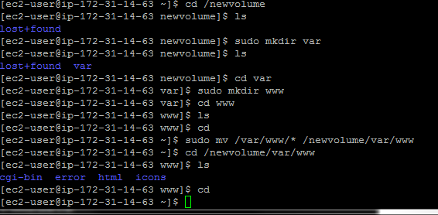

Changed the DocumentRoot (/var/www/html) to /newvolume/var/www/html.

Changed directory from / to /newvolume in httpd.conf file (/etc/httpd/conf/httpd.conf)

sudo vi /etc/httpd/conf/httpd.conf command is used to edit the httpd.conf file.

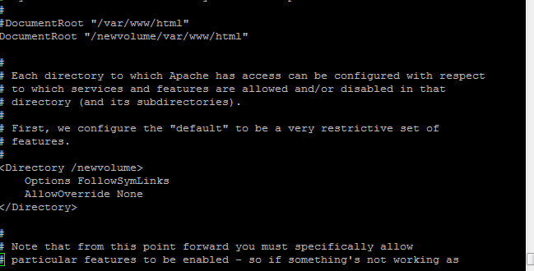

Starting httpd server

Sudo service httpd start

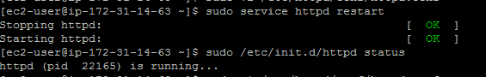

Creating index.html inside /newvolume/var/www/html/index.html

sudo vi /newvolume/var/www/html/index.html

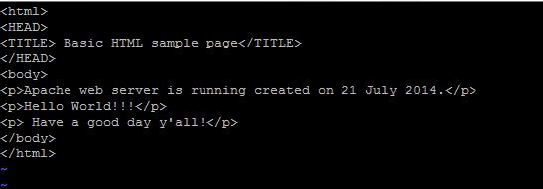

This is the output using public IP address of Linux_Apache Instance.

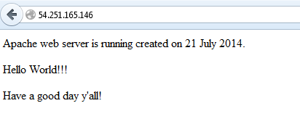

1. **Creating AMI (AMIFromLinux_ApacheEC2Instance) from Linux_Apache Instance**

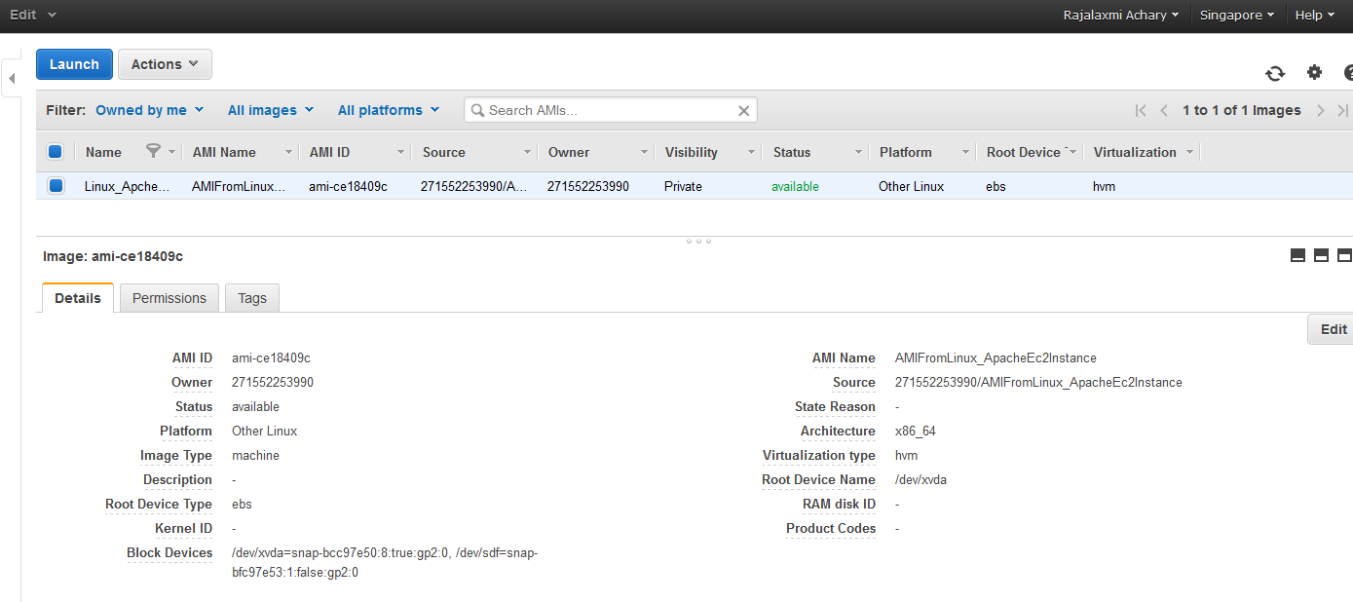

Launching EC2 Instance FromAMI using AMIFromLinux_ApacheEC2Instance AMI

InstanceName: FromAmI

Public DNS: ec2-54-179-131-243.ap-southeast-1.compute.amazonaws.com

PublicIP Address: 54.179.131.243

