Om

mkdir AI_Chatbot_Project

cd AI_Chatbot_Project

python –version

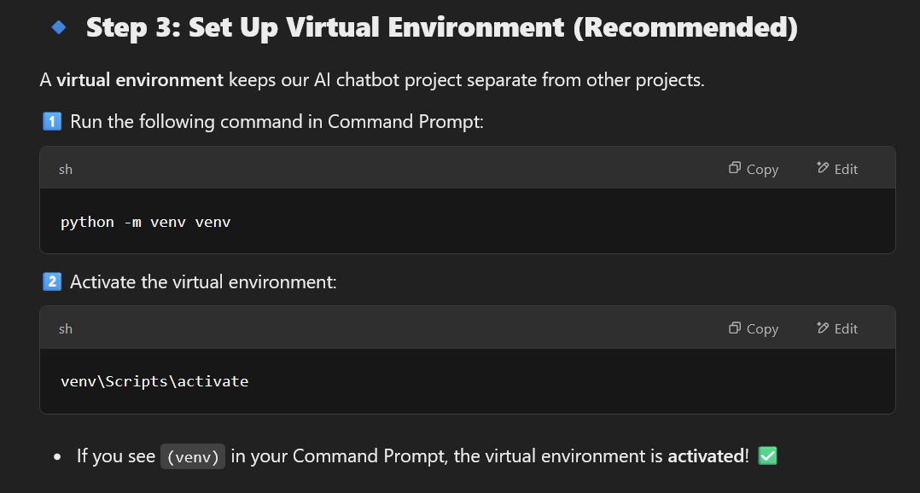

Next

