# Cybersecurity Project

# Monthly Project report template

**For further information:**

Steve Gale

Business and ICT

Email: [sgale@gordontafe.edu.au](https://d.docs.live.net/7503200b517357fd/2020-Teaching/Python%20ADCSE2/2020%20new%20Handouts/sgale@gordontafe.edu.au),

# Guide

## Monthly Project tracking meetings

Refer to Gant Chart and Trello

Meeting 15+5 minutes

* referring to MS Project Gant Chart and Trello board
* Monitor progress and track:
  + Procurement
  + Project progress to timelines
  + Identify and document variations
  + Monitor risks – update risk register
  + Quality (Testing) - Verify Prototype is meeting project technical requirements
  + Budget progress relative to projections
  + Critical path analysis
  + Sprint Retrospective – What went well , what needs improvement
* Meeting minutes
* Documentation
* Retrospective (5 Mins)

## Procurement progress and tracking

* Procurement is not in the scope of the Project.

## Project progress to timelines

* We are behind in progress as there have been complications in the production phase, but we believe we can make up for this in the testing phase.

## Identify and document variations

* File share server and connection to NTP server was established

**Monitor risks – update risk register**

| Id | Description of Risk | Impact or consequence | Likelihood/ Seriousness | Grade | Change | Mitigation Actions  (Preventative or Contingency) | Individual/Group Responsible for Mitigation Action | Timeline for Mitigation Action |
| --- | --- | --- | --- | --- | --- | --- | --- | --- |
| ~~CP1~~ | ~~Availability of resource like MS Project~~ | ~~H~~ | ~~Medium~~ | ~~C~~ |  | ~~Work at College premises~~ | ~~Group~~ |  |
| ~~CP 2~~ | ~~Availability of resource Memory in laptop~~ | ~~H~~ | ~~Medium~~ | ~~B~~ |  | ~~Get a PC with required memory~~ | ~~Individual~~ | ~~Sooner~~ |
| CP 3 | Logs from server not transfering | H | Medium | B |  | Redo server | Group |  |

CP 1 and CP 2 mitigated

**Quality - Verify Prototype is meeting project technical requirements**

* Network configuration is setup as per requirements.

**Budget progress relative to projections**

* Add Gant chart excerpt – report task cost overview compared to baseline
* 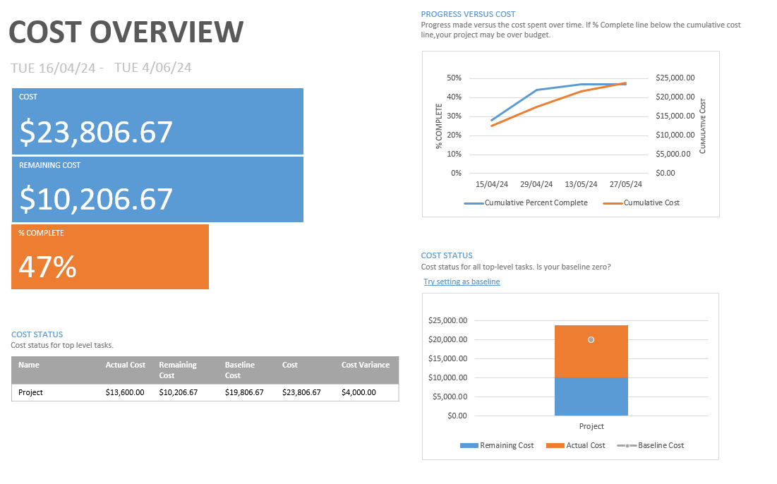
* The cost of the project is projecting as expected under the circumstances. Under the current conditions it appears it will cost $23,806 however the cost may become lower as w make up time in the testing.

**Critical path analysis**

* Add Gant chart excerpt – report: in progress > critical tasks
* 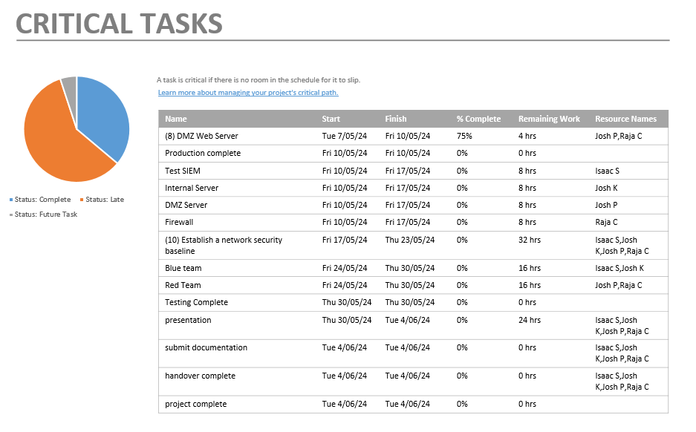
* The project is proceeding late, however we believe this will not affect the final due date.

**Sprint retrospective**

* + Palo alto setup and connection went well
  + Client to domain controller setup went well
  + DMZ initial configuration went well
  + The tasks are interdependent therefore we are getting stuck without any progress flowing, should streamline tasks more.
  + DMZ prototyping and production stuck at agent installation
  + More focus on documentation should be taking place
  + Documentation should be coordinated as not to overlap.

### Activities:

1. Update Project documentation (monthly report) to include items discussed in progress report
2. Revise Gant chart
3. Update risk register
4. Monthly project tracking meeting minutes documented
5. Sprint retrospective

### References:

Critical path - <https://support.microsoft.com/en-us/office/show-the-critical-path-of-your-project-in-project-desktop-ad6e3b08-7748-4231-afc4-a2046207fd86>

MS Project cost totals - <https://support.microsoft.com/en-us/office/view-project-cost-totals-0d3a2451-fb1e-4ba0-826e-20ee3b3d60cc>

Baseline – MSProject - <https://support.microsoft.com/en-us/office/create-or-update-a-baseline-or-an-interim-plan-in-project-desktop-7e775482-ac84-4f4a-bbd0-592f9ac91953>

**MS project reports**

Project > project Information > Statistics

Report > dashboard > Project Overview

Report > costs > task cost overview

Report > In progress > Milestone report

Report > resources > resource Overview

**Key to Risk Rating Symbols used:**

|  |  |  |  |
| --- | --- | --- | --- |
| Rating for Likelihood and Seriousness for each risk | | | |
| L | Rated as Low | E | Rated as Extreme (Used for Seriousness only) |
| M | Rated as Medium | NA | Not Assessed |
| H | Rated as High |  |  |

|  |  |  |  |  |  |
| --- | --- | --- | --- | --- | --- |
| Grade: Combined effect of Likelihood/Seriousness | | | | | |
|  | Seriousness | | | | |
| Likelihood |  | low | medium | high | EXTREME |
| low | N | D | C | A |
| medium | D | C | B | A |
| high | C | B | A | A |

|  |  |
| --- | --- |
| Recommended actions for grades of risk | |
| Grade | Risk mitigation actions |
| A | Mitigation actions to reduce the likelihood and seriousness to be identified and implemented as soon as the project commences. |
| B | Mitigation actions to reduce the likelihood and seriousness to be identified and appropriate actions implemented during project execution. |
| C | Mitigation actions to reduce the likelihood and seriousness to be identified and costed for possible action if funds permit. |
| D | To be noted - no action is needed unless grading increases over time. |
| N | To be noted - no action is needed unless grading increases over time. |

|  |  |  |  |
| --- | --- | --- | --- |
| Change to Grade since last assessment | | | |
| NEW | New risk | ↓ | Grading decreased |
| — | No change to Grade | ↑ | Grading increased |