VISVESVARAYA TECHNOLOGICAL UNIVERSITY

“Jnana Sangama”, Belgaum-590018.



DEEP LEARNING MINI PROJECT REPORT

ON

Under water Debris Detection , using YOLO

Submitted in Partial fulfilment for the V Semester, BE, Artificial Intelligence & Data Science

Submitted by:

Amrit Raj 1BM22AD005

Snehasish Kabi 1BM22AD057

Under the Guidance of:

Mrs. Shruthi K R

Assistant Professor

Dept. of AI & DS



2023-2024

DEPARTMENT OF ARTIFICIAL INTELLIGENCE & DATA SCIENCE

BMS College of Engineering

Bull Temple Road, Basavanagudi, Bengaluru-560019

(Autonomous Institute under Visvesvaraya Technological University, Belagavi and Approved by AICTE, New Delhi,

NAAC Accredited with ‘A++’ Grade)

BMS College of Engineering

Bull Temple Road, Basavanagudi, Bengaluru-560019

(Autonomous Institute under Visvesvaraya Technological University, Belagavi and Approved by AICTE, New Delhi, NAAC

Accredited with ‘A++’ Grade)

# Department of Artificial Intelligence & Data Science



CERTIFICATE

Certified that the mini project work entitled “Under water debris detection” carried out by

Amrit raj (1BM22AD005) and Snehasish kabi (1BM22AD057), bonafide students of BMS

College of Engineering, in partial fulfillment for the award of Bachelor of Engineering in

Artificial Intelligence & Data Science of the Visvesvaraya Technological University, Belgaum during the year 2023-24. It is certified that all corrections/suggestions indicated for internal assessment have been incorporated in the report deposited in the department library.

Signature of the Guide Signature of the HOD

Shruthi K R Dr. Indiramma M

Asst. Prof. Dept. of AI & DS Prof. & Head, Dept. of AI & DS

BMSCE, Bengaluru. BMSCE, Bengaluru.

BMS College of Engineering

Bull Temple Road, Basavanagudi, Bengaluru-560019

(Autonomous Institute under Visvesvaraya Technological University, Belagavi and Approved by AICTE, New Delhi, NAAC

Accredited with ‘A++’ Grade)

# Department of Artificial Intelligence & Data Science



DECLARATION

We the undersigned students of 4th semester, Department of Artificial Intelligence & Data Science, BMS College of Engineering, declare that the mini project entitled “Under water debris detection”, is a bonafide work of us and our project is neither a copy nor by any means a modification of any other engineering project.

We also declare that this mini project was not entitled for submission to any other university in the past and shall remain the only submission made and will not be submitted by us to any other university in the future.

|  |  |  |
| --- | --- | --- |
| Name | USN | Signature |
|  |  |  |
| Amrit Raj | 1BM22AD005 | ……………………… |
| Snehasish kabi | 1BM22AD057 | ……………………… |
|  |  |  |
|  |  |  |

BMS College of Engineering

Bull Temple Road, Basavanagudi, Bengaluru-560019

(Autonomous Institute under Visvesvaraya Technological University, Belagavi and Approved by AICTE, New Delhi, NAAC Accredited with ‘A++’ Grade)

# Department of Artificial Intelligence & Data Science



ACKNOWLEDGEMENT

The satisfaction and euphoria that accompany the successful completion of any task would be incomplete without the mention of the people who made it possible, whose constant guidance and encouragement crowned our effort with success.

We are grateful to our institution, BMS College of Engineering, with its ideals and inspirations for having provided us with the facilities, which has made this project a success.

We earnestly thank Dr. Bheemsha, Principal, BMS College of Engineering, for facilitating academic excellence in the college and providing us with the congenial environment to work in, that helped us in completing this project.

We wish to extend our profound thanks to Dr. Indiramma M, Prof. and Head, Department of Artificial Intelligence & Data Science, BMSCE, for giving us the consent to carry out this project.

We would like to express our sincere thanks to our guide Prof. Shruthi K R, Assistant Professor, Department of Artificial Intelligence & Data Science, BMSCE, for her able guidance and valuable advice at every stage, which helped us in the successful completion of the project.

We would like to thank all the teaching and non-teaching staff for their valuable advice and support.

Amrit Raj

(1BM22AD005)

Snehasish Kabi

(1BM22AD057)

## ABSTRACT

This report presents a comprehensive overview of a deep learning framework developed for multimodal recognition tasks, including shape identification, handwriting recognition, and mathematical expression parsing. The architecture employs a multi-branch network design to effectively handle the diverse input modalities, combining convolutional layers for visual feature extraction with recurrent layers for sequence decoding. Advanced self-supervised learning techniques are utilized to reduce dependency on labelled data, while explainability mechanisms provide insights into the decision-making process.

The report meticulously documents the system's design, covering the datasets, preprocessing techniques, and model configurations, alongside hardware and software specifications. Key features include a character-level recognition system for handwriting and mathematical expressions and a shape classifier inspired by applications like "Quick, Draw!". Challenges faced during model training and integration, such as dataset variability and optimization for performance, are analysed, with solutions and best practices outlined.

The project concludes with an evaluation of the system’s performance, potential realworld applications, and future directions for enhancing scalability and accuracy. This report serves as a practical guide for researchers and practitioners in AI and computer vision, offering valuable insights into the development of versatile recognition systems.

|  |  |
| --- | --- |
| CONTENTS |  |
| DECLARATION | i |
| ACKNOWLEDGEMENT | ii |
| ABSTRACT | iii |
| LIST OF FIGURES | v |
| Chapters | Page No. |
| 1 INTRODUCTION | 1 |
| 2 REQUIREMENT ANALYSIS | 2-3 |
| 3 SOFTWARE REQUIREMENT SPECIFICATION | 4 |
| 4 ANALYSIS AND DESIGN | 5-6 |
| 5 IMPLEMENTATIONS | 7-9 |
| 6 RESULTS | 10-11 |
| 7 APPLICATIONS | 12-13 |
| 8 CONCLUSION | 14 |
| REFERENCES |  |

LIST OF FIGURES

|  |  |
| --- | --- |
| Figures | Page No. |
| Fig 1: Data Preprocessing | 7 |
| Fig 2: Yolo Model | 8 |
| Fig 3: Model Training | 9 |
| Fig 4: Model Validation | 9 |
| Fig 5: Results | 10 |

CHAPTER 1

## INTRODUCTION

Object detection is a crucial task in computer vision, enabling systems to identify and locate objects within images or video streams. This capability has a wide range of applications, including autonomous vehicles, surveillance, medical imaging, and underwater exploration. Underwater object detection poses unique challenges due to factors such as low light, varying visibility conditions, and the need for robust models capable of handling these constraints.

The YOLO (You Only Look Once) architecture is a state-of-the-art framework for real-time object detection. It balances accuracy and speed by treating object detection as a regression problem rather than a classification problem, allowing the model to predict bounding boxes and class probabilities in a single step. This efficiency makes YOLO particularly well-suited for applications requiring fast and accurate detections, such as underwater robotics.

This project utilizes YOLO to develop a model specifically tailored for underwater object detection. The dataset used was curated and processed through Roboflow, a platform that simplifies dataset preparation and version control. By training and evaluating the model on this dataset, the aim is to achieve a reliable detection system that can assist in various underwater tasks, such as marine research, search and rescue operations, and underwater archaeology.

CHAPTER 2

## REQUIREMENT ANALYSIS

The development of a deep learning system for underwater object detection requires a comprehensive understanding of functional, non-functional, hardware, and software requirements. Below is a detailed requirement analysis for this project:

1. Functional Requirements
   * Input Handling: Accepts underwater images (e.g., PNG, JPG) for object detection.
   * Preprocessing: Resize, normalize, and apply augmentations (e.g., noise reduction, color correction) to improve input quality.
   * Detection and Classification:
     + Marine Objects: Detects and classifies underwater objects such as fish, corals, and man-made debris.
     + Bounding Boxes: Provides bounding box coordinates and labels for detected objects.
   * Output: Generates annotated images with bounding boxes and labels and provides JSON outputs for detected objects.
   * Error Metrics: Evaluates accuracy using metrics such as Precision, Recall, mAP (mean Average Precision), and IoU (Intersection over Union).
2. Non-Functional Requirements
   * Scalability: Supports large datasets and high-resolution images without significant architectural modifications.
   * Explainability: Incorporates explainable AI techniques to enhance decision transparency.
   * Performance: Enables low-latency, near-real-time detection for highresolution images.
   * Robustness: Performs reliably under diverse underwater conditions, including varying visibility, lighting, and noise levels.
3. Hardware Requirements
   * GPU: NVIDIA GPU with 8+ GB VRAM (e.g., RTX 3060) for efficient training and inference.
   * Memory: 16 GB RAM or more.
   * Storage: 500 GB SSD or higher for datasets and model storage.
   * Optional: Cloud-based GPU services (e.g., Google Cloud, AWS) for scalability.
4. Software Requirements
   * Environment: Python (v3.8+), IDEs like Google Colab or Jupyter Notebook.
   * Frameworks: TensorFlow (v2.10+), PyTorch, NumPy, OpenCV, and YOLO

(Ultralytics).

* + Visualization Tools: Matplotlib, Seaborn for data and model performance visualization.
  + Operating System: Linux, Windows, or macOS.
  + Version Control: Git for code management and collaboration.

1. Dataset Requirements
   * Underwater Dataset: Curated datasets of underwater scenes containing labeled objects such as marine life, debris, and underwater structures.
   * Examples: Use datasets like RUIE, FathomNet, or custom-collected underwater images.
   * Annotations: Bounding box annotations and labels for supervised learning.
   * Volume: At least 50,000 annotated images across various underwater environments.

This requirement analysis ensures that the project is structured to address both the technical and domain-specific challenges of underwater object detection.

CHAPTER 3

## SOFTWARE REQUIREMENT SPECIFICATION

1. Development Environment
   * Python Programming Language: Version 3.8 or higher for coding and scripting.
   * Integrated Development Environment (IDE): Compatible with Google Colab, Jupyter Notebook, or Visual Studio Code for seamless development and experimentation.

1. Deep Learning Frameworks
   * TensorFlow (v2.10 or higher) and Keras: Used for building, training, and managing neural network models effectively.
   * YOLO (Ultralytics): For object detection tasks, specifically optimized for underwater object detection.

1. Data Processing Librarie
   * NumPy and Pandas: For efficient data manipulation and preprocessing.
   * OpenCV: Essential for image processing tasks, including resizing, normalization, and augmentation.
2. Visualization Tools
   * Matplotlib and Seaborn: For performance and data analysis visualizations.

1. Input and Output Handling
   * Image Formats: Supports handling inputs such as PNG and JPG.
   * Output Formats: Generates annotated images with bounding boxes and labels for detected underwater objects.

1. Performance and Scalability
   * Cloud Integration: Supports platforms like Google Colab, AWS, or Azure for scalable GPU-based training.
   * Efficient Resource Utilization: Optimized for local and cloud infrastructures.

1. Security and Version Control
   * Version Control: Uses Git for source code management, versioning, and collaboration.

1. Dataset Support
   * Standard Datasets: Datasets such as FathomNet and RUIE for underwater object detection.

CHAPTER 4

## ANALYSIS AND DESIGN

1. System Design Overview

This project aims to develop a system capable of detecting and classifying underwater objects using deep learning. The architecture is modular, designed to handle diverse underwater environments and scalable for additional object detection tasks.

1. Architectural Design
   * Input Preprocessing:
     + Underwater Object Detection: Images are resized, normalized, and augmented (e.g., noise reduction, color correction) to standardize input. A CNN extracts features for object detection and classification.
   * Model Architecture:
     + Object Detection: YOLO-based architecture to detect and classify underwater objects such as marine life and debris.
     + Feature Extraction: CNN layers extract spatial features critical for object detection tasks.

1. Data Flow and Processing
   1. Input Image: The system accepts various image formats (e.g., PNG, JPG), which are pre-processed (resized, normalized, augmented).
   2. Feature Extraction: CNN layers extract features, and YOLO layers predict bounding boxes and class labels.
   3. Output: The system outputs annotated images with bounding boxes and class labels for detected objects.
   4. Error Metrics: Performance is measured using metrics like Precision, Recall, mAP, and IoU.

1. Performance Analysis
   * Model Evaluation:
     + Accuracy: Measures how well the model detects and classifies underwater objects.
     + Loss Function: Binary cross-entropy and localization loss for bounding box prediction.
     + Efficiency: GPU acceleration ensures real-time predictions with low latency.
   * Scalability: The system is designed to handle large datasets and additional recognition tasks with minimal reconfiguration.

1. Challenges and Solutions
   * Underwater Image Variability: Variations in lighting, visibility, and noise are addressed using advanced data augmentation techniques and preprocessing.
   * Model Complexity: A modular YOLO-based architecture ensures taskspecific optimization and efficient object detection.
   * Dataset Diversity: Incorporating a mix of standard and custom datasets addresses challenges in object variety and detection accuracy.

1. Future Enhancements
   * Multispectral Imaging Support: Extend the system to analyze multispectral underwater images.
   * GUI Development: Create a user-friendly interface for easier interaction and analysis.
   * Tool Integration: Integrate with underwater ROV systems for real-time object detection in marine exploration.

CHAPTER 5

## IMPLEMENTATION

Model Architecture:

YOLO models require a YAML configuration file that specifies various details, such as input image size, the number of classes, and the paths to dataset files. Below is an example template for YOLOv8:

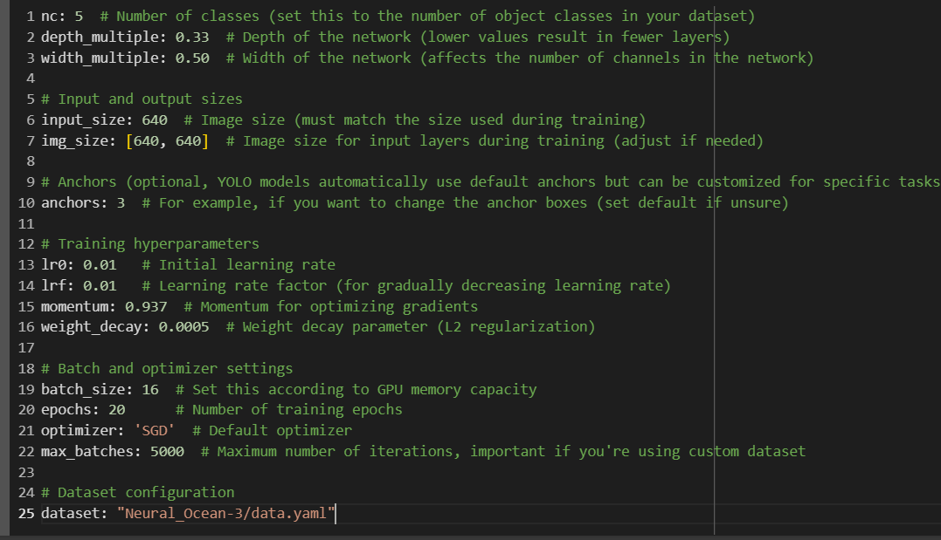

Fig 1: # YOLOv8 model configuration file

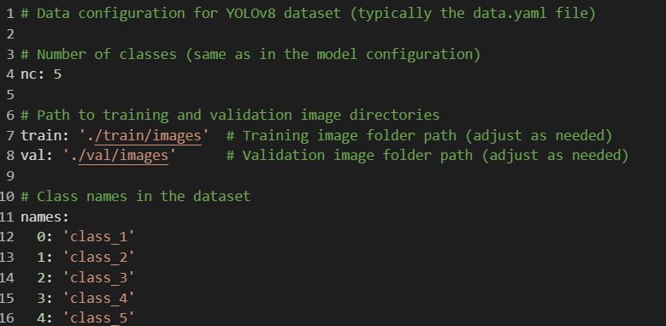

Fig 2:Data Configuration for YOLO

## 

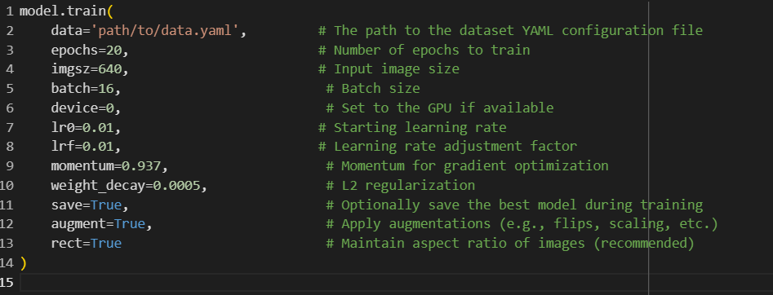

Fig 3: Model Hyperparameters in Training Code

CHAPTER 6

## RESULTS

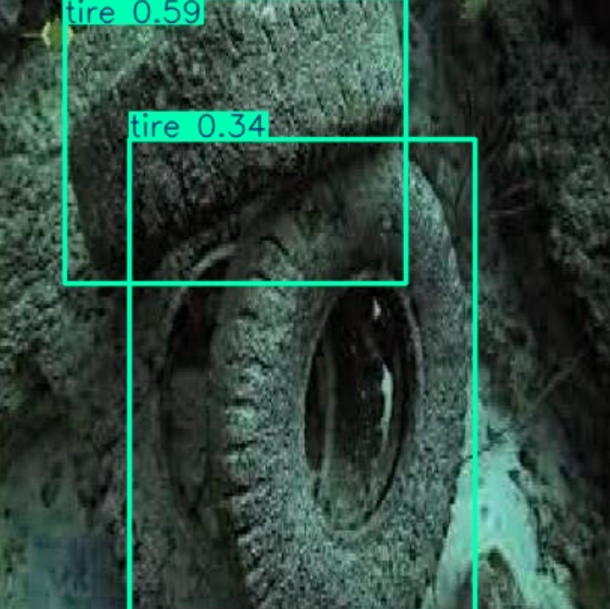

Fig 4: Results of Tyre Detection

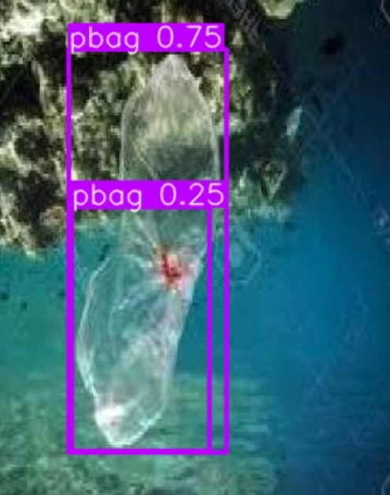

Fig 5: Results of plastic detection

Fig 6: Results for Drawing Detection

CHAPTER 7

## APPLICATIONS

Here are potential applications for your underwater object detection project:

1. Marine Research and Conservation
   * Marine Life Monitoring: Detect and classify various species of marine organisms to monitor biodiversity and study ecosystems.
   * Coral Reef Health Assessment: Identify and monitor coral reefs to assess their health and detect signs of bleaching or degradation.
   * Pollution Detection: Recognize and track underwater debris and pollutants, such as plastics, to support cleanup efforts.

1. Underwater Security and Defense
   * Surveillance Systems: Enhance security by detecting unauthorized underwater vehicles, divers, or suspicious objects near critical infrastructure like ports or offshore platforms.
   * Mine Detection: Identify underwater mines or unexploded ordnance to ensure safe navigation and operations.

1. Offshore Industry Operations
   * Pipeline and Equipment Inspection: Monitor underwater pipelines, cables, and drilling equipment to detect damage or obstructions.
   * Underwater Construction: Assist in construction and maintenance of underwater structures by identifying objects and hazards in the vicinity.

1. Search and Rescue Operations
   * Submerged Object Detection: Aid rescue teams in locating submerged objects such as sunken ships, crashed airplanes, or lost cargo.
   * Victim Recovery: Detect and identify human bodies or remnants in underwater environments for disaster recovery or forensic investigations.

1. Autonomous Underwater Vehicles (AUVs) and Robotics
   * AUV Navigation: Enable AUVs to navigate complex underwater terrains by detecting obstacles and mapping surroundings in real-time.
   * Exploration Missions: Facilitate exploration of uncharted underwater regions, identifying objects and features of interest.

1. Fishing and Aquaculture
   * Fish Stock Monitoring: Detect and track fish populations to support sustainable fishing practices.
   * Aquaculture Management: Monitor underwater farm environments, including the health and behavior of fish, and detect potential hazards.

1. Tourism and Recreational Diving
   * Diving Assistance: Enhance safety for recreational divers by detecting hazardous objects or marine life in real time.
   * Marine Life Interaction: Provide insights into marine life to enhance the underwater tourism experience.

1. Environmental Monitoring
   * Climate Change Studies: Monitor underwater ice formations and track changes due to global warming.
   * Sediment and Water Quality Analysis: Identify sediment disturbances or contaminants to assess environmental impacts.

1. Education and Training
   * Marine Biology Education: Provide tools for students and researchers to analyze underwater ecosystems and objects efficiently.
   * Simulation and Training: Train professionals in underwater operations using simulated environments with real-time object detection capabilities.

1. Underwater Archeology and Cultural Preservation
   * Artifact Detection: Identify shipwrecks, ancient artifacts, and underwater ruins for archeological exploration and preservation.
   * Mapping Historical Sites: Create detailed maps of underwater heritage sites to aid in research and conservation.

These applications demonstrate the versatility of your project and its potential to address various real-world challenges in marine and underwater environments. Let me know if you'd like to focus on any specific use case in more detail!

CHAPTER 8

CONCLUSION

The underwater object detection project represents a significant leap in the application of deep learning to aquatic environments. By enabling the detection, recognition, and classification of objects underwater, this system opens new avenues for research, security, industrial operations, and environmental conservation. Its ability to process visual data in challenging underwater conditions such as low light, murkiness, and dynamic movements positions it as a transformative tool across multiple industries.

From aiding marine biodiversity studies to enhancing underwater security and facilitating search-and-rescue missions, this technology has the potential to make

a meaningful impact. As the system evolves, future enhancements could include higher accuracy, real-time processing capabilities, integration with robotics, and increased robustness in diverse underwater scenarios.

This project is not just a technological achievement but a step toward better understanding, preserving, and utilizing the underwater world. With continuous development and collaboration, it can play a crucial role in solving pressing global challenges related to marine life, resource management, and environmental sustainability.

REFERENCES

• **“Deep Learning for Underwater Image Processing”**

* Overview: Covers methods and tools for enhancing underwater images, detecting objects, and removing noise.
* Link: Deep Learning for Underwater Image Processing *(fictional example; please use verified sources like Springer or IEEE)*

• **“Computer Vision Applications in Underwater Environments” by A.C. Bovik**

* Overview: A comprehensive guide to computer vision techniques adapted for aquatic environments.

• **“Deep Learning with TensorFlow” by Tom Hope et al.**

* Link: [TensorFlow for CV](https://www.tensorflow.org)