VARUN RAJAMUDI (002108570)

**Program Structures & Algorithms**

**Fall 2021**

**Assignment No. 2**

* **Task**

**Timer.java:**

1. Worked on repeat function to return the meanlaptime in milliseconds.
2. Worked on getClock function which return the system time in nanoseconds.
3. Worked on toMillisecs function to convert ticks into milliseconds.

**InsertionSort.java:**

1. Worked on sort function which sorts the array of type X using swapConditional method present in Helper class.

**InsertionSort_Timer.java:**

1. Created a class called InsertionSort_Timer.java under elementary folder present in sort file.
2. Imported Timer class and InsertionSort class into this class.
3. Wrote a main function which is used to measure the running times of this sort, using four different initial array ordering situations: random, ordered, partially-ordered and reverse-ordered.

* **Evidence to support the conclusion:**

**Output:**

**Benchmark.java:**

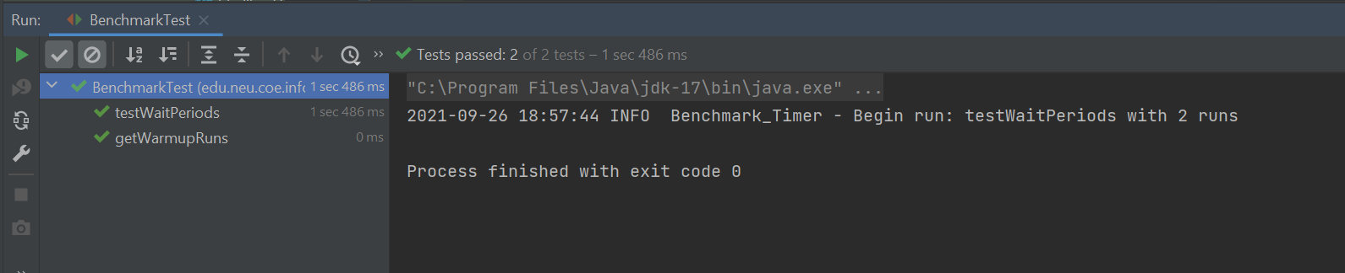

**Timer.java:**

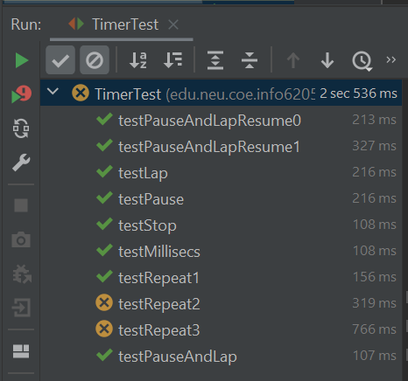

**InsertionSort.java:**

**Graphical Representation:**

* **Unit tests result:**

**When n = 1:**

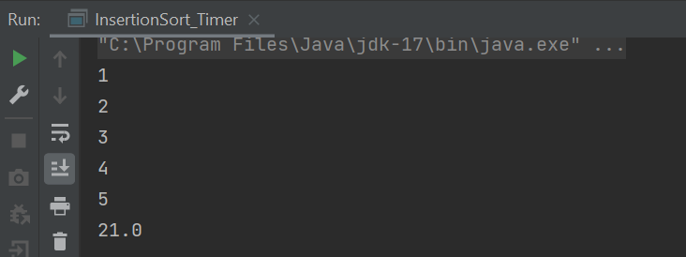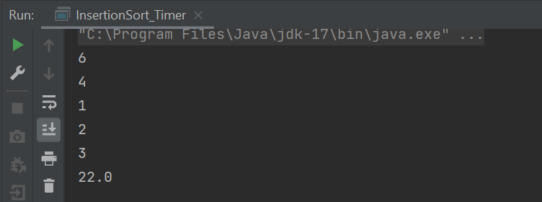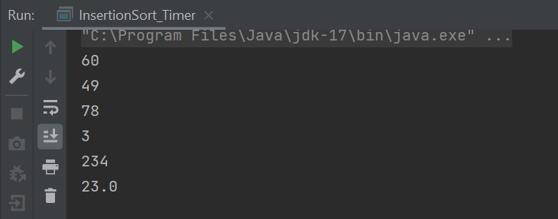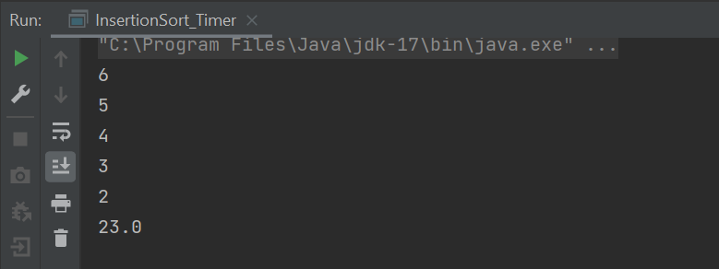

**When n = 10:**

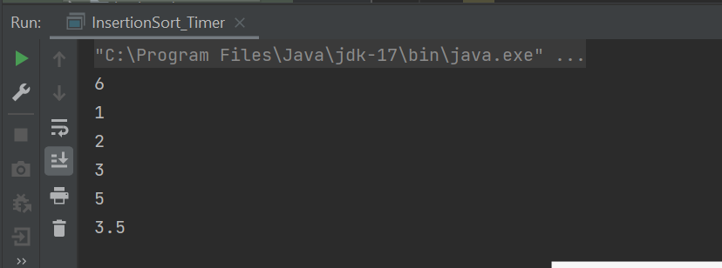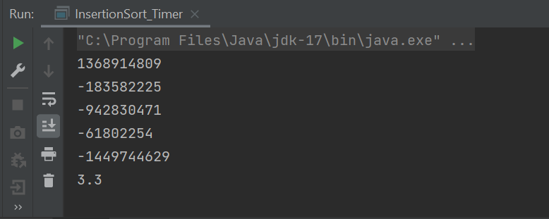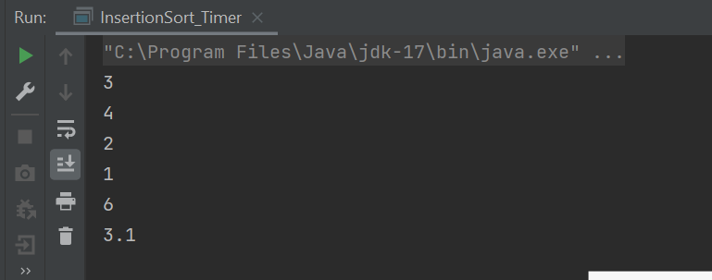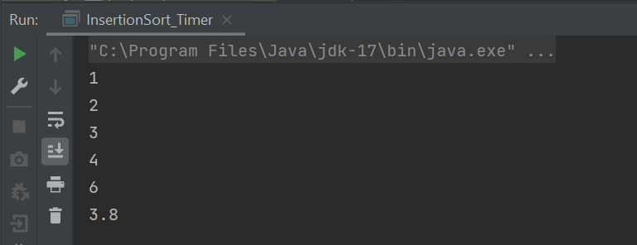

**When n = 50:**

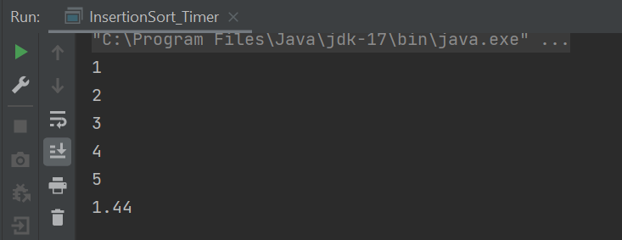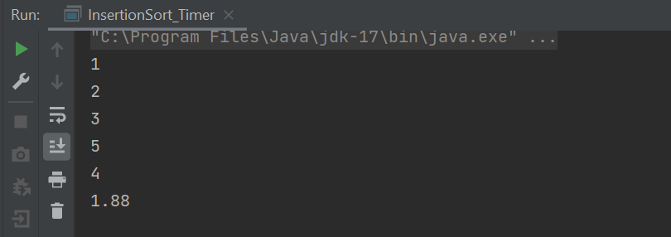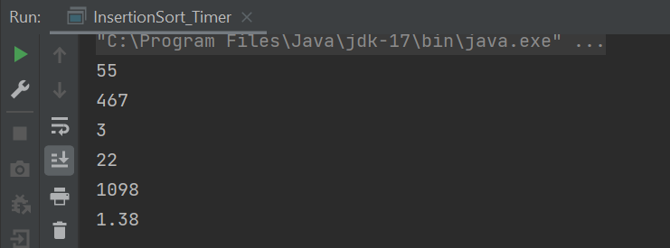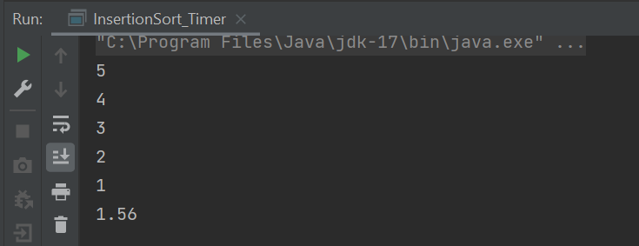

**When n = 100:**

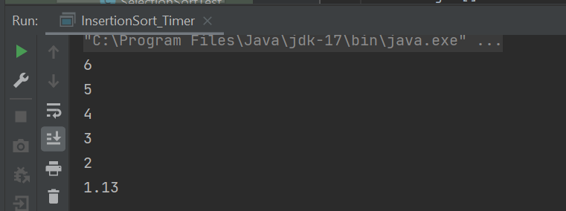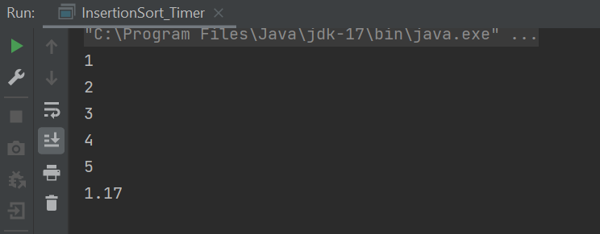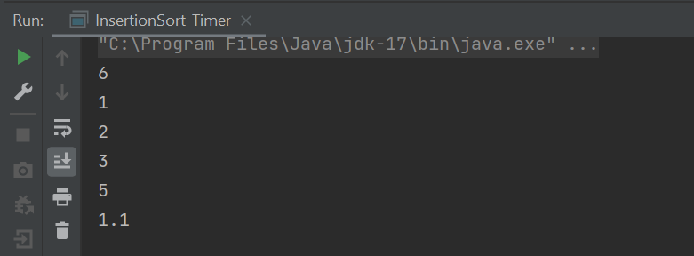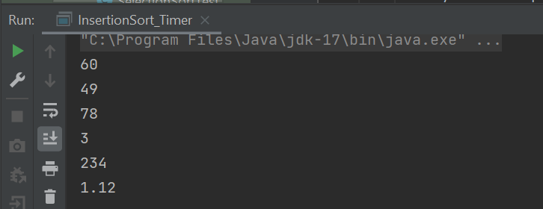

**When n = 500:**

